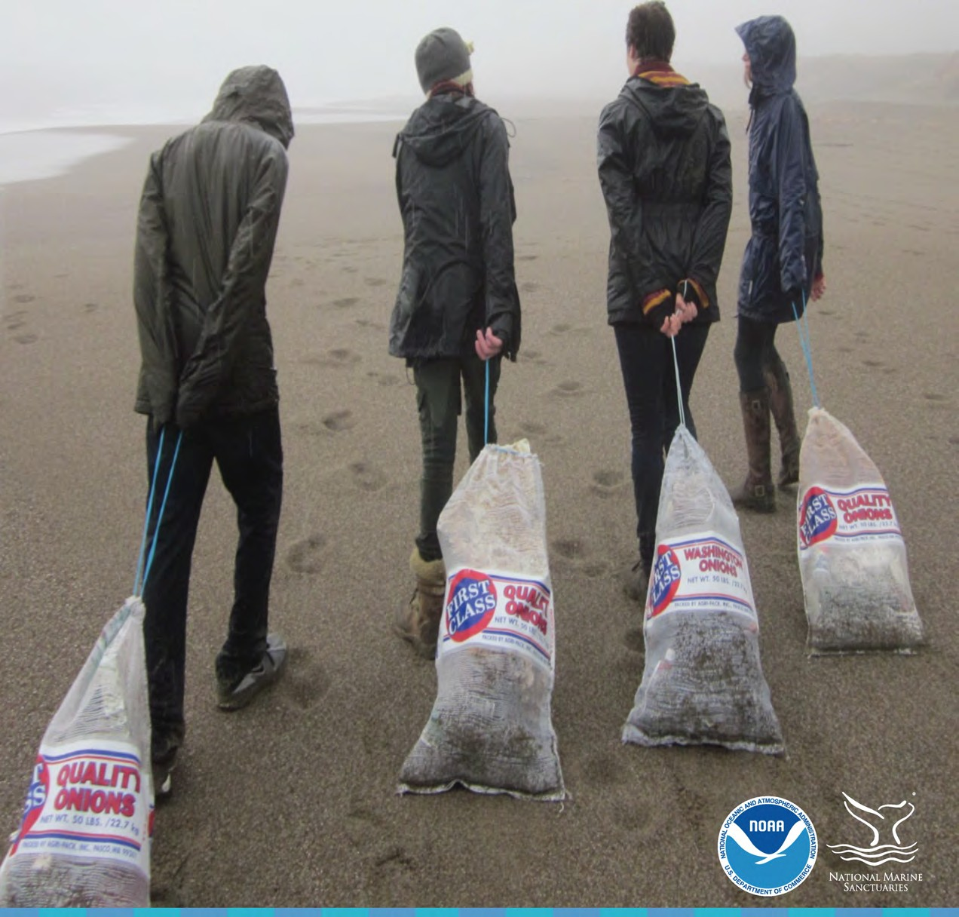
NOAA Marine Debris Program
NOAA Office of National Marine Sanctuaries
Marine Debris Toolkit

for educators

Marine Debris Toolkit
for educators
Alyssa Nally1, Sherry Lippiatt2, 3, Seaberry Nachbar1, and Naomi Pollack1

- National Oceanic and Atmospheric Administration Office of National Marine Sanctuaries
Ocean Guardian School Program Monterey, CA 93940, USA
- National Oceanic and Atmospheric Administration Office of Response & Restoration
Marine Debris Program
Silver Spring, MD 20910, USA
- I.M. Systems Group, Inc. 3206 Tower Oaks Boulevard Suite 300
Rockville, MD 20852, USA

Photo NOAA Marine Debris Program

April 22, 2017 Earth Day
UNITED STATES DEPARTMENT OF COMMERCE
National Oceanic and Atmospheric Administration NATIONAL OCEAN SERVICE

Marine debris is one of the most prevalent issues across our one ocean. It comes in all shapes and sizes and can impact the environment, navigation safety, the economy, and human health. Preventing marine debris begins at the individual level, through commitments to reduce and responsibly manage our waste.
Efforts to address this preventable challenge vary and can include focused research to better understand distribution and abundance of debris, workjng with academia to pursue research projects, and removal and mitigation efforts (e.g., beach cleanups, "ghost gear, removal). In addition efforts can include engaging community partners through locally­ driven projects. However, the key to changing perso11al action and making changes from within communities comesfrom targeted education and outreach.
,
In response to this problem, the NOAA Marine Debris Program and the Office of National Marine Sanctuaries are pleased to introduce the NOAA Marine Debris Kit; one tool in helping the next generation understand the impacts of marine debris through hands-on, investigative surveys that involve the student from beginning to the end. This kit will provide a way to engage youth, educate them on the issue of marine debris, provide them opportunities to collect and analyze marine debris in their local community, and compare their results with youth across the nation and world. Most importantly, it provides our youth the tools to make a difference and the encouragement to find their
VO!Ce.

NOAA is committed to making tangible changes which will benefit our environment. We believe every student, regardless of where they live, should be involved in making these changes with us and become stewards for our one ocean.
Sincerely,

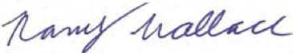

Nancy Wallace | John Armor
Director | Director
NOAA Marine Debris Program | NOAA Office of National
 | Marine Sanctuaries

Roadmap to Student Success
Welcome to NOAA's Marine Debris Toolkit! Thank you for your interest in engaging your students in marine debris monitoring. Your students' monitoring and outreach efforts are an important step towards protecting marine environments from the dangers of marine debris.

The Marine Debris Toolkit is an excellent tool for developing a marine debris monitoring program in your classroom. Successful use of this kit involves a full-circle approach - beginning with education, continuing with monitoring efforts, and looping back around to student-driven engagement and outreach.
In this kit you will find four sections:

Section 1. Teacher Resources
In this section you will find a compilation of teacher resources to aid you in your marine debris education efforts. Links to the recommended curriculum, Winged Ambassadors, and additional curricula are provided, along with educational articles, videos, and websites. In addition, a web-based PowerPoint presentation on marine debris is included with informational notes to help supplement the text within the presentation.

Section 2. Guidelines for Data Collection

Comprehensive guidelines for data collection through NOAA's Marine Debris Monitoring and Assessment Project are included in this section. Safety guidelines, survey methods, datasheets, a recommended monitoring tools list, and a photo identification guide are also incorporated.

Section 3. Guidelines for Data Analysis

This section presents a brief overview of how to submit your students' data into the Marine Debris Monitoring and Assessment Project database as well as templates for analyzing student data.

Section 4. Community Engagement and Outreach

The Community Engagement and Outreach section provides several ideas on how to engage your students in marine debris activities on campus. This includes ideas on how to empower your students to share their message with their community.

We are committed to making this kit work for you and your students. We hope you will share your feedback with us in the teacher reflection form located at the end of this kit.

Keep n 'Tips fro,,,
a eye out for
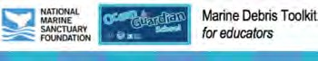
Ut this ti educators/
experienced ed by

Contents
Section 1: Teacher Resources 1
Curriculum & Lesson Plans 1
Educational Articles 3
Educational Videos 4
Educational Websites 5
Introduction to Marine Debris 7
PowerPoint Presentation Notes 7
Section 2: Guidelines for Data Collection 10
Marine Debris Monitoring & Assessment Project 10
Marine Debris Monitoring - Safety FirstI 11
Survey Types & Site Selection 12
Accumulation Surveys 14
Accumulation Survey Sheets 15
Marine Debris Monitoring Supplies 19
Marine Debris Survey Photo Identification Guide 20
Section 3: Guidelines for Data Analysis 29
Entering Data into the MDMAP Database 29
Analyzing Your Data 30
Section 4: Community Engagement and Outreach 31
School Activities List 31
Action Project Ideas 32
Writing to a Member in Your Community 34
Marine Debris Toolkit - Teacher Reflection Form 35

Section 1: Teacher Resources

Curriculum & Lesson Plans
Category Title Grade Level Link

Source
NOAA Office of

Winged Ambassadors
Grades 6-8
National Marine

- Marine Debris with extensions httQ://www.downloadwingedambassadors.org
'Top choice for curriculum for 9-12

httQs://marinedebris.noaa.gov/curriculum/comQreh
- Marine Debris Marine Debris - Composition and Abundance Grades 4-5 ensive-web-based-marine-debris-steamss-
curriculum
Sanctuaries, Oikonos, Papahanaumokuakea Marine National Monument
Oregon Coast Aquarium; NOAA Marine Debris Program

- Marine Debris
Turning the Tide on Trash: A Learning Guide on Marine Debris
Grades 1-12 httQs://marinedebris.noaa.gov/turning-tide-trash
NOAA Marine Debris Program

- Marine Debris
The Educator's Guide to Marine Debris:
Grades 5-8
httQs://marinedebris.noaa.gov/educators-guide-
NOAA Marine Debris

Southeast and Gulf of Mexico marine-debris-southeast-and-gulf-mexico

- Marine Debris

"How can a model describe how microplastics move in the ocean?"

Grades 6-12
httQ://www.montereybayaguarium.org/-
/m/Qdf/education/curriculum/aguarium-6-12-gyre- in-a-bottle-ngss.Qdf

Monterey Bay Aquarium*

- Marine Debris
"Where can you find plastic in the water column httQ://www.montereybayaguarium.org/- and how might it affect the animals that live Grades 6-8 /m/Qdf/education/curriculum/aguarium-6-8- there?" Qlastics-in-thewater-column.Qdf

Monterey Bay Aquarium*

- Marine Debris C-MORE Science Kits - Marine Debris Grades 8-12
httQ://stemQreacademy.hawaii.edu/c- more/marine-debris
University of Hawai'i*

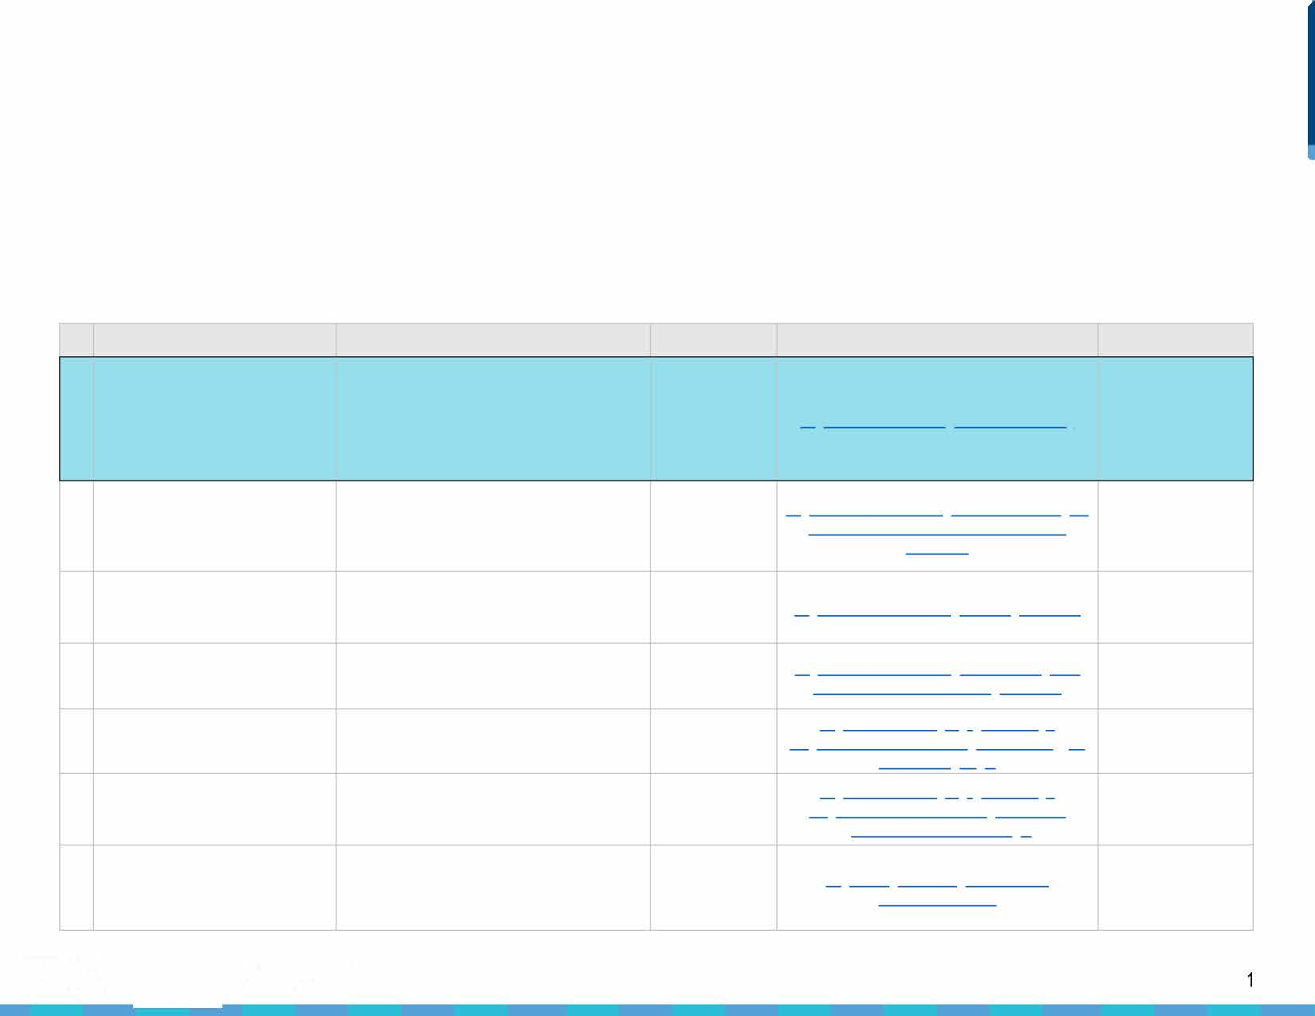

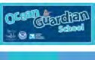
� ^{NATIONAL} Marine Debris Toolkit
-=- MARINE
---:- SANCTUARY for educators
FOUNDATION

- Marine Debris

Marine Debris

- Marine Debris

- Marine Debris

- Marine Debris

- Marine Debris

Ocean Health/Marine Debris/Recycling
14

- Refuse/Reduce/Reuse/Recycle/Rot

- Refuse/Reduce/Reuse/Recycle/Rot

- Refuse/Reduce/Reuse/Recycle/Rot
"How can hazardous waste be cleaned up with the least impact on the environment while keeping within a budget?"

Teaching Your Students About Marine Debris: A Classroom Activity

Marine Debris Keiki Education and Outreach (MDKEO) Program

An Educator's Guide to Marine Debris

Waves, Wetlands, and Watersheds

Washed Ashore Curriculum

Bag It! Curriculum for Teachers

"What types of plastics do we use the most? How can we reduce our single-use plastics?"

"How do we use plastics? Are there better or worse uses of plastics?"

Reducing, Reusing, and Recycling Classroom Waste

Grades 3-5

Grades K-8

Grades K-5

Grades K-12

Grades 3-8

Grades 5-8

Grades 4-12

Grades 6-12

Grades 6-8

Grades K-3
htt12s://www.montereybayaguarium.org/-
/m/12df/education/curriculum/aguarium-6-8-beach- contamination.12df

htt12://ocean.si.edu/blog/teaching-your-students- about-marine-debris-classroom-activity

htt12s://marinedebris.noaa.gov/curricula/marine- debris-keiki-education-outreach-12rogram

htt12s://marinedebris.noaa.gov/educators-guide- marine-debris

htt12s://www.coastal.ca.gov/12ubliced/waves/waves 12dfs.html

htt12://washedashore.org/iamdc/

htt12://bagitmovie.com/downloads/EducationPacke t_7.(2df

htt12://www.montereybayaguarium.org/-
/m/12df/education/curriculum/aguarium-6-12- 12lastic-use-audit-ngss.12df

htt12://www.montereybayaguarium.org/-
/m/12df/education/curriculum/aguarium-6-8- 12lastics-reduce-use-recycle-ngss.12df

htt12://www.calrecycle.ca.gov/education/curriculum
/CTL/K3Module/Unit2/Unit2.(2df
Monterey Bay Aquarium*

Smithsonian: National Museum of Natural History*

Hawai'i Wildlife Fund*

North American Marine Environment Protection Association*
California Coastal Commission*

Washedashore.org*

bagitmovie.com*

Monterey Bay Aquarium*

Monterey Bay Aquarium*

CalRecycle*

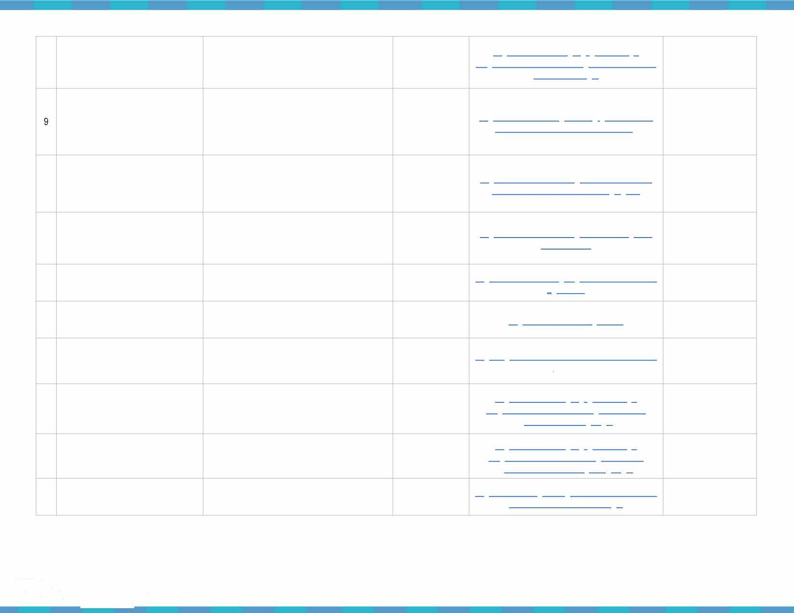

Don't forget to check out the Marine Debris Toolkit- Introduction to Marine Debris PowerPoint presentation! *Partner source
[https://marinedebris.noaa.gov/curricula/marine-debris-monitoring-toolkit-educators]

� NATIONAL Marine Debris Toolkit
-=- MARINE
for educators
2
SANCTUARY
--.iii:'" FOUNDATION

Title
Category
1 | Marine Debris
2 | Marine Debris
3 | Marine Debris
4 | Marine Debris
5 | Marine Debris
6 | Marine Debris
7 | Marine Debris
8 | Marine Debris
9 | Ocean Protection
10 | Plastic Reduction
11 | Plastic Reduction

Educational Articles
Grade Level

Link

Partner Source

Innovative Solutions to Tackling Plastic Pollution in the Ocean

The Best Way to Deal with Ocean Trash

2015 Trash Free Seas Report: By the Numbers

Ocean Trash: 5.25 Trillion Pieces and Counting, But Big Questions Remain

Leading Ocean Advocacy Groups Join Forces to Tackle Microfiber Pollution

Bottles, Bags, Ropes and Toothbrushes: the Struggle to Track Ocean Plastics

Understanding Plastic Pollution: A Call for Community Action

Photos: 1,300 Students Make Coastal Cleanup their Mission for the Day

Why It's Important to Save Our Seas' Last Pristine Places

100 Steps to a Plastic-Free Life

10 Ways to Reduce Plastic Pollution

Grades 4-12

Grades 4-12

Grades K-12

Grades 4-12

Grades 6-12

Grades 9-12

Grades 6-12

Grades K-12

Grades 6-12

Grades K-12 Grades K-12

httQ://resQonse.restoration.noaa.gov/about/media/innovative
-solutions-tackling-Qlastic-Qollution-ocean.html

httQ://news.nationalgeograQhic.com/news/2014/04/140414- ocean-garbage-Qatch-Qlastic-Qacific-debris/

httQ://www.oceanconservancy.org/our-work/international- coastal-cleanuQ/2015-by-the-numbers.html

httQ://news.nationalgeograQhic.com/news/2015/01/150109- oceans-Qlastic-sea-trash-science-marine-debris/

httQs://www.theguardian.com/lifeandstyle/2016/seQ/07/micro fiber-Qollution-ocean-advocacy-grouQs-alliance

httQ://www.nature.com/news/bottles-bags-roQes-and- toothbrushes-the-struggle-to-track-ocean-Qlastics-1.20432

httQ://www.huffingtonQost.com/lonely-whale- foundation/understanding-Qlastic-Qollution-a-call-for- community-action b 10316800.html

httQ://www.ocregister.com/2016/06/03/Qhotos-1300- students-make-coastal-cleanuQ-their-mission-for-the-day/

httQ://www.nationalgeograQhic.com/magazine/2017/02/savin g-our-seas-Qresident-obama-oceans-conservation/

httQs://myQlasticfreelife.com/Qlasticfreeguide/

httQs://www.nrdc.org/stories/10-ways-reduce-Qlastic- QOllution
NOAA: Office of Response and Restoration

National Geographic

Ocean Conservancy

National Geographic

The Guardian

Nature

Huffington Post - the Lonely Whale Foundation

The Orange County Register

National Geographic

My Plastic Free Life

Natural Resources Defense Council

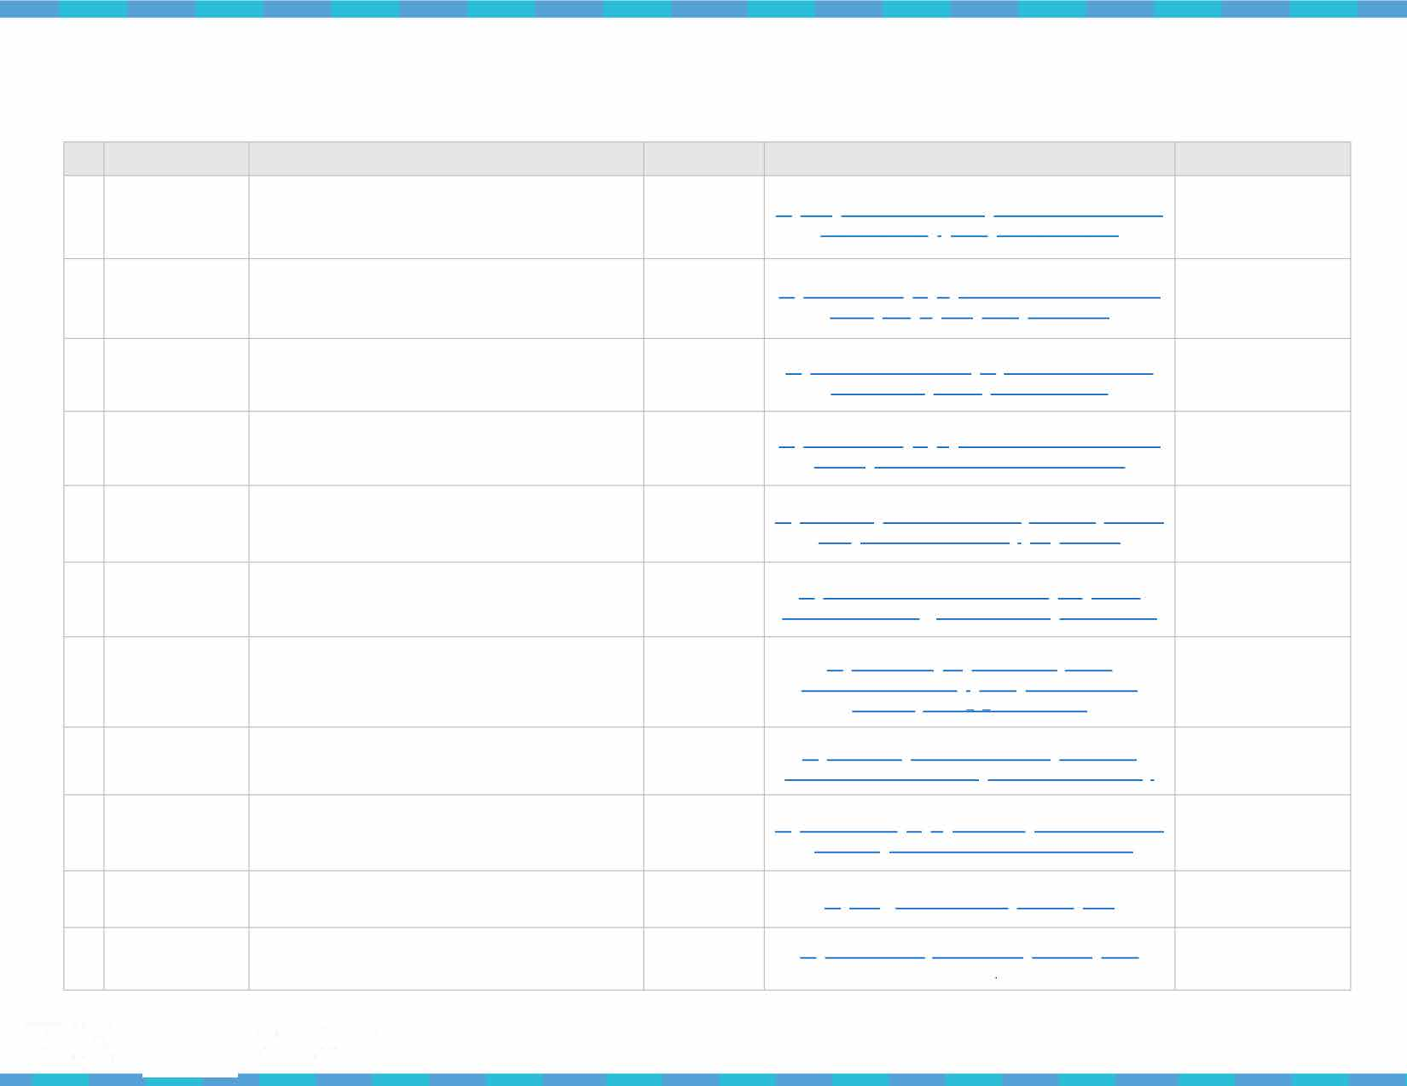
� ^{NATIONAL} Marine Debris Toolkit
-=- MARINE
3
---:- SANCTUARY for educators
FOUNDATION

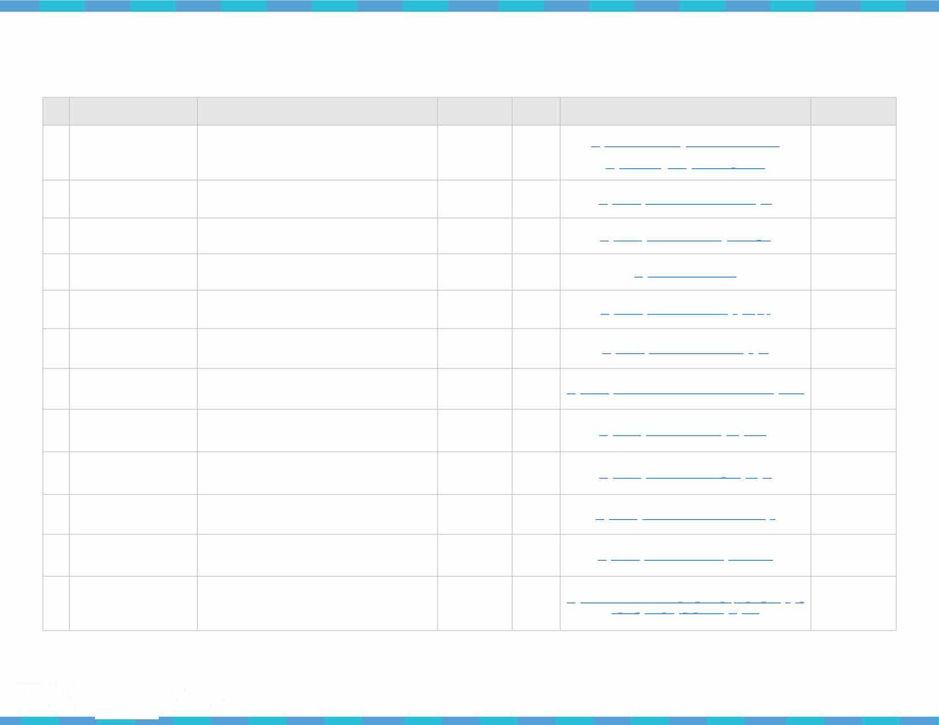
Educational Videos

 | Topic |  | Title | Grade Level | Video Length | Link | Source
1 | Marine Debris |  | Trash Talk | All Ages | 2:08 | htt12s://marinedebris.noaa.gov/discover-issue/trash-talk  htt12://oceantodatnoaa.gov/trashtalk webinar/ | NOAA: Ocean Today
2 | Marine Debris |  | The Plastic Vagabond | All Ages | 6:58 | htt12s://www.youtube.com/watch?v=Yio40ZMxgmY | Tara Expedition*
3 | Marine Debris |  | Ocean Confetti | All Ages | 2:56 | htt12s://www.youtube.com/watch?v=gVoFeELi vQ | MinuteEarth*
4 | Marine Debris |  | Plastic Pollution in the World's Oceans | Grades 6-12 | 3:01 | htt12s://vimeo.com/113359330 | The 5 Gyres Institute*
5 | Marine Debris |  | The Nurdles' Quest for Ocean Domination | All Ages | 4:54 | htt12s://www.youtube.com/watch?v= K12V12JsDjWj8 | TedEd*
6 | Marine Debris |  | Two Minutes on Oceans w/ Jim Toomey: Marine Litter | All Ages | 2:13 | htt12s://www.youtube.com/watch?v=DtfAhy21gAA | James Toomey*
7 | Marine Debris |  | How Plastic Microbeads are Causing Big Problems | Grades 6-12 | 4:35 | htt12s://www.youtube.com/watch?v=Bic7QEVRNe4&feature=youtu.be | Lush Cosmetics*
8 | Refuse/Reuse/Reduce/ Recycle/Rot |  | Why I Live a Zero Waste Life: Lauren Singer | Grades 9-12 | 13:30 | htt12s://www.youtube.com/watch?v=12F?212x2R3Hg | Ted Talk*
9 | Refuse/Reuse/Reduce/ Recycle/Rot |  | What Really Happens to the Plastic You Throw Away | All Ages | 4:06 | htt12s://www.youtube.com/watch?v= 6xlNyWP12B8 | TedEd*
10 | Refuse/Reuse/Reduce/ Recycle/Rot |  | You Can Live Life Without Producing Trash | Grades 6-12 | 4:37 | htt12s://www.youtube.com/watch?v=nYDQcBQUD12w | Seeker Stories*
11 | Refuse/Reuse/Reduce/ Recycle/Rot |  | How This Town Produces No Trash | Grades 6-12 | 5:05 | htt12s://www.youtube.com/watch?v=eym1OGGidQU | Seeker Stories*
12 | Take Action |  | Our Campaign to Ban Plastic Bags in Bali | All Ages | 11:00 | htt12s://www.ted.com/talks/melati and isabel wijsen our cam12aign to ban 12lastic bags in bali?language=en | Ted Talk*
 |  |  |  |  |  | *Partner source
�-=- NATIONAL  MARINE  SANCTUARY  ---:- FOUNDATION |  | Marine Debris Toolkit  for educators |  |  |  |  | 4

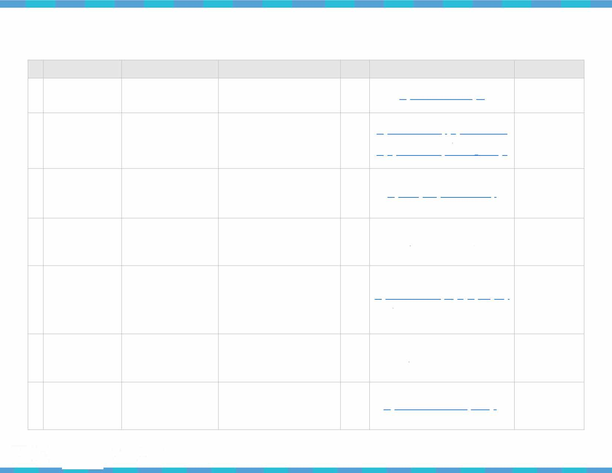
Educational Websites

 | Category | Title | Description | Grade Level | Link | Source
1 | Marine Debris | NOAA Marine Debris Program | A richly informative website dedicated to NOAA's efforts in addressing the national and international issue of marine debris. | Grades  K-12 | httQs://marinedebris.noaa.gov/ | NOAA
2 | Marine Debris | Rise Above Plastics | RAP's mission is to reduce the impacts of plastics in the marine environment by raising awareness about the dangers of plastic pollution and by advocating for a reduction of single-use plastics and the recycling of all plastics. | Grades  K-12 | httQs://www.surfrider.org/Qrograms/rise-above-  Qlastics httQ://Qublic.surfrider.org/RAP/RAP Toolkit.Qdf | Surfrider Foundation*
3 | Marine Debris | Plastic Pollution Coalition | This international alliance of individuals, businesses and organizations is working together to stop plastic pollution in our environment. Learn about how they are making a difference and how you can help. | Grades  K-12 | httQ://www.QlasticQollutioncoalition.org/ | Plastic Pollution Coalition*
4 | Marine Debris | Marine Research and Education | The Algalita Marine Research Foundation is one of the leading research organizations of marine plastic pollution. They offer a variety of educational resources and materials for use in the classroom. | Grades  K-12 | h ttQ://www.algalita.org/ | Algalita Marine Research Foundation*
5 | Marine Debris | Inquiry to Student Environmental Action | The "Inquiry to Student Environmental Action" (12SEA) project promotes international collaboration among high school and secondary school students as they learn about, discuss, and envision solutions to shared environmental challenges. | Grades  K-12 | httQ://web.stanford.edu/grouQ/inguiry2insight/cgi  -bin/i2sea-r2b/i2s.QhQ?Qage=about | Stanford University*
6 | Marine Debris | More Ocean. Less Plastic. | The 5 Gyres Institute aims to educate the public on the dangers of plastics polluting our oceans. They implement local, national, and international projects with the goal of creating a world with plastic-free oceans. | Grades  K-12 | h ttQs://www.5gyres.org/ | The 5 Gyres Institute*
7 | Marine Debris | From the Bow Seat | From the Bow Seat hopes to inspire the next generation of ocean caretakers through using means of writing, poetry, music, crafting, painting, or developing a film to tell the story of our world oceans. | Grades  K-12 | httQ://www.fromthebowseat.org/index.QhQ | From the Bow Seat*
�-=- NATIONAL  MARINE  SANCTUARY  ---:,- FOUNDATION |  | Marine Debris Toolkit  for educators |  |  |  | 5

Refuse/Reuse/Reduce/ Recycle/Rot
8

Refuse/Reuse/Reduce/

Stop Waste
This integrated public agency consists of a collaboration between the Alameda Waste Management Authority and the Alameda County Source Reduction and Recycling Board. The agency offers resources, programs, and support to schools in Alameda County to promote recycling and other waste reduction strategies.

In addition to a Watershed Resource Center and a Reuse Store, this environmental

Grades http://www.stopwaste.org/ Stop Waste Project*

Grades http://www.exploreecology.org/environmental-
K-12

- Recycle/Rot
Art From Scrap
education organization in Santa Barbara brings a Green School Education Program into the classroom.

Waste Free Lunches provides information on why being "waste-free" is important and how
K-12 education-presentations.php
Explore Ecology*

- Refuse/Reuse/Reduce/
Waste Free Lunches
one can start a program at their school or in
Grades
http://www.wastefreelunches.org/
Waste Free Lunches

Recycle/Rot

Refuse/Reuse/Reduce/ Recycle/Rot
11

Recycle Works
their workplace. In addition, they supply helpful tips for getting started, tracking progress, and maintaining the program.
Includes recycling curriculum and project ideas for students, information about setting up recycling programs at school, gardening and composting projects, lips for your facilities and maintenance staff, and the latest news about legislation.
K-12 Project*

Grades http://www.recycleworks.org/ RecycleWorks*
K-12

*Partner source

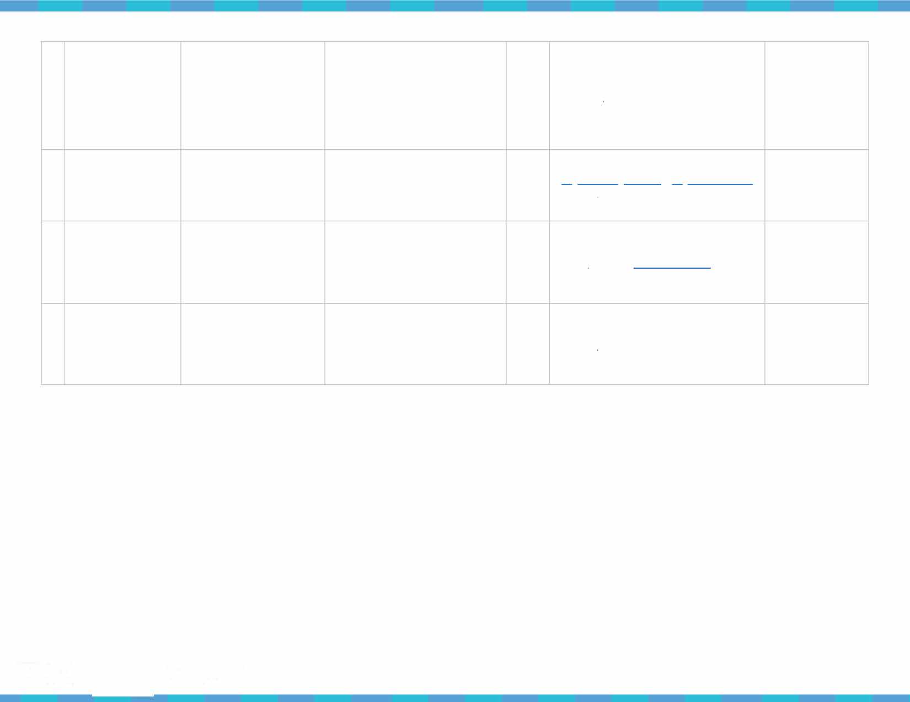

� ^{NATIONAL} Marine Debris Toolkit
-=- MARINE
for educators
6
SANCTUARY
--..;,- FOUNDATION

SLIDE 1: Intro Slide

Introduction to Marine Debris

PowerPoint Presentation Notes
Check out the 'Introduction to Marine Debris' PowerPoint Presentation :
[https ://marinedebris.noaa.gov/curricul a/marine-debris-monitori ng-toolkit-educators]

SLIDES 2 - 8: There is one global ocean system - visit National Ocean Service http://oceanservice.noaa.gov/facts/howmanyoceans.ehtml
The ocean covers 71 percent of the Earth's surface and contains 97 percent of the planet's water. More than 95 percent of the underwater world remains unexplored .

SLIDES 9 - 12: Thank You Ocean Report - "The ocean takes care of us. Let's return the favor." http://www.thankyouocean .org/
"The ocean is a vital resource that provides food , water, commerce, recreation, medicine and even the air we breathe. Today, our ocean faces unprecedented threats from pollution , trash, declining fisheries and multiple impacts from climate change."

For more information about the ocean, visit National Ocean Service, America's ocean and coastal agency - http://oceanservice.noaa.gov/about/

SLIDES 13 e- 17: National Marine Sanctuaries, http://sanctuaries.noaa.gov/ FAQs, http://sanctuaries.noaa.gov/about/faqs/welcome.html
History, http://sanctuaries.noaa.gov/about/history/welcome.html
The National Marine Sanctuary System is composed of 13 national marine sanctuaries and two marine national monuments. The sites range in size from less that one square mile of Monitor National Marine Sanctuary to almost 583,000 square miles of Papahanaumokuakea
(Hawaiian name meaning 'a sacred name, a sacred place') Marine National Monument.

SLIDE 18 : NOAA - http://www.noaa.gov/
NOAA history - http://www.history. noaa.gov/index.html
The National Oceanic and Atmospheric Administration (NOAA) is a federal agency that is with in the Department of Commerce. Similar to NASA, where NASA focuses on space and aeronautics, NOAA focuses on the ocean and atmosphere.
NOAA is concerned with the conditions of our ocean and atmosphere and informing people about the changing conditions around them. NOAA's missions include:
- Science, Service, and Stewardsh ip.
- To understand and p redict changes in climate, weather, ocean, and coasts,
- To share that knowledge and information with others, and
- To conserve and manage coastal and marine ecosystems and resou rces. NOAA's line offices include:
  - National Weather Service
  - National Marine Fisheries Service
  - National Environmental Satellite Data, Information and Service
  - National Ocean Service
  - Office of Oceanic and Atmospheric Research
  - Office of Program Planning and Integ ration

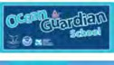
� ^{NATIONAL} Marine Debris Toolkit
-=- MARINE
for educators
7
SANCTUARY
-4iiii:'" FOUNDATION

SLIDE 19: The ocean is a magnificent place! Know Your Ocean:
http://oceantoday. noaa.gov/knowyourocean/ http://www.whoi.edu/know-you r-ocean/
To learn more about what lies beneath the ocean's su rface, check out: noaa.gov/fisheries
Earth is Blue : http://sanctuaries.noaa.gov/earth isblue.html
When you look at our planet from space, one thing is abundantly clear: Earth Is Blue. Our planet is an ocean planet, and whether you live near the coast or a thousand miles from it, the ocean is part of your life. From providing the food we eat to determining our weather, the ocean matters to each of us -- and the National Marine Sanctuary System protects this vital resource.
With that in mind, the photos and videos of Earth Is Blue bring these ocean treasures directly to smartphones and computers all over the world, where they can serve as a tangible reminder that no matter where you are, the ocean and Great Lakes are in your hands. We hope these images inspire you to help care for our ocean and to spread the word that Earth isn't green -- it's blue.

SLIDES 20 - 22 : Introduction to Marine Debris What is marine debris?
Our oceans are fi lled with items that do not belong there. Huge amounts of consumer plastics, metals, rubber, paper, texti les, derelict fishing gear, vessels, and other lost or discarded items enter the marine environment eve ry day, making marine debris one of the most widespread pollution problems facing the world's ocean and waterways.
Marine debris is defined as any persistent solid mate rial that is manufactu red or p rocessed and directly or ind i rectly, intentionally or unintentionally, disposed of or abandoned into the marine environment or the G reat Lakes. It is a global problem, and it is an
everyday problem. There is no part of the world left untouched by debris and its impacts. Marine debris is a th reat to our environment, navigation safety, the economy, and human health .
Learn more about marine debris th rough NOAA's Marine Debris Prog ram: https://marinedebris.noaa.gov/discover-issue
What we cu rrently know about plastic marine debris: https://marinedebris.noaa.gov/what-we-know-about-plastic-marine-debris

Types and sou rces of Marine Debris:

-issue/types-and-sou rces

https ://marinedebris.noaa.gov/discover

SLIDE 23: What are Gyres?
An ocean gyre is a large system of circular ocean currents formed by global wind patterns and forces created by Earth's rotation. - National Geographic

To learn more about types of gyres and how they form, check out: http://www.nationalqeoqraphic.orq/encvclopedia/ocean-qyre/

These whirlpools of water attract floating pollutants, acting as an epicenter for marine debris in the ocean. Check out 5 Gyres to learn more about the impacts of plastic pollutants in these gyres: https ://www.5gyres.org/

SLIDE 24 - 26: What is the difference between a macroplastic and a microplastic? What are their impacts?
Microplastics are small plastic pieces less than five millimeters long which can be harmful to our ocean and aquatic life.
To learn more about microplastics: http://oceanservice.noaa.gov/facts/microplastics.html
Whereas, macroplastics are any plastic pieces larger than five millimeters long. Both forms of plastic pollution can be harmful to our environment. To learn more about the impacts of plastic pollutants on marine organisms, check out: http://www.cleanwater.org/problem­ marine-plastic-pollution

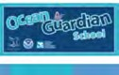
� NATIONAL Marine Debris Toolkit
-=- MARINE
8
---:- SANCTUARY for educators
FOUNDATION

SLIDE 27: How can plastic ingestion harm humans?
It is sti ll unknown whether plastic pollutants can move up the food chain and onto our very own plates . However, scientists
speculate that this may not be unlikely.
A g reat informational PDF created by Nate Seltenrich goes into more detail about th is uncertainty: https ://ehp. n iehs. nih .gov/wp-content/uploads/1 23/2/ehp. 1 23-A34 . alt.pdf

SLIDES 28 - 30 : Where do microplastics originate from?
Plastics d o not biodegrade, instead they photodegrade:
Once exposed to wave action and sunlight, large plastic pieces (such as a water bottle, or floating plastic fragment) break down into smaller and smaller pieces. Specifically, when exposed to UV light and infrared radiation (from the sun), the polymer in the plastic piece becomes brittle causing it to break down into ever-diminishing pieces. This process takes time, but with the abundant amount of plastics in our ocean, it doesn't take lonq for macroplastics to create microplastics.

The problem with plastic microbeads:
Macroplastics are not the only thing contributing to the microplastic issue, many microplastics start out as just that - a microplastic.
Plastic microbeads are microplastics that are often used in cosmetics as an exfoliator. Your toothpaste, face wash and body soaps can potentially contain these little pollutants.
Due to their design, these microbeads wash down the drain and make their way to your local wastewater treatment facil ity. At these facil ities, the microbeads make their way through the fi ltration system and back out into local rivers, streams and the ocean.
To learn more about the issues surrounding plastic microbeads, check out: http://storyofstuff.org/plastic-microbeads-ban-the-bead/
To learn more about the Federal Microbead- Free Waters Act of 20 15 , visit:
https ://www.fda.gov/cosmetics/guidanceregulation/lawsregulations/ucm531 849 . htm
The truth about microfiber pollution:
Tiny synthetic fibers, that orig inate from synthetic textiles (e .g . polyester, acrylic, nylon), are being found in waterways and
the ocean.
o Water treatment facilities currently do not have anything in place to capture these microscopic fibers.
Researchers have recently located plastic fibers in fish and shellfish being sold in California and Indonesia for human
consumption: https ://www.nature.com/articles/srep14340
-
To learn more about what you can do to reduce microfiber poll ution, visit: http://www.plasticpollutioncoal ition.o rg/pft/20 1 7/3/2/15
ways-to-stop-microfiber-pollution-now

SLIDES 31 - 40 : What can YOU do?

What we do on land has a di rect impact on our local watersheds and ocean. What can you do on land to better protect marine environments?
For more tips on how to reduce waste at school, in your community and at home, check out the EPA's webpage on

how to reduce waste in several aspects of your life:
https ://www.epa.gov/recycle/reducing-waste-what-you

-can-do

Make art, not trash: tu rning your trash into art is a great way to repurpose items that would otherwise end up in the landfill. For your students next art project, consider using the trash on campus as their medium.
For ideas and examples of artwork, check out the followi ng links: http://time.com/4358434/world-oceans-d ay-art-marine-plastic/
http://magazines.scholastic.com/news/20 1 6/09/Turni ng-Trash- I nto-Art

NATIONAL
�
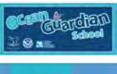-=- MARINE
•
Marine Debris Toolkit
9

---:- SANCTUARY for educators
FOUNDATION

Section 2: Guidelines for Data Collection

Marine Debris Monitoring & Assessment Project
As a part of your school's participation in actively preventing marine debris, you will be contributing to the Marine Debris Monitoring & Assessment Project (also known as the MDMAP). You may ask yourself, what is the MDMAP? Below we provide an overview of the main goals of the MDMAP.
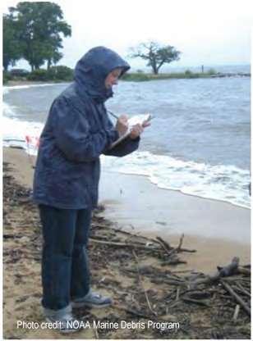
What is marine debris?
Marine Debris has become a pervasive form of pollution in our ocean. It is a unique
environmental issue in that most debris is visible to the naked eye, making it easy for us to make connections between the debris we see in the environment and items we use in our everyday lives.
What is the MDMAP?
The MDMAP is a citizen science in itiative to survey and record the amount and types of marine debris in the environment by engaging NOAA partners and volunteers across the nation.
MDMAP Background
The NOAA Marine Debris Program created the MDMAP in order to provide monitoring tools to partner organizations nationwide. The NOAA monitoring protocols were designed to be widely
applicable and inexpensive to implement, and intended to promote standardization of shoreline marine debris monitoring efforts.
What will my students' data be used for?
Regular, rigorous, long-term monitoring studies conducted through the MDMAP can provide meaningful data on the
distribution, types, and abundance of debris in the marine environment. Knowing where, how much, and what types of debris are present, as well as how the debris load is changing over time, is essential to developing new and effective prevention
policies and strateg ies for education and outreach .
    - Further, the MDMAP's network of partner organizations and the resu lts of locally-based shoreline monitoring studies provide g reat opportunities for outreach and raising awareness about marine debris issues, sharing the message that every individual can become a part of the solution.
You and your students will be making a difference!
MDMAP volunteers are the backbone of this effort, and we would not have a successful project without them. The countless hours that our volunteers and partners have contributed over the lifetime of this project, and will in the future, is commendable and
something we are incred ibly grateful for. MDMAP partners have come from the non-profit, academic, and government sectors, and in some cases we've even had ind ivid ual volunteers adopt a shoreline monitoring site.
Every individual can become a part of the solution.
Participation in the MDMAP puts data collected on debris from your local beaches into a larger national context. All data
uploaded to the MDMAP Online Database is openly available to the research community for any data analysis efforts,
including any projects sponsored by NOAA. The NOAA Marine Debris Program is committed to continuing to work with the marine debris community, applying MDMAP monitoring data to answer key research questions about debris in the
environment. This will hopefully bring us to the ultimate goal of developing more effective prevention and mitigation strateg ies to prevent the impacts of marine debris on our ocean. Last but not least, MDMAP is a g reat excuse to get outside and get to know your local shoreline.
Get MDMAP Updates!
The MDMAP Get Started Toolbox is a repository for the latest MDMAP information and results . You can also send an email to MD.monitoring@noaa.gov to sig n up for the MDMAP E-Newsletter.
•

� NATIONAL
-=- MARINE
SANCTUARY
-4iiii:'" FOUNDATION
Marine Debris Toolkit
for educators 10

Marine Debris Monitoring - Safety First!
The health and safety of you and your students is the number on e priority during any field activity. Always use caution befo re, during, and after field surveys to prevent inju ry to yourself, other beach goers, or the environ ment. Establish student boundaries before beginning your monitoring survey and determine a signal for notifying a student if they have crossed a set bounda ry.
- Before you leave your school site for any survey activity, make sure you've considered how you will get help if needed.
  - First and foremost, use the buddy system. Your students should always have at least one other student with them in the field at all times (in add ition to adult chaperones).
  - Second, make sure you have a way to communicate with others in case of emergency - whether that is a cell phone, rad io, or emergency responder.
  - Lastly, make sure someone at your school site knows where you are going to be and when you expect to return .
- Always check the weather and tidal conditions before scheduling your survey. NOAA weather forecasts can be found at www.weather.gov.
  - Never conduct field operations in severe weather.
- Always bring proper gear and multiple layers of clothing for the range of possible weather cond itions.
  - In add ition to being prepared for inclement weather, it's important to recog nize and understand the symptoms of heat stress.
    - These can include headache, nausea, weakness, th irst, and heavy sweating or red, hot, d ry skin. If you or any of your students experience these symptoms, stop your survey immediately to rest and hydrate, and call 91 1 if your symptoms are severe.
- Ocean cond itions can change rapidly. Check the tides at your survey site at www.tidesandcurrents.noaa.gov. o Surveys should always be conducted at low tide.
  - Going out at low tide is a good safety precaution, especially in areas that may be flooded or inaccessible at high tide. Continuously keep an eye on the tide as you conduct your survey.

Tips from the field: Mal<.e sure your students bring
n
plenty of wat�r.t�
- Make sure you pack everything you might need in the field . o Always wear and have sunscreen with you, even if it
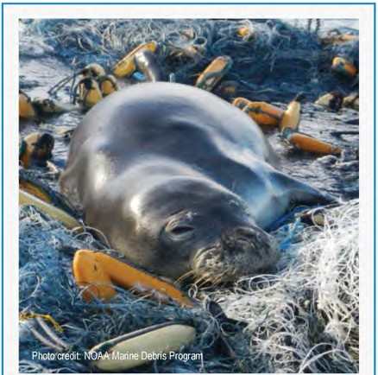
is cloudy.
o In add ition, bring a first aid kit, hand sanitizer, plenty

each site v1S1 . of water, and a snack.
- Make sure you and your students are wearing appropriate clothing such as:
  - Closed toed shoes
  - Gloves (if you are handling debris items)
- Stay alert and be aware of your surroundings and any potential hazards.
  - If you come across any potential hazardous materials - such as oil, chemical drums, or propane tanks - alert local
personnel or land managers (such as a park ranger)

immediately.
    - In some cases, you may need to dial 9

- 1 - 1 and the

National Response Center at 1 -800-424-8802 .
  - Do not attempt to move or pick up any item that looks like it
Interacting with marine mammals is very dangerous. At all times, keep your students away from any live

may be dangerous or pose any kind of hazard .
  - Establish a list of items that you would like your students to avoid picking up prior to your first field trip.
    - Dead animals, syringes, needles, sharp or rusty items, or other hazardous objects.
marine mammals you may come across during your survey. If the animal appears to be injured , call your
local rescue network.
http://www.fisheries.noaa.gov/pr/health/report.htm

Review these safety tips on a regular basis and make sure any new students or adult chaperones are properly trained and prepared.
•

� NATIONAL
-=- MARINE
SANCTUARY
-4iiii:'" FOUNDATION
Marine Debris Toolkit
for educators 11

Survey Types & Site Selection
Step 1. Familiarize you rself with the MDMAP Su rvey Protocol prior to beginning your monitoring efforts .
To help educate you rself and your students, check out the MDMAP's Get Started Toolbox: https ://marinedebris.noaa.gov/research/monitoring-toolbox.

MDMAP Survey Protocol
What is an accumulation survey?
Accumulation surveys provide information on the rate of deposition of debris onto the shoreline. This type of survey is more suited to a stretch of shoreline where you can conduct a thorough cleanup, since debris needs to be removed from the entire length of the
shoreline for each visit.
These protocols are flexible for participating schools. Although it is recommended to su rvey the site at least two times throughout the year - choose a schedule that fits well for your school .

Survey Characte n.sf1cs
Characteristic | Accumulation Surveys
Will debris be removed during the survey? Time req uired per survey  Length of shoreline monitoring site | Yes More  1 00 meters
Types of data that can be collected | - Debris deposition ratee(# of items per unit area per unit time)  - Debris material types  - Debris weight
Step 2. Select your Survey Site. Before choosing your survey site, there are a few things you should consider. How to Choose your Su rvey Site
- Choose an appropriate shoreline location based on the objectives of your students' study. If your students wish to examine debris deposited onto the shoreline from offshore, select a site with low recreation or human usage.
- Pull up your planned site on google maps to view an aerial image of your study site. Within this image, categorize the various areas within your location . For example, your location may cover a span of shoreline 1 km long . Within that 1 km, there may be an area with heavy recreational use and another area where an urban stream mouth is
located . Identify any barriers to shoreline access or offshore structures that may affect nearshore circulation (such as jetties) . See example image below.
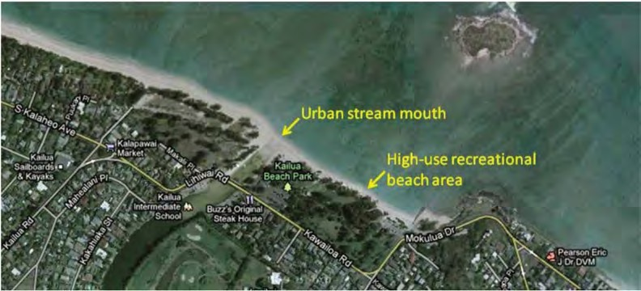

NATIONAL
•
�
-=- MARINE
for educators
Marine Debris Toolkit 12

SANCTUARY
-4iiii:'" FOUNDATION

- Select a survey site according to the followi ng characteristics:
  - Sandy beach or pebble shoreline
  - Clear, di rect, year-round access
  - No breakwaters or jetties
  - At least 1 00 m in length parallel to the water (sites less than 1 00 meters are acceptable for accumulation
surveys) .
  - No regular cleanup activities
o Check with local cleanup organizations to determine which sites are already heavily monitored
Each of these characteristics should be met where possible, but can be modified to best fit
your school's resources and accessibility. Your shoreline surveys may be conducted at a Tips from e

local river or stream if you cannot easily access a beach . However, it is important to note that the river's shoreline should be 1 00 meters in length and easily accessible for your
h me,,:· r at eore
tPeractice, rihe mfiel:
2 - i� , l

g roup of students.

Before You r Students Begin Their Surveys
3 flfnes
ast

  - It is highly recommended that your students practice their survey method on campus at least once before their planned survey date. This is a/so a great way to keep your campus free of debris! Pick a 100-meter section of campus to test drive your chosen survey method.
*Campus debris data should not be recorded in the MDMAP database.

Prior to your student's fi rst data collection , a trained adult chaperone should visit the site and complete the Shoreline Characterization Sheet for your site. On this datasheet the followi ng will be noted :
    - GPS coordinates in decimal degrees* at the beginning and end of your shoreline site, or at the site's four corners if the width of the beach is less than 6 meters

Pract_Tips gfrog·m the f.eld•· •
Shoreline characteristics (e.g . tidal range and substrate) ; and

latitu ice /o
tng 1ong,tude and •
Surrounding land-use characteristics that may influence the delivery of land-based

sch
de with your students on debris to the site (e .g. farmland 5 kilometers from a small town or urban parkland 50 meters away from a river mouth).

com
tng them
ers ofyour campus/
to the four

* To teach your students more about GPS coordinates (and how to convert a coordinate to decimal degrees), check out the following You Tube video: https ://youtu. be/ALN7gXF1 thY

Note: The Shoreline Characterization Sheet needs to be completed only once per site per year unless major changes occur to the shoreline.

Shore IDs (on the Shoreline Characterization Sheet) should be created based on the shoreline name or location (e .g. Fort Smallwood). In addition , be sure to add '_MDschool' to the end of your shoreline ID. This extension is to ensure that you wi ll be able to locate your shoreline data AND other participating school's data within the MDMAP database. For example, if your site name was Fort Smallwood, your site ID would read FortSmallwood_MDschool.

The Shoreline Characterization Sheet and Debris Datasheets were adapted from Chesire et al. (2009) 1 .
1 Cheshire, A.C., E. Adler, et al. (2009). UNEP/IOC Guidelines on Survey and Monitoring of Marine Litter, UNEP Regional Seas Intergovernmental Oceanographic Commission: 132 pp.

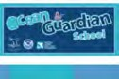� NATIONAL Marine Debris Toolkit
I
-=-- MARINE
for educators
13
SANCTUARY
-;,e;;-- FOUNDATION

Accumulation Surveys
The following protocol should be followed when conducting an accumulation survey.
- BEFORE arriving at the site, check local tide tables and plan to arrive at your site during low tide.
- ONCE ARRIVED begin fi lling out the Accumulation Survey Debris Datasheet's Additional Information section . Mark the beginning and end of your shoreline site, perhaps with flags or stakes. Measure the shoreline width near the midpoint of the survey area, and record GPS coordinates at the corners of the site (GPS coordinates are marked in red in the diagram below) . REMEMBER to pick up these markers at the end of your survey to make sure they do not become marine debris!
  - The back of the shoreline is where the primary substrate (e .g., sand) changes (e.g ., sand becomes gravel)
or at the fi rst barrier (e.g ., vegetation line) .
  - If you haven't already completed the Shoreline Characterization Sheet for your site during a previous visit,
do so now.
- As one of the adult chaperones completes the fi rst page of the Accumulation Survey Debris Datasheet and/or the Shoreline Characterization Sheet, have another chaperone split the students into g roups of 3 or 4:
  - Based on the number of students present, divide the site (using more flags or other
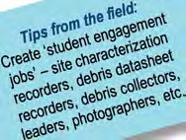
markers) and assign one group per section of shoreline.
  - One student should be in charge of tal lying the debris data onto the Accumulation
Su rvey Debris Datasheet. Each g roup wi ll have their own datasheet for tallying debris.
  - Another student can search for and pick up the debris as they come across it (an
additional student can assist with this) .
- The th i rd student in the group can be in charge of taking pictu res of the debris found by the group.
- In order to cover the entire site from water's edge to the back of the shoreline, decide whether your students will walk the survey area parallel or perpendicular to the water. Once determined, divide the survey area evenly and distribute the student g roups among these sections. Student surveyors should traverse the survey area in a
pre-determined walking pattern until the enti re site is cleared of marine debris.
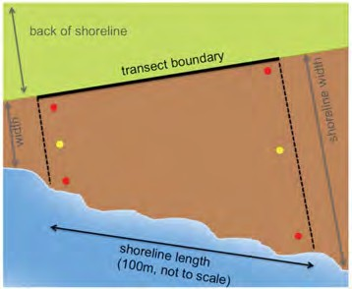
Examples of walking pattern schematics
Wa lking Pattern #1: Walking Pattern #2

Perpendicular to Shoreline
mm
A >
Parallel to Shoreline
;m·

II
III
II
III
II II ·E.!11
·m
II

;m·
;m·

E water's ed1e ) E
water s edae )

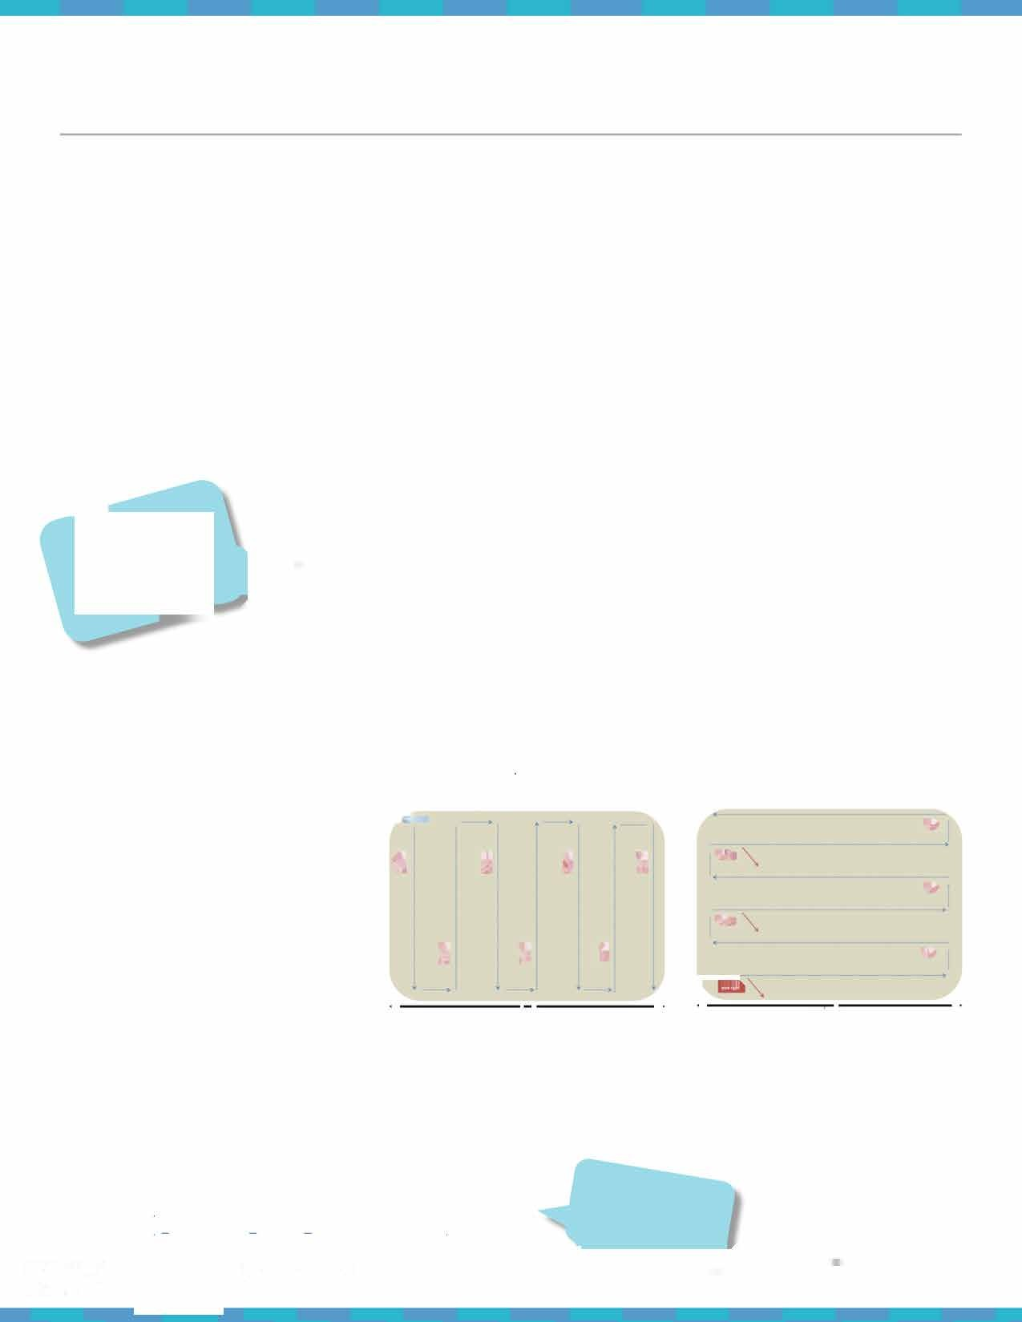
- Record on your Accumulation Survey Debris Datasheet counts of debris items that measure over 2.5 cm, or 1
inch (-bottle cap size) , in the longest dimension. Debris smaller than 2.5 cm should sti ll get picked up, just not recorded on the datasheet. Record large debris items, anything bigger than 1 foot (- 0.3 m, typical
forearm length from palm to elbow) in the large debris section of the Accumulation Survey Debris Datasheet.
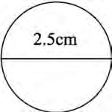
- Take photos of your shoreline site and some of the debris items!

To view an accumulation survey tutorial visit: https://marinedebris.noaa.gov/sites/default/files/videos/original/ 5 accumulation KSedits withSLaudio.mp4.mp4
Visit.
Tips from the Re1,1:
WiGtho over
tut
ori
als
Your :tu ents be
:8
e
v
t,

� ^{NATIONAL} Marine Debris Toolkit
I
-=- MARINE
for educators
14
SANCTUARY
-;,e;;-- FOUNDATION

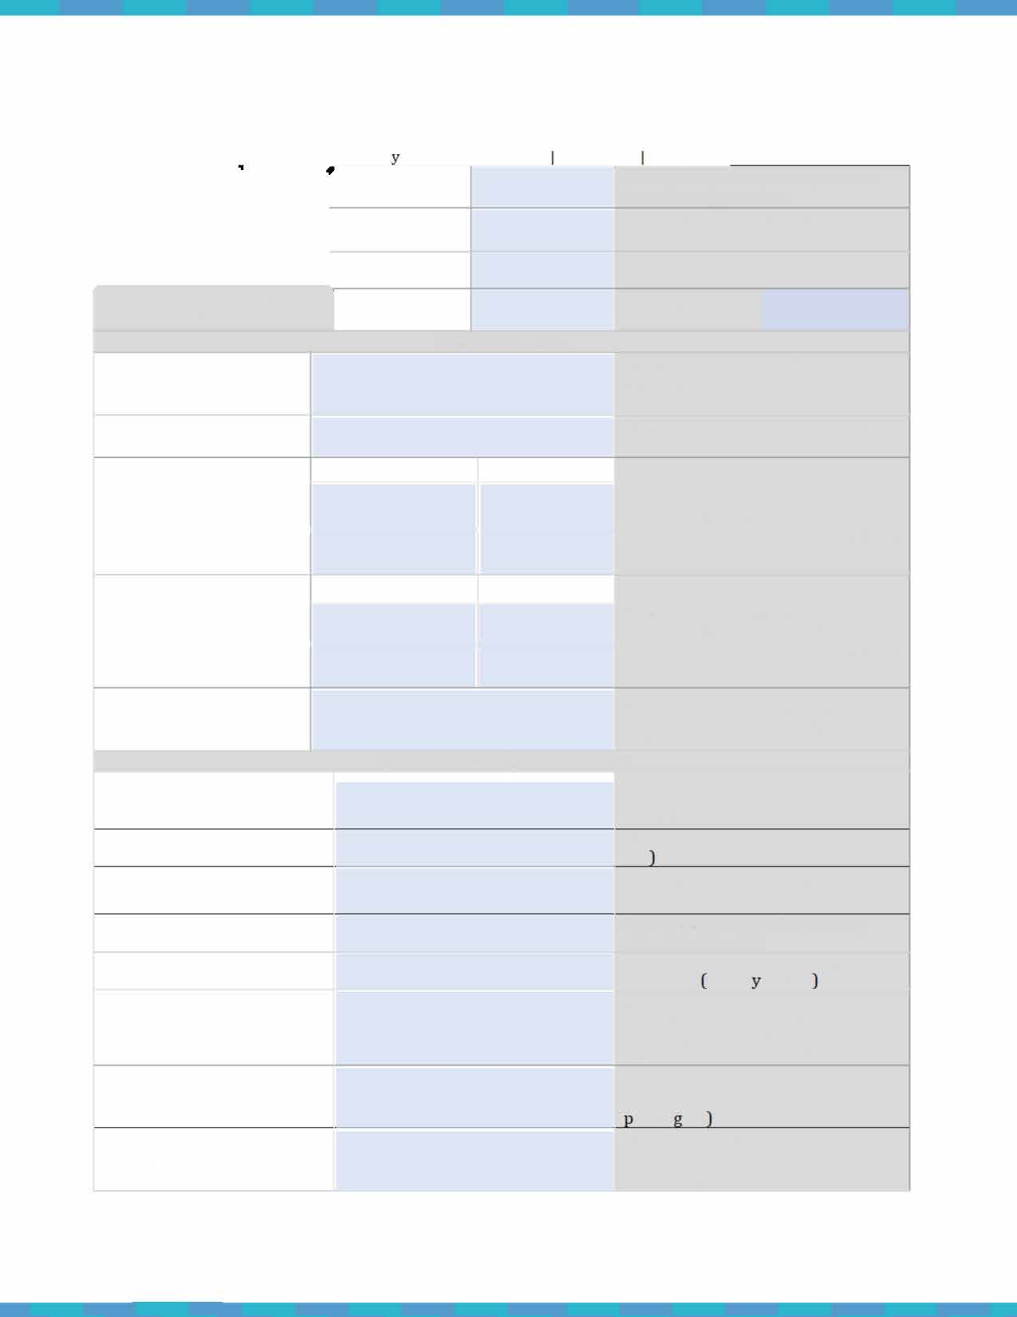
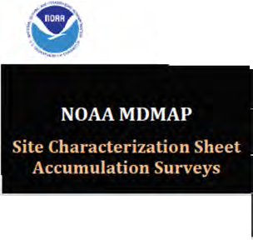
Accumulation Survey Sheets

Accumulation Surve Site Characterization Version 2.0 March 2016
Complete this form ONCE for each site location |  | Organization |  | Name of organization responsible for collecting the data
 |  | Surveyor name |  | Name of person responsible for filling in this sheet
 |  | Phone number |  | Phone contact for surveyor
 |  | Date |  | Date of this survey
SAMPLING AREA
Shoreline name |  |  |  | Name or ID by which this section of  shoreline is known (e.g., beach name, park)
State/County |  |  |  | State and county where your site is  located
Coordinates at start of shoreline section | Latitude |  | Longitude | Recorded as XXX.XXXX (decimal degrees) at start of shoreline section (in both corners ifwidth > 6 meters)
 | r--------- |  | i
Coordinates at end of shoreline section | Latitude |  | Longitude | Recorded as XXX.XXXX (decimal degrees) at end of shoreline section (in both corners if width > 6 meters)
 | >--------- |  | -+-----------<
Photo number/ID |  |  |  | The digital identification number(s) of photos taken of shoreline section
SHORELINE CHARACTERISTICS
Length of sample area (usually 100 m)  Shoreline slope (0) Substratum type  Substrate uniformity |  |  |  | Length parallel to water measured  along the midpoint of the shoreline (in meters)  Slope above horizontal [between O - 9Qo  For example, a sandy or gravel beach  Percent coverage of the primary substrate type (%)
Tidal range |  |  |  | Max & min vertical tidal range. Use  tide chart usuall in feet .
Tidal distance |  |  |  | Horizontal distance (in meters) from  low- to high-tide line. Measure on beach at low and high tides or estimate based on wrack lines.
Back of shoreline  Aspect |  |  |  | Describe landward limit (e.g.,  vegetation, rock wall, cliff, dunes, arkin lot  Direction you are facing when you look out at the water (e.g., northeast)

The Site Characterization Sheet needs to only be filled out once per site per year.
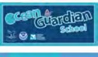� NATIONAL Marine Debris Toolkit
I
MARINE
for educators
15
� SANCTUARY
-tei:'" FOUNDATION

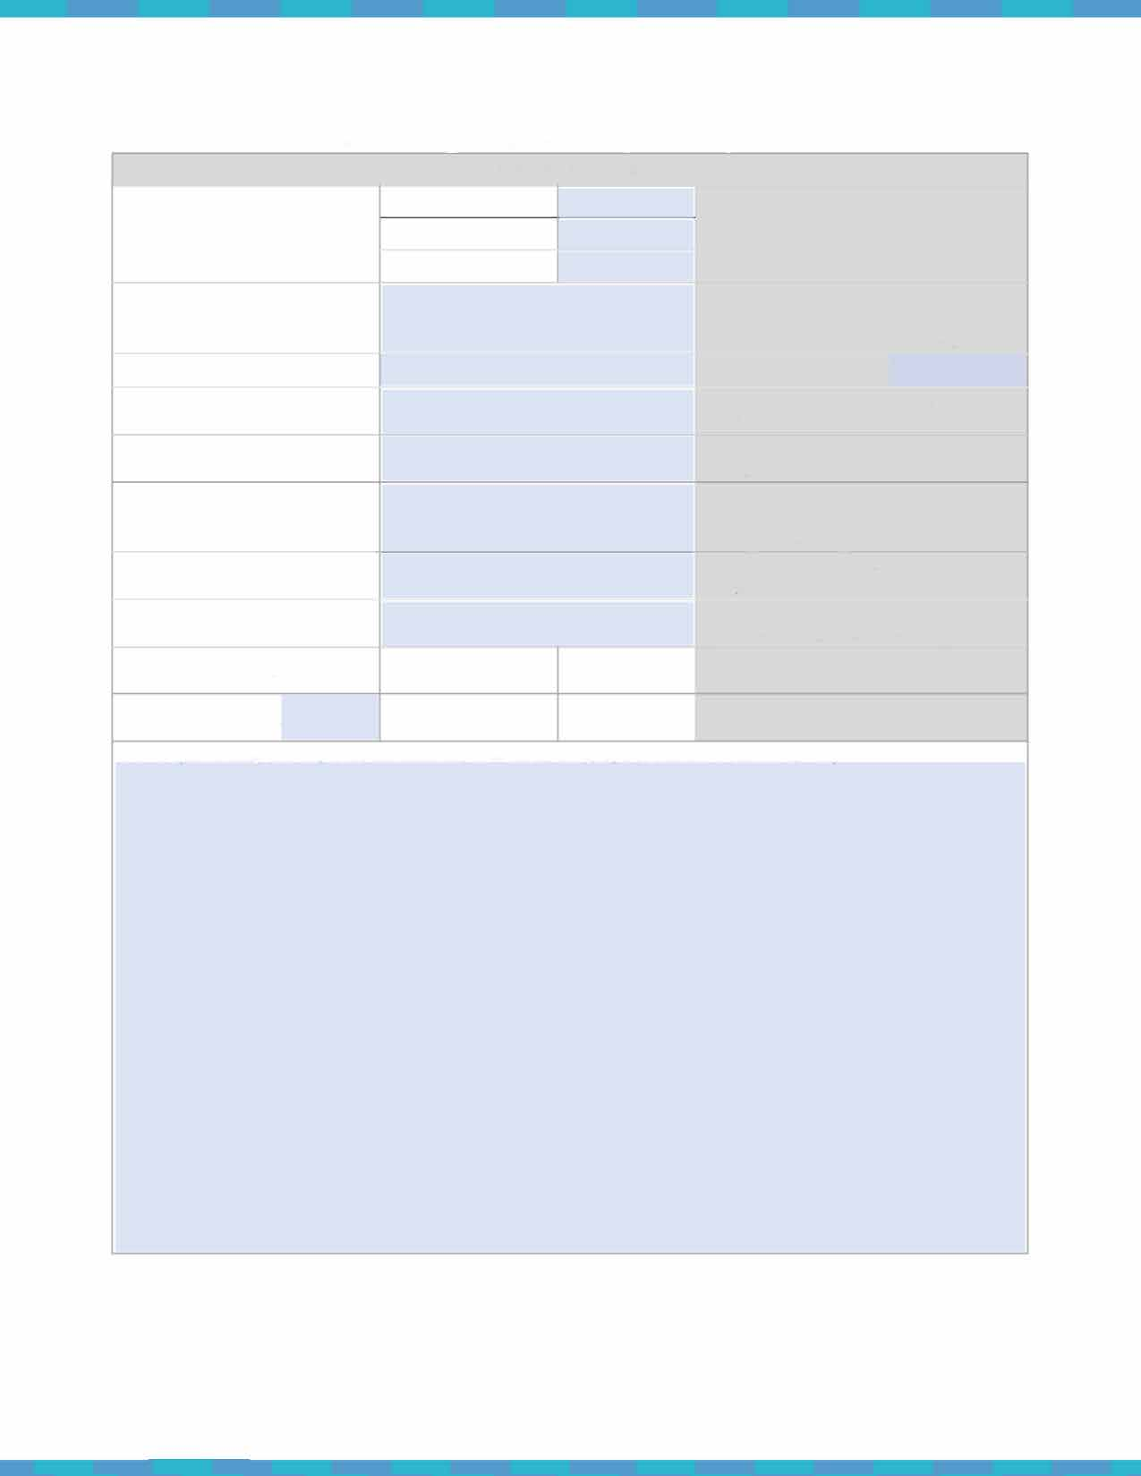
Accumulation Survey Site Characterization I Version 2.0 I March 2016

•v�
LAND-USE CHARACTERISTICS
Location & major usage | Urban  Suburban |  | Select one and indicate major usage (e.g., recreation, boat access, remote)
 | Rural
Access |  |  | Vehicular (you can drive to your  site), pedestrian (must walk), isolated (need a boat or plane)
Nearest town |  |  | Name of nearest town
Nearest town distance |  |  | Driving distance to nearest town  (miles)
Nearest town direction |  |  | Direction to nearest town (cardinal  direction)
Nearest river name |  |  | If applicable, name of nearest river  or stream. If blank, assumed to mean no inputs nearby
Nearest river distance |  |  | Straight line distance to nearest  river/stream (km)
Nearest river direction |  |  | Direction to nearest river/stream  (cardinal direction from site)
River/creek input to beach | YES | NO | Does nearest river/stream have an  outlet within tl1is shoreline section?
Pipe or drain input | YES | NO | Is there a storm drain or channelized outlet within shoreline section?
Notes (including description, landmarks, coastal hydrography, offshore barriers. etc.) :

The Site Characterization Sheet needs to only be filled out once per site per year.

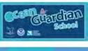� NATIONAL Marine Debris Toolkit
I
MARINE
for educators
16
� SANCTUARY
-tei:'" FOUNDATION

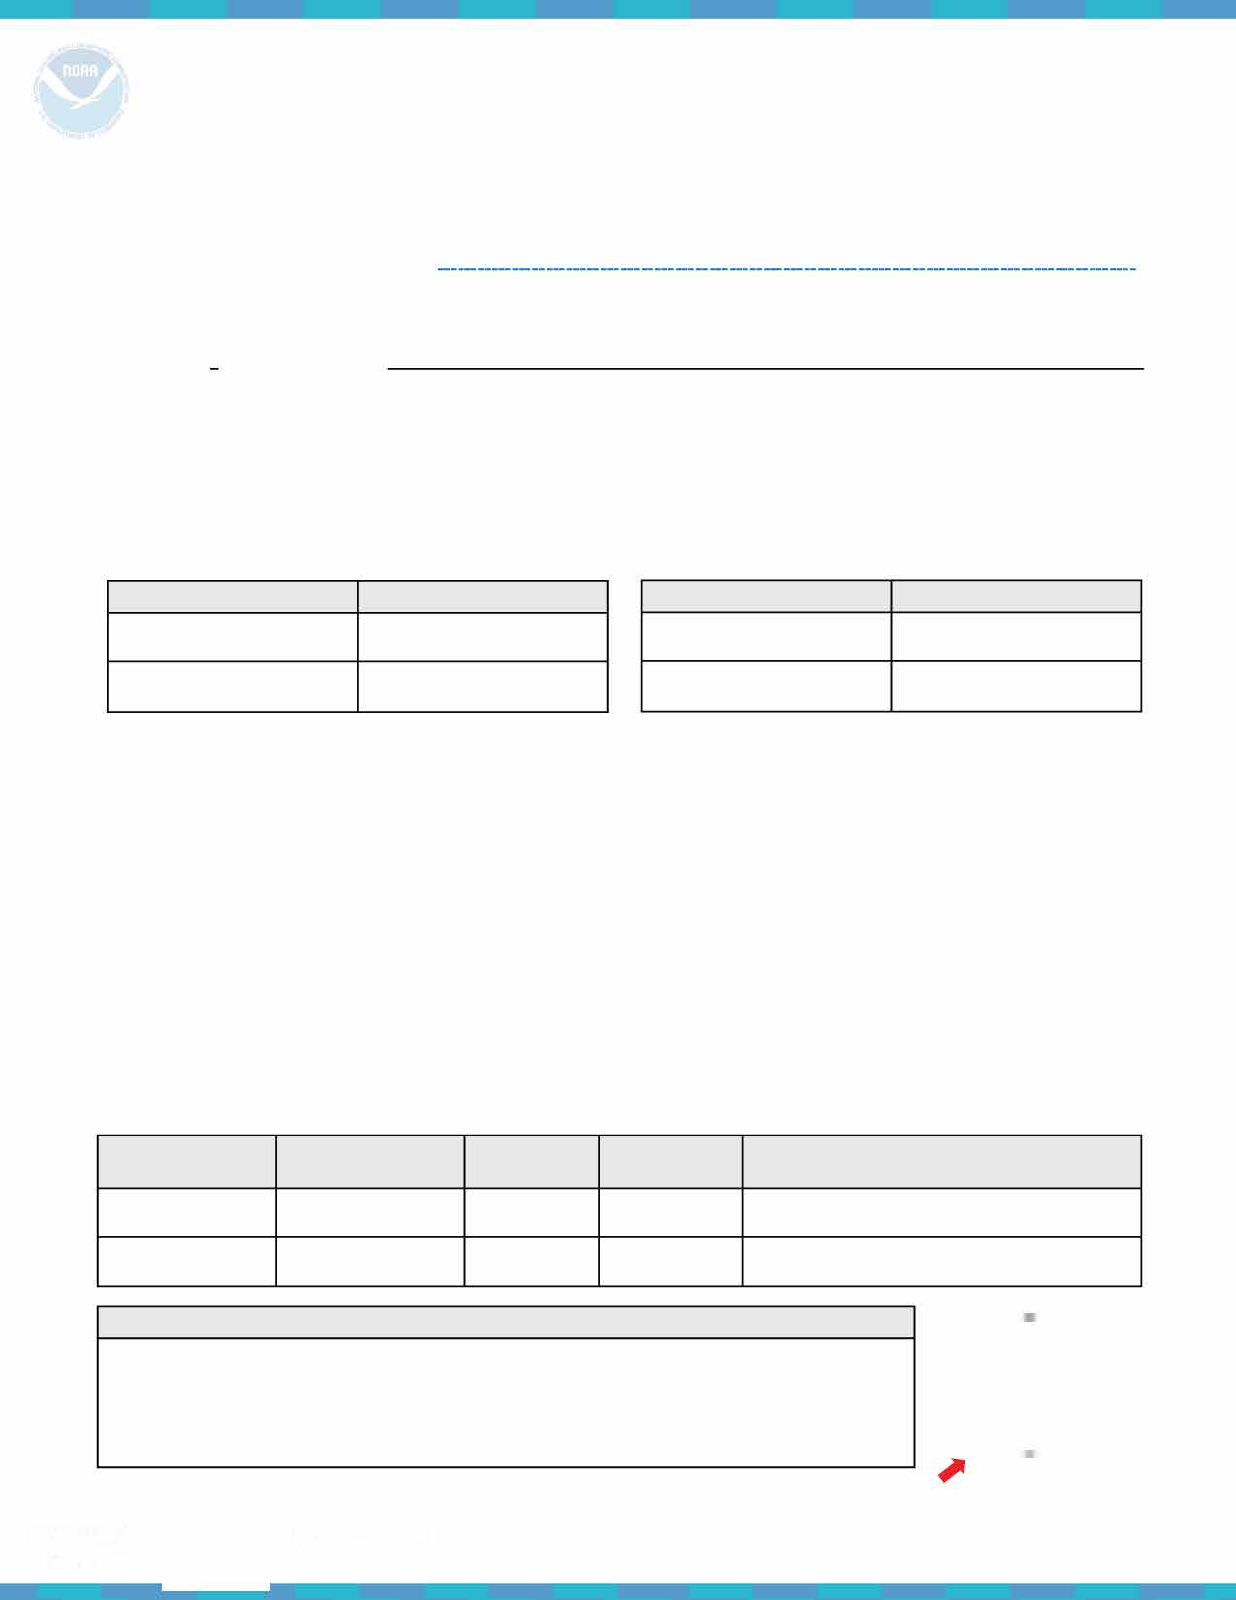
NOAA Marine Debris Toolkit - Accumulation Survey Debris Datasheet

Surveyor name(s):
Number of people conducting the survey: -------
Date
of survey: _______________
Su rvey Site Information ---
Name of organization (School name, group name, etc.): _ Survey type: Accumulation Survey
Location --------------------------------------------------------------------------------------------------------------
D D
Location type (check one) : Beach (coastal) Watershed (i nland waterway; river, stream, lake)
Shoreline name (beach, stream, river or park name) MDSchool

What are the coordinates of the start of your shoreline site? |  | What are the coordinates of the end of your shoreline site?
Record coordinates in decimal degrees. |  | Record coordinates in decimal degrees.
Latitude | Longitude | Latitude | Longitude

What is the width of the beach?
Measure the width of the beach by measuring the meters from the water's edge to the back of the shoreline.
Time --------------------------------------------------------------------------------------------------------------------
Survey end ti me: -
Survey start time:
_____________
Time of low tide (list time of most recent, or upcoming low tide):
Se as on (winter, spring, summer, fall, tropical wet, etc.):
Date of previous survey (leave blank if this is your first survey):
Recent storm activity: _
Describe any significant storm activity within the previous week

Large Debris (larger than 1 ft.; do not include these items in your tallies) ---------------------------------------
Description
Item type | Status (sunken, | Approximate | Approximate
(vessel, net, etc.) | stranded, buried) | width (meters) | length (meters)

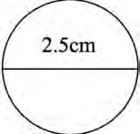
Please list any notes you took on debris items and/or description(s) of items you were unable to classify below.

Only record debris items that are larger than 2. 5 cm on the back of this datasheet.
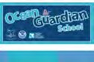
� ^{NATIONAL} Marine Debris Toolkit
-=-- MARINE
for educators
17
SANCTUARY
-;,e;;-- FOUNDATION

Debris Collected
Total of tallies for each item should be added into the blue boxes at the end of your su rvey. Items listed as 'other' should be specified on the blue dotted line.
Example: 0ther [ <;ef.f.'."':!: . �!P. l J.Hf_l_l I

Plastic -----------------------------------------------------------------------------------------------------------------
Plastic fragments I I Hard _ _ ---�F-oam�ed _ _..I Film _

..__
! Food wrappers _
__.I Beverage bottles

..__ IOther jugs or containers I Bottle or container caps

_..!Cigar tips

_..! Disposable cigarette lighters

I Cigarettes ____________
6-pack rings _

_ IB ags Pl astic rope/small net pieces _
..__ ! B uoys & floats __,eFishing lures & line

- !Cups

(1nd. polystyre ne/loamed pastic)

__, Pl astic utensils ₋₋₋₋₋₋₋₋₋₋₋

.--- --.1Straws _ _ --- Balloons - Mylar
I
_..I Personal care products Other [ ] _

MetaI ------------------------------------------------------------------------------------------------------------------

I_ -�!Aluminum/tin cans _
-I ! Metal fragments

�IAerosol Cans _
�I Other [ ]

GIass ------------------------------------------------------------------------------------------------------------------

..___e! Beverage bottles _

_ _.I Jars

V.E:> _ !Glass fragments _

_ �IOther [ ]

·�w.:::

Rubb� -------------------

��0,
-·I -�.! Flip-flops -----------

_.I Gloves _ _

I !Tires _
_ I Balloons - Latex

! I _ ! Rubber fragments _
�I Other [ ]

-� Processed Lumber (no natural wood)
-1__!cardboard cartons_
I-__e IPaperebags _ _

--------------------------------------------------
�IPaper and cardboard _
�I Lumber/building material _ _

_____.lather [ l

CIoth/Fabric ---------------------------------------------------------------------------------------------------

-1__lclothing & shoes _
I.._
__..
!Towels/rags
________

�I Gloves (non-rubber) _
__.I Rope/net pieces (non-nylon) _

I-__! Fabric pieces _

__.I Other L. ..l

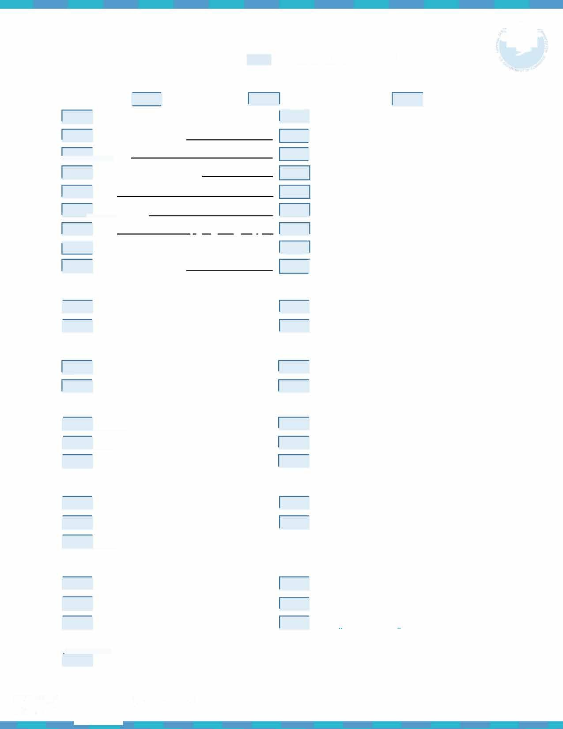
0ther/Unclassifi abIe -----------------------------------------------------------------------------
I !
Before entering your data into the MDMAP database, combine all datasheets fro m each group participating in the survey into a single dataset. Only one dataset per survey should be submitted to the MDMAP database.
I
� ^{NATIONAL} Marine Debris Toolkit
-=-- MARINE
for educators
18
SANCTUARY
-;,e;;-- FOUNDATION

Marine Debris Monitoring Supplies

Below are some suggested tools for your monitoring efforts. Absolute necessities are listed in red , whereas suggestions are listed in green.

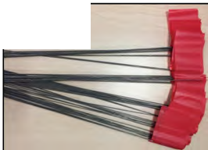
Survey Flags :
Tool :
Survey flags : used to mark out your site
- 1 set per site
Measuring tape (hand-held): for measuring your site
- 1 00-meter tape preferred
- 1 per site
- For measuring survey sites
Gloves: for students to use during monitoring
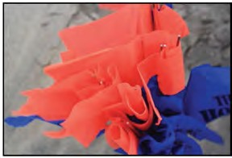
- 1 glove per student is recommended to save resou rces and

Where to buy:
Home improvement stores, online

Home improvement stores, online

General merchandise retailers, home

reduce waste
- Single-use nitrile gloves or multi-use gardening gloves work best
improvement stores, online

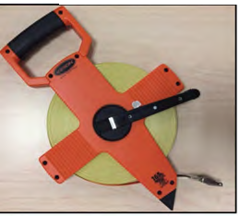
Measuring Tape:

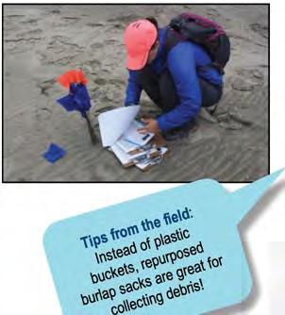
Bags*: for storing items collected during monitoring
- 1 per g roup of students to save resources and reduce waste
- Only needed for accumulation surveys

GPS Tracking Tool : for record ing coordinates
- 1 per g roup of students

Datasheets: to keep a tally of debris
- 1 per g roup of students
Pencils: to keep a tally of debris
- 1 per g roup of students
Clipboards: for carrying/record ing on datasheets while monitoring
- 1 per g roup of students

Buckets**: for storing items collected during monitoring
- 1 per g roup of students to save resources and reduce waste

Sturdy 12' Ruler: for measuring marine debris
- 1 per survey site

Camera: for photographing marine debris
General merchandise retailers, home improvement stores, online
FREE Google Maps app is the easiest way to track your coordinates on Apple or Android phones.

Printed from this toolkit!

Office supply store, general merchandise retailers, online
Office supply store, general merchandise retailers, online

Home improvement stores, online

Office supply store, general merchandise retailers, online

General merchandise retailers, online

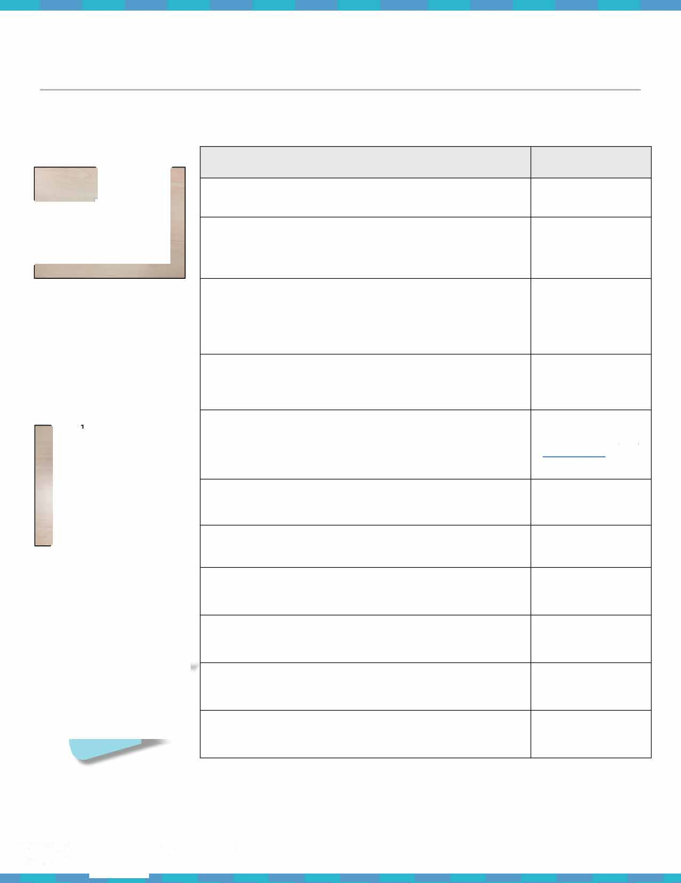
* Make it waste free! Have your students create their own reusable bags using old t-shirts . Check out the 'Action Project Ideas' section to learn how to make no-sew t-shirt bags.
** Buckets are a durable alternative to plastic trash bags, however this is only a suggestion - choose the best item for your school's budget/resources .
� ^{NATIONAL} Marine Debris Toolkit
I
MARINE
19
-=--
for educators
SANCTUARY
-;,e;;-- FOUNDATION

Marine Debris Survey Photo Identification Guide
This guide is a tool for categorizing marine debris items during monthly field surveys. The examples of debris types within each category are meant to assist in reporting survey results. To view and search the full photo identification guide and photo captions, visit the MDMAP Get Started Toolbox online Monitoring Photo Gallery at https://marinedebris.noaa.gov/research/monitoring-toolbox.
Print a copy of this guide and laminate it for students to use in the field!

Plastics

Hard Plastic Fragments*

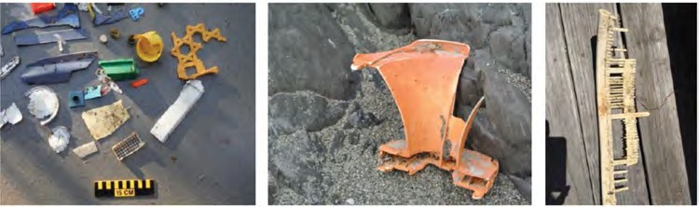
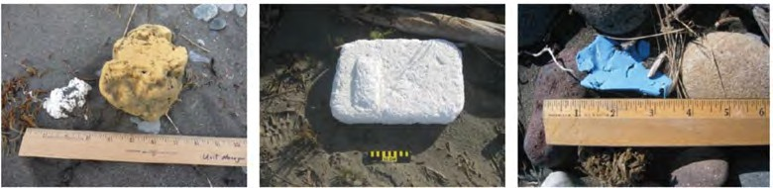
Foamed Plastic Fragments*

Filmed Plastic Fragments*

Plastic fragments > 2.5 cm that retain hard structure (though with
weathering, hard plastics may
become brittle and break apart when a little force is applied) .

Plastic fragments > 2.5 cm that are lig htweight and can generally be
broken apart or that crumble easily (however, exposure to the
environment may reduce 'crumble­ abil ity') .

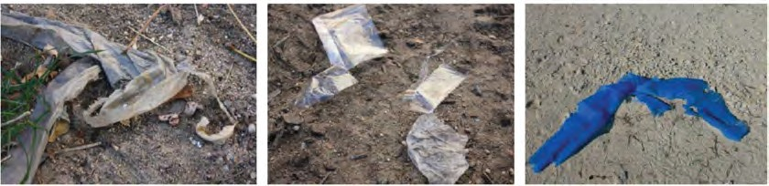
Plastic fragments > 2.5 cm that are composed of th in plastic sheets/films; these filmed plastics are flimsy
and bend easily.

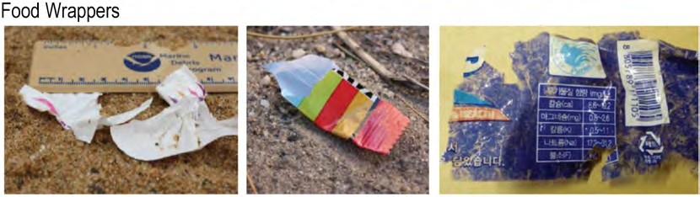
*A fragment is a piece of a larger item that cannot be identified, or that is less than 50 % of the original item.

Food wrappers are
distinguished from plastic films by identifiable labels . Food
wrappers come in a variety of types and sizes .

NATIONAL
�
-=- MARINE
•
Marine Debris Toolkit
20
for educators

SANCTUARY
-4iiii:'" FOUNDATION

Plastic Beverage Bottles

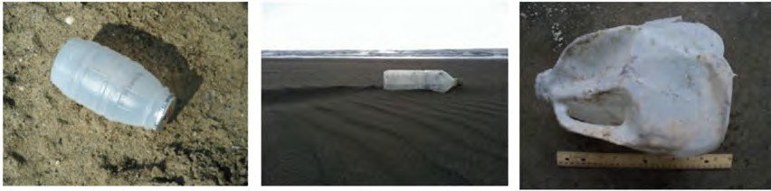
Other Jugs/Containers
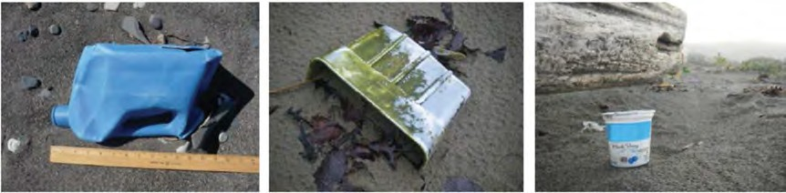
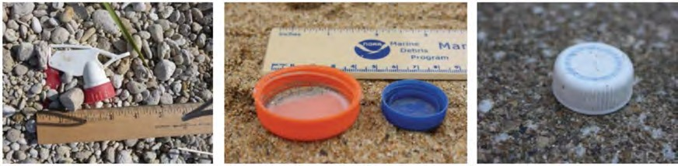
Bottle Caps/Container Caps

Plastic beverage bottles can include milk/juice jugs, or containers for soft drinks, water, juice, and sports
drinks. They come in a variety of sizes and colors (translucent, green, brown, light blue, etc.).

Other jugs/containers include a variety of
plastic packaging types. Examples include: food containers (yogurt, take out, etc.), plastic buckets, baskets, or barrels.

Bottle and container caps come in various sizes and colors.

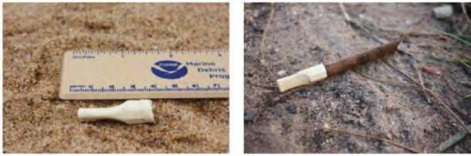
Cigar Tips

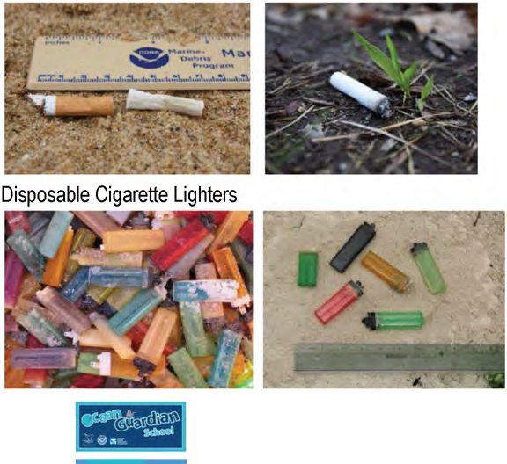
Cigarettes & Cigarette Filters

Cigar tips come on some cigar brands and are typically off-white in color. Only record cigar tips that are longer
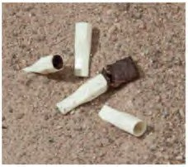
than 2.5 cm.

Cigarettes and cigarette filters can be hard or spongy (both are made of a synthetic polymer).
Some cigarettes may not have filters and are composed of only tobacco and paper. Only record cigarette butts that are longer then 2.5 cm.

Disposable cigarette lighters have a casing made of hard plastic (usually with a metal top). They may or may not contain fluids. Be very careful
when picking up a cigarette lighter - make sure an adult chaperone is with you at all times.
for educators
21

NATIONAL MARINE I
�
Marine Debris Toolkit

� SANCTUARY
-te:'" FOUNDATION

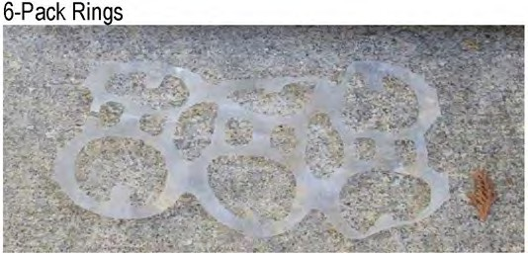
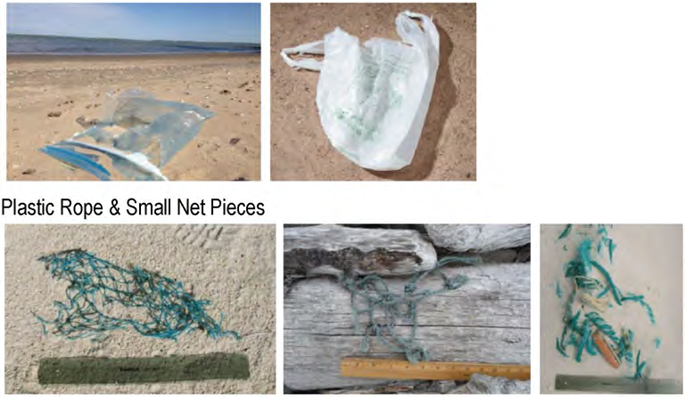
Bags
- Pack Rings are composed of a semi-flexible (but very strong) plastic material. They are used in the packaging ofsoda cans and other types of beverages.

Plastic bags are made of a thin film. Examples include bags used for: dry cleaning, newspapers, bread, frozen foods, bulk ice, fresh produce, grocery bags, household garbage, etc. As long as at least half of the bag is
present, these items should be recorded as bags.

Buoys & Floats
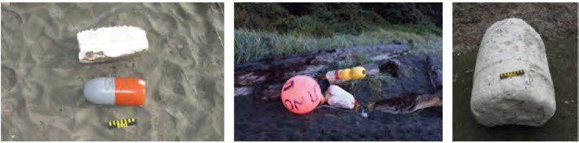
Fishing Lures & Line
Plastic rope and small net pieces are composed of synthetic material rather than cloth or fabric. Fishing line is NOT included in this category, but should be recorded under "Fishing Lures & Line".

Generally associated with fishing and boating activities, a buoy floats
at the surface and is attached to the seafloor. These come in various
sizes, shapes and colors.

Cups
Fishing lures come in a variety of shapes, sizes and materials depending on their function. Modern types are made of plastic with hooks and eyes for lines. Fishing line with lures attached should be recorded as one item.

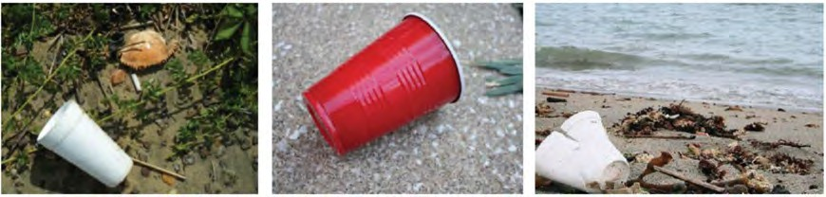
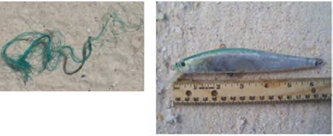Cups can be made of hard or foamed plastic. Most paper cups are coated with a plastic film.
. -
. -
Plastic coated cups are
included in this category.

� NATIONAL Marine Debris Toolkit
I
MARINE
for educators
22
� SANCTUARY
-te:'" FOUNDATION

Plastic Utensils
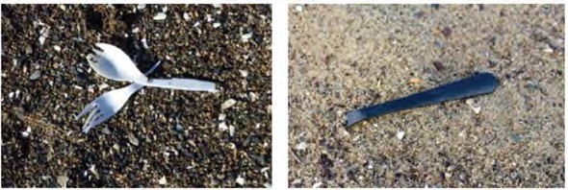
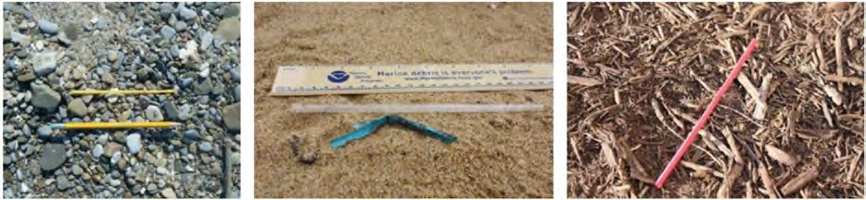
Straws

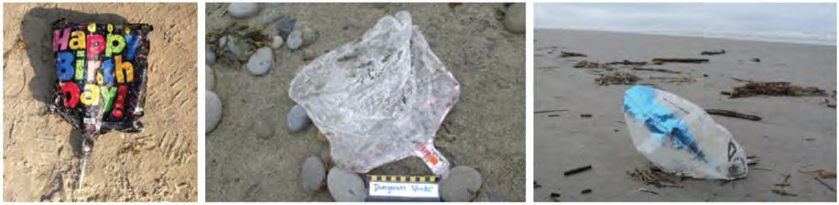
Balloons - Mylar

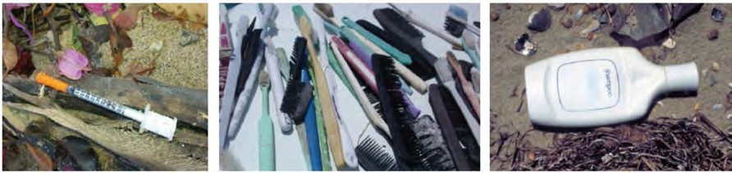
Personal Care Products

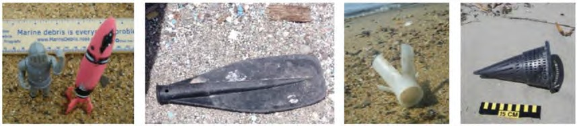
Plastic Other

Plastic utensils include disposable knives, forks, and spoons.

Straws come in various colors and
sizes ranging from shorter
ones to longer ones.

Mylar balloons have a seam and are made of foil coated plastic.
They usually have a shiny, reflective
surface and often have designs w/ pictures
and/or words.
This category is broad. Various products such as health and beauty containers, combs, toothbrushes, chap stick tubes, etc. are
included in this category.

Items that do not fit into one of the plastic categories above.
Describe the "other'' items in the notes section.

� NATIONAL Marine Debris Toolkit
I
MARINE
for educators
23
� SANCTUARY
-tei:'" FOUNDATION

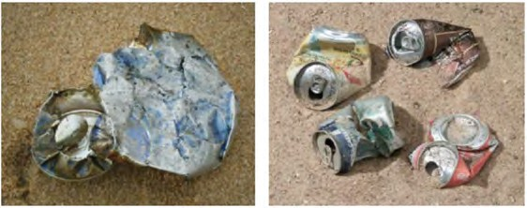
Aluminum/Tin Cans

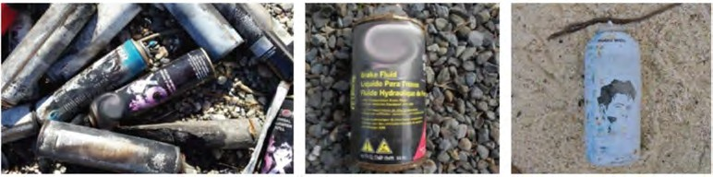
Aerosol Cans
Metal

Aluminum/Tin cans are used for beverages (e .g .
sodas, juice, etc.) and food items . Exposure to the environment will cause these containers to
deteriorate - aluminum cans become brittle over time and collapse. Tin cans rust when exposed to the environment.

Metal Fragments

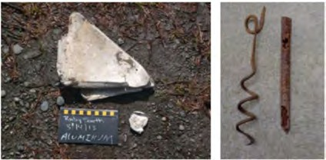
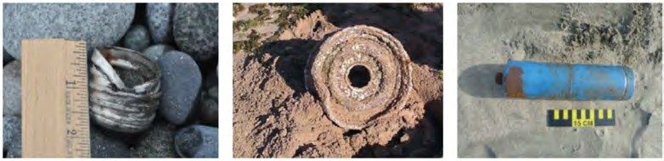
Metal Other
Aerosol cans have an outer shell made of metal (aluminum or steel)
and compressed contents . The spray valve will be made of plastic and the cap is also usually plastic. The spray valve and cap will most likely not be attached to the canister.

A metal fragment is a piece of a larger item that cannot be
identified , or that is less than 50% of the original item. Metal pieces that have been exposed to the environment may rust depending upon their material .

Items that do not fit into one of the metal categories above.
Describe the "other" items in the notes section .

Glass Beverage Bottles
Glass

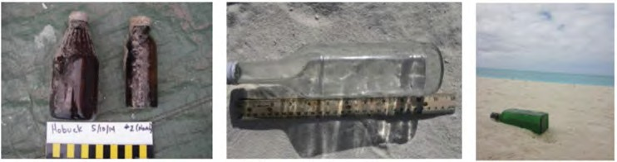
Glass beverage bottles are used for sodas, water, and other types of
liquids. These bottles come in
assorted colors (clear, green, brown, blue, etc.) and in different shapes and sizes . Most glass beverage bottles
have metal caps.

� ^{NATIONAL} Marine Debris Toolkit
I
-=- MARINE
for educators
24
SANCTUARY
-;,e;;-- FOUNDATION

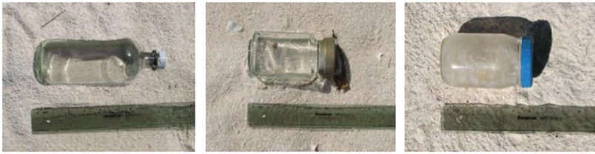
Jars

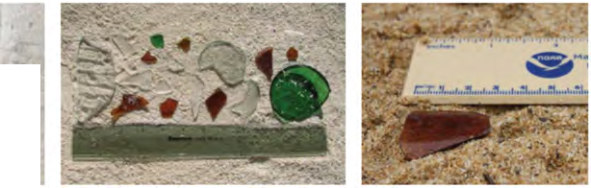
Glass Fragments

Rv8 'f S" v"'n-1
• • • • • • • 1

Many glass jars are used for
food , condiments, make-up, and other materials . This type of
debris is usually associated with household waste (land-based
sources) or gallery waste (ocean­ based sources) . The lids are
usually metal .
Glass frag ments are pieces of larger glass
items that cannot be identified , or are less than 50% of the orig inal item. If glass
fragments have been in the environment for long periods of time, they may become

7/ 'J"/t � weathered and appear with smooth edges
..r . -7J\
and a frosty appearance (e .g . sea glass).
Newly-fragmented glass pieces are likely sha rp, so ta ke ca re in picking up these items (use gloves or a scooper to remove sharp pieces of glass) . Always make sure to have an adult chaperone with you.
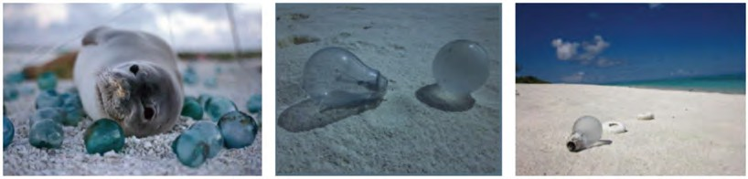
Glass Other

Flip Flops

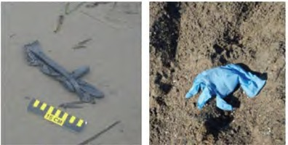
Rubber Gloves

Rubber
Items that do not fit into one of the glass categories above.
Describe the "other'' items in the notes section .

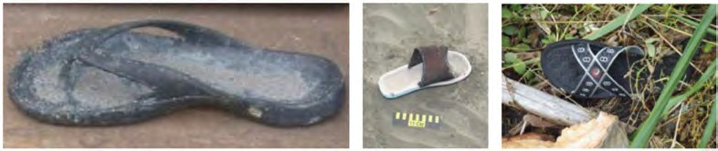
Flip-flops or "slippers" are
primarily composed of a rubber sole. Other shoes that have a
primarily rubber exterior, such as fishing boots, should be recorded under Rubber - Other.

Work gloves used for fishing may be made of natural rubber latex, nitrile (synthetic rubber compound), neoprene (polychloroprene) , or
polyvinyl alcohol rubber (synthetic) . Note: In some geographic areas, evidence of sea turtles attempting to feed on discarded gloves can
be seen with diamond-shaped bites in the gloves .

� ^{NATIONAL} Marine Debris Toolkit
I
-=-- MARINE
for educators
25
SANCTUARY
-;,e;;-- FOUNDATION

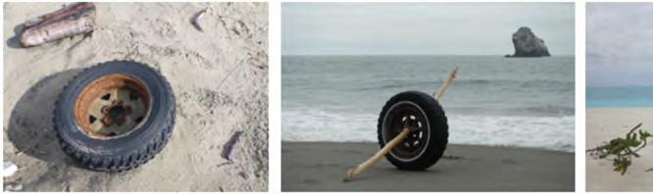
Tires

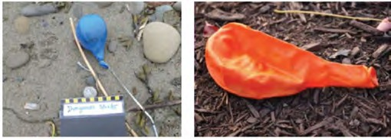
Balloons - Latex

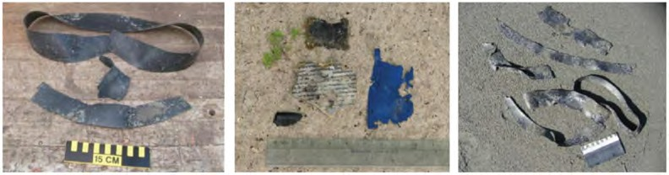
Rubber Fragments

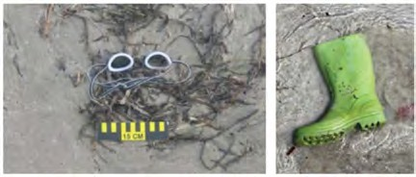
Rubber Other

Tires can come in various sizes (trucks, cars, trailers, bicycles, recreational vehicles, lawn
mowers, etc.) and may have the wheel rim (metal) , hub cap
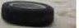 (metal) and/or covering lug nuts (metal) still attached .

Latex balloons are the trad itional "party" balloons. They are also often used at festivals, open houses, sales, mass
balloon releases, etc. These balloons are made of natural or synthetic latex, are usually round or oval in shape, and can come in a variety of colors.

A rubber fragment is a piece of a
larger item that cannot be identified , or that is less than 50% of the
original item. Rubber fragments may not feel like "rubber" due to
their degradation when exposed to the environment. Due to oxidation , rubber may even feel brittle.

Items that do not fit into one of the rubber categories above. Describe the "other" items in the notes section .

Cardboard Cartons

Paper and Cardboard
Processed Lumber

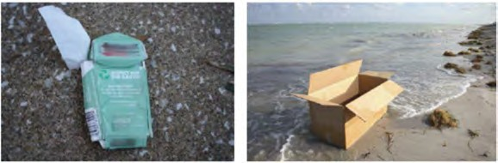
Cardboard cartons can be anything from cereal boxes to moving boxes, and are distinguished from Paper
and Cardboard because they hold their
carton/container shape. They will begin to deteriorate the longer they are exposed to the environment. The longer it is exposed the faster it will deteriorate.

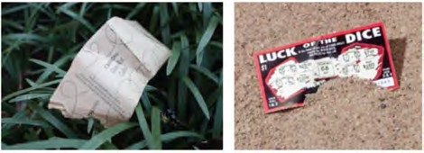
� ^{NATIONAL} Marine Debris Toolkit
I
-=- MARINE
for educators
SANCTUARY
-;,e;;-- FOUNDATION
Paper consists of newspapers, magazines, books, and other items . These materials will deteriorate due to exposu re to the environment.

26

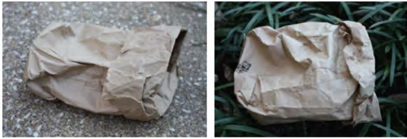
Paper Bags

Lumber/Building Material

Processed Lumber Other
Examples of paper bags include: fast food bags (e.g . fast food consumed on/near the beach),
grocery bags, etc. The bags will begin to deteriorate the longer they are exposed to the environment. As bags absorb moisture, the paper will fall apart.

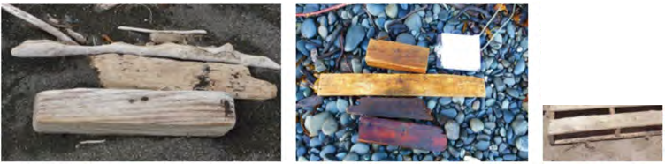Lumber that has been cut into
� -
A
��� � �
beams/planks or treated by humans should be recorded as
lumber/building material . Natural
woody debris and burnt firewood are not considered marine debris.

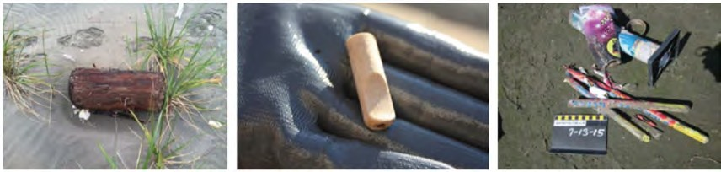
Items that do not fit into one of the processed
lumber categories
above. Describe the "other" items in the notes section .

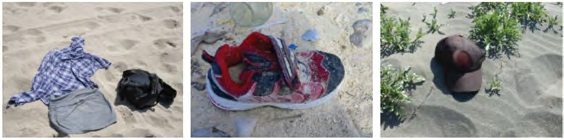
Clothing & Shoes

Gloves (non-rubber)
Cloth/Fabric

Examples of clothing items include: shorts, tops,
underwear, socks, etc. Shoes recorded here should be
primarily composed of
cloth/fabric on the exterior.

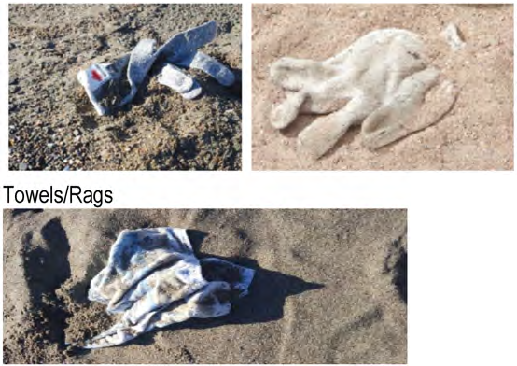
Gloves (non-rubber) made of fabric.

Fabric towels/rags left behind by beach-goers or used on boats for working with equipment and maintenance
(cleaning) activities .

� ^{NATIONAL} Marine Debris Toolkit
I
-=- MARINE
for educators
27
SANCTUARY
-;,e;;-- FOUNDATION

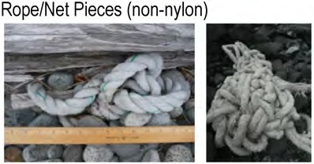
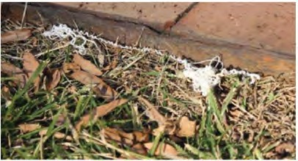
Fa bric Pieces

Cloth/Fabric Other
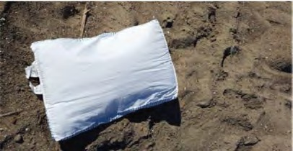
Rope/net pieces that are made of fabric can be identified by a "softer" feel in most cases. This
includes large (very th ick) natural ropes used as mooring lines for ships when in port.

Fabric pieces can't be identified as an
original object due to deterioration . Fabric pieces may tear when pulled apart.

Items that do not fit into one of the
cloth/fabric categories above. Describe the "other" items in the notes section .

Other/U nclassified

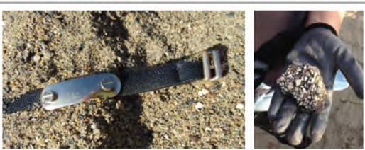
Other/U nclassified

If the primary material type could not be identified or is not listed , record the item as "other or unclassified". This may include leather items, concrete, etc.

Photo Identification Guide adapted from the MDMAP Photo Identification Guide: https://marinedebris.noaa.gov/mdmap-database-reference-documents/mdmap-photo-identification-guide

� ^{NATIONAL} Marine Debris Toolkit
I
-=- MARINE
for educators
28
SANCTUARY
-;,e;;-- FOUNDATION

Section 3: Guidelines for Data Analysis

Entering Data into the MDMAP Database

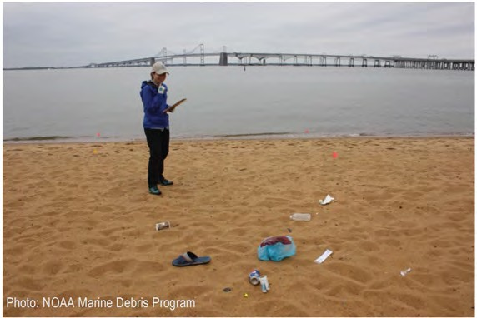
The MDMAP Database is an online repository for MDMAP shoreline marine debris survey data, and is the only way to submit your students' data to NOAA. The database was created as a tool to assemble data from various local
marine debris monitoring efforts. This enables us to compile a bigger picture of the issue at regional and
national scales. The database facilitates data sharing and analysis by making survey data available to researchers, students, and other interested parties. The database is
housed at https://mdmap.orr. noaa.gov/, and featu res a map of MDMAP shoreline sites on the homepage.

Ch ck Tips from the field·
� you r students' data BEFORE
  - To access the database, navigate to https ://mdmap.orr. noaa.gov/ and select "request an they input it into the MDMAP databas
Only ONE database entry
account." You'll receive an email letting you know when your account is active. should occi�
after each site visit.
    - Set up a single account that can be used by all students in your classroom to
ensure that your school's data is kept in one place.
  - The database has site characterization and survey entry pages that mirror the paper datasheets used in during your field
survey. To create a shoreline site in the database, look for the blue "Add a New Site" button in the top rig ht-hand corner, fill out your site characterization information (don't forget to add "_MDschool" at the end of your site name) and upload any
photos you may have taken of your site.
  - Once your site is created, you can submit survey data and photos after each survey. From the site characterization page, look
for the blue "Submit New Survey" button to navigate to the survey submission page. Then, simply translate the information from your paper datasheets into the online form. For standing stock surveys, each transect is submitted as a separate survey.
Shoreline sites and surveys created under your account log in can only be edited by you, but other users can download your
survey data and view your photos. Any photos uploaded to the database can be used by NOAA. Photos showing students' faces should not be uploaded without parent consent.
o The database has a Custom Data Tab (located in the top left tool bar), which is where users can add unique debris types to their datasheets within the framework of the debris types on the standard datasheet. This featu re allows
users to track data on debris items that may be locally relevant, but are less common on a national scale. Refer to
the Database User Guide (link at bottom of the page) for more information on how to create and work with custom data.
  - The homepage of the database also features an "other sites" section where you can explore other survey teams' sites,
surveys and photos. All data and photos go th rough a verification process before being made public. Keep in mind that other users can explore your data as well.
    - This is an excellent way for your students to explore _MDschool data from other participating schools!
  - You can download survey data to an excel file from the reporting tab - located in the top left tool bar. There are a few
different types of reports to choose from, depending on whether you' re looking for accumulation or standing stock survey data. Reports are filtered based on location and time, so you can choose which sites and surveys you' re interested in.
An in-depth explanation of these processes can be found in the Database User Guide. For more information, visit: https://marinedebris.noaa.gov/sites/defau1Ufiles/publications­ files/NOAA%20MDMAP%20Database%20User%20Guide.pdf
To view the data entry tutorial visit: https://marinedebris.noaa.gov/sites/default/files/videos/original/6 Data Entry KSedits withSLaudio.mp4.mp4
•

� NATIONAL
-=- MARINE
SANCTUARY
-4iiii:'" FOUNDATION
Marine Debris Toolkit
for educators
29

Analyzing Your Data
The Importance of Creating Visual Displays with Your Data
Creating figu res using the data collected during your students' surveys is a g reat way for students to analyze patterns in debris as well as better understand the impacts marine debris may have on local marine environments. Encourage your
students to build figu res and design infographics to share with thei r peers, families, or community members! Allowing them to share their data beyond the classroom is an excellent way to give your students an active voice in the fight against
marine debris. For more ideas on how to spread awareness about marine debris, check out the final section of the Marine Debris Toolkit on Community Engagement and Outreach .

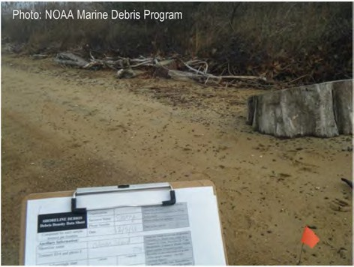
The MDMAP has excellent resou rces for mapping and analyzing the
data collected during your students' surveys . The MDMAP data analysis templates provide interested volunteers, students, partners, or
organizations an opportunity to easily visualize shoreline monitoring data from the MDMAP database. The templates will take your students from
raw data to marine debris visualization tools/fig u res with as few 'clicks'
as possible. The tabs are arranged in an 'order of operations' manner at the bottom of the excel files, starting with Tab 1. Enter Accumulation Data Here. At the top of each tab, instructions walk th rough the steps req uired to create your figu res. Tab 2. Debris by User category
analyzes debris by three user categories: Plastic Consumer Products,
Plastic Smoking Products, and Plastic Fishing Related Products. After following instructions for tabs 1 and 2, you are ready to view your figu res!

TO BEGIN: have your students download the excel files and figure example documents from: https://marinedebris.noaa.gov/mdmap-data-analysis-examples-and-templates

Dry Creek West - Total Debris by Material Type |  | 0.0003 | Dry Creek West - Plastic Debris Grouped by User Category (Flux)
- Uncluslfled
- Cloth/Fabric  - Processed Lumber  - Rubber | �i  E | 0.00025  0.0002 | - Plfl1k F1M11nc Rel,tedProclucts  ·Fko
- Glass |  |  | - Plnllc Smokln1  Products • FI IDI
a M l  a Plntlc |  | 0.00015
 | ;. |  | - Plntk: Conwmer  Products -Flux
 | ;:;: | 0.0001

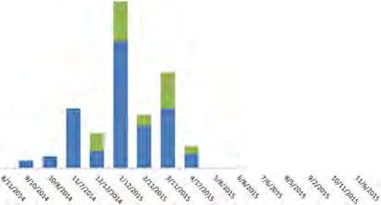
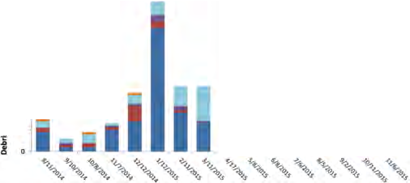C 0.00005
u 10
•• L1
I 10
80
.l:
'o 60

,, so

§ 40
� 30
..
0
- 20
- . I I

Examples of Marine Debris data fig ures can be found on the webpage listed above along with informative PDFs on how to interpret their data.
T

gett. Paflence in
for educators

NATIONAL
�
-=- MARINE
•
Marine Debris Toolkit 30

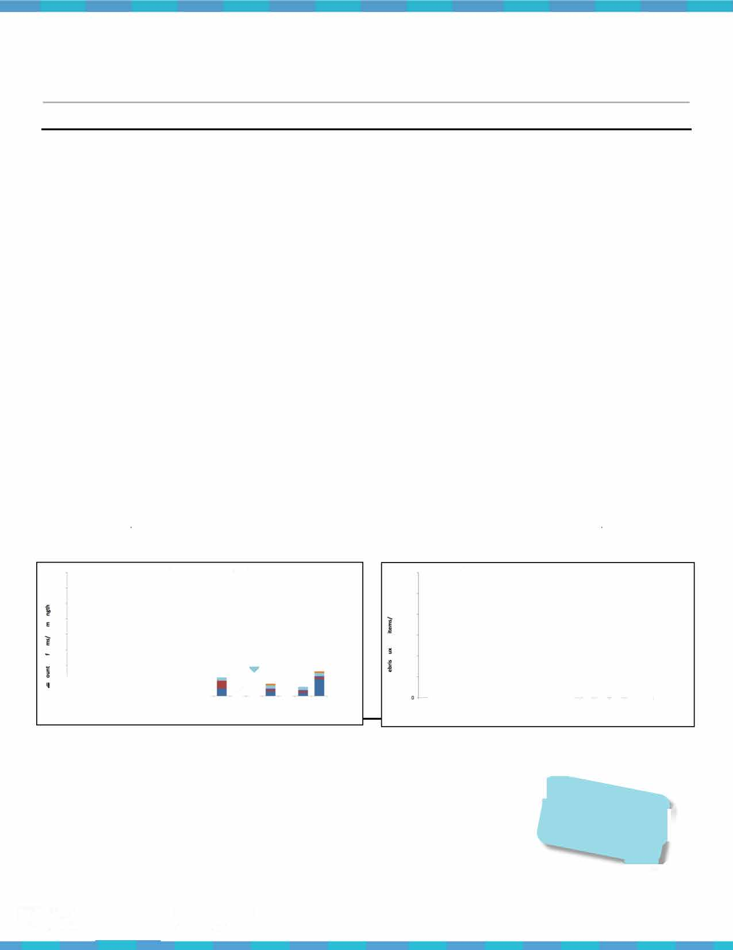
SANCTUARY
-4iiii:'" FOUNDATION

Section 4: Community Engagement and Ouach

School Activities List
Below are some suggested activities and resou rces to help educate, energize, and engage your students as they learn how to combat marine debris at school, at home, and out in their communities*.
*Please note: These activities are not directed to specific grade levels. Please adjust accordingly.

Litterless Lunch Contest: Create a competition (between classes/grades) to see who can produce the least amount of waste during contest duration.
Debris Scavenger Hunt: Turn your school campus' debris into a scavenger hunt! Put together a list of common debris items that can be found on your campus and reward the students who collect the most items off this list!
Plastic is a Deadly Meal: See what it's like for marine animals to find food in a sea of debris! Put together a bowl of rice ("food") and lentils ("plastic") and see how much "food" they can scoop out while avoiding the "plastic."
Swedish Fishing Contest: See what it's like to be an albatross trying to sort through an ocean of plastic trash (bottle caps, plastic bags, etc.) to find the fish. Put trash into a large bucket/bin and hide the sweet treats (i.e. Swedish Fish) in there (ideally in individual wrapped packets so that students could eat them when they catch them). Have students use trash picker-uppers that mimic a bird's beak to grab them.
Sorting Contest: Students are given a variety of waste items to try to get in the right sorting buckets within a limited amount of time (i.e. landfill vs. recycling vs. compost).
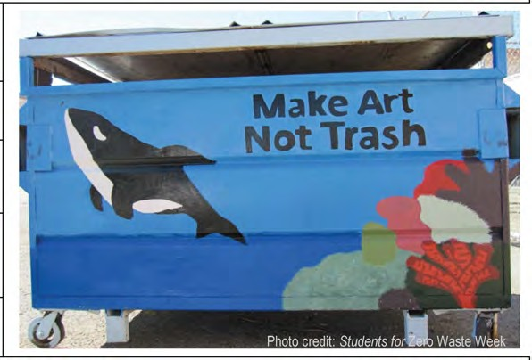
Get the Word out About Marine Debris: Include student-written notes/letters/articles/editorials about marine debris in student newspapers, email blasts, or letters home to parents. Flood the local newspaper with students' "Letter to the Editor"! Have your students present their findings to the local city council, school board, Rotary Club, etc. about why it is important to protect the ocean and/or local watershed from marine debris.
Art for Change: Create big and small art using waste materials (from beach/stream cleanups, school, or at home) and celebrate with a school-wide art exhibit.
Trashion Show: Host a "Trashion" show where students can model their original fashion attire created with recycled/reusable "debris"!
Create/Decorate Reusable Bags: Provide materials for your students to decorate reusable bags or better yet, make reusable bags out of old T-shirts!
Tote-Your-Own-Trash Day: Students carry their own trash bag around with them for a day to gain insight into how much waste they generate. Make time for student reflection.
Waste Audits: Have students assess and brainstorm ways to reduce waste at school, in the community, and/or at home.
"Do Without" Week: Challenge your students to choose one debris item that they can do without for the week (single-use plastic water bottles, snack bags, etc.). Have students write a reflection about how easy or difficult it was for them to do without. Bonus points for students who share this reflection with their peers via word-of-mouth, an online blog, or a social media post!
Public Service Announcements: Have your students create Public Service Announcements (PSAs) about the dangers of marine debris to share during morning announcements or with local radio stations.

� ^{NATIONAL} Marine Debris Toolkit
-=-- MARINE
for educators 31
SANCTUARY
-;,e;;-- FOUNDATION

Action Project Ideas

Category Title I Description
Courtney Mattison is an artist and ocean advocate working to
- Marine Debris - Art Our Changing Seas Series inspire policy makers and the public to conserve our changing
seas.
Grade Level
Grades K-12

Link Source
http://courtneymattison.com/ Courtney Artist*
Mattison;

- Marine Debris - Art Picking Up the Pieces
A woman from Californ ia photographs the trash she finds daily Grades
on her walks, hoping to raise awareness for marine debris. K-12
Washed Ashore builds and exhibits aesthetically powerful art

http://thereisnoaway.net/
There is No "Away" Project*

- Marine Debris - Art Art to Save the Sea
to educate a global audience about plastic pollution in oceans Grades
http://washedashore.org/
Washed

and waterways and spark positive changes in consumer K-12 Ashore*
habits.
Bow Seat Ocean Awareness Programs believes that students
Awareness

- Marine Debris - Art
From the Bow Seat: Ocean Awareness Programs
who learn by creating and making experience deeper learning and longer-lasting behavior change. The arts provide diverse
Grades K-12
http://www.fromthebowseat.org/ Bow Sea

and powerful opportunities for expression and communication Programs*
of ideas.

What is a fun way for students to raise money for their Zero Zuleika
Grades https://snapguide.com/guides/make-a-tote-

- Marine Debris - Art No-sew T-shirt Bags
K-12 bag-from-an-old-t-shirt-no-sewing/
Waste projects? Recycle old !-sh irts by creating no sew tote bags! This easy to follow, step-by-step guide shows you how to create an excellent alternative to single-use plastic bags!

Have your students create a Marine Debris Blog to share what How to choose the best platform :
http://www.wpbeginner.com/beginners-
they have learned with others! Free blogging platforms are

Lambe on Snapguide*

Marine Debris - available online, with easy formatting for students to customize Grades guide/how-to-choose-the-best-blogging- NOAA's

- Community Marine Debris Slogging the look of their blog . This activity gives students a great

6-12
platform/ Marine Debris

Engagement opportunity to use their voice to raise awareness about the dangers of marine debris.

Feeling a bit overwhelmed by the idea of ridding your life of plastic products? Start small! The Last Plastic Straw
Idea inspired by:
https://marinedebrisblog.wordpress.com/

http://thelastplasticstraw.org/
Program

Marine Debris -
8 Community
movement inspires participants to empower and educate the
Join the Last Plastic Straw public on plastic pollution - starting with plastic straws. Have Grades
Leave these printable, double-sided cards at the restaurants you reach out to:
The Last

Engagement
Movement
your students reach out to local restaurants to ask them to
stop serving straws, to only serve them upon request, or to switch out their plastic straw supply with a more sustainable option such as paper straws.
K-12
http://thelastplasticstraw.org/wp-
content/uploads/201 4/09/The-Last-Plastic- Straw-Info-Card .pdf
Plastic Straw*

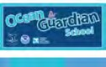
� ^{NATIONAL} Marine Debris Toolkit
MARINE
-=-

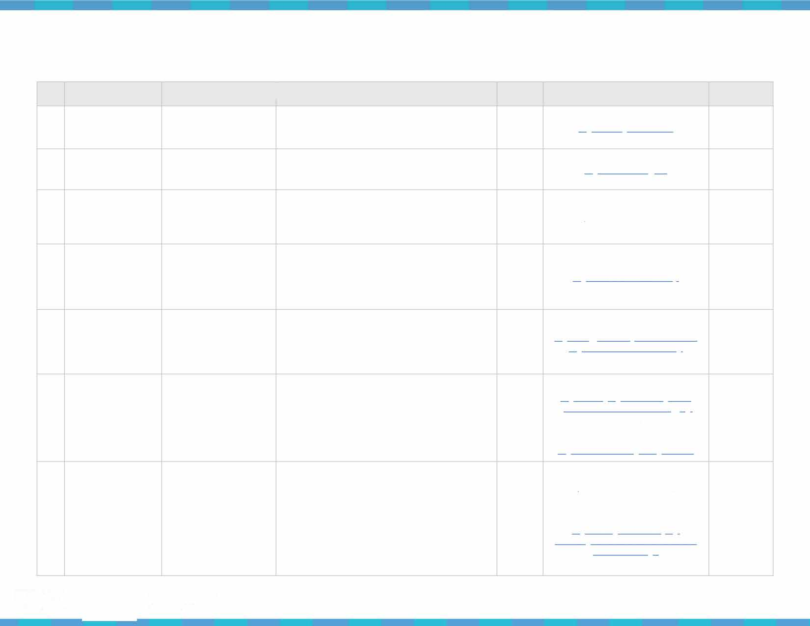
SANCTUARY
� FOUNDATION
for educators 32

Marine Debris -
9 Community Engagement
Contact your local community members to raise awareness
about your students' efforts or to let them know about the Interested in writing a letter to the ed itor? Write a Letter to Your Local issues surrounding marine debris and what we can do to help. Grades Check out the link below for a list of Community Members Encourage your students to share their survey data in their K-12 newspapers in your area:
letter to inform members of the community of their efforts. htt12:i/www.usni2l .com/
Check out the 'Writing to Your Community' template below!

Help reduce the use of single-use plastic bottles by installing Check out this neat article about how a high

United States Newspapers (USNPL)*

Marine Debris - Install Water Refill Stations Campus Engagement on Campus
10
water refill stations on your campus. Raise money for this action project through crowd-funding, selling reusable water
bottles on campus, or reaching out to your local drinking water

Grades K-12
school accomplished a similar installation: htt12s://www.banthebottle .net/articles/water-
refill-stations-heli2-students-sta�-h�d rated-

Ban the Bottle*

provider. du ring-san-diego-drought/

Check out the following articles to learn more about what students are trying to do in their school cafeterias:
Noticing debris from those pesky spork packs on your htti2://highschool.latimes.com/bell-high-
campus? Give your students the option to choose only ONE school/012inion-awa�-with-straws/ LA Times,

single-use item by replacing these packs with bulk dispenser
11 Marine Debris - Reduce Waste in Your options - such as a fork, spoon, or plastic straw dispenser. Grades

htti2://www .alaska12ublic.org/201 7/02/27/stude nts-work-to-reduce-ocean-trash-one-si2ork-at-
Alaska Public Media, & the

Campus Engagement Cafeteria
Does your school still have Styrofoam trays? Replace single- use Styrofoam trays with cardboard trays - a more sustainable option!
K-12
a-time/
For more information on how to reduce waste in your cafeteria, visit:
htt12s://www.fns. usda.gov/school-
meals/creative-solutions-ending-school-food- waste
USDA Food
and Nutrition Service*

NOAA's
Office of
Students for Zero Waste Week is a school-driven, week-long National
campaign to reduce waste on school campuses and within Marine
12 Marine Debris - Students for Zero Waste Grades htt12://sanctuaries.noaa.gov/education/ocean Sanctuaries
local communities with the intentions of moving towards zero
Education Week waste. This campaign is a g reat way for students to determine K-12 guardian/zero-waste-week/ and The
how to transform their Zero Waste Week into a Zero Waste
Ocean Guardian School Program
way of life.
School Garden

13 Marine Debris - Education
Establish a sustainable way to provide food for your school's cafeteria or other school programs by starting a school garden!
School gardens help reduce waste, can act as an outdoor
classroom, and can further connect students to the world we live in.

Grades httQs://www.ecoliteracy.org/sites/default/fi Center for
K-12 les/uQloads/getting-started-2009.Qdf Ecoliteracy*

*Partner source

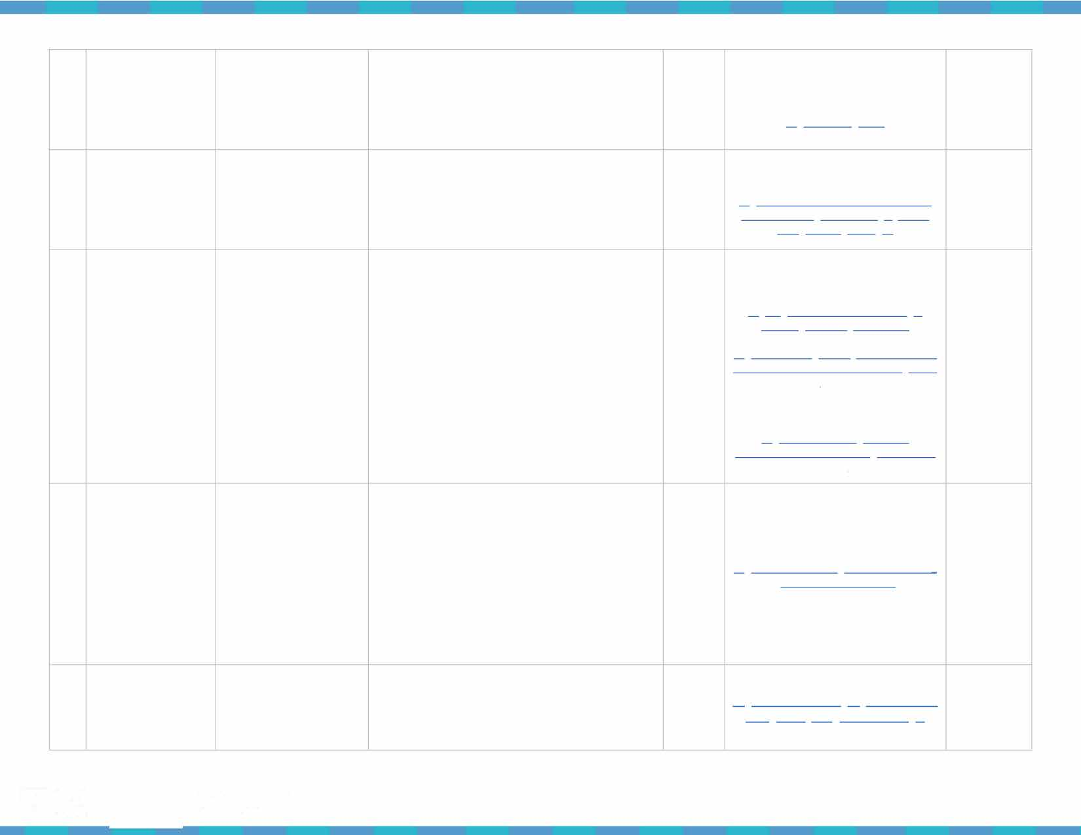
� ^{NATIONAL} Marine Debris Toolkit
-=- MARINE
for educators
33
SANCTUARY
--..;,- FOUNDATION

Writing to a Member in Your Community
Sample formatting for a letter to your community members

Follow the below template to write an informative letter to your local community members (e.g. restaurants, business owners, letters to the editor, etc.). Remember to keep your letter brief, no longer than one page- typed.

Return Add ress

Date

Community Member's Add ress

Salutation

Introduce you rself by stating your name, where you live, what school you attend

Why are you writing your fellow community member?

Ask for a response

Thank your fellow community member for his/her time

End with your signatu re
Your Name Add ress
City, State Abbreviation Zip Code

[insert date]

[insert community member's fu ll name] Community member's Add ress
City, State Abbreviation Zip Code Dear Mr. or Ms.[insert last name]:
My name is [insert your name] and I live in [insert your city, state]. I am currently a [insert grade] student at [insert school name].

I am writing you to ask that you consider the impact marine debris has on our
environment. [Include a few sentences on how marine debris has an impact on the environment and the organisms living within it. Inform your fellow community
member of your efforts to keep the environment clean th rough marine debris monitoring. If you have completed your survey(s) add a sentence or two about
what you fou nd. Finish up this section with a sentence about how you think they may be able to help protect marine environments. Be specific!].

I appreciate your help and request that you please consider sending me a response to let me know your thoughts on th is issue.

Thank you for your time.

Sincerely,
[sign your name]
[clearly write your name if your signature is difficult to read]

NATIONAL
�
-=- MARINE
•
for educators
Marine Debris Toolkit 34

SANCTUARY
-4iiii:'" FOUNDATION

Marine Debris Toolkit - Teacher Reflection Form
Thank you for utilizing the Marine Debris Tool kit! Your feedback is valuable - please take the time to fi ll out the followi ng reflection form so we can determine how to mold th is kit to best suit your needs. Completed forms should be scanned and emailed to Seaberry Nachbar: seaberry.nachbar@noaa.gov.

What did you find most helpful about th is kit?

What did you find least helpfu l about this kit?

Did you util ize any of the recommended curricula?

How effective was the use of the recommended curriculum?

Which survey method did you end up utilizing? Why?

� NATIONAL
-=- MARINE
SANCTUARY
---:- FOUNDATION
Marine Debris Toolkit
for educators
•
35

Did you find any aspects of your monitoring efforts difficu lt?

What section do you think could use the most improvement?

What more would you like to see in th is toolkit?

Did you notice any behavior changes amongst your students?

Did your students share their marine debris monitoring with their peers and/or the community? If so, what was their sharing method?

� NATIONAL
-=- MARINE
SANCTUARY
---:- FOUNDATION
Marine Debris Toolkit
for educators 36
•

