Keep Houston Beautiful
Elliot and Friends

Recycling Activity Book

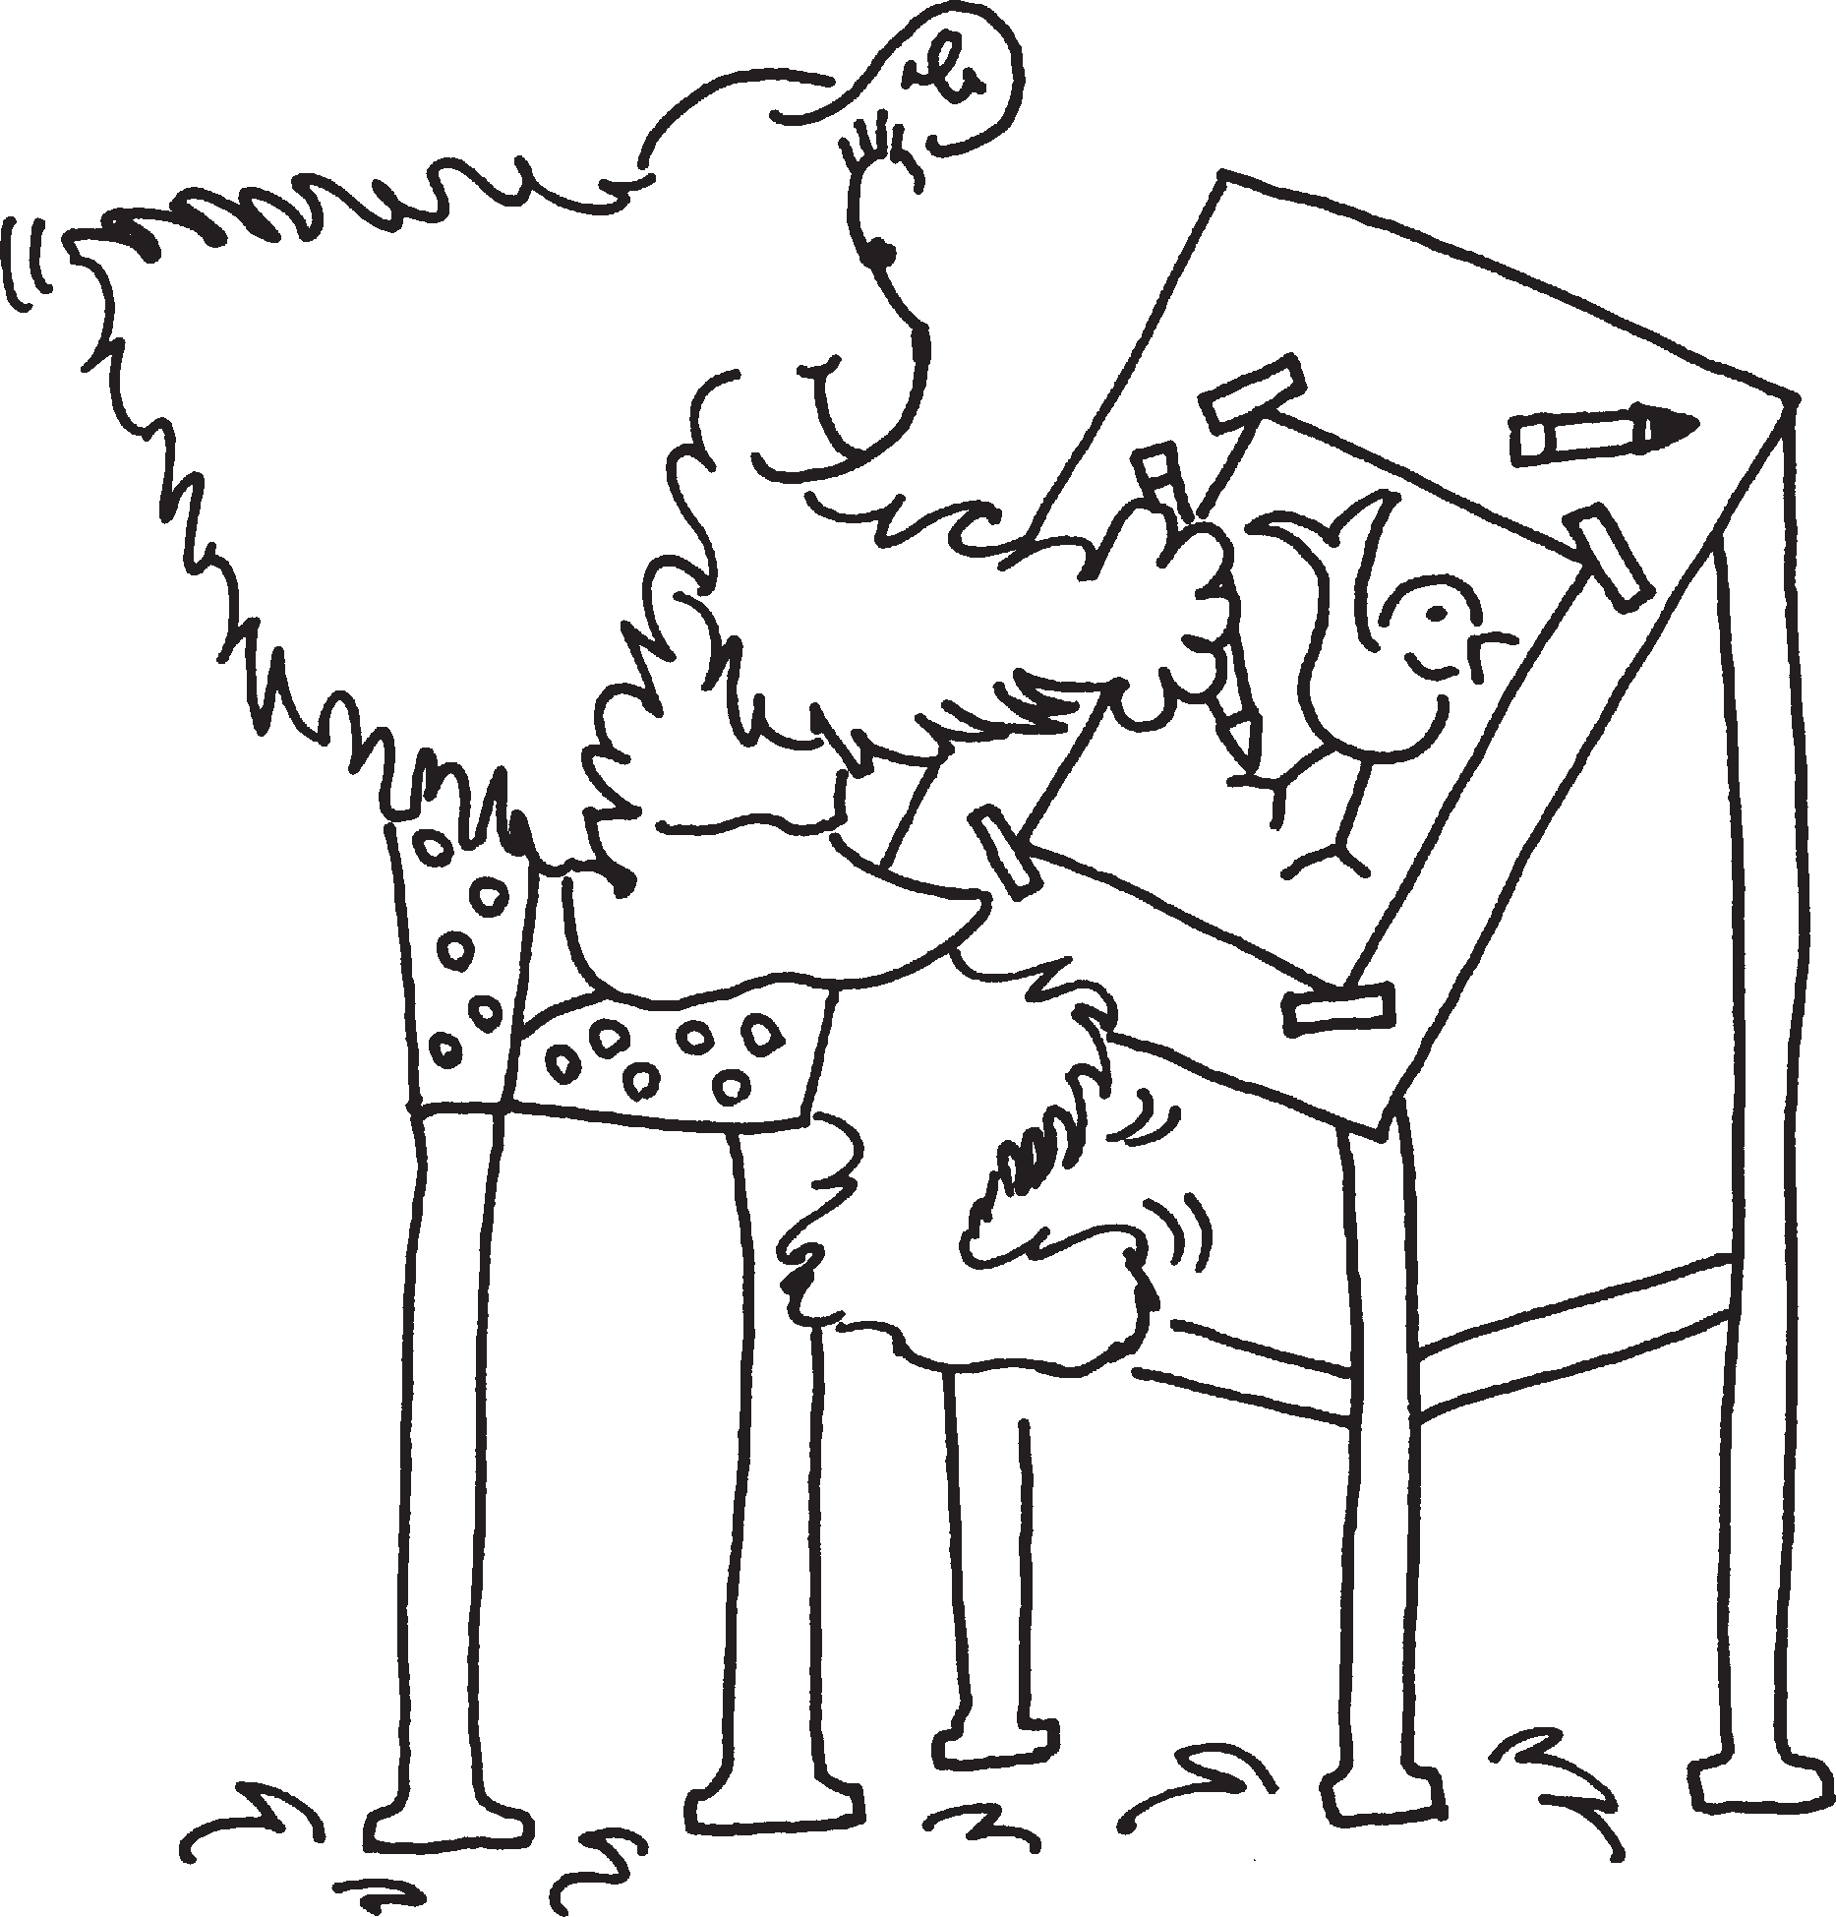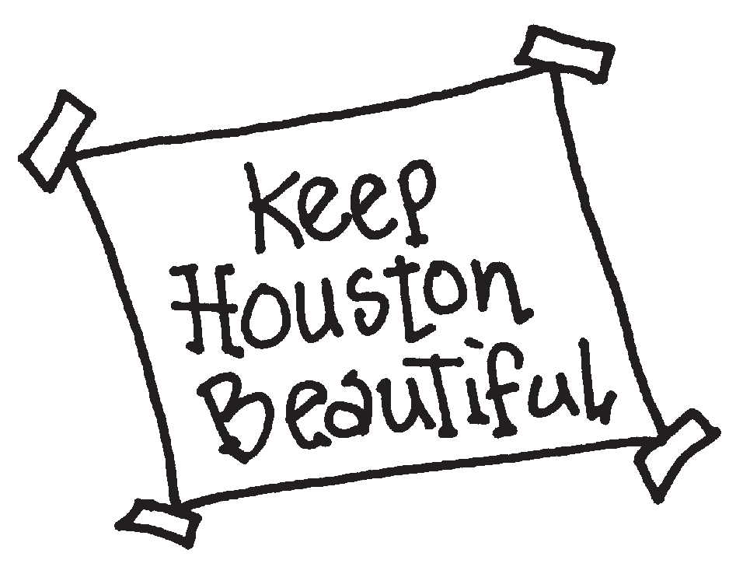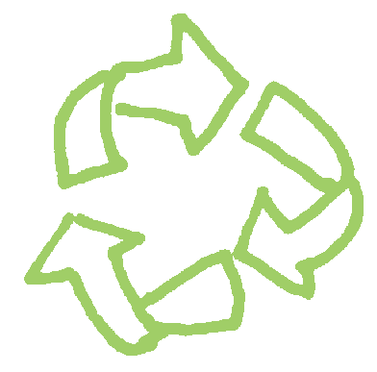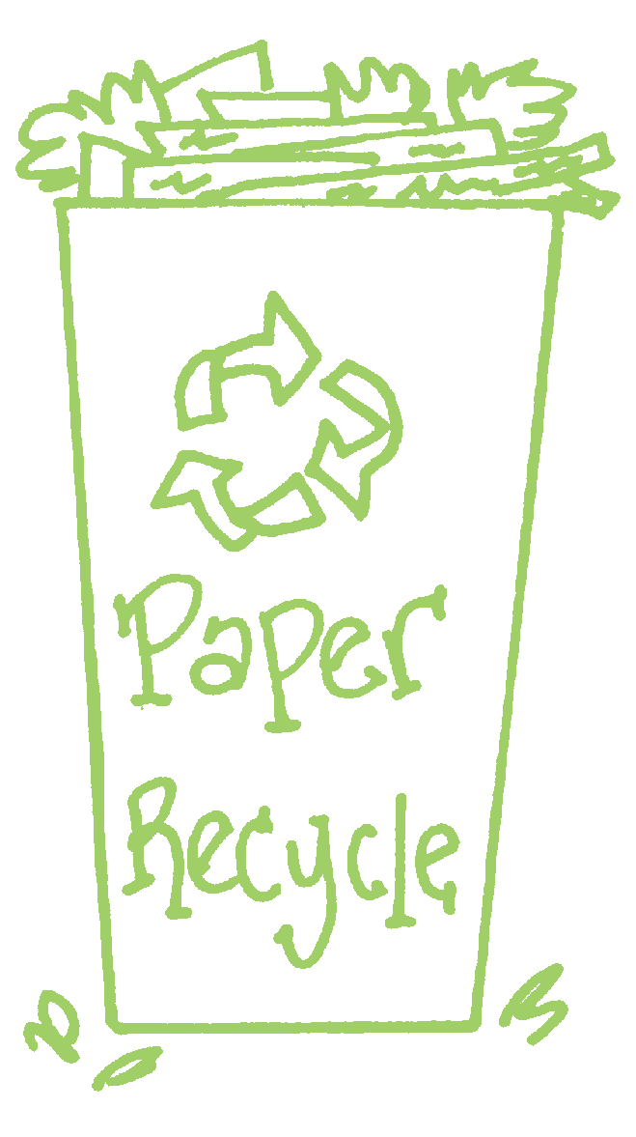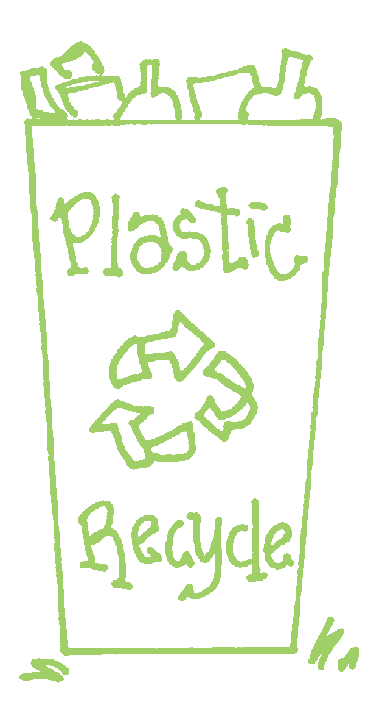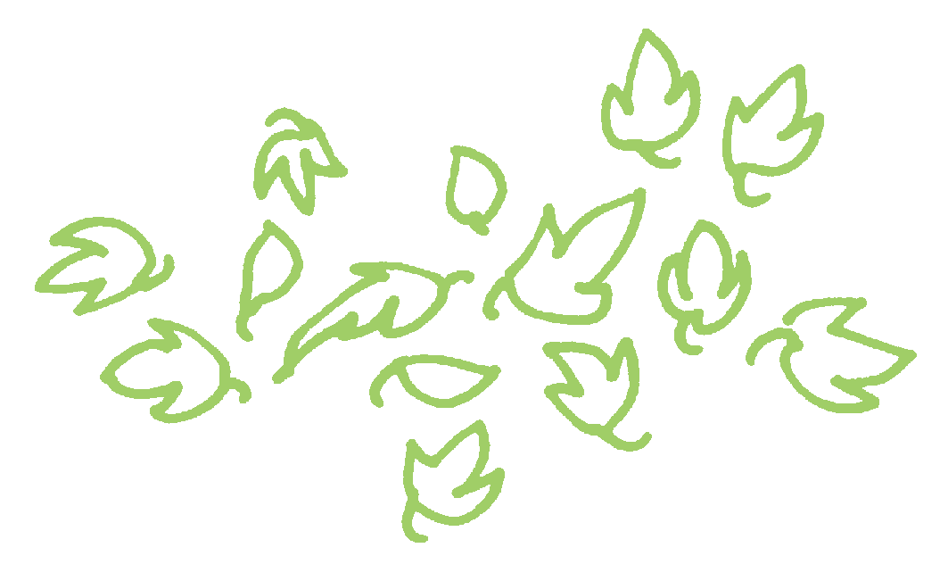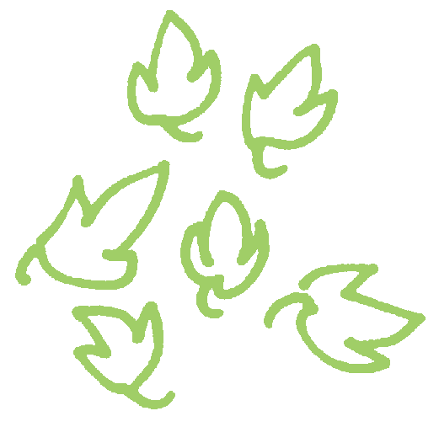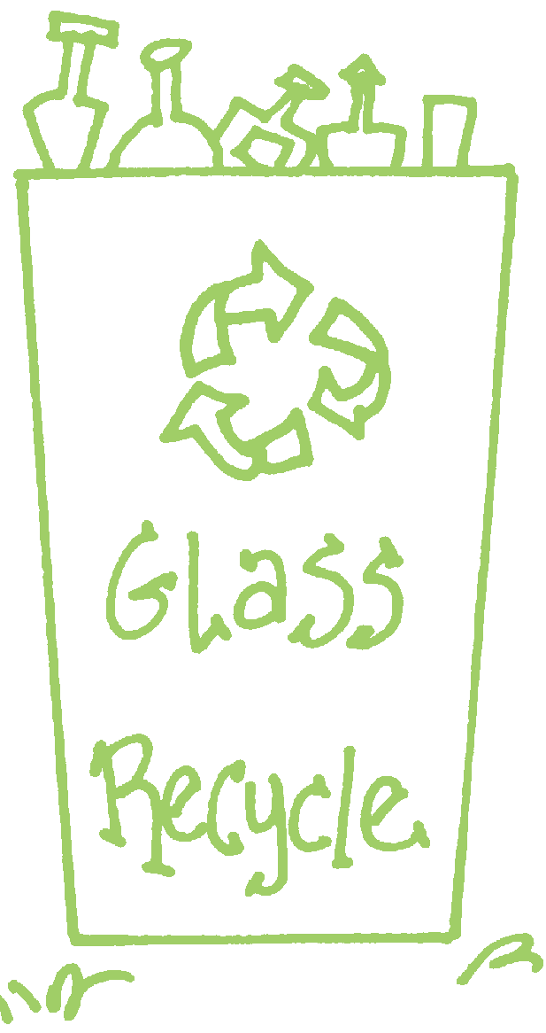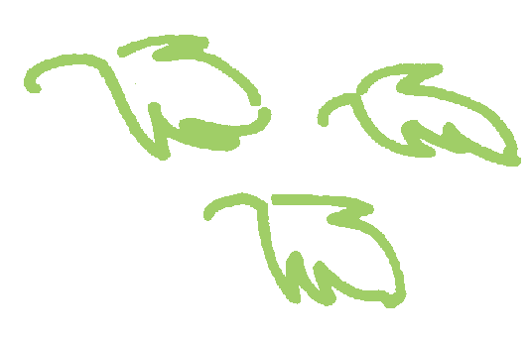written and illustrated by debi mcnabb published by Keep Houston Beautiful

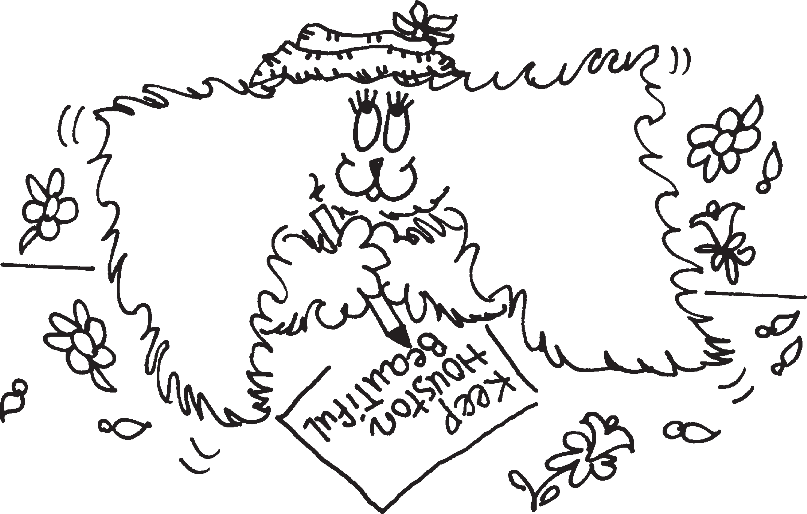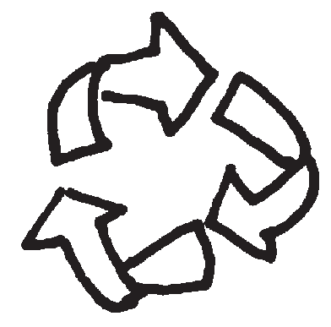

Collecting Recyclables
Lily and Buzz collected lots of trash during Neighborhood Clean Up.
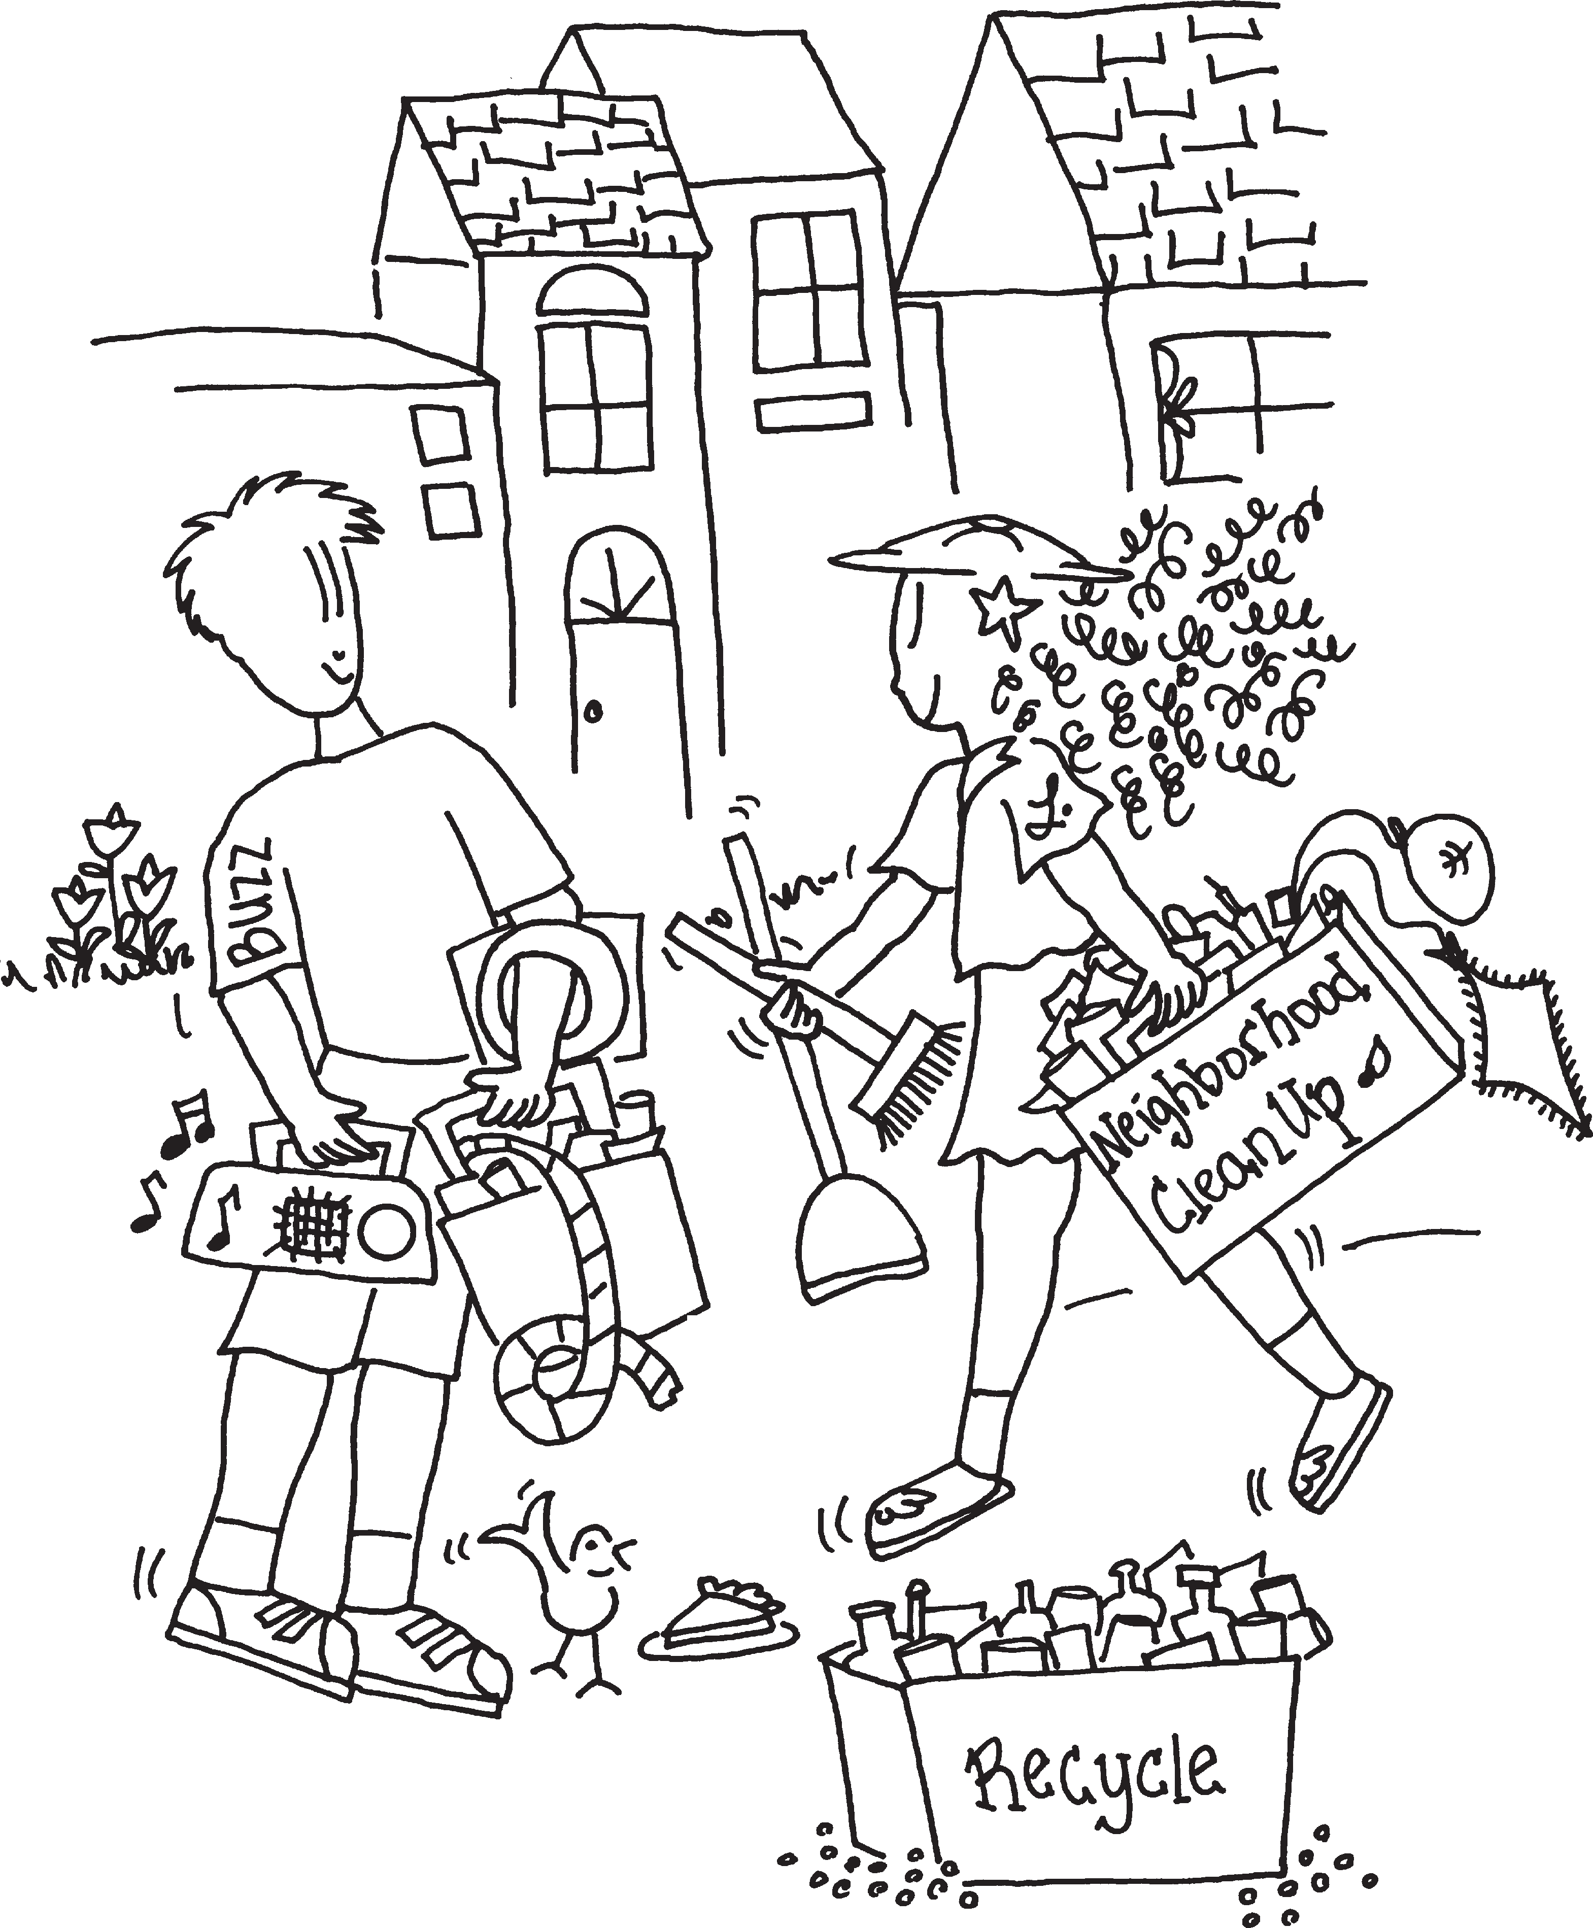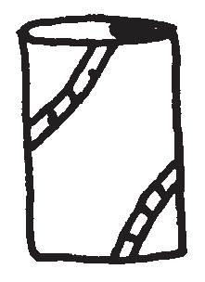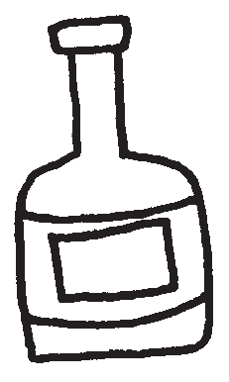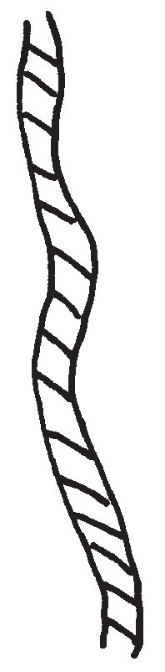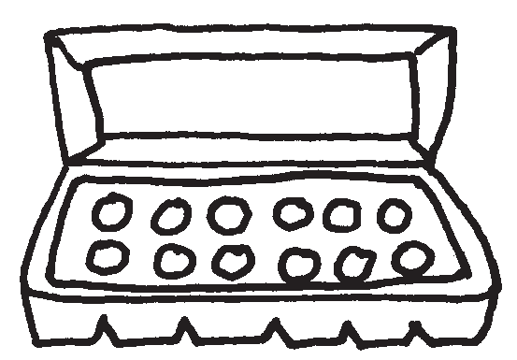Circle 7 things they found that can be recycled.

Light bulbs

Juice packs
Paper cups

Rope, string

Styrofoam Egg cartons

Cans Glass bottles
Plastic bags

MSW
Trash, garbage, refuse, junk are also called Municpal Solid Waste or MSW. Ming and Hubert like playing at a clean park but Litter bugs have been there. Color the picture and write R - recycle or C - compost next to the MSW word for what should be done with it.
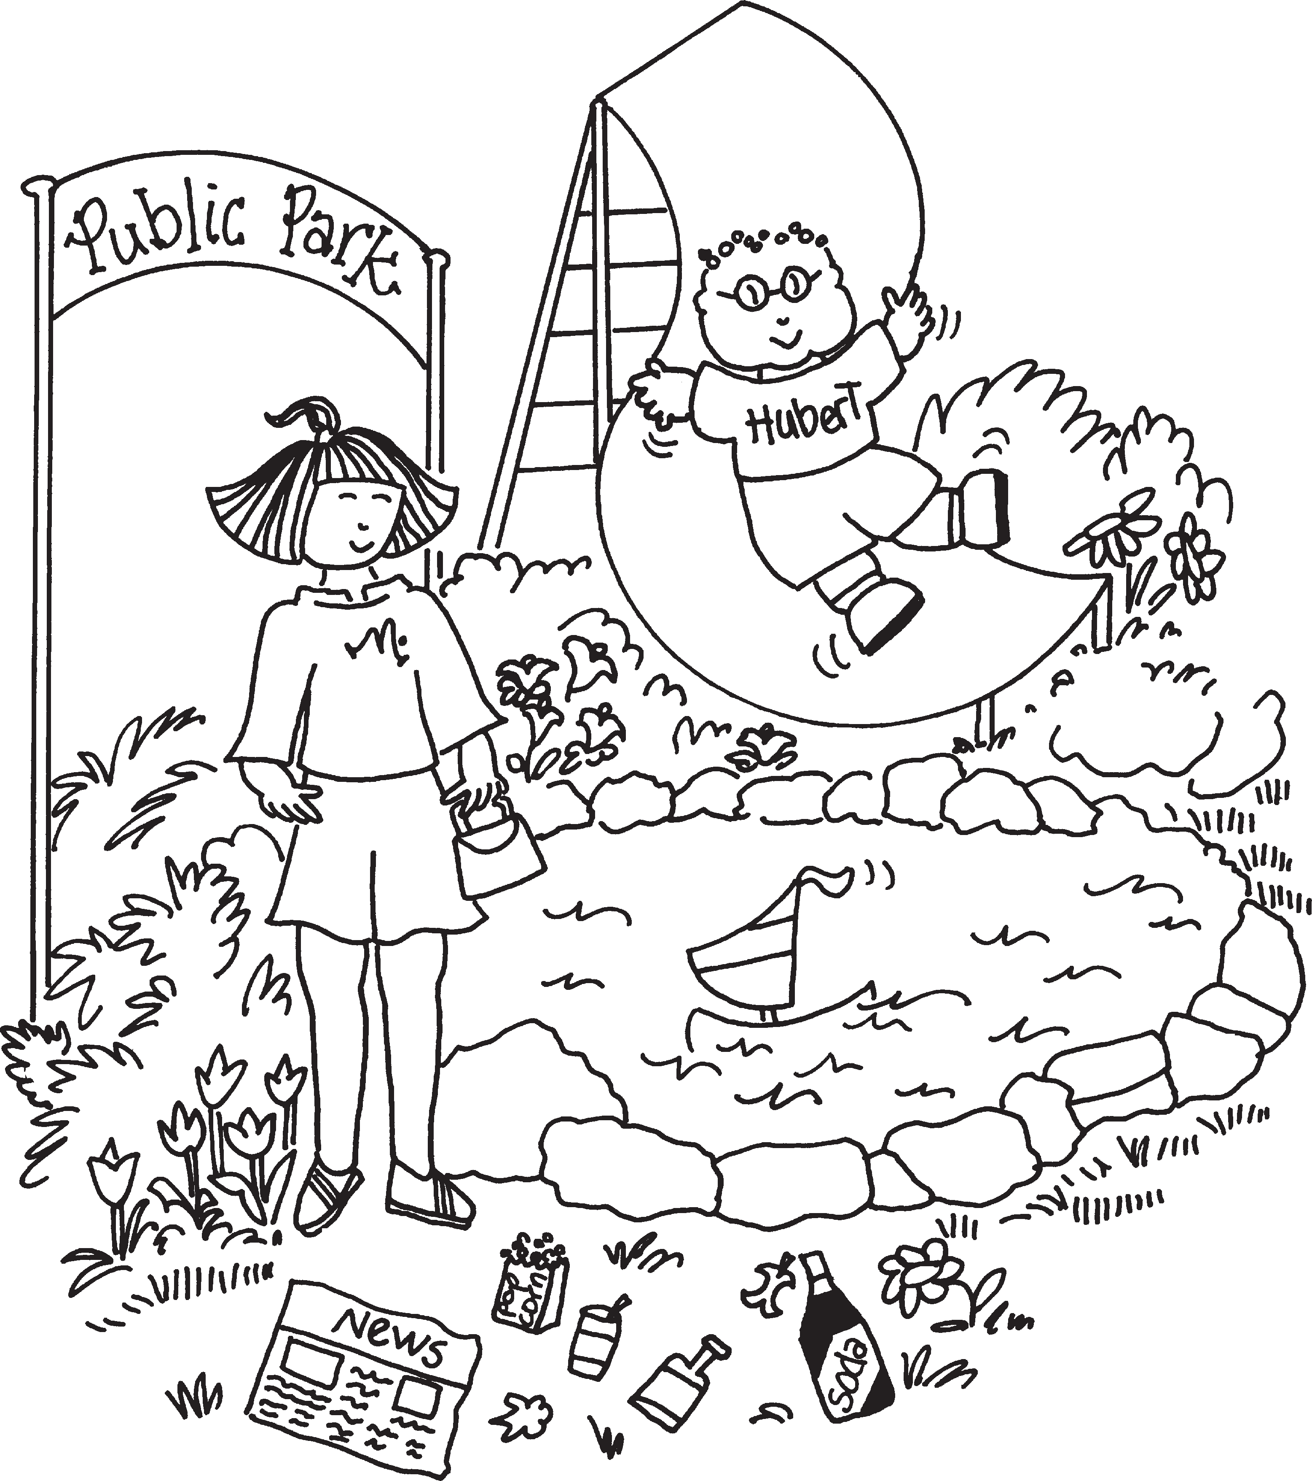plastic bottle glass bottle newspaper apple core
soda can

Recycle
Recyclables are MSW that can be recycled. Recycling is collecting and separating recyclables instead of throwing them in the trash.
Recyclables are made into new things people will buy. Jasmine’s jacket is made from plastic bottle caps. Have fun coloring the picture.
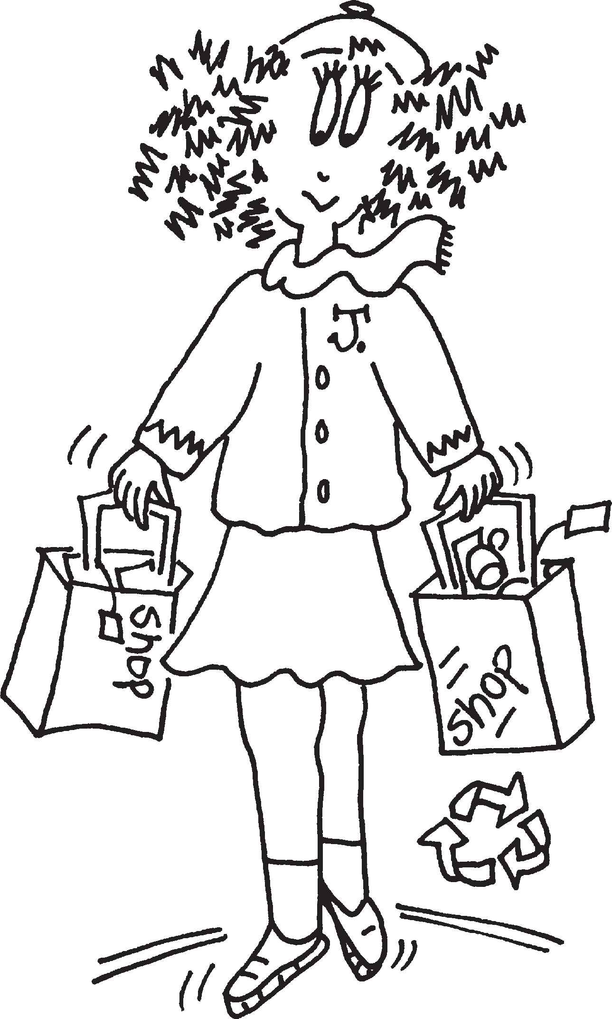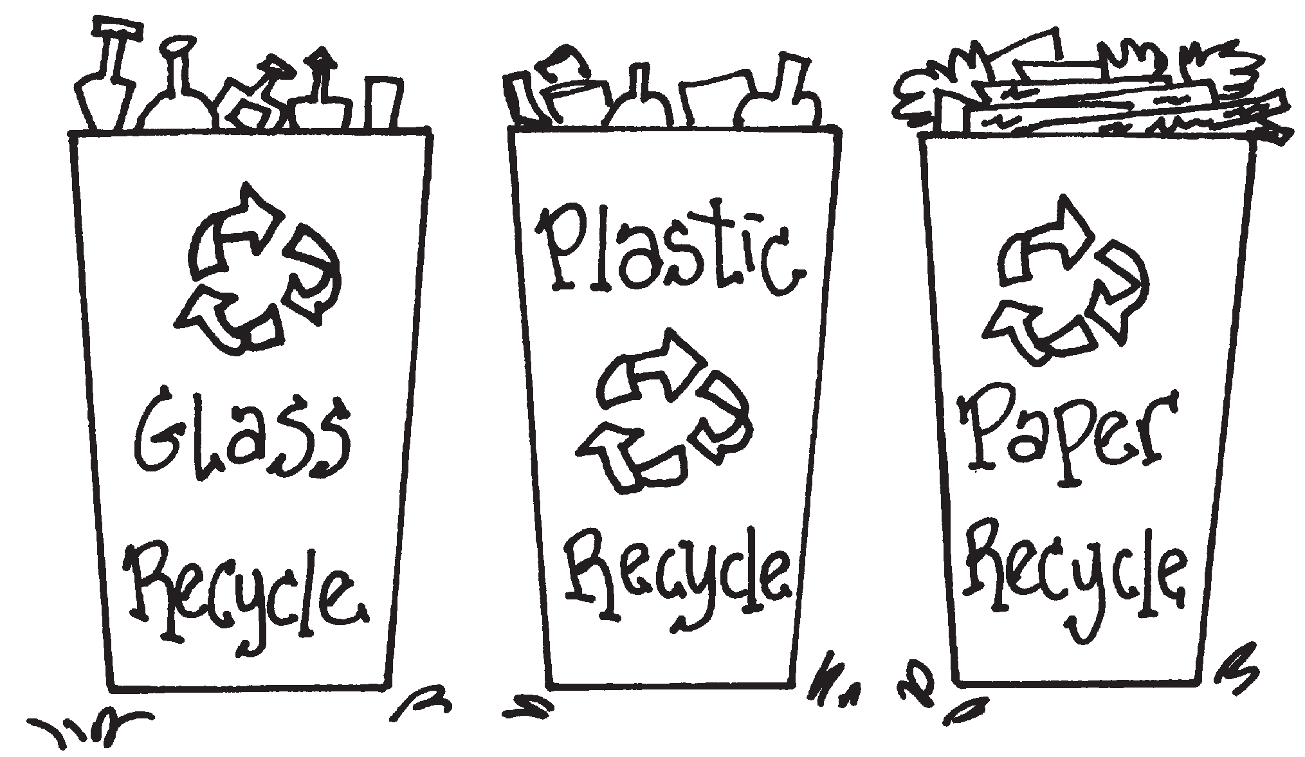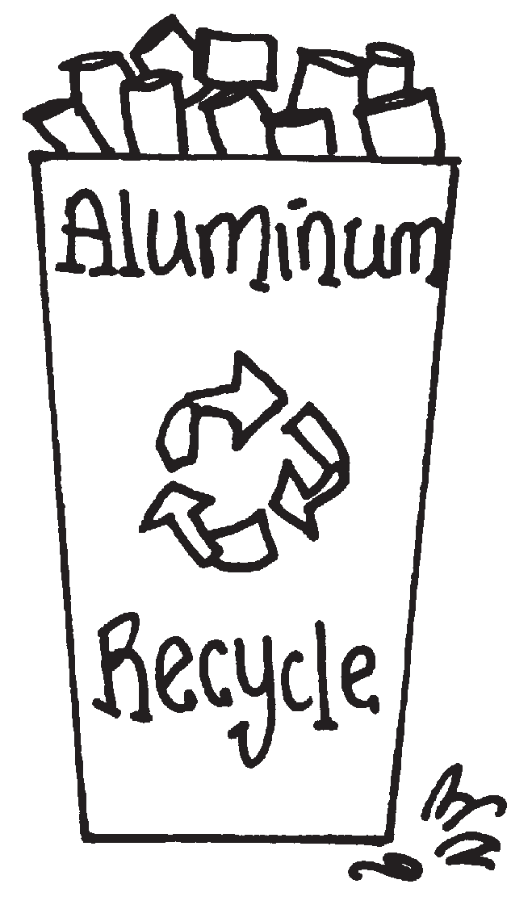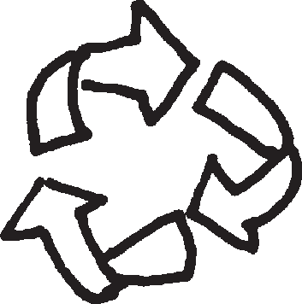
Match the names of new products with the recycled materials they are made from.

Stationary Soda cans Jacket
Road pavement Steel cans
Recycled aluminum cans Recycled glass Steel scrap
Old Maps Recycled plastic bottle caps

Compost
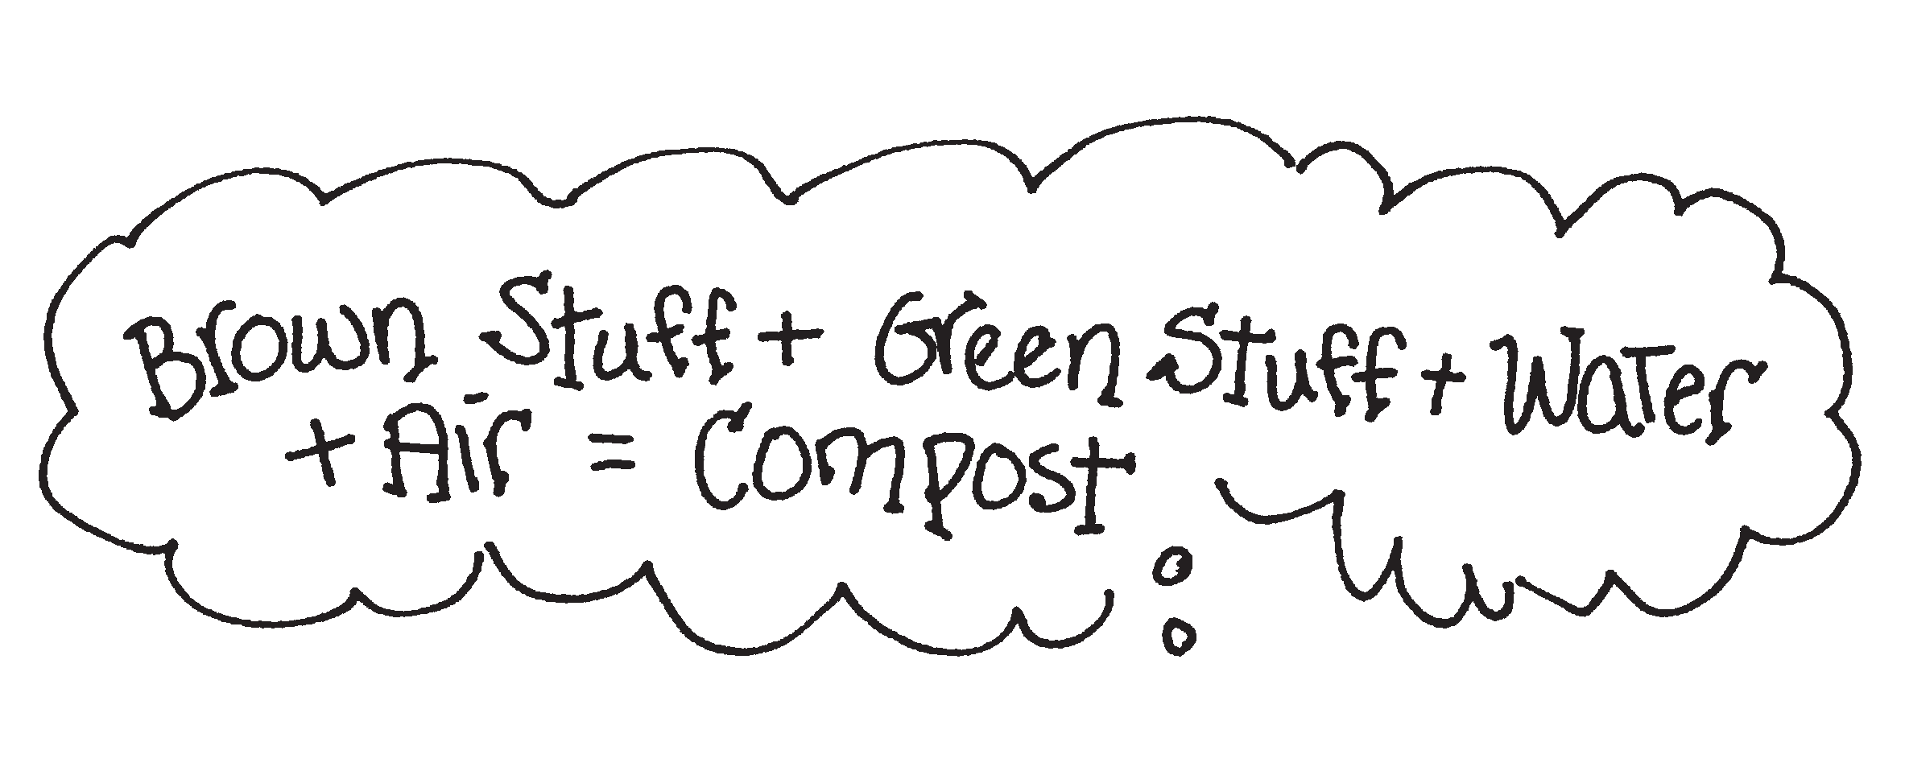
Have fun coloring!

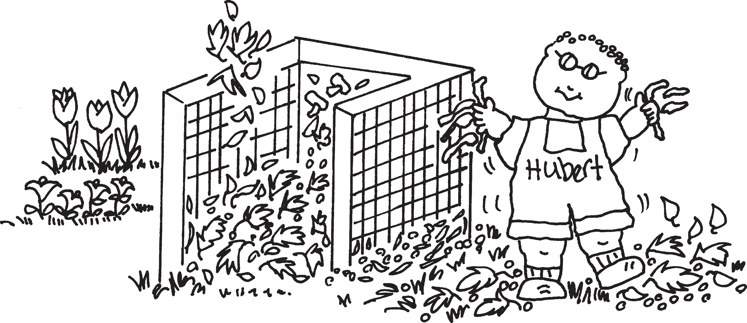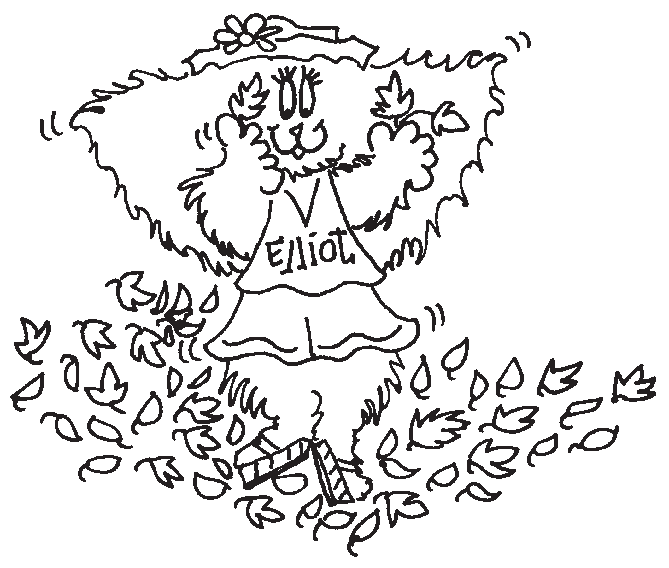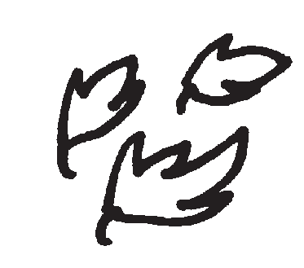Green Stuff grass clippings fruit peels garden plants kitchen scraps
Brown Stuff fallen leaves dried hay straw
wood chips

There is a compost bin in the garden. The compost bin is for organic garbage that will turn back into soil and the rich soil can be used for growing plants. Hubert is adding red worms to the compost bin.
Worms help make compost. Draw some worms for the compost bin.

What can be done with MSW?
Help Lily, Buzz and Jasmine unscramble the words to learn what can be done with MSW.
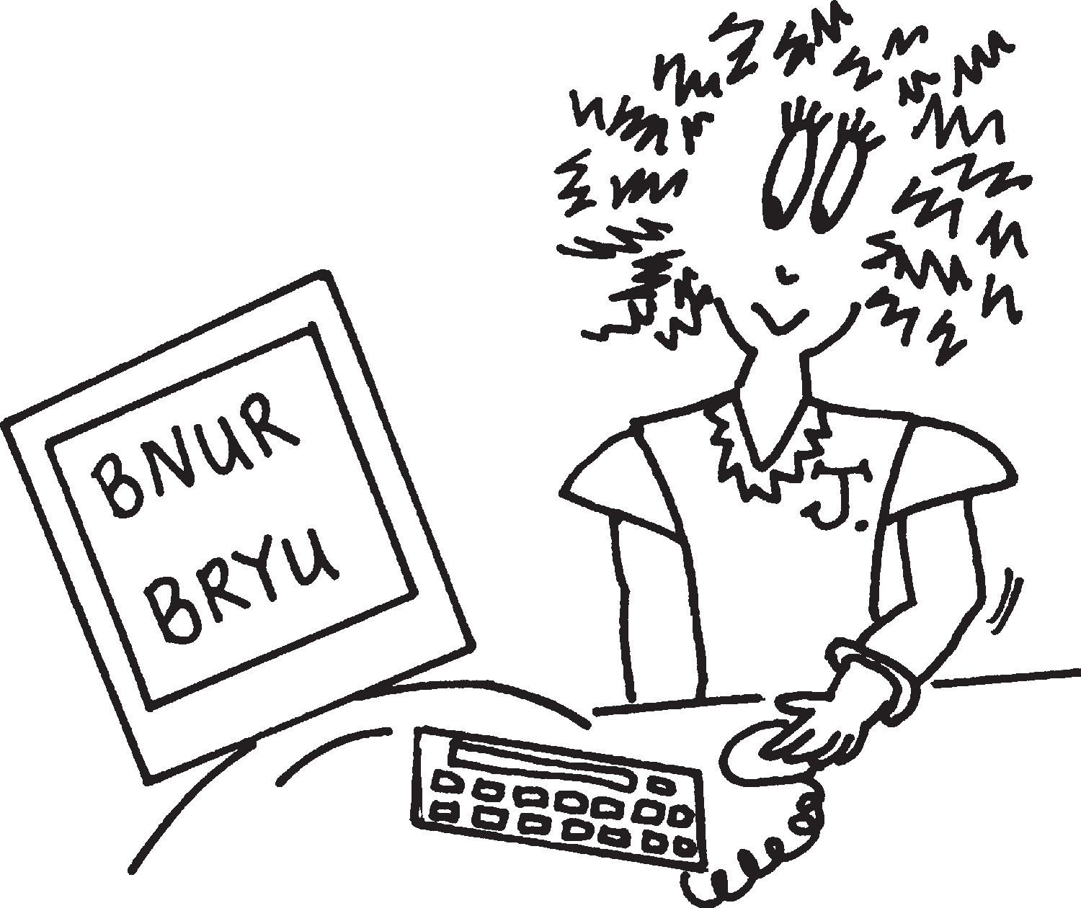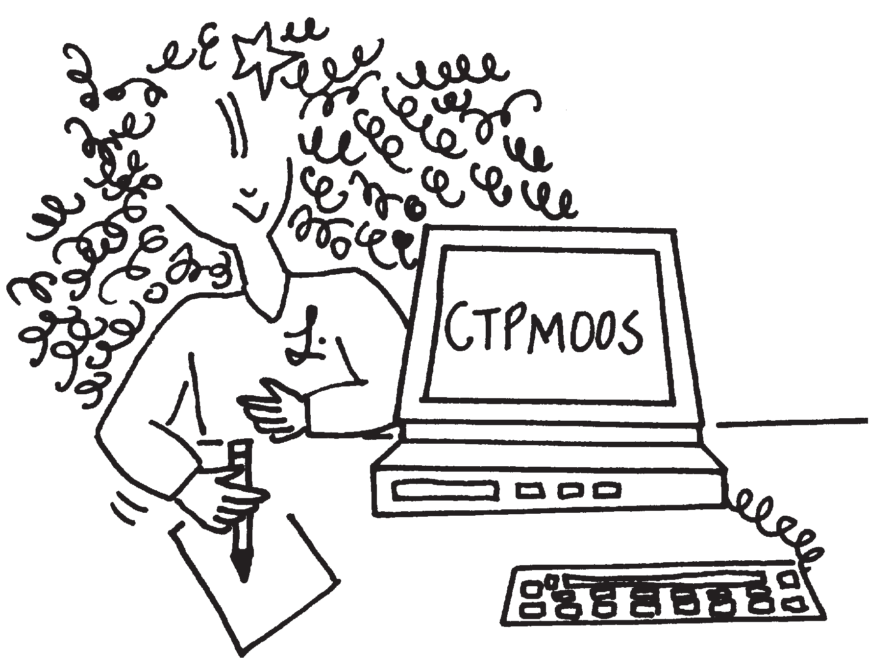
M S TPOO
Helps natural waste in MSW recycle.
C
R
NUB
Burned waste is turned into energy.
B RUY
MSW is buried in a landfill.

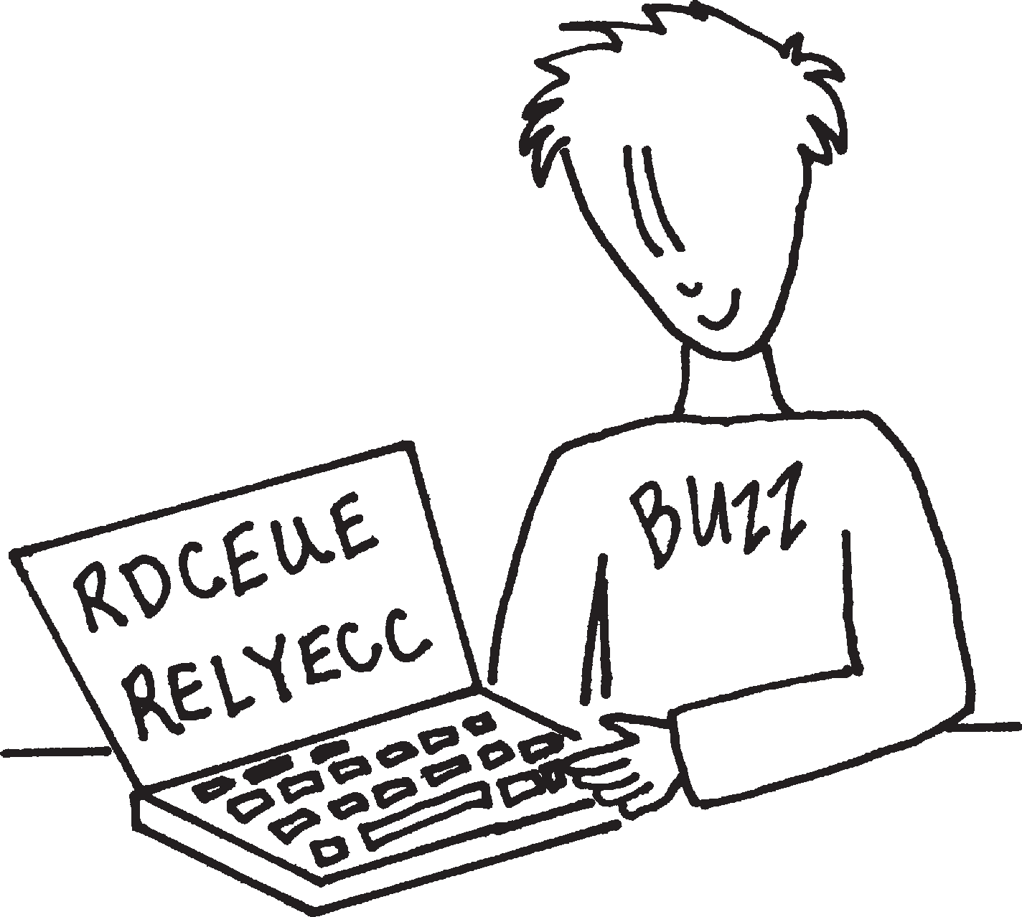R D ECUE
Make less trash.

R C L E YEC
Make it into something new.

Recycling Equation
Collect + Separate + Manufacture + Buy = Recycle
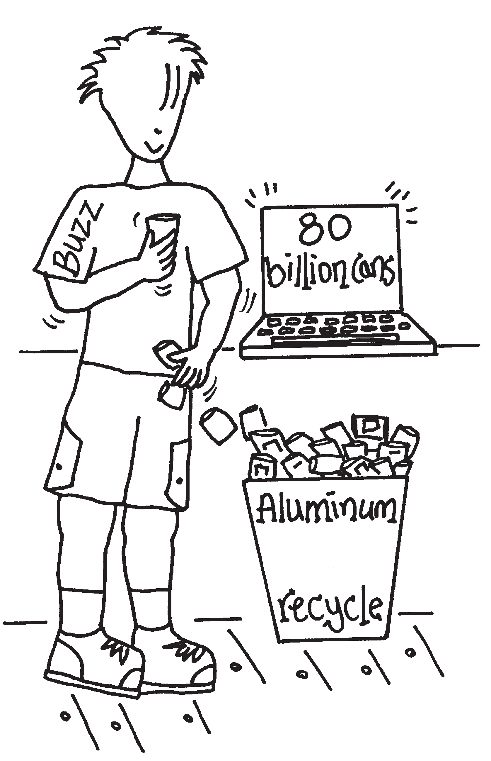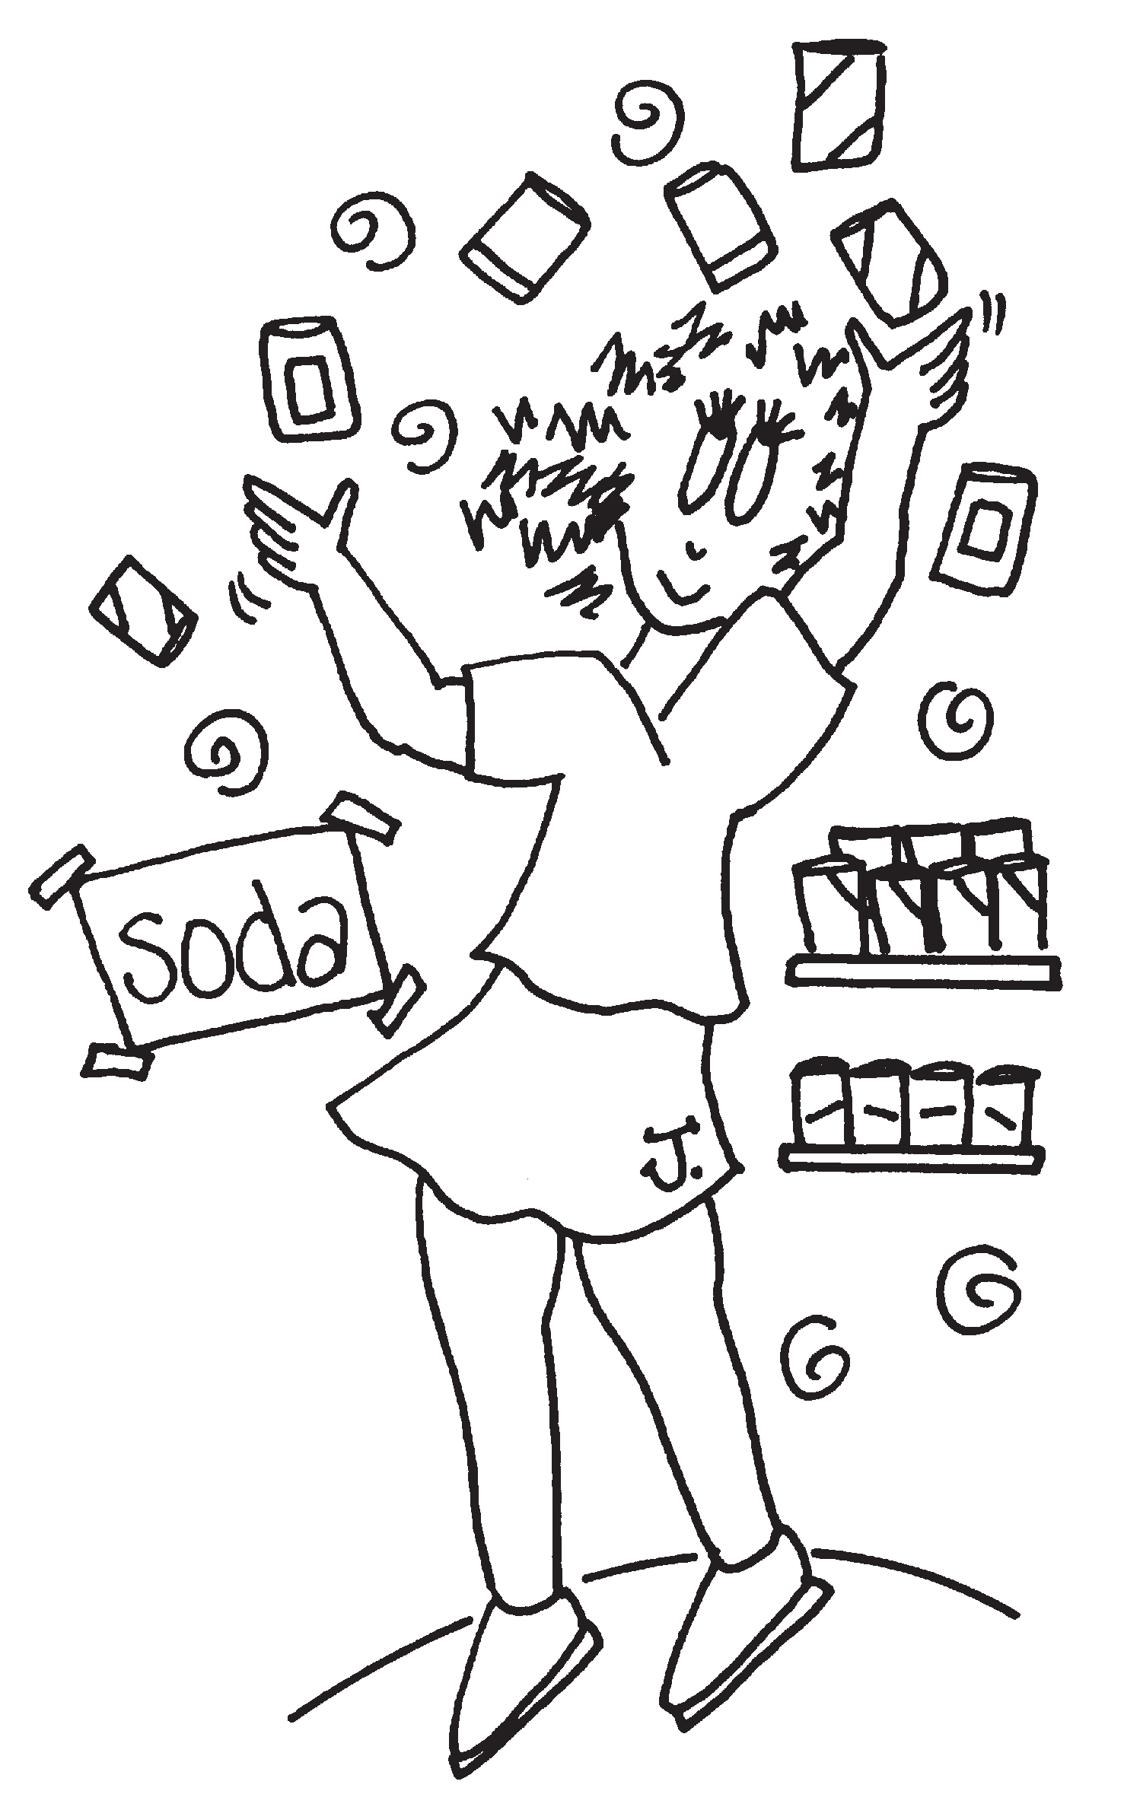
Soda cans are recycled into new soda cans. The cans are sent to factories where they are ground into metal chips, melted down and turned into solid aluminum bars. Bars are rolled into sheets of aluminum and sold to companies to make new cans.

What is Buzz doing to participate in the recycling equation? What can you do to help with the recycling equation?

Buzz’s Word Hunt
Help Buzz find the words. Look across, down and diagnonally.

Recycle Reduce Reuse Glass Aluminum Compost Packaging
Landfill Burn Earth Plastic Paper Cardboard

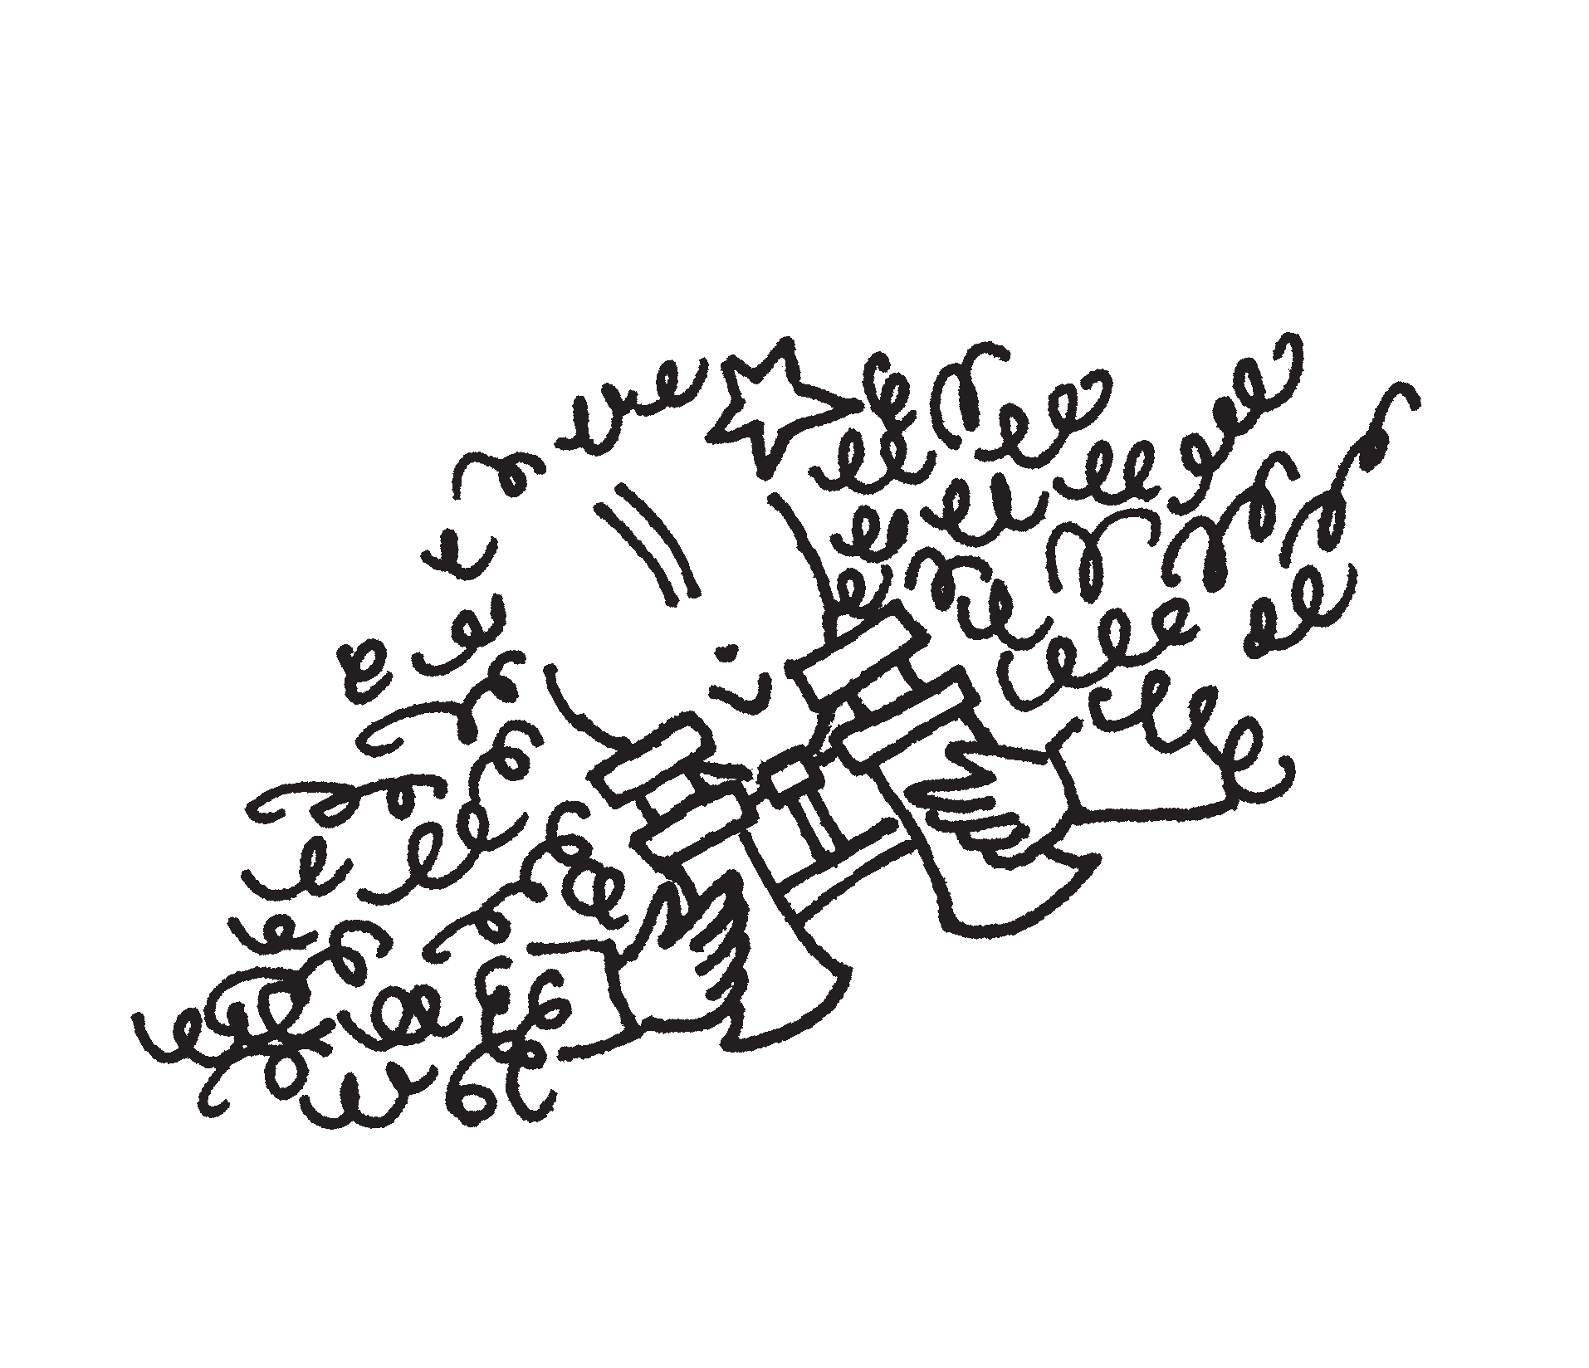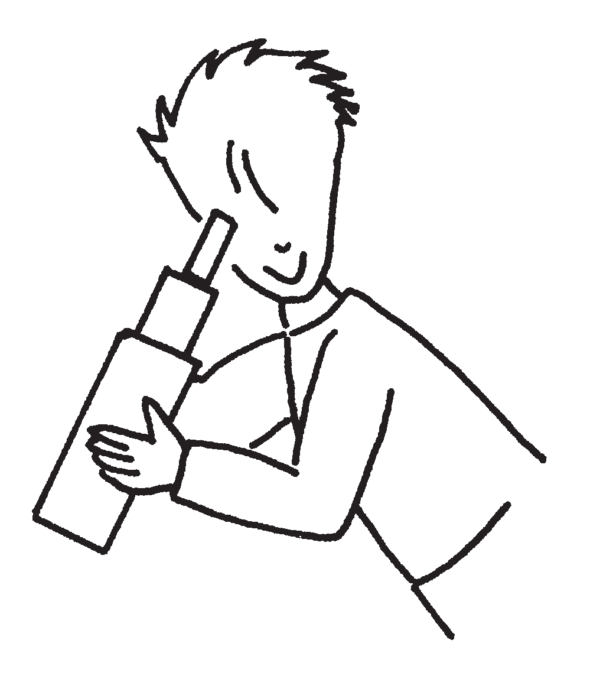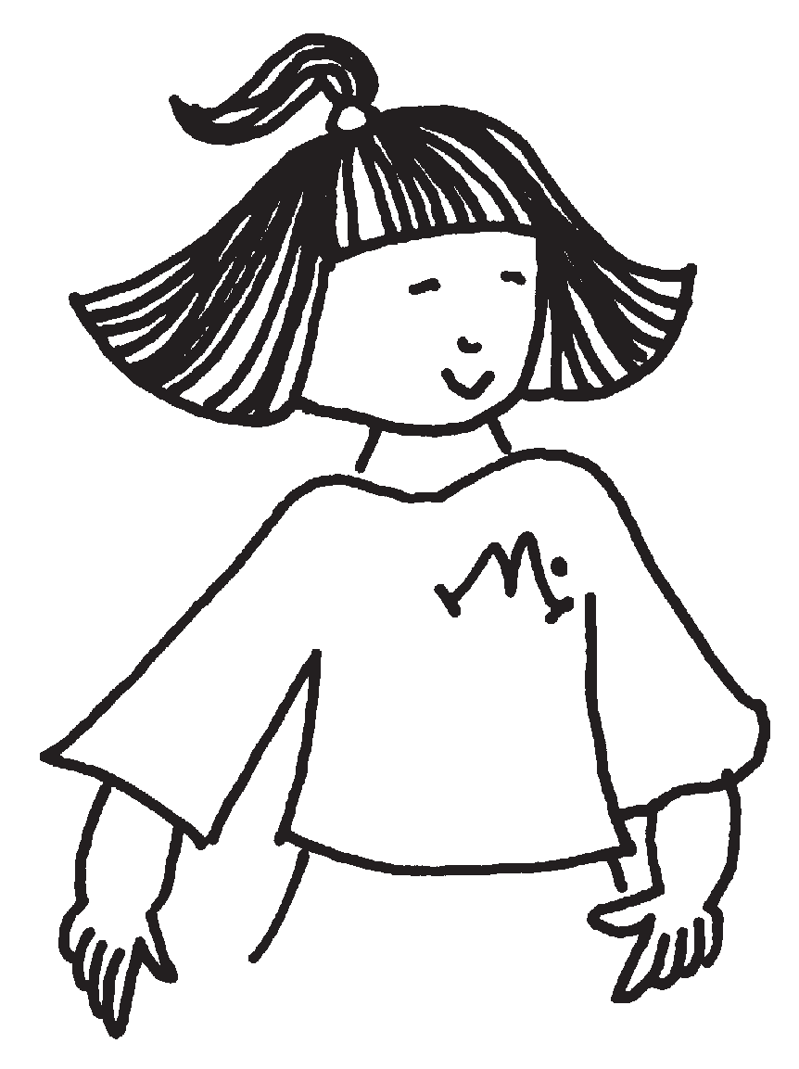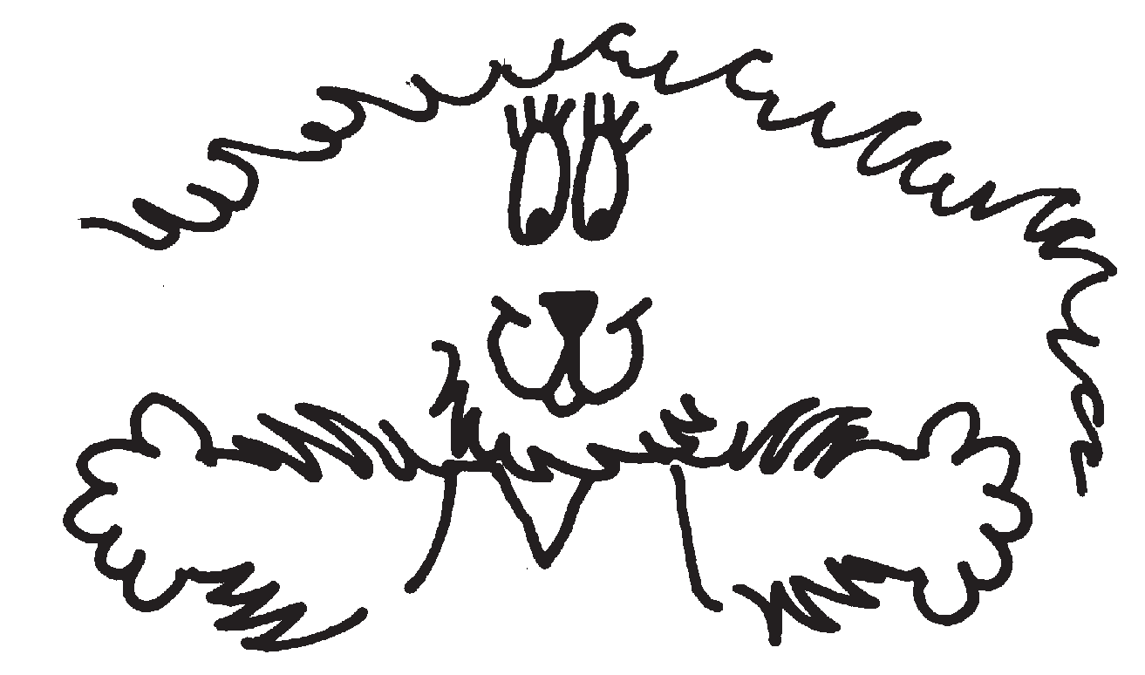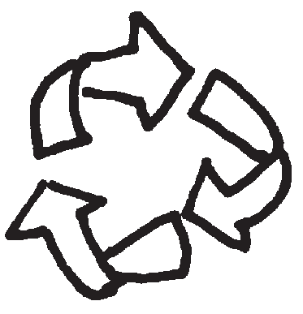

R | E | D | U | C | E | W | P | A | P
L | E | A | R | T | H | R | A | L | A
A | P | C | F | Q | B | E | P | U | C
N | L | O | Y | O | T | U | E | M | K
D | A | M | G | C | G | S | R | I | A
F | S | P | Y | K | L | E | Q | N | G
I | T | O | R | H | A | E | F | U | I
L | I | S | Y | J | S | W | S | M | N
L | C | T | E | O | S | X | O | Y | G
C | A | R | D | B | O | A | R | D | Z

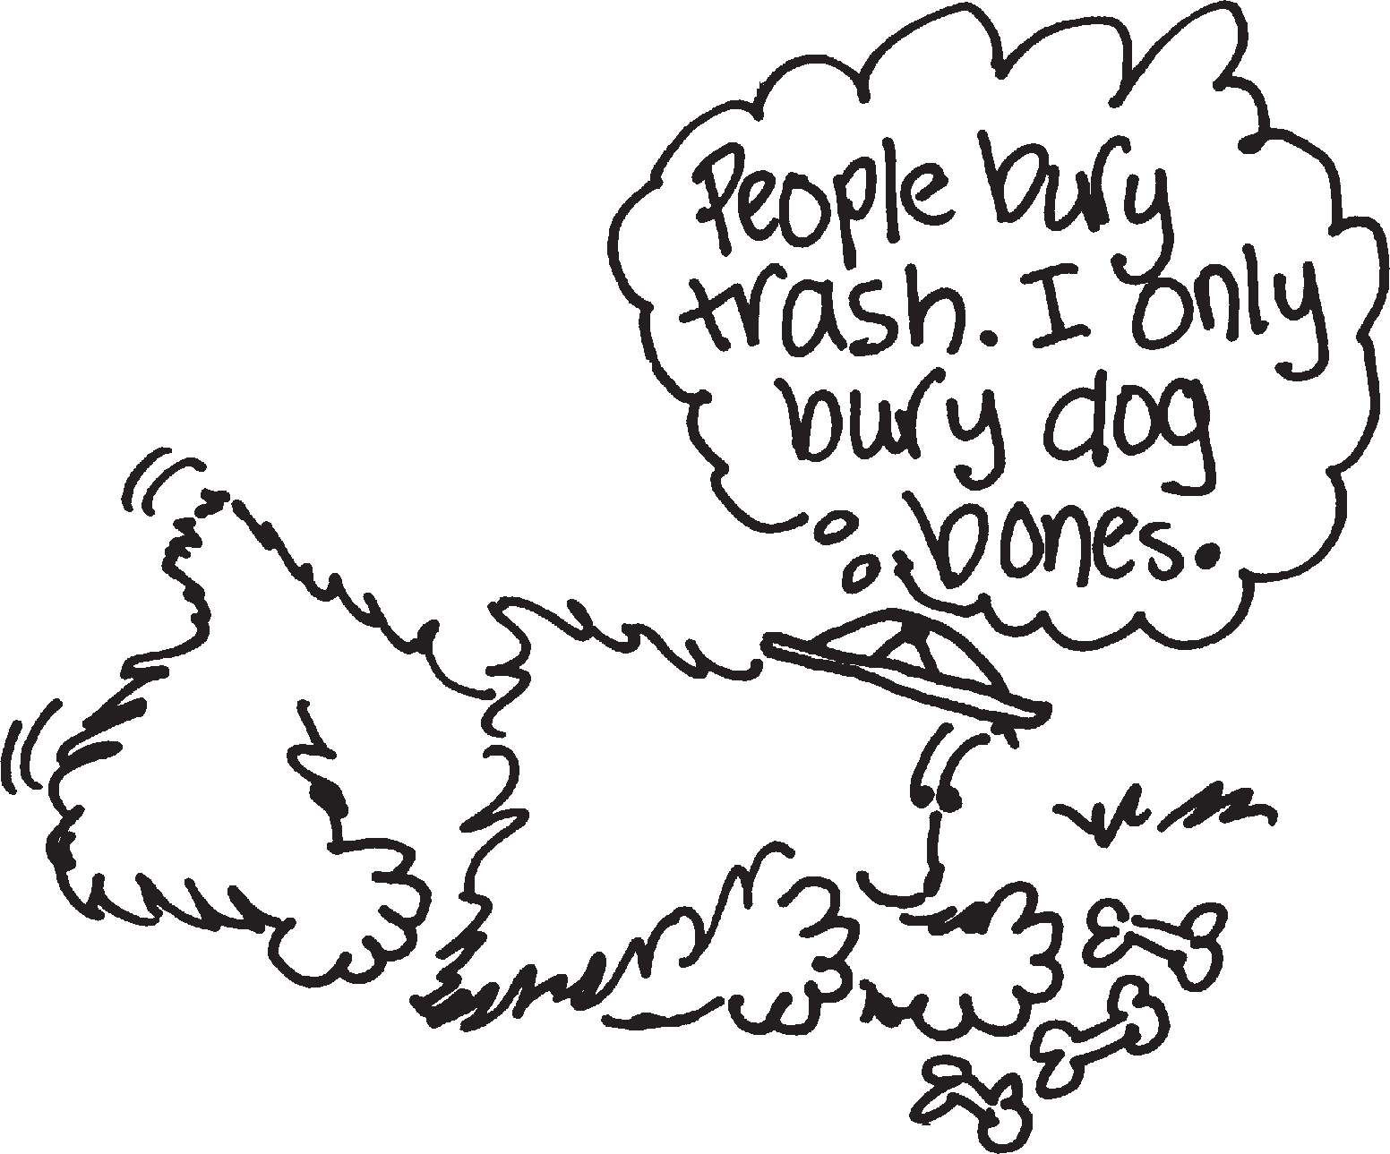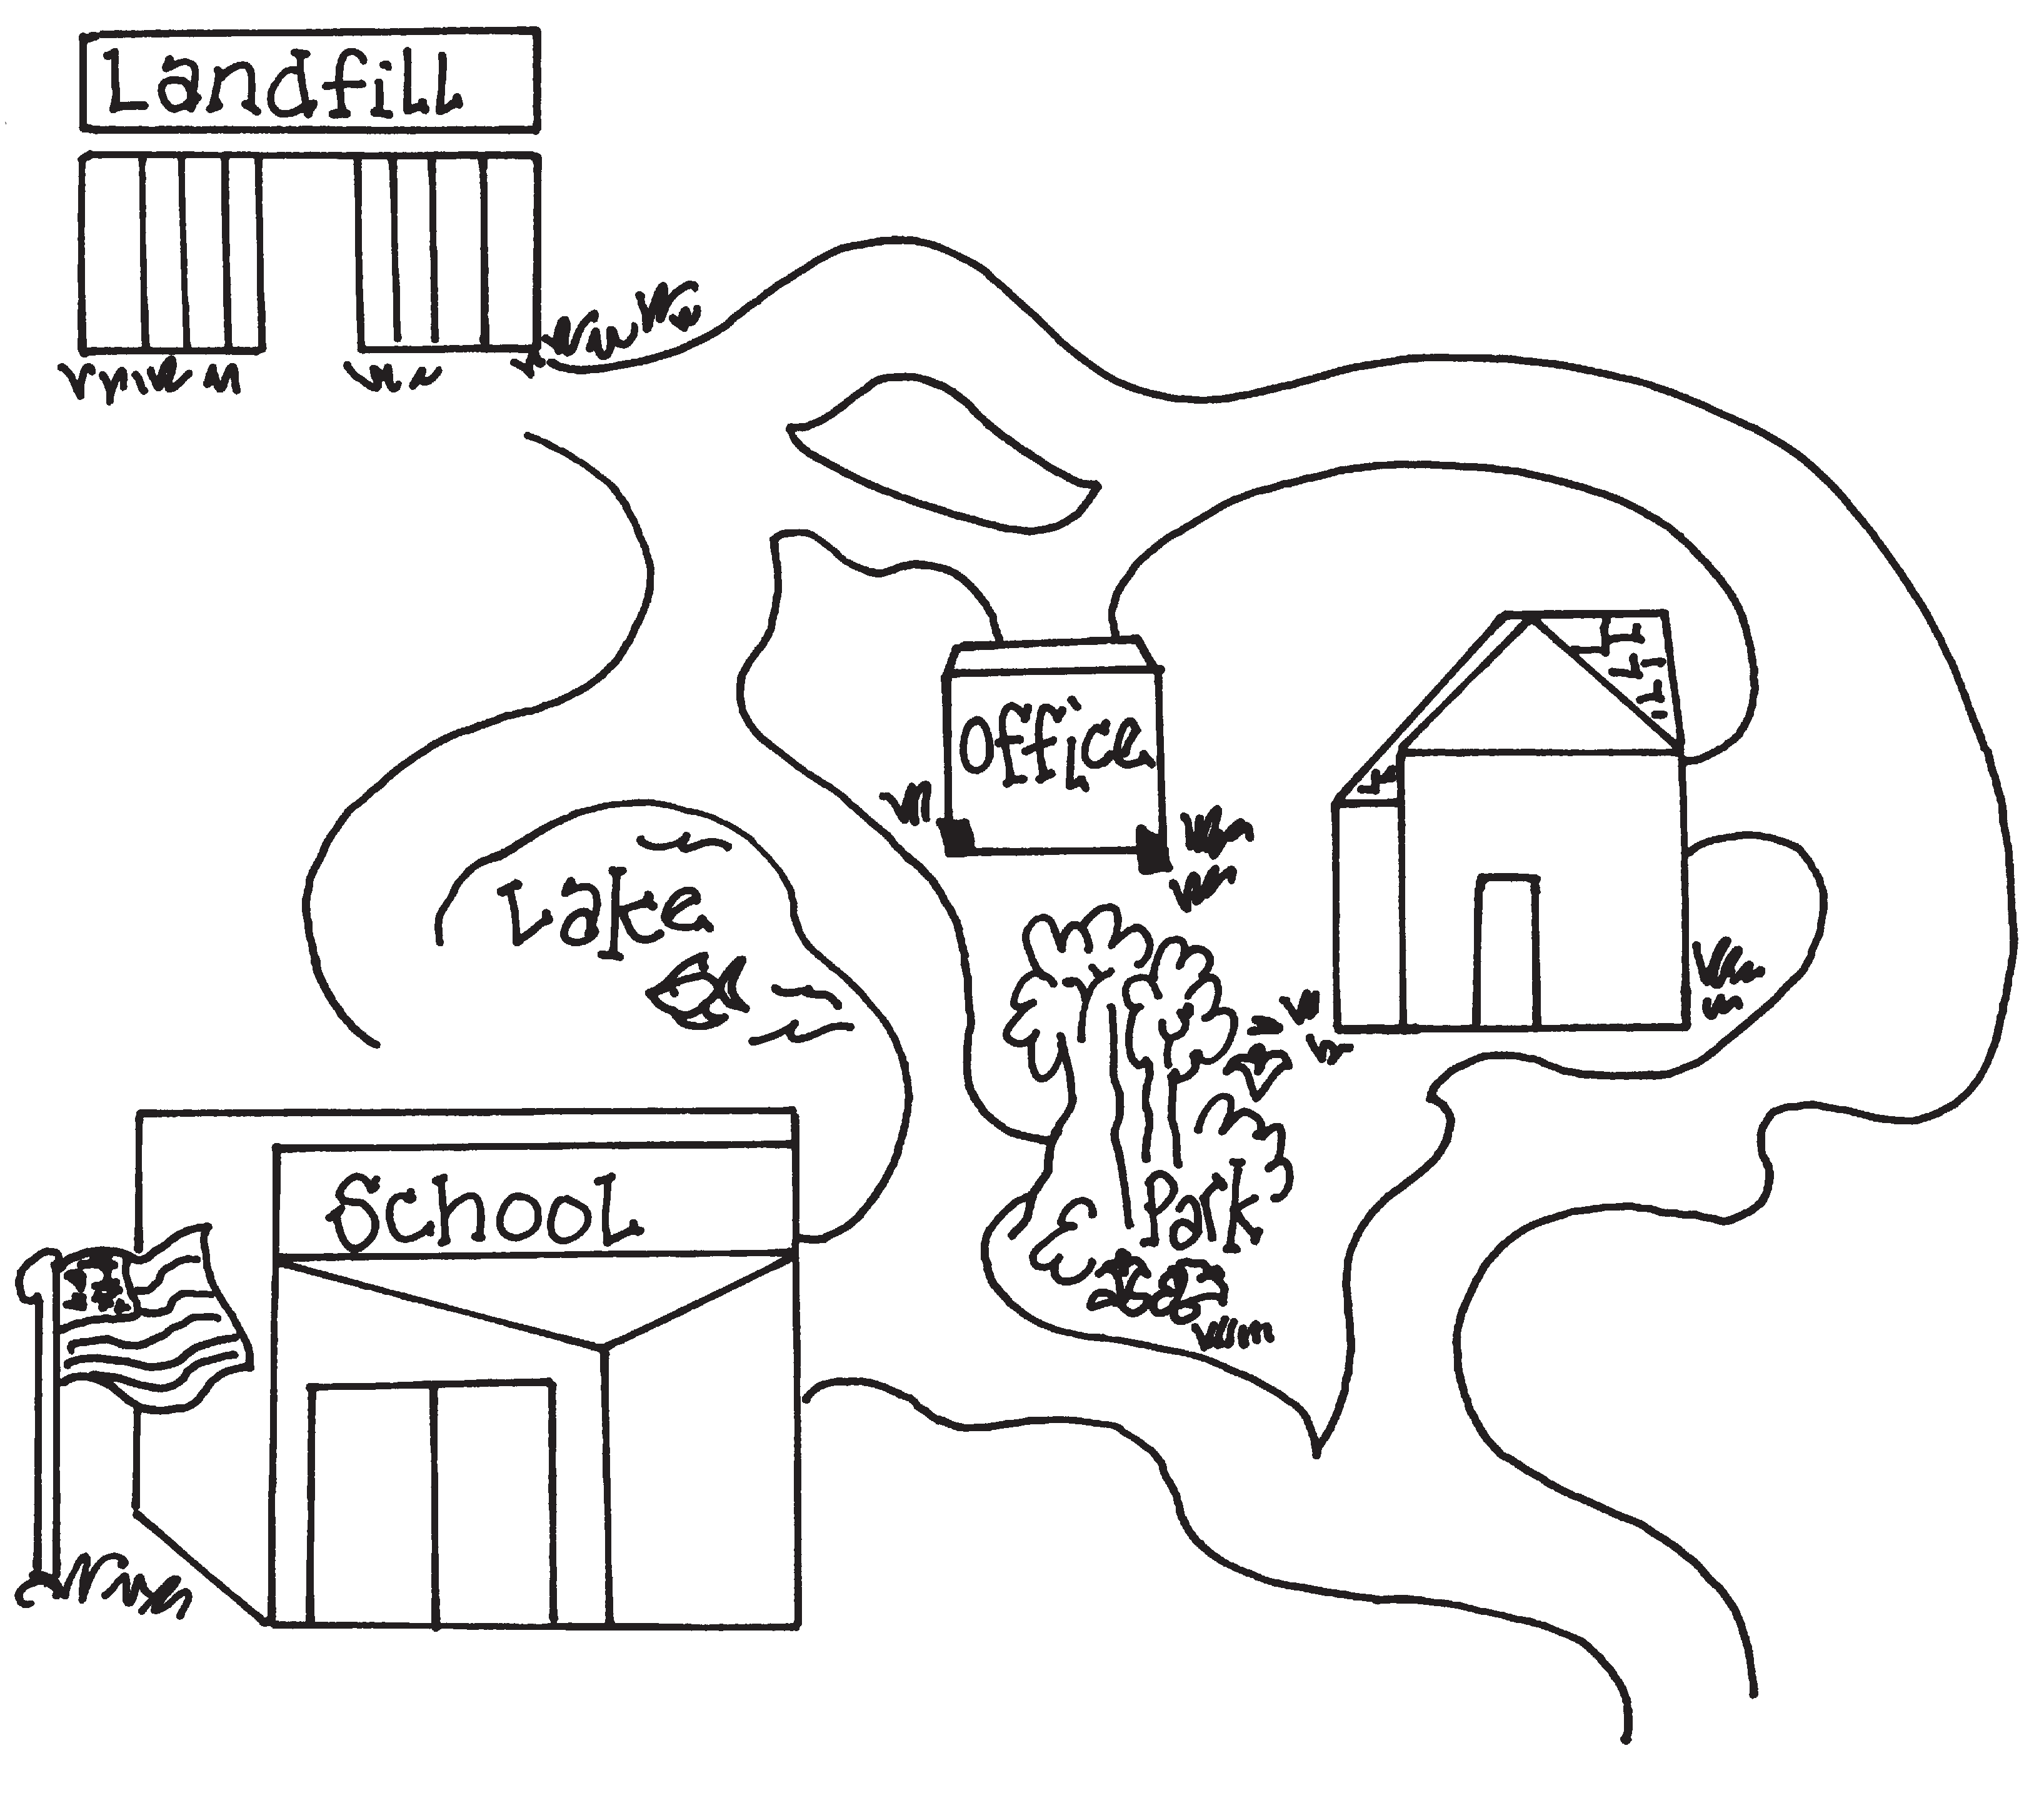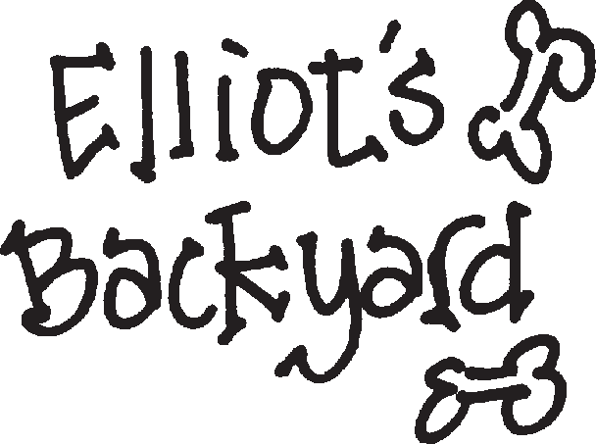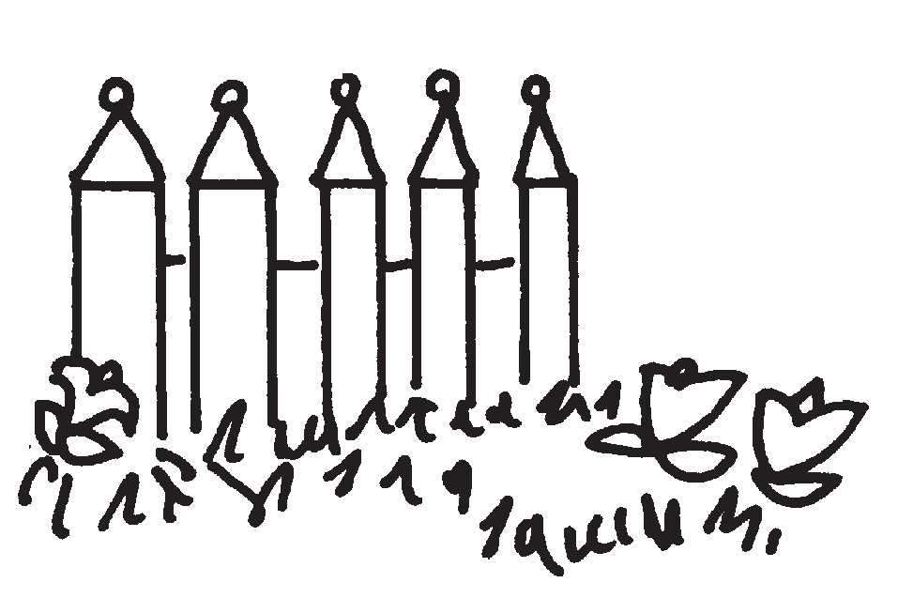Landfills
Lots of trash is buried at landfills. Recycle and help reduce the need for more landfills. Follow the path from the landfill to Elliot’s backyard.

Start

Finish

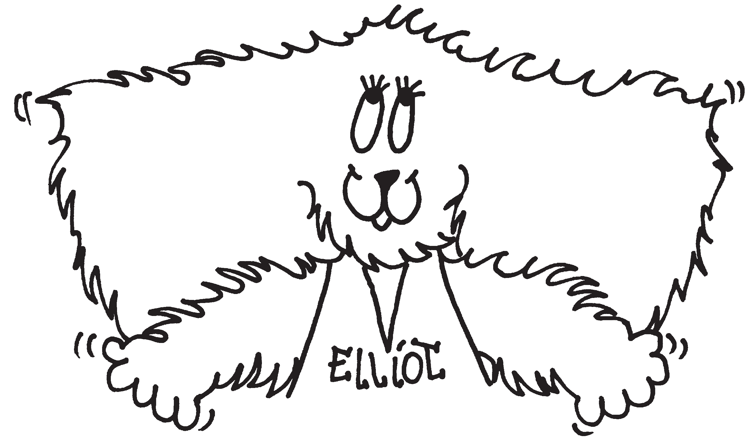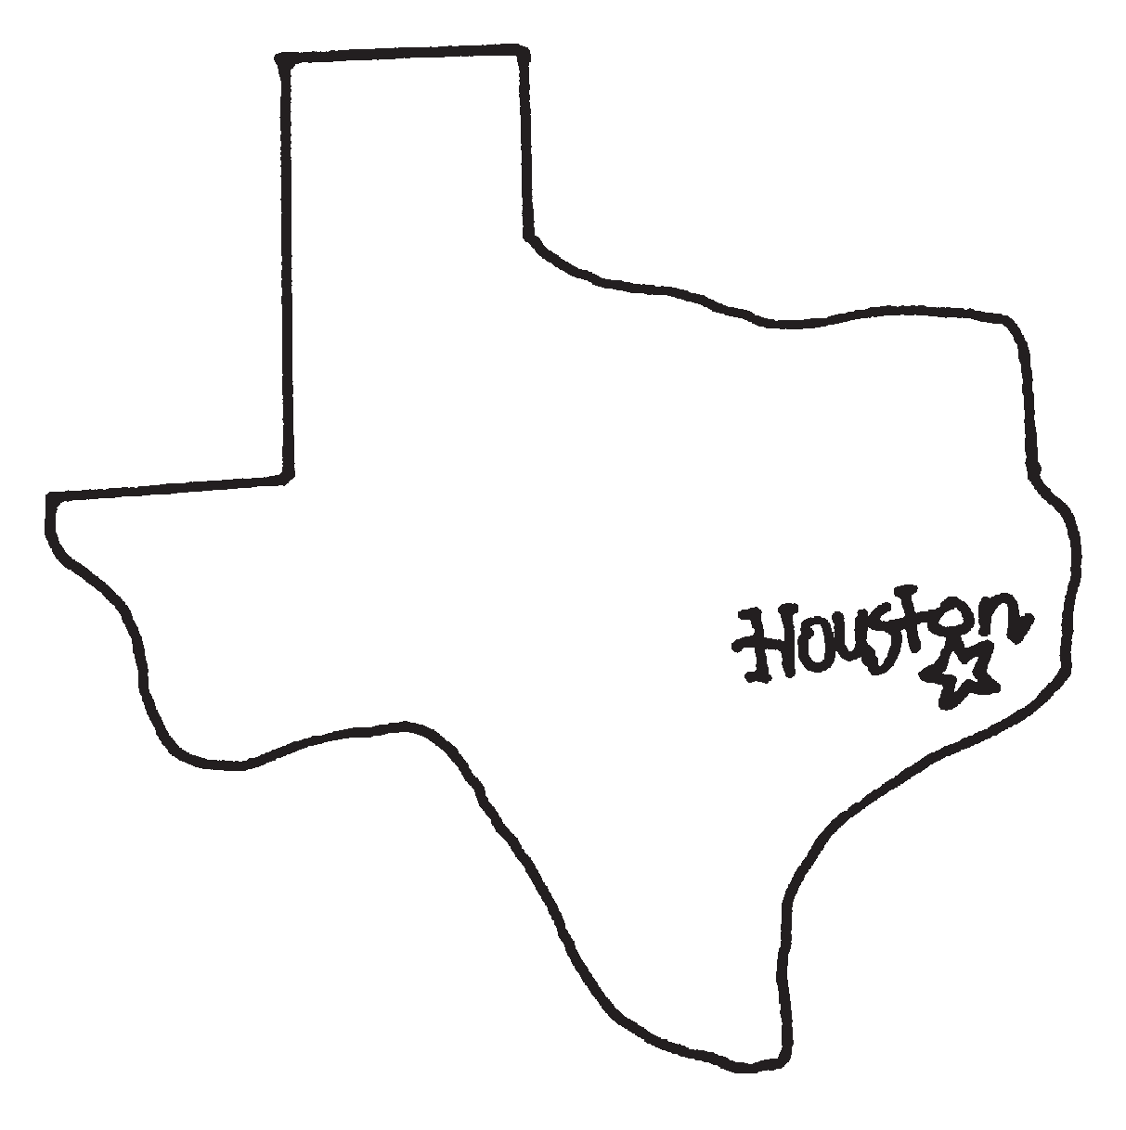Draw a Picture about Recycling

Name of Artist

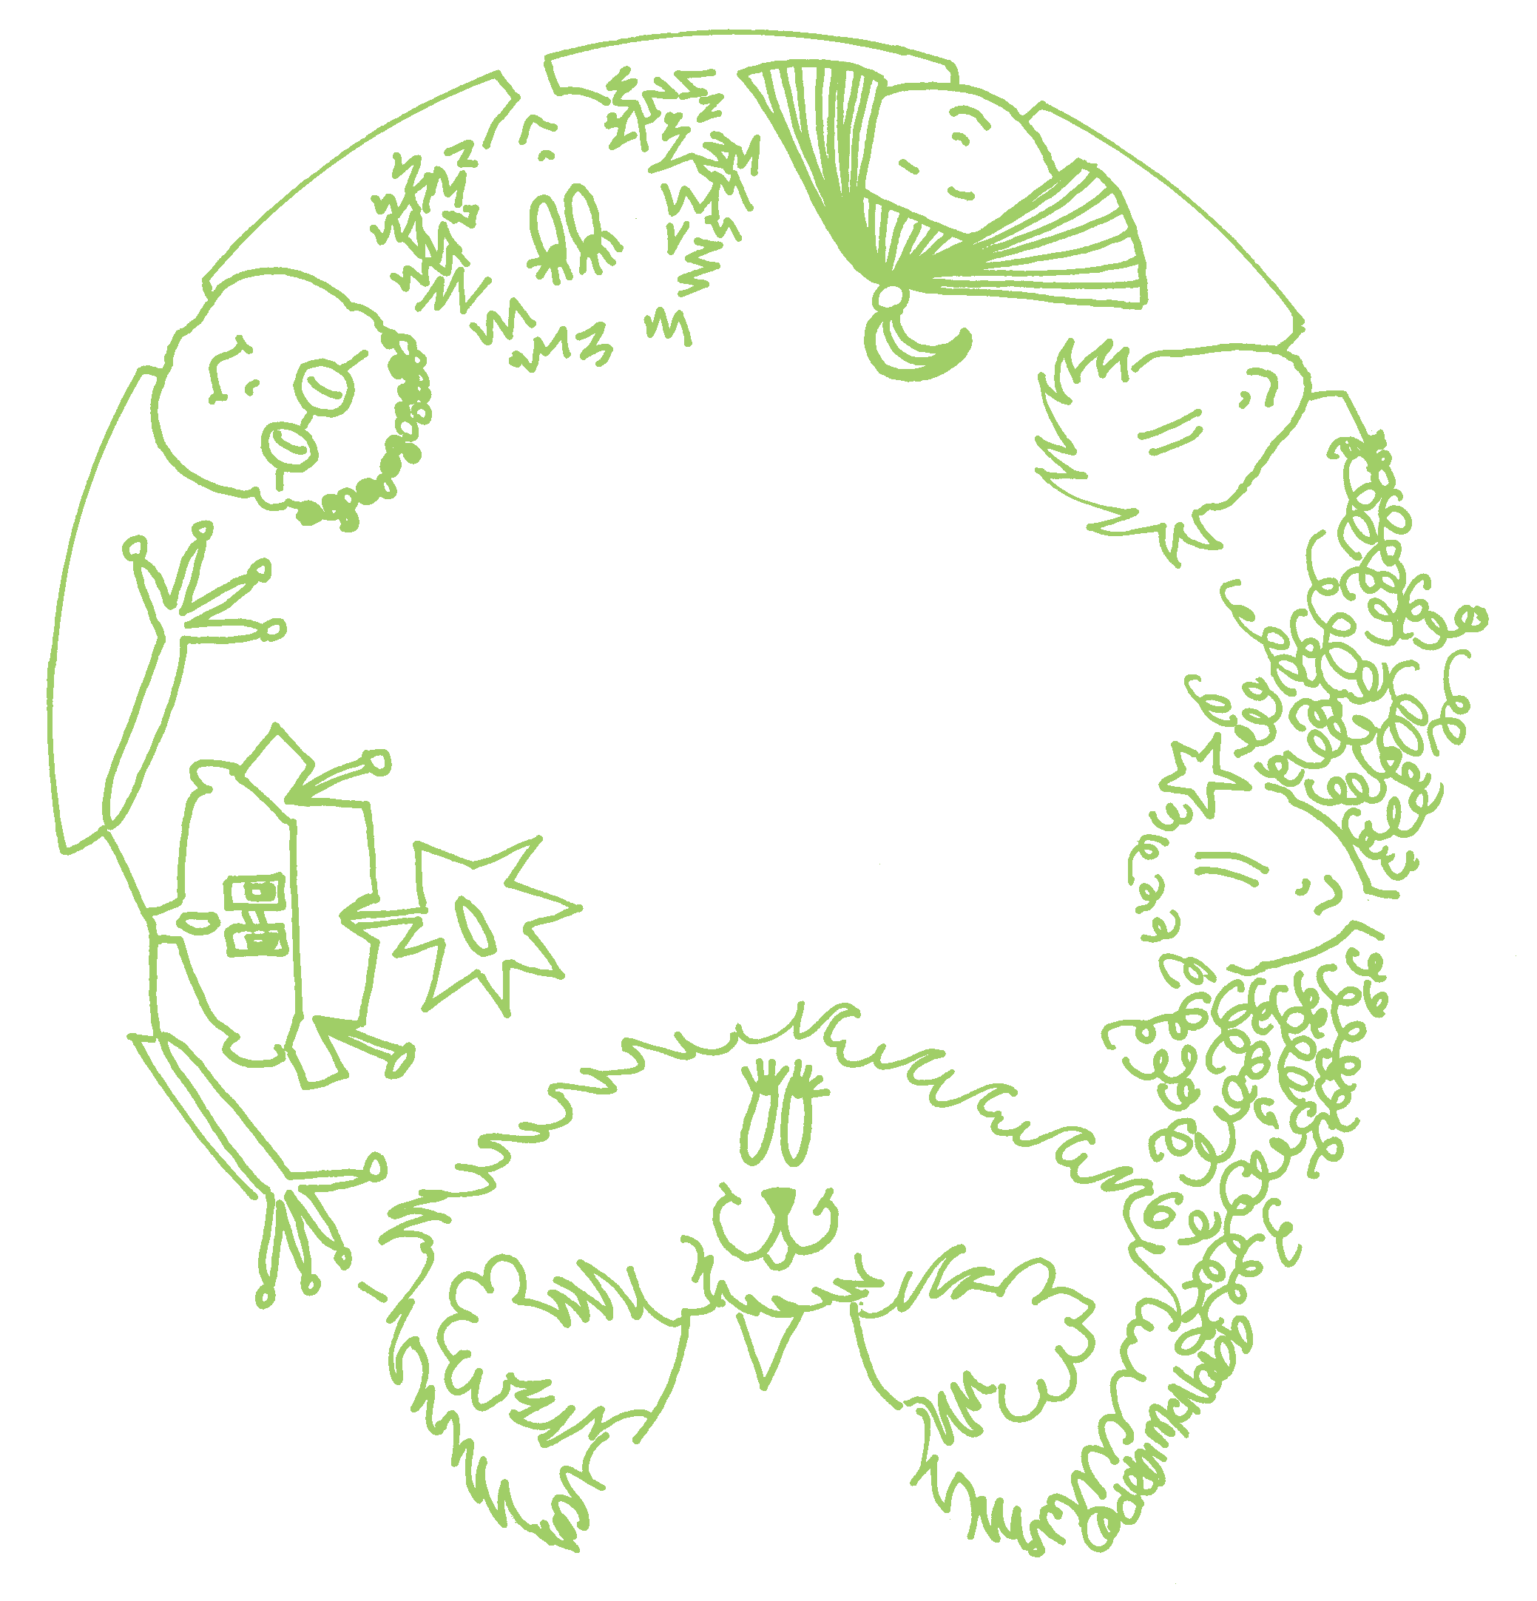www.elliotandfriends.com
Calling
All Kids!

Keep Houston Beautiful
P.O. Box 460648 • Houston, Texas 77056-8648 • 713/839-8855 www.houstonbeautiful.org
William C. Linthicum, Chairman Robin M. Blut, Executive Director

