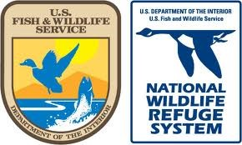

Wetland Survival 101
Grade Level, Teks Science Objective:
Science, Grades K-5, TEKS: 2, 3, 4, 5, 9 & 10

Topic: Wetland habitat and critters that live there
Theme: All creatures are adapted to live best in their environment
Performance Objectives: Name at least one wetland critter, describe a wetland
Materials: Laminated sheets of wetland habitat, wildlife and adaptations, blue, green and brown construction paper, glue sticks, coloring utensils

Introduction: Presenters introduce themselves and the Fish and Wildlife Service/ National Wildlife Refuge system. Explain briefly what a National Wildlife Refuge is, what they can do there, and where they are. Explain how the program works such as holding the sign to talk, having a brief discussion and an activity with a take home, and how we pass the sign around the circle where everyone will give their name and the answer to the day’s question.

Introductory Question: What’s helpful to have when living in Houston?

Transition: What is it called when an animal has a unique feature that helps them survive their environment? An adaptation. All the wildlife that live on a national wildlife refuge have adaptations that help them survive. What are some habitats and adaptations animals might have to help them survive there?

Content: Wetlands are one of the habitats the National Wildlife Refuge System protects., and wetland critters have some particularly cool adaptations. A wetland is where water meets land. (Show pictures of wetlands) It’s a swampy, marshland place where the soil is covered with water all or part of the year. For example, Brazoria NWR is over 44,000 acres of land. For a better reference, one acre is about the size of one football field. There’s all kinds of wildlife and plants that can be found in such a habitat. Wetlands are a type of habitat and animals that live here have lots of cool adaptations to help them live in this unique environment.

Transition: What are some animals that live in wetlands and what are their adaptations?

Content: All types of birds, alligators, turtles, crabs, fish, snakes, frogs, marsh rabbits, and more! All these critters have adaptations that help them live in the wetland habitat.
Alligators have these magnificent feet. (show picture of alligator feet) They have long toes and sharp claws they use to help them dig around in the dirt and mud of the wetland. They have a hard, dark exterior to protect themselves from predators and stay camouflaged. Their powerful tail helps them swim!
What else swims in a wetland? How about ducks! They have special design feet for swimming. (show pic of duck feet) How do duck feet look different from ours? Their webbed and that helps them swim faster. The webbed feet of the duck also make it easier for the duck to walk on the slippery wetland banks and scurry along the water. Some ducks migrate so for such a long journey, their adapted feet are especially important.
What do you know about crabs? (show picture of Blue crab) Where are some places you know crabs live? A wetland! How many legs does a crab have? 6. What do you think a crab eats? They feed on almost anything they can get hold of, including mussels, snails, fish, plants, even smaller blue crabs. How big do you think it is? Large males can reach up to 9 inches. What are some other features about this crab? Color? What about the blue on the claws? Crabs use their claws to gather food and eat, some crabs use their claws to impress the ladies! Crab legs are shaped for movement. How are our legs shaped for our movements? How many legs do we have? Crabs are extremely quick and move very swiftly.

Transition: So why are wetlands important to wildlife and people?

Content: Wetlands provide the four necessities for life: air, food, water, and land/space. Wetlands also act as a filtration system for pollutants, fertilizers, and other chemical wastes, things we definitely don’t want in our drinking water. Wetlands help improve the water quality in rivers and the bay. Wildlife need clean water just like people. These wetlands are fed by rivers from all over Texas and the waters from the bay; also known as a riparian zone. This means that there are rivers or streams close to the wetland that feed the marshy area when it overflows. Better a wetland than your home, right?

Transition: Let’s see what it would be like to be a critter with special wetland adaptations. What was one type of adaptation that a lot of wetland critters had? Special ways to move easily through wetland habitat!

Activity: Wetland Scramble
- Have kids line up on the start line. There are 4 wetlands critters they’ll be imitating. (duck, alligator, frog, and crab)
- Each critter moves in different way in the wetland to get around. Demonstrate all 4 different movements.
- The scramble is conducted in four rounds, each round a different critter and movement. Have kids do the assigned critter for that round from the start line to the other side of the gym/grassy area and then back.
- Repeat this process for the other 3 critters. When finished, compare/contrast the critters/walks. Which one did you think was most difficult?
Note: Rounds can be adjusted for time
Transition: Was it hard to try and move like wetland critters? How are we specially adapted to travel around our environment? Now let’s do a craft and see if we can identify some more adaptations of a blue crab!

Conclusion: What would happen if you had to live in a wetland? Would you be well adapted? Do you think you’d have the best chances of survival? We aren’t well adapted to a wetland, and although they are fun to visit, we would probably have a harder time living in one than these critters do. We are better adapted to live in communities/cities, but the city keeps expanding as more and more people move here. What happens to wetland habitat when the city is expanding? It is decreasing really fast. What happens to the wetland animals when we destroy wetlands? Many of them are dying off because they can’t survive in the city. Loss of wetland habitat is bad for us too though. What benefits do wetlands have to people? They help filter water and protect us from flooding. What can you do? Remember that wetlands are important habitat and should be protected. If you visit a wetland, be sure to be respectful to the land while you are there, for example, don’t litter. We can all help keep our existing wetlands clean.

Craft/Activity: Pape Blue Crab in a wetland
Talk kids through making the craft seen below. Have them write what habitat they can find this critter in. Have them also, label the adaptations this critter has. (Claws, legs, body, color, etc.)

Notes/Helpful Hints:

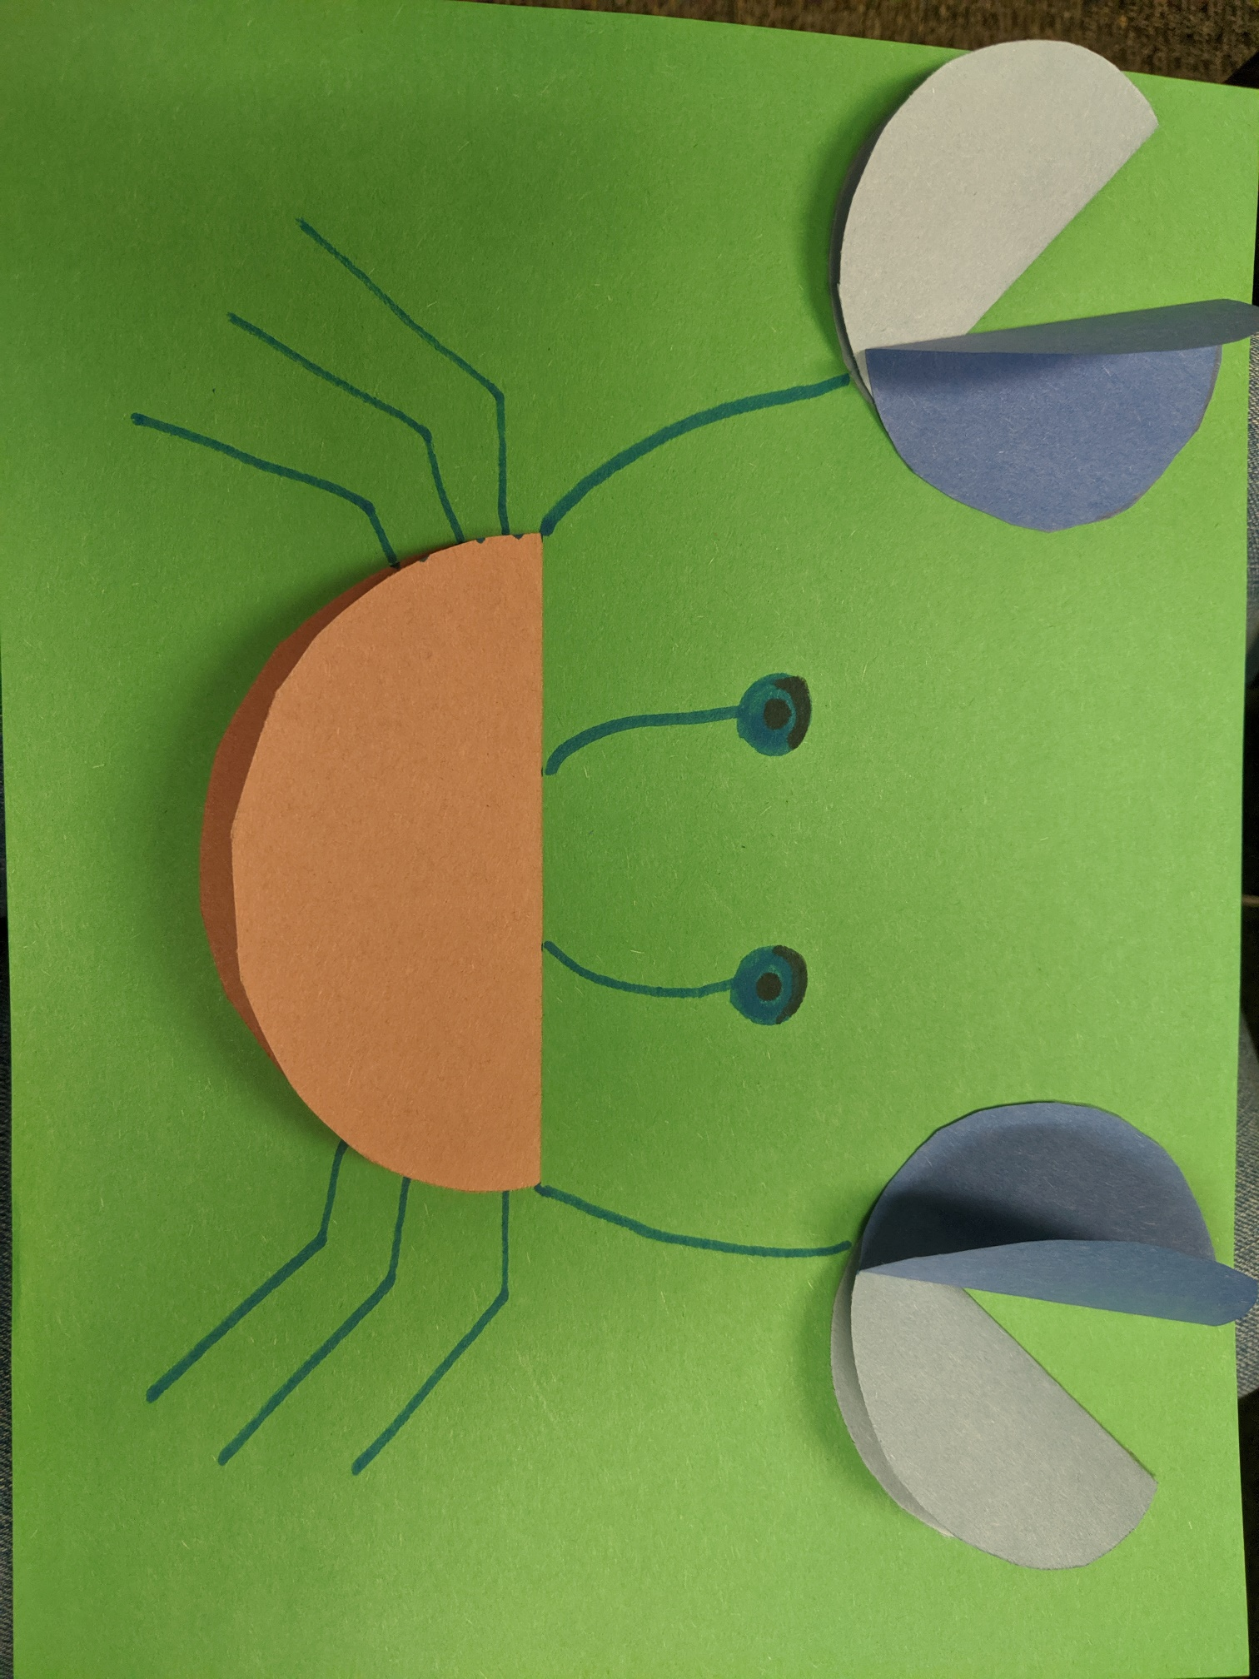
Alligator Feet
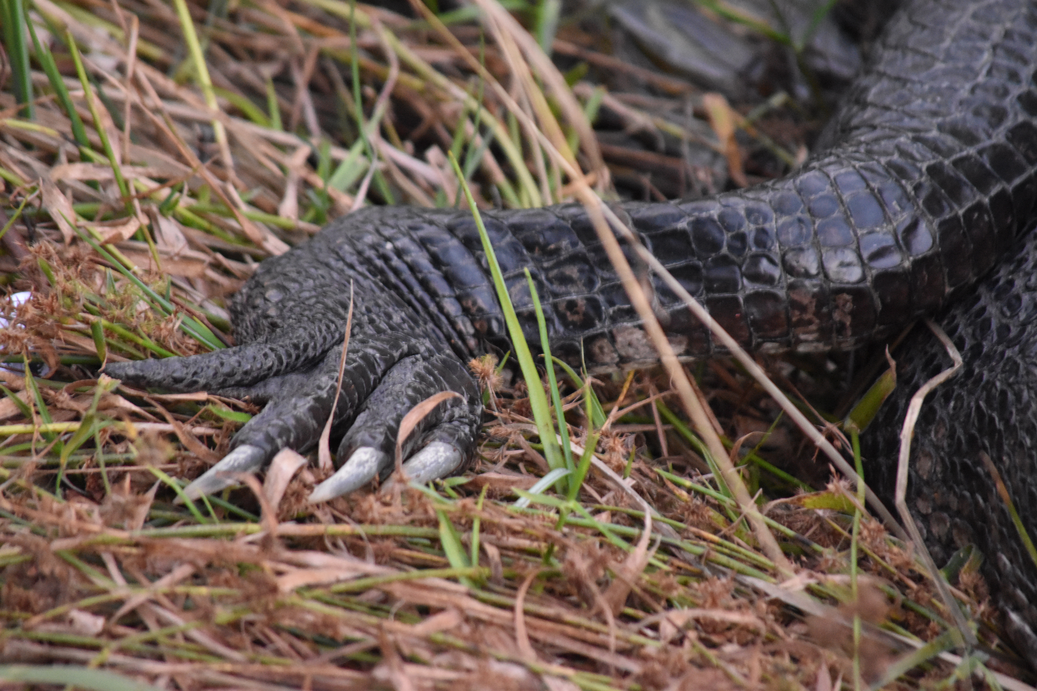Image by FWS/Megan Porter

Duck Feet
Image by Elton Harding/Creative Commons

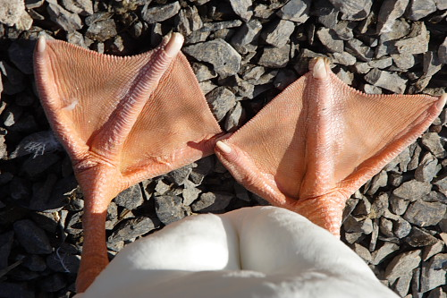

Blue Crab
Image by FWS
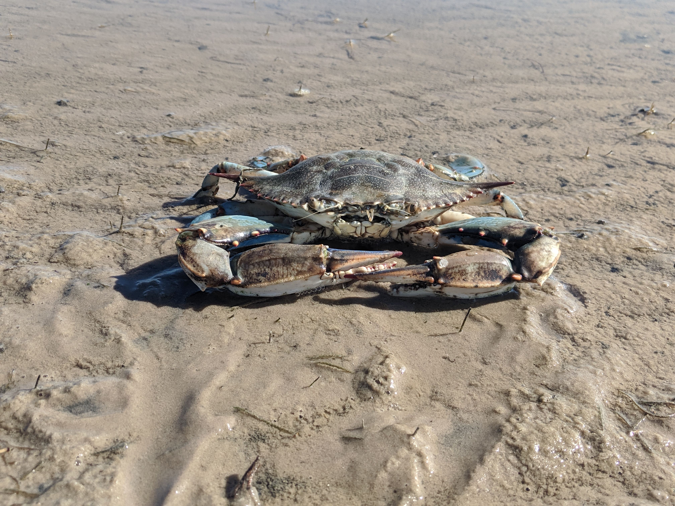

WetlandsImage by FWS/ Norman Welsh