Home Sweet Home
Grade Level TEKS Objectives:
Kinder: 2A-E, 3B, 4B, 5A, 9A&B
Grade 1: 2A-D, 3B, 5A&C, 9A&C, 10A
Grade 2: 2A&D, 3B, 5C&D, 9A&C, 10A
Grade 3: 2F, 3B, 9A, 10A
Grade 4: 2D, 10A
Grade 5: 2D, 9A, 10A
Topic: Different Animal Homes and their Benefits
Theme: Much like the great variety of homes in our own communities, animals in the wild have a wide variety of types of homes that provide them with an array of different benefits and services.
Tangibles: Houses, Building Materials
Intangibles: Home, Community, Safety
Performance Objectives: Know what the FWS/NWR System is and what they do, be able to name three types of homes for wildlife, know the main benefit of a shelter, be able to use critical thinking to make the connection between a type of shelter and why it benefits it’s inhabitant, and understand why different types of animals need different types of homes.
Materials: Take home color/activity sheet, ziploc bags with building materials for homes: nest (sticks and leaves), shell (paper bowl, brown paper, brown and green playdough), Beehive (yellow playdough, straws, pipe cleaners, tape), burrow (paper bowl, toilet paper roll, brown paper bag, sticks, grass)
Introduction: Introduce us and the USFWS and Refuge System. Presenters introduce themselves and the Fish and Wildlife Service/ National Wildlife Refuge system. Explain briefly what a National Wildlife Refuge is, what they can do there, and where they are. Explain how the program works such as holding the sign to talk, having a brief discussion and an activity with a take home, and how we pass the sign around the circle where everyone will give their name and the answer to the day’s question.

Introductory Question: Tell us something that is useful in your house?

Transition: Just like how we all live in different homes with different things, animals live in lots of different types of homes too. What are some different types of animal homes?
Animals live in a diverse variety of homes because they all have specific needs, abilities, and preferences. One of the basic needs for life is: shelter. What are some of the things that an animal might need from their specific shelter? If they don’t know, ask them what some of the things are they get from their home. Mainly protection from predators but examples could also be temperature control, space for babies, and access to food. Animals also need to have access to materials or specific locations in order to have a certain type of shelter. Would it be hard to dig a burrow in a bed of rocks? What about a big stick nest in a grassland? What are some of the materials that animals use to make different types of shelters?
Transition: Would you want everyone to know where you lived?
Just like yours and mine, animal homes are for protection. One of the ways animals can protect their homes is by camouflaging them in their environment. For example, rabbits burrow underground and often times the entrance of the home isn’t detectable. Snakes find homes on the ground under lots of leaf litter or up in tree with lots of branches. Location is a big factor. Not all homes are suitable for any kind of habitat. A song bird’s nest made of leaves and twigs would not do well on a beach. The same way we like to feel safe and secure at home, so do wildlife!
Transition: Do animals live in neighborhoods like us?
It depends! Some animals build their homes in close proximity to other animals like them. During nesting season, many birds nest closely together in places that have lots of resources like water and food. Access to needed resources makes some locations popular “neighborhoods.” Some animals are just inherently community-driven and make homes near each other to greaten their numbers and chances of survival. Smart!
Transition: What do you say we go look around outside here and see what types of animal homes we can find?
Activity: Walk around the outdoor space with the kids and see what types of animal homes you can find. Allow what you find to lead to informal discussions. Some places will be better than others. Common homes to find are spider webs, hives, ant hills, under leaf litter. Might also find a bird nest, a dead tree, a crawfish burrow, a shell, or other.
Craft/Activity: Kids will break off into groups/teams. Each group will pick one mystery bag. Inside each of the bags will be an informational card about a type of shelter and some pictures of examples as well as some materials. Each group will, using the pictures as examples, use the materials in their bag to create that type of shelter. When finished or after a certain amount of time, the whole group will talk about each group’s shelter. Kids in the group have information on their card and will teach the rest of the group about it when finished creating. Would include, for example, what it is made from in the wild, what would use it, and what advantages or disadvantages it has. Number of bags/types of shelter should depend on the number of staff delivering the program. It is good to have the same number of staff members as there are groups so each can help one group. They will probably need guidance with the project.

Take Home: https://www.education.com/worksheet/article/match-the-animal/
Hand out coloring/activity sheets at the end so they have a take home.
Notes: Activity can be difficult and can easily get a little out of hand, therefore it is good to make sure that there are as many staff as there are groups. There is no problem with having only two groups, in fact it works well this way.
Activity bag materials and home types are very open to modification, what we’ve used in the past can always be changed if there are new ideas or to mix up the activity if the kids start to get too familiar with it.
At Clinton Park, use the pocket prairie as part of the nature walk.

Nest
Usually used by birds but many animals build nests including mice, squirrels, and some insects.
Nests can come in many different forms but are most often made from plant matter such as sticks and leaves but can include things such as fur and mud as well.
Nests are a good place to live because they offer protection from predators and the weather. Many nests help to create a warm place for small babies to stay comfortable or for eggs to be incubated (kept warm).
Nests are usually used as a place for animals to raise their babies and are not lived in year long.
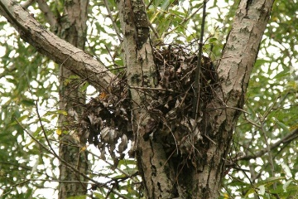
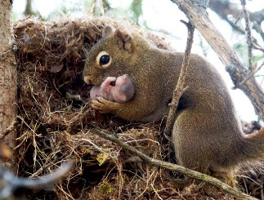
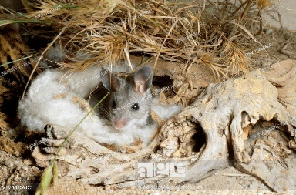
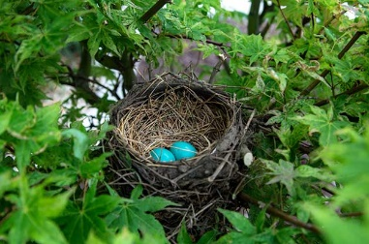
Some nests look like:

Shell
Used by many animals including turtles, snails, hermit crabs, and clams.
Some animals like turtles, have shells as an adaptation to help them survive. Hermit crabs don’t grow their own shells but steal shells of other critters to make a home and protect themselves.
Shells are a good place to live because they are very hard, giving the animal a tough protection against predators and are a great place to hide.
Some shells grow with the animal as it gets bigger like turtles, while other animals must find new, bigger shells as they grow bigger.
Shells are made of different materials depending on the type of animal making it.
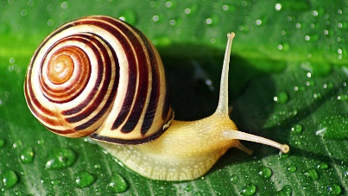
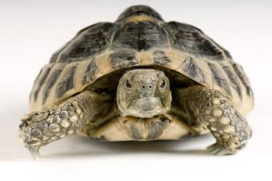
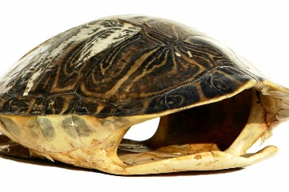
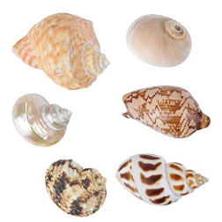
Some shells look like:
Honeycomb/Wasp Nests
Bees and wasps live and work in a really cool structures called honeycombs or paper nests. They’re unique because of their geometric build.
Honeycombs are made of hexagonal wax cells. The comb’s store the queen’s eggs, honey, and pollen. When a cell is filled with honey, worker bees seal the cells with wax and keep building!
Most wasps make nests from paper, but some use mud.
Nests can be found in sheltered areas, such as the eaves of a house, branches of a tree, inside tree cavities and under edges of objects to hide from predators.
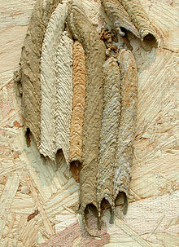
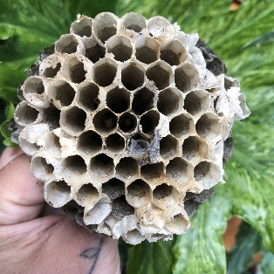
Some nests look like:
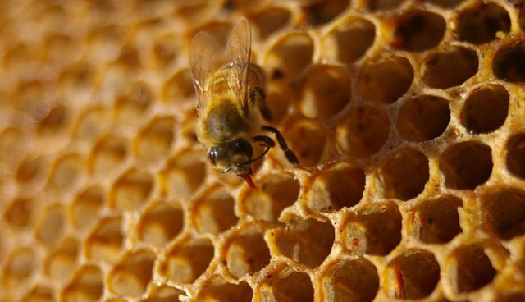

Burrows
Home to many animals including rabbits, burrowing owls, and ground squirrels.
Many burrowing animals are prey. Burrows are a good place for these animals to be safe from predators.
Burrows also provide warm places for animals, especially their babies.
Not all wildlife that use burrows as homes dig their own. Some create homes in existing underground spaces.
Burrows not only serve as a home, but they benefit the environment by promoting healthy soil and encouraging plant growth!
Some burrows look like:
