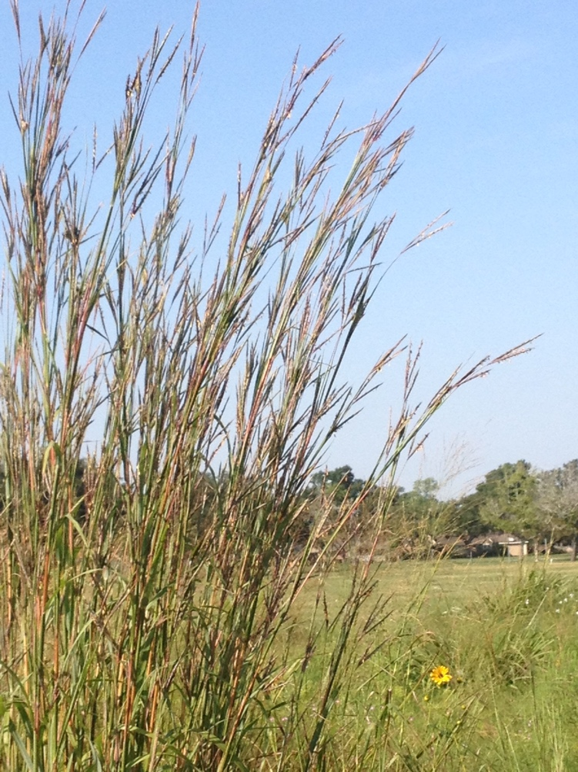
Got Grass?

Introduction

Before the mid- 1800’s about one million acres of native prairie stretched across the Gulf coast from Louisiana to south Texas. (See map in resource section.) Today there is less than 1% of this unique and highly endangered ecosystem remaining.

This lesson will bring students in contact with some of the special grasses that grow on the tall grass prairie remnants remaining in the greater Houston area.
Students will have the opportunity to observe native grasses and plants providing the bases of food webs needed to sustain the native insects populations which play vital roles as pollinators, consumers, predators, and prey in the prairie ecosystem.
Big Bluestem
Early Fall

Go to prairiepartner.org (“Visit a Prairie Today”) to locate a prairie near you, or contact the Katy Prairie Conservancy for field trip information.

Grade Levels: 7th & 8th Grades

Objectives (TEKS in Resource section)
Students will:
- Examine prairie grass structures and use a dichotomous key to identify grasses.
- Observe and describe how a prairie environment supports different varieties of organisms.
- Describe how biodiversity contributes to sustainability of a prairie ecosystem.
- Describe consumer/producer relationships in a prairie ecosystem.
- Investigate how organisms and populations in a prairie ecosystem depend on and may compete for biotic and abiotic factors.
- Describe how organisms respond to external stimuli from the environment.
- Explore how short- and long-term environmental changes affect organisms.
- Use appropriate tools to record information.
- Demonstrate safe practices during a field investigation.
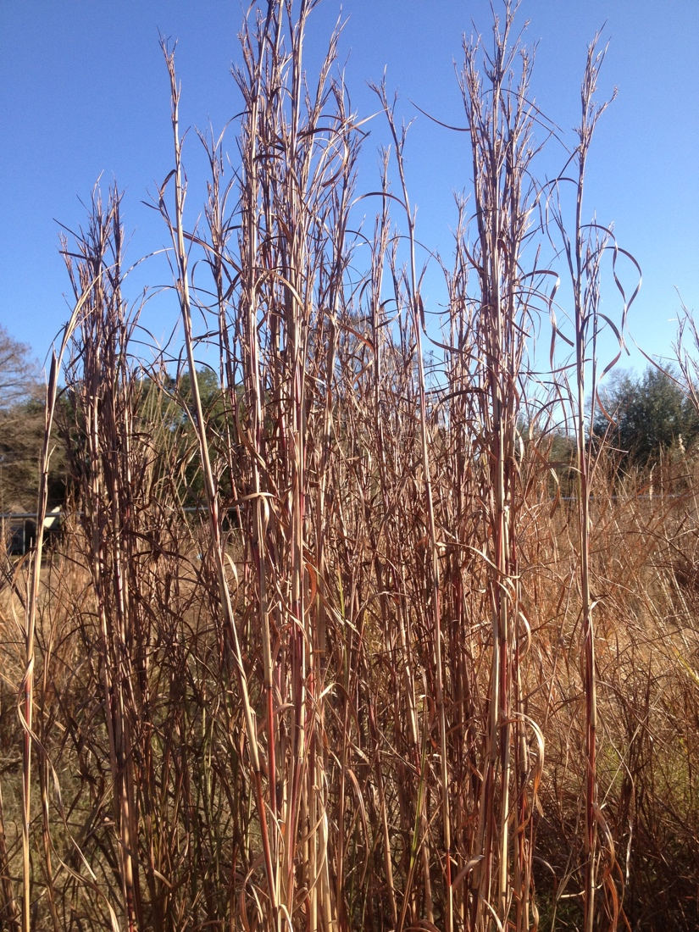
Teacher Preparation

Materials needed

- Quickly cut grass samples on arrival. Place in a mixing bowl
- Scissors for cutting grass
- A paper plate for each group of students
- Student science journals for notes
- Class set of hand lenses
- Poster boards and markers
- Copies for each student of: Dichotomous Grass Key Student Page (A), Grass Diagram/Vocabulary, Student Page (B), Field Work Directions, Student Page (C), and Group Presentation Grading Rubric, Student Page (D) (See Resources.)
- Copies of chapter excerpts from Tallamy’s book, Bringing Nature Home (see Elaborate section) or Library and Internet research

Teacher needs to make copies of all Student Pages and readings for the Elaboration activity.

Engage
Classroom Introduction

It is very Important for the success of the field investigation to help students become familiar with the information they will be using on the field trip.
Give students experience with the Grass Key, Student Page (A), The Grass Parts and Vocabulary, Student Page (B), and the Field Directions, Student Page (C).

Introduction to Grass Studies
Either collect a few samples of grass from the roadside, have students bring in samples, or check out grasses on the school grounds. Give one sample to each cooperative group.

Ask students to look for the structures illustrated in the Grass Parts/Vocabulary Student Page B. Then have students use The Grass Key, Student Page A to identify the grass they are studying.
Have students draw a picture and label the parts of the grass used by the group in their journals.

When students finish have each group share their results with the class pointing out the different structures and the identifying characteristics. Have students verify each group’s results.

Students should glue/tape their keys and field directions into their journals. Go over the field directions with students during your introductory activities and then again right before the field trip.

Biodiversity on the School Grounds
Have students work together in pairs or small groups to count species of plants and insects on the school grounds. Set up meter squares or use hula hoops to set up areas for each group to conduct their counts in a variety of places around the school grounds including flower beds, lawns, open areas, sites near the building and as far away from the building as possible on the school grounds. Students should count the number of different types of plants and insects in their assigned area.

Conduct a class discussion to compare results of the different groups.
- Did populations vary in different parts of the school grounds?
- Which areas seemed to be more diverse?
- What factors seemed to affect the number of plants and insects found in any of the areas?
- Were areas closer to the building or farther away from the building more diverse?

Introduction to Effects of Humans on Prairie Ecosystems
Look at the map of the Historical Range of Coastal Prairie Ecosystems of Texas. Have students discuss how much of this area still exists and some of the changes that have occurred in the last 50-100 years in the area.
- What caused the changes in the amount of prairie that is still able to exist?
- Is there any way that these changes could have been completely avoided?
- What kinds of actions could be taken today to improve the ecosystem for native prairie plants?

Field Introduction: Salad Anyone?

Toss pieces of cut mixed grasses around in the bowl, as though mixing a salad. Then serve each group a portion of grasses on a paper plate.
Have a 3-4 minute class discussion brainstorming questions about the grasses. Remind students that brainstorming means no discussion or answering questions. They should only contribute questions.

Example Questions Students Might Ask:
• What organisms eat grass?
• How can you tell if a grass has been eaten?
• Do all grasses have the same structure?
• If not, how are the alike? How are they different?
• How do grasses spread?
• What organisms live in grassy areas.

Have students record questions that they develop and work as a group to pick at least three questions to investigate at the prairie field trip or in the Elaborate section of the lesson.

Explore
Name that Grass!

Time considerations
(Allow 45 -60 minutes for exploration.)

Students will work in pairs using the Grass Identification Key (Student Page A) and the Diagram of Grass Parts (Student Page B) to identify as many grasses as time permits.

Students will complete the observations and journal work as assigned in the Student Field Work (Student Page C) directions.

Explain
So What’s With All this Grass?

Gather students for a discussion. Divide students into small groups and have them share their observations about the microhabitats, species diversity, relationships among grasses and other organisms (producer/consumer, competition, etc), and biotic and abiotic factors.
Allow students to provide explanations based on their observations and inferences.

Ask students to include the following questions in their discussion and write their ideas in their journals.

1) How do the structures of the grass show that it is adapted to its environment?
2) Why is so much emphasis placed on the planting of native plants not only in the
prairie, but in our yards as well?
3) How do the grasses seem to compete for abiotic factors, and how are they affected
by biotic factors in the prairie?
4) Why is prairie restoration and conservation important to our ecosystem and planet?
5) How do native prairies contribute to biodiversity?
6) Why is biodiversity important?
7) What is sustainability?
8) How does biodiversity contribute to sustainability?

Have groups share their ideas with the class.

Elaborate
Bringing Nature Home

Classroom Follow-up to Prairie Field Trip
Choose either of the following activities:
(A) Readings from Douglas Tallamy’s book, Bringing Nature Home, or
(B) Have groups of students conduct library and Internet research on biodiversity, native plants, and insects.

- Readings from Bringing Nature Home by Douglas Tallamy
Prepare readings before class
Buy or borrow the Tallamy book and make multiple copies of the pages from the chapters listed below. Depending on the reading abilities of your students and the amount of reading time available, assign a whole chapter to be read or parts of the chapter to different students so that all the material content is read.

Chapter 4, “Who cares about biodiversity?”
Chapter 5, “Why can’t insects eat alien plants?
Chapter 6, “What is native and what is not?”

- Assign each student to silently read one (or part of one) of the excerpts from Douglas Tallamy’s book, Bringing Nature Home.

2) After the reading time, assign students to gather in groups to discuss/share what
they read. Be sure that every group has students that have read each of the chapters . This will ensure that all three chapters are included in the discussion and all class members are exposed to all the information.

Allow time for students to share what they have learned from the readings from Tallamy’s book.

- Each group of students will make a poster presentation based on their
understanding gained from the Tallamy readings; the assigned topic will be the same for each group Provide each student with a copy of the Group Presentations Grading Rubric (D),
and briefly explain the rubri

(B) Alternate Activity– Research Projects
Assign each group of students to conduct libarary and Internet research on one of these topics:
1) Biodiversity
What is biodiversity?
What factors contribute to biodiversity?
How is biodiversity measured?
How does a native prairie contribute to biodiversity?
- Native Plants
What is a “native” plant?
Why is it important to plant native plants?
What are the benefits of native plants to other organisms?
Why do we want to discourage planting “exotic” plant species?
- Insects
What insects are found in a native prairie?
How do insects contribute to the biodiversity of a habitat?
Why is a native prairie important to insects?
What are some organisms in a native prairie food web?

Have all groups assigned to one topic work together to present their topic to the class. They might divide the questions up and each present what they learned about the question or they might work in pairs to discuss each questionl Other groups should take notes on each presentation.

Or you could jigsaw the students into new small groups of 3 or 6 students in which every group has one or two students who researched each topic. All students should take notes and be responsible for all of the information. Students will use the information they learned to create the posters below.

The topic they research does not necessarily have to be the one that they use to make their posters. You could have students draw straws or pop-cycle sticks with the names of the topics on them, or assign a card to each topic and have students draw cards. Example: All Aces will indicate Native Plants, all Diamonds indicate Biodiversity and all Hearts indicate Insects. In this manner, all students are held responsible for all topics. Students can choose to work independently or work with 2 or 3 other people with the same topic.

Poster assignment:
Ask students to synthesize the information about biodiversity, insects, and native plants to:
Create a poster to inform and encourage youth (and adults) to participate in activities that promote conservation and restoration of prairies and neighborhoods.

Give each student a copy of the Poster Presentation Rubric, Student Page D before they begin their work and have them fill in the top of the sheet. Rubrics of each group can be clipped together, top rubric graded, and information transferred to other group members’ rubrics when time permits. This way every student has a graded rubric to take home.

Evaluate
Conservation Posters

Have each group present their posters.

After the presentations, the class can evaluate which poster(s) made them feel most prompted to take action to preserve or restore prairies or neighborhoods.

What was it about these posters that made them most effective?

The posters could then be hung in the hall, and later given to the Katy Prairie Conservancy or another organization to display.

Assessment of Students:

Grading Rubric for Poster Presentations (Student Page (D)
Field Work in Student Journals

Resources

Brown, Lauren. Grasses, an Identification Guide. 1979. New York: Houghton Mifflin
Company.

Coastal Prairie Partnership, www.prairiepartner.org.
Check out this website for basic and advanced information on the coastal prairie.
Lots of photos, videos, and publications.

Gould, Frank W. Common Texas Grasses, An Illustrated Guide. 1978. College
Station: Texas A & M University Press.

Katy Prairie Conservancy. Conservation Education Director - Jaime Gonzales -
jgonzalez@katyprairie.org

Pasture and Range Plants. 1963. Oklahoma; Philips Petroleum Company.

Shaw, Robert B. Guide to Texas Grasses. 2012. College Station: Texas A & M
University Press.

Tallamy, Douglas W. 2007. Bringing Nature Home. Portland: Timber Press.

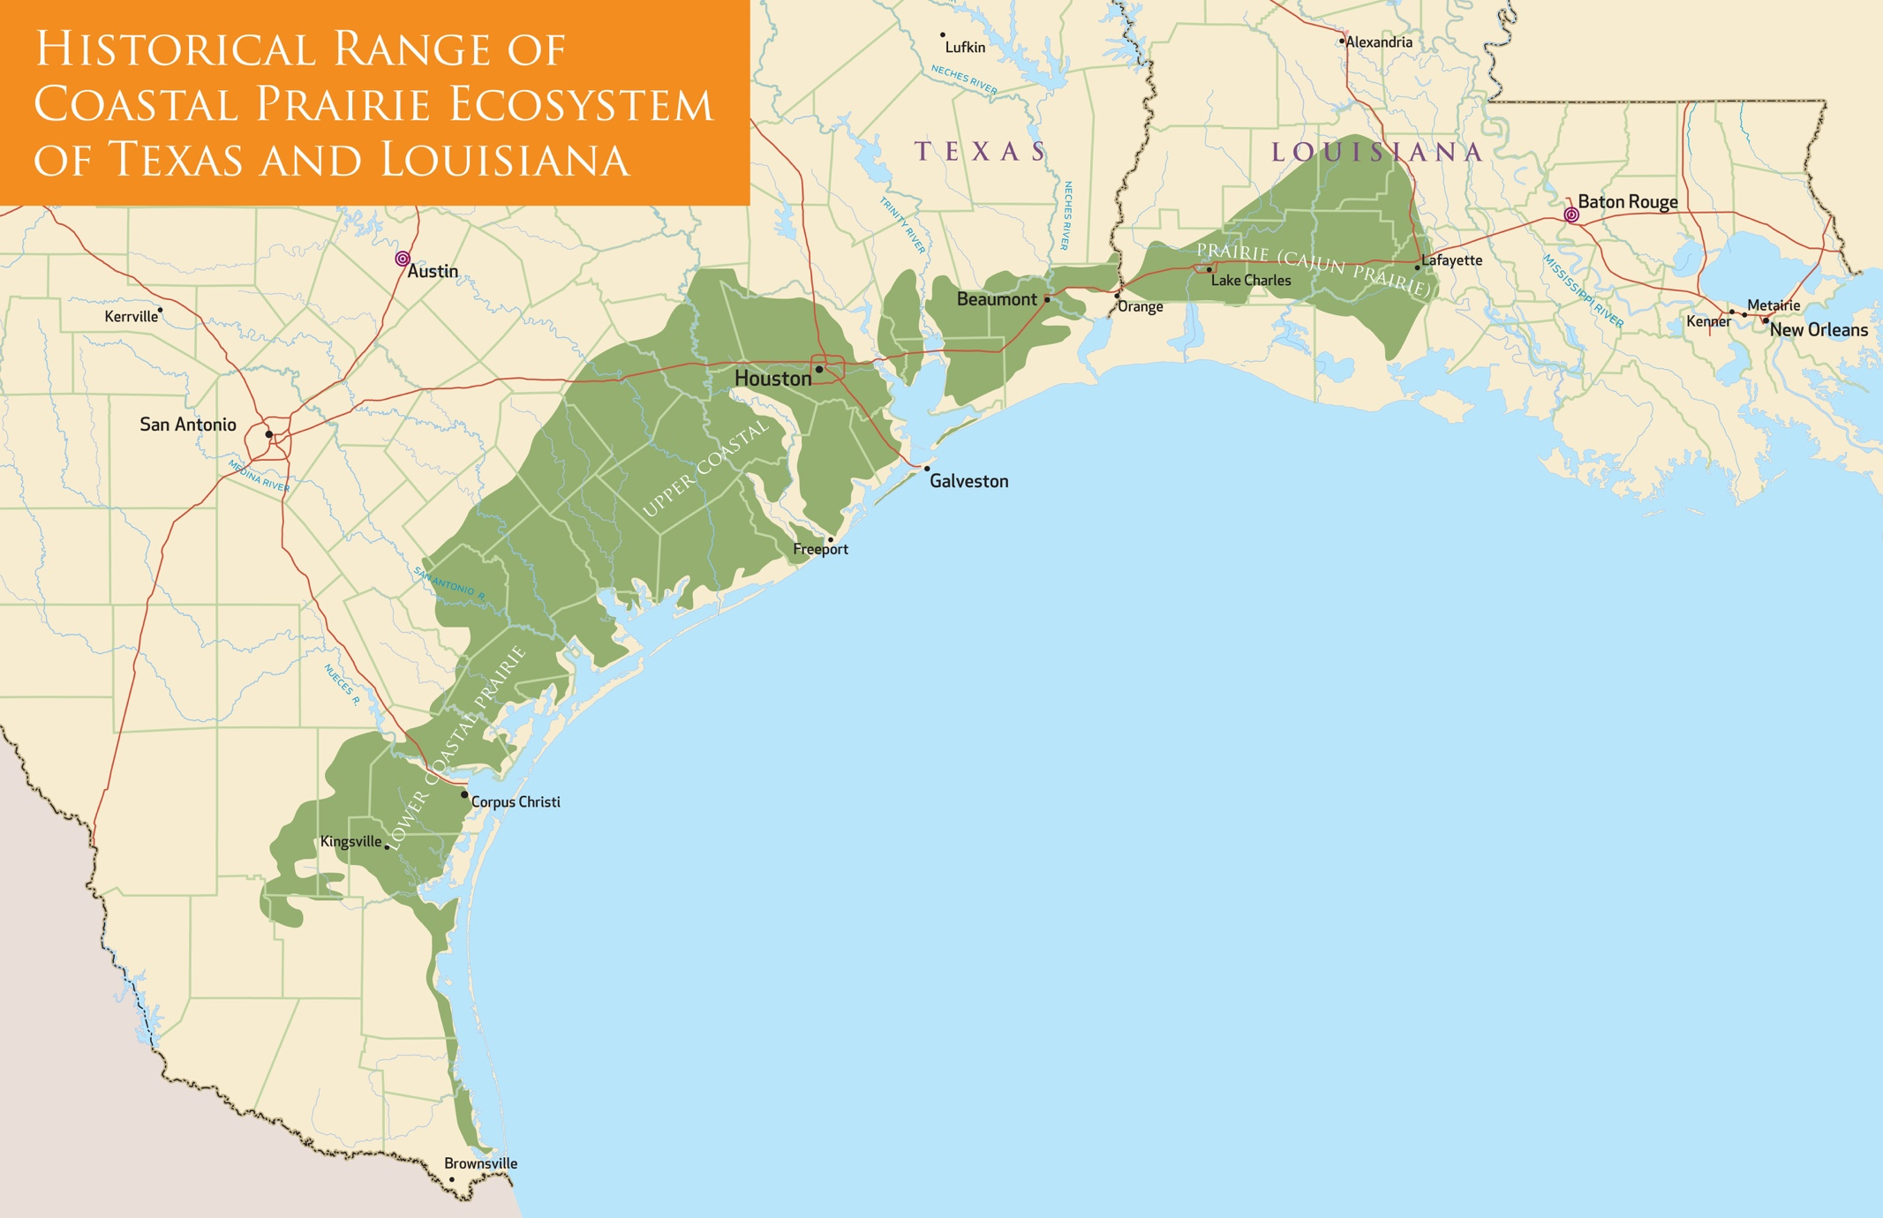
Student Page A
Simplified Grass Identification Key for the Tall Grass Prairie Big 5

Identifying grasses can be very technical and intimidating, however this chart will use the common characteristics of a few major prairie grasses so that you can successfully identify certain grasses.

When you arrive at the prairie, scan for the tallest and largest clumps of grass. Depending on the time of year and the amount of rainfall during the Spring and Summer, the tallest grasses should be Big bluestem, Switchgrass, Indiangrass, Eastern gamagrass, Little bluestem, and Vasey grass, which are the grasses to be identified using this chart.
Very rounded at base of stem
prominent
light- colored mid-vein
Start by examining the culm

Eastern gamagrass
leaves up
to 4 cm wide
with
prominent
mid-vein
Indiangrass
inflorescence is a large golden plume,

mature blades
have smooth
edges
Vasey grass
non native
invasive from
S. America
inflorescence
looks like little alternating branches
basal stems reddish
with lots of short white hairs
Leaves not pale,
very green
stem very flattened
at base
Not very rounded
at base
basal stems hairy but not reddish
Little bluestem
fluffy white
inflorescence
grass is rust- colored in Fall
Big bluestem
inflorescence
shaped like a turkey foot
mature leaves
have purple
patches
stem slightly flattened at base
No prominent mid-vein
pale gray-green leaves
Mature blades have wavy edges
Student Page B
Switchgrass
inflorescence is like a large open fan, green then tan colored
Johnson grass
non-native
invasive
from Asia and Africa
inflorescence is like a large
open fan, tan to reddish

Basic Grass Parts and Vocabulary
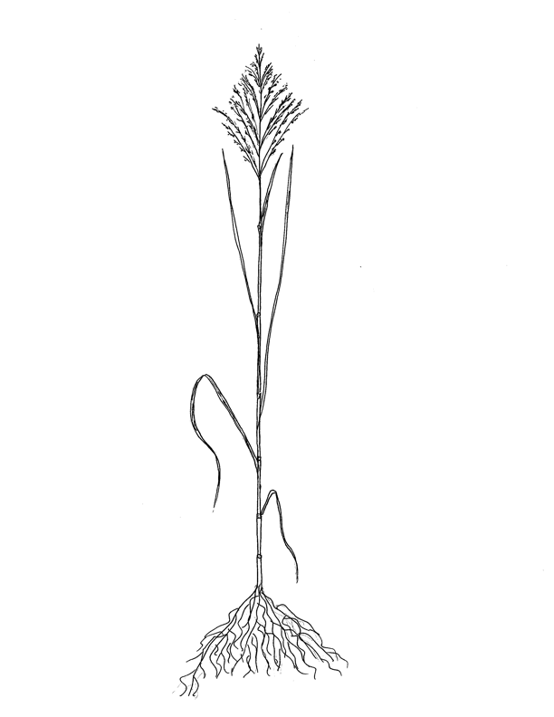
________________ seed: the dry fruit, “grain”
_________________ inflorescence: The flowering part of the
grass is very important for
classifying.
___________________ blade: The blade is the upper part of the
grass leaf. Blade color and width are
helpful in identifying grass.

helpful in identification
____________ tip: the growing point (apical meristem)
________________ sheath: The sheath is the base of the leaf that grows
out from the node and wraps
tightly around the culm.
contributing to its rigidity
_____________ node: Nodes are solid and often swollen looking.
Leaves are produced at the nodes.
Just above each stem node is a growing
zone, (intercalary meristem), so that grass
can still grow if the tip is removed.
grow
from these zones, even if tip is cut off.

drawing and text by A. Shong
_______________ culm: The culm is the erect stem, usually smooth and
cylindrical; can be hollow, solid, or semi-solid.

______________ roots: Roots are fibrous and serve to
take in water and nutrients.
Roots anchor the grass in the
ground and store some food.
Prairie grass roots can be
several feet deep.

Student Page C
Student Field Work Directions

- Tape or glue these directions into your journal.
- Work with a partner.
- Record Information in your journal.

Grass Observations

1. Locate a clump of tall grass to observe.

2. Measure and record the height and circumference of the grass clump.

3. Examine grass from the ground (crown) to its highest point (most likely an inflorescence).

4. Observe the details of the grass structure such as arrangement of the blades, “hairs”, color, etc.

5. Draw a simple sketch of the clump of grass including the culm, blade, and inflorescence (if in bloom).

6.Use the dichotomous key to identify the grass.

7. Examine three or more stems of the same grass (in the same clump and other clumps of the same grass). Record any variation in external features that you see among plants of the same species. Record your explanation for any variation.

8. How do the external features of the plant aid its survival?

9. Remove and open one grass stem, then use your hand lens to observe the internal structures of the grass. Record your observations. How do the internal structures enhance survival?

10. Compare your grass to another type of grass nearby. How are they alike? How are the different?

Microhabitat Observations

1. Observe and record the “microhabitat” around the clump you are working with, noting in your journal the number of different species (both plant and animal) you observe within a 3 foot radius of the clump.

2. What types of organisms do you find?

3. How does the biodiversity in this sample compare to the diversity you found on the
school grounds?

4. Do the organisms interact in any way with the grass clump? If so, how?

5. Do the organisms interact with each other? If so, how? What relationships among
organisms exist in this ecosystem?

Observation of Interactions in the Ecosystem

1. Investigate the prairie area in general and describe how organisms and populations
in a prairie ecosystem depend on and may compete for biotic and abiotic factors.
Record organisms and factors you observe.

2. List any interactions between organisms in the ecosystem.

4. What abiotic factors are important in this microhabitat?

5. How do the things that live in the area respond to the external stimuli provided by
abiotic factors?

6. How do organisms depend on and compete for biotic and abiotic factors in the
ecosystem?

7. How would environmental changes such as fires or floods affect organisms in this
ecosystem?

8. How do humans affect the prairie environment?

Student Page D

Group Presentations Grading Rubric

Date: ___________

Your name: ___________________________________________

Partners’ names: ________________________________________________________________

________________________________

Topic:

Criteria | 3 points | 2 points | 1 point
Topic Content | All 3 topics of the assignment were addressed. Rich in details. | At least 2 topics of the assignment were addressed, and/or  sparse details. | Only 1 topic of the assignment was covered, few if any details, or the presentation wandered off track.
Visual Presentation  of Poster | Diagrams and sketches were easy to interpret and were appropriate to the topic. | Most diagrams and sketches were easy to interpret and/or most were appropriate to the topic. | Most diagrams and sketches were not easy to interpret and/or were not appropriate to the topic.
Poster and Oral Presentation  Participation | All students contributed to the poster content and the oral presentation | Most of the students contributed to the poster and/or the oral presentation | Poster and/or presentation was dominated by one or two students.

9 pts = 100 8 pts = .95 7 pts = 90 6 pts = 85 5 pts = 80 4 pts = 75
3 pts = 70
Your group’s grade: ____________________________

Texas Essential Knowledge and Skills

Grade 7 Science

    - Scientific investigations and reasoning. The student, for 40% of the instructional time conducts laboratory and field investigations following safety procedures and environmentally appropriate and ethical practices.
The student is expected to:
7.1A Demonstrate safe practices during laboratory and field investigations as
outlined in the Texas Safety Standards.

  - Science investigation and reasoning. The student know how to use a
variety of tools and safety equipment to conduct science inquiry.
The student is expected to:
7.4A Use appropriate tools to collect, record, and analyze information, including
hand lenses, metric measuring tapes, journals, computers, etc.

7.10 Organisms and environments. The student knows that there is a relationship between organisms and the environment.
The student is expected to:
7.10A Observe how different environments, including microhabitats in
schoolyards and biomes, support different varieties of organisms.
7.10B Describe how biodiversity contributes to the sustainability of an
ecosystem.

  - Organisms and environments. The student knows that populations and
species demonstrate variation and inherit many of their unique traits through gradual processes over many generations.
The student is expected to:
7.11A Examine organisms or their structures such as insects or leaves and use
dichotomous key for identification.
7.11B Explain variation within a population or species by comparing external
features, behaviors or physiology of organisms that enhance their survival such as migration, hibernation, or storage of food in a bulb.

  - Organisms and environments. The student knows that living systems at
all levels of organization demonstrate the complementary nature of structure and function.
The student is expected to:
7.12A Investigate and explain how internal structures for organisms have adaptations in plants.

  - Organisms and environments. The student knows that a living
organisms must be able to maintain balance in stable internal conditions in response to external and internal stimuli.
The student is expected to:
7.13A Investigate how organisms respond to external stimuli such as
phototropism and fight or flight.

Texas Essential Knowledge and Skills

Grade 8 Science

  - Scientific investigations and reasoning. The student , for at least 40%
of instructional time, conducts laboratory and field investigations following safety procedures and environmentally appropriate and ethical practices.
The student is expected to:
8.1A Demonstrate safe practices during laboratory and field investigations as
outlined in the Texas Safety Standards.

8.4 Scientific investigations and reasoning. The student knows how to use a variety of tools and safety equipment to conduct science inquiry.
The student is expected to:
8.4A Use appropriate tools to collect, record, and analyze information, including hand lenses, metric measuring tapes, journals, computers, etc

8.11 Organisms and environments. The student knows that interdependence occurs among living systems and the environment and that human activities can affect those systems.
The student is expected to:
8.11A Describe producer/consumer, predator/prey, parasite/host relationships as they occur in food webs within marine, freshwater, and terrestrial ecosystems.
8.11B Investigate how organisms and populations in an ecosystem depend on
and may compete for biotic and abiotic factors such as quantity of light,
water, range of temperatures, or soil composition.
8.11C Explore how short- and long-term environmental changes affect
organisms and traits in subsequent populations.

North American Association for Environmental Education
Fifth through Eighth Grade

8.1C Collecting Information–Learners are able to locate and collect reliable information about the environment or environmental topics using a variety of methods and sources.

8.1E Organizing Information–Learners are able to classify and order data, and to organize and display information in ways that help analysis and interpretation.

8.1G Drawing conclusions and developing explanations–Learners are able to synthesize their observations and findings into coherent explanations.

8.2.2A Organisms, populations, and communities–Learners understand that biotic communities are made up of plants and animals that are adapted to live in particular environments.

8.2.2C Systems and connections–Learners understand major kinds of
interactions among organisms or populations of organisms.

8.2.2D Flow of matter and energy–Learners understand how energy and matter flow among the abiotic and biotic components of the environment.

8.2.4A Human/environmental interactions–Learners understand that human-caused changes have consequences for the immediate environment as well as for other places and future times.
Eastern gamagrass
leaves up
to 4 cm wide
with
prominent
mid-vein
Indiangrass
inflorescence is a large golden plume,

mature blades
have smooth
edges
Vaseygrass
non native
invasive from
S. America
inflorescence
looks like little alternating branches
basal stems hairy but not reddish
Little bluestem
fluffy white
inflorescence
grass is rust- colored in Fall
Big bluestem
inflorescence
shaped like a turkey foot
mature leaves
have purple
patches

