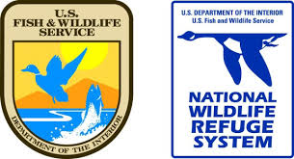

Dance like an Attwater’s Prairie Chicken
Grade Level, TEKS Science Objective:
Kinder: 2A, 4A, 9A&B, 10A&B
1st: 2A, 4A, 9A&B, 10A&C
2nd: 2A, 4A, 9A&B, 10A
3rd: 4, 9AB&C, 10A
4th: 4, 9A, 10A&B
5th: 4, 9A&C, 10A&B

Materials:
Speaker and kid-friendly music
Markers or Crayons
Print (found at end of document)
- Pictures in color for visual aids
- Multiple sheets of “insects, leks, prairie” place markers
- Attwater’s Prairie Chicken Masks
Additional Resources:
https://www.fws.gov/refuge/attwater_prairie_chicken/
https://www.youtube.com/watch?v=BGSWi_vgu9A
9:00 minute video “Little Grouse on the Prairie”: https://attwater.org/
https://www.audubon.org/news/what-heck-lek-quirkiest-mating-party-earth

Introduction: Presenters introduce themselves and the U.S Fish and Wildlife Service/National Wildlife Refuge System. Explain briefly what a National Wildlife Refuge is, what they can do there, where the nearest one to them is located. Explain how the program works, such as holding the boundary sign to talk, brief discussion, activity, and a take home. Ensure everyone will get a chance to talk and to always be respectful of whoever has the sign.

Introductory Question: Who is your favorite dancer? Show us your favorite dance!
Transition: We’re going to talk about a fun little bird that likes to dance. Refuge rangers at Attwater Prairie Chicken National Wildlife Refuge and other partners in Texas work hard to protect their habitat because they aren’t many left.
Introduce the bird with visual aids; show Attwater pictures/point out features
Show booming video a few times: https://www.youtube.com/watch?v=BGSWi_vgu9A
9:00 minute video “Little Grouse on the Prairie”: https://attwater.org/
About the Attwater’s Prairie Chicken (APC)
- Not technically a chicken, but a species of bird closely related to the grouse.
- Male bird likes to dance and boom (which means it makes a loud noise to attract a female partner)
- Male has large, orange sacs on the side of his face that attract females
- Bird is becoming so scarce that there are only two known places in Texas where the bird exists
- Requires tall grass prairies because it provides a safe environment to raise babies and hide from predators as well as provides a food source of insects, seeds, and flowers
- Houston was once covered in a coastal prairie
- Leks are like stages for the Attwater’s prairie chicken. They are areas with shorter grasses, where the male birds will put on a show and do the booming display. For more information, go to the Audubon site https://www.audubon.org/news/what-heck-lek-quirkiest-mating-party-earth
- APC chicks eat insects but the adults eat seeds and flowers. Food items for the chicks might include grasshoppers, butterflies, moths, dragonflies and spiders, all critters found on the prairie.
Transition: What challenges do the Attwater’s prairie chickens face?
APC’s are an endangered bird due to loss of important prairie habitat. Urbanization of Houston has taken the majority of the bird’s native habitat. What does endangered mean? Endangered means there aren’t many left and they at are risk of extinction, being gone forever. What does urbanization mean? Urbanization is when cities and societies grow very fast, they take up more natural space leaving less areas for wildlife to live.
-Fire ants are a non-native and invasive species that harm baby birds by eating their food supply, insects. What does non-native mean? Non-native species are species that are introduced to an area outside of the native range. What does invasive mean? Invasive species are species that are also outside of the native range and cause damage/harm to the habitat because they have no natural predators. Exotic species are also non-native but are not destructive. Fire ants are both non-native and invasive.
Transition: What can we do for this special bird?
-Protect habitat for birds, in places like the Attwater Prairie Chicken National Wildlife Refuge.
-Participate in the Friends of the Attwater Prairie Chicken Student Festival Art Contest to raise awareness and concern.
-Plant native plants in our yards and school grounds.

*Lead students through any of these activities!
Activity 1: What adaptations does the bird have?
Students color their own male bird mask to match the colors of a prairie chicken.
Students vote on their favorite, as a female bird would do! Graph the results.

Activity 2: High Grass Prairie Chicken Musical Chairs
- Count the number of kids and place that number of place markers, or “chairs,” (insect, lek, prairie) out in the playing area.
- The “chairs” include leks, insects, and prairie. The “chairs” are essential to the life and survival of the bird.
- Begin the music and have the kids dance around like APC in a circle. Ensure that there is always one less “chair” than number of kids.
- Once the music stops, the kids to run to one of the “chairs”. Whoever does not make it is out.
Add “chairs” for times when refuge rangers:
- protect more habitat
- have a successful captive breeding season causing lek gains
- females like the dancing of male birds, causing lek gains
- more grasses are planted in an area causing habitat gains
- good weather causing insect gains
- no pollution causing insect gains
Remove “chairs” for times when the community:
- freeway built causing loss of habitat
- hurricane causes loss of habitat
- industrial fire causes loss of insects
- runoff of pesticides into waterways causes loss of insects
- predatory hawks cause loss of leks (birds keep running and hiding)
- female birds don’t like the dancing of male birds, causing loss of leks

Activity 3: APC Dance- Off!
Ask for 3-4 volunteers. Have them do their best APC impression for 30 seconds (dancing and booming)
Have their peers vote by clapping the most/loudest!

Activity 4: Insect Sweep
Using nets, sweep the grasses around your area to collect insects. Put them in a small container, and determine if there are enough bugs to sustain a population of birds at your school. For every one bird, you need ten insects per day. No nets? Just let the kids look around…
More detail here: https://www.youtube.com/watch?v=vKVVrIkSW5w
Not enough insects? Let students brainstorm what to do around the area to increase the number of insects. Hint: add native plants, which is their food source, or add hiding places, to escape predation.

Leks

Leks
Insects

Insects
Prairie

Prairie

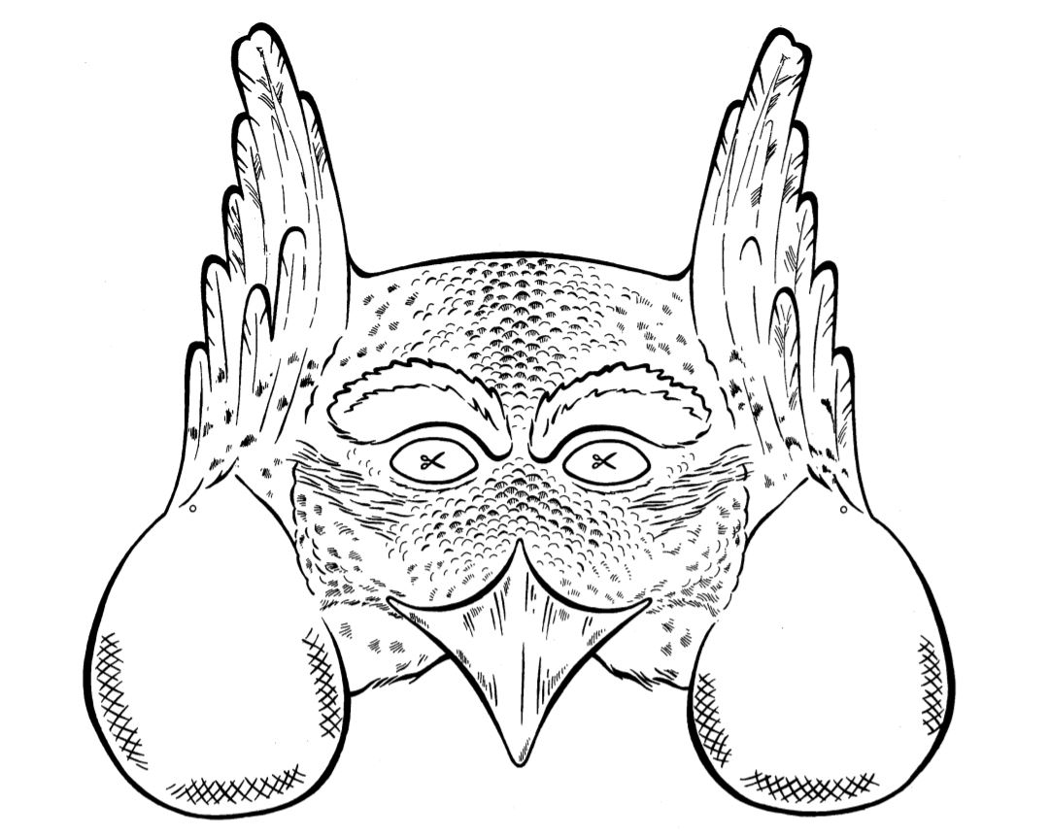

Attwater Prairie Chicken
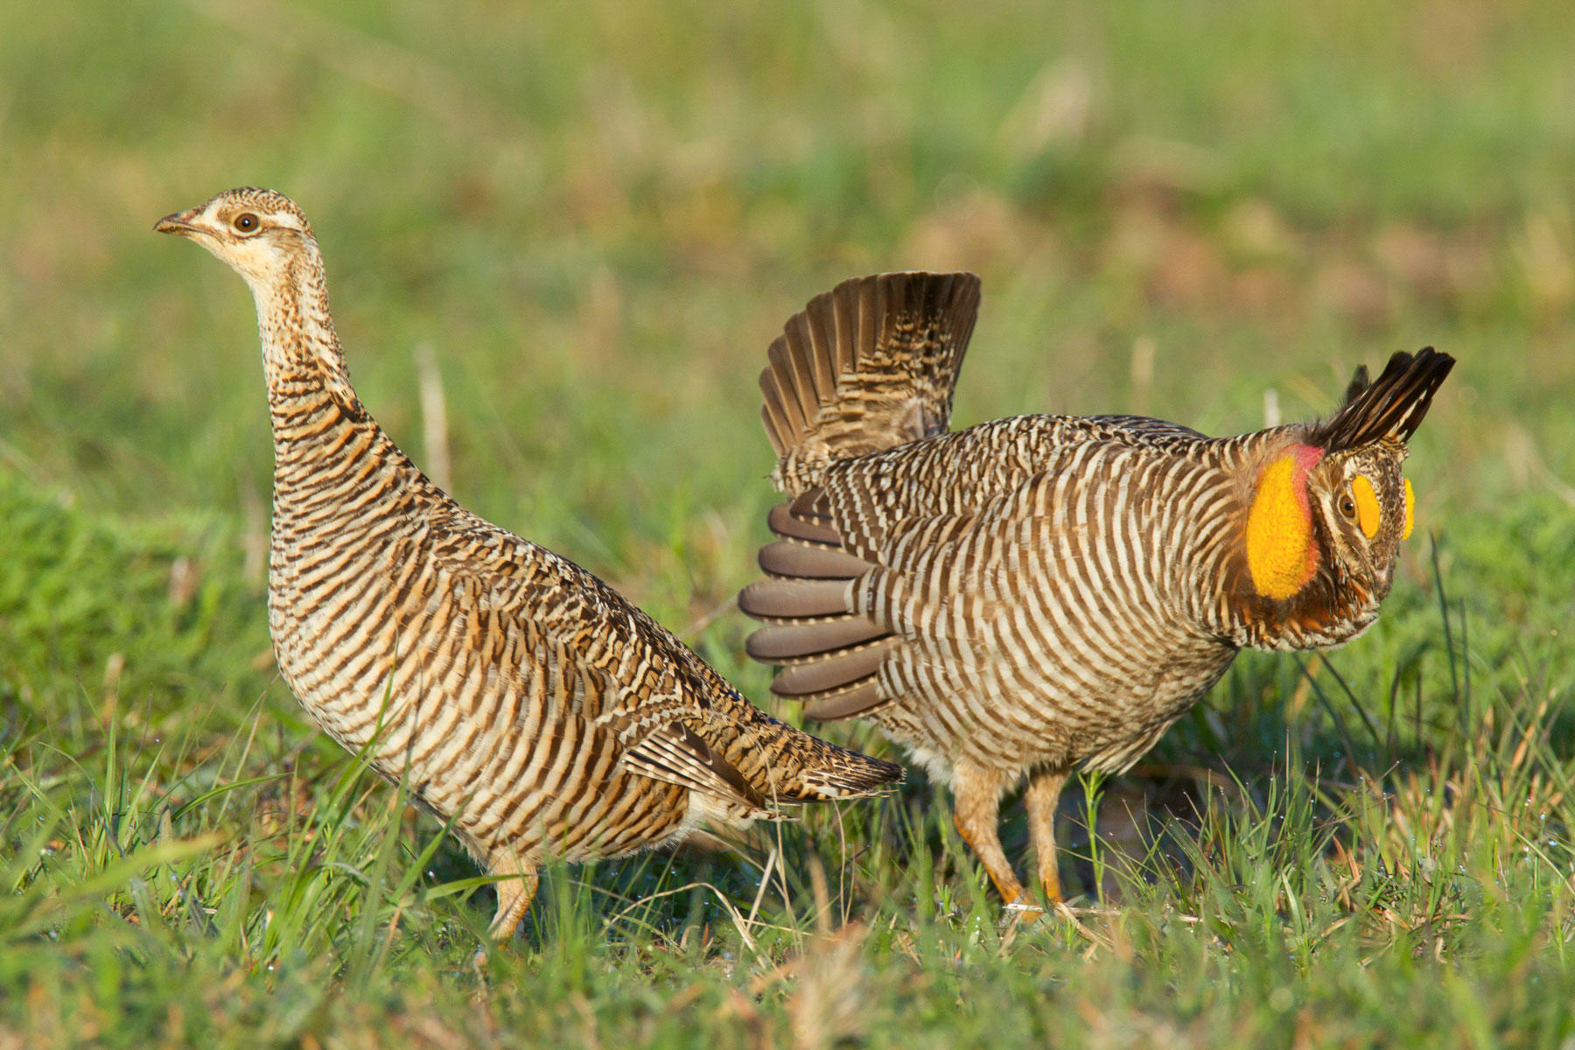

Coastal Prairie Habitat
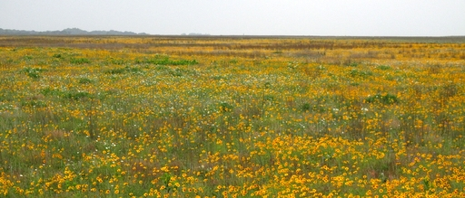

Baby Attwater Prairie Chicken
