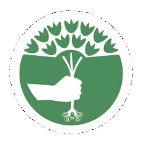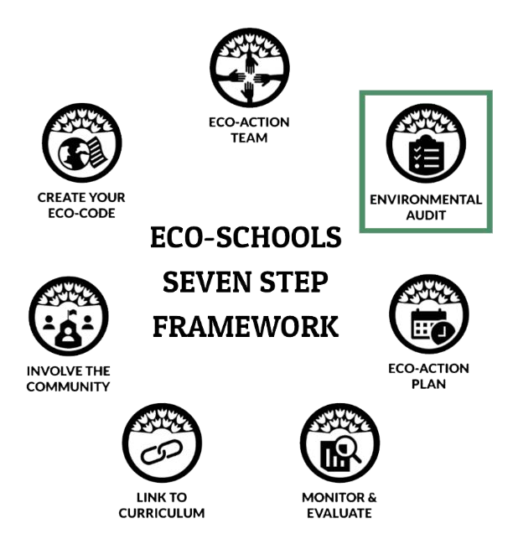

Schoolyard Habitats® Pathway
BEFORE, DURING AND AFTER THE AUDIT, GRADES 6-8

BEFORE THE AUDIT

BE PREPARED
- Read through this document, the baseline audit and the post-action audit.
- Invite community experts to participate.
- Gather science tools (if applicable) and print materials.
- Conduct mini-lessons (if needed) to strengthen concept foundation.

ENDURING UNDERSTANDING
- The main cause of species decline is loss of habitat and degradation
- Climate change, pollution and invasive species make significant contributions to species and habitat decline.
- Schools and communities play an important role in protecting habitat and conserving wildlife.

COMMUNITY AND CULTURE
- Gardening helps to relive stress and increase a feeling of wellness. By way of increasing one’s physical activity it benefits one’s ability to refocus, concentrate, learn and remember.
- Gardens in the community help build a sense of community by bringing people together.
- Cultural diversity, including Indigenous, Western and Eastern way of knowing are a source for learning sustainable practices and creating and improving habitat critical to the survival of local wildlife.
- Intercultural and intergenerational dialogue should be a guiding principle in developing solutions, raising awareness and promoting action.
- Create an inclusive, safe place for Eco-Action team members and others within and outside of the school community to participate.

Questions? eco-schoolsusa@nwf.org

INTERDISCIPLINARY CONNECTIONS

- 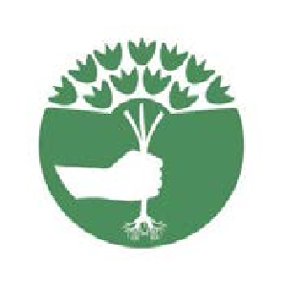Language Arts – Create a field guide for the school community and visitors to learn more about what makes the schoolyard habitat critical to the protection of wildlife and conservation of habitat.
Civics
Technology
Agriculture
Science
Language Arts
Math
Art

- Math – Calculate the amount of each type of soil amendment needed for the size of the schoolyard habitat(s) and determine how much to purchase or request for a donation that will be needed for the entire year.

- Agriculture – Investigate the important role pollinators have on our crop systems. How can we grow food for a growing population while at the same time reverse the decline in pollinator species?

- Art – Research shows art enhances brain function. Invite students to create works of art, murals, stepping stones, signage, etc. in an effort to engage more students in outdoor learning.

In 2016, seventeen Global Goals for Sustainable Development were adopted by world leaders at a United Nations Summit. These goals universally apply to all countries, therefore Eco-Schools USA is committed to doing our part. Over the next fifteen years, efforts will be made by governments, institutions and citizens all across the globe to end all forms of poverty, fight inequalities and tackle climate change, while ensuring nobody is left behind.

Make cities and human settlements inclusive, safe, resilient and sustainable.

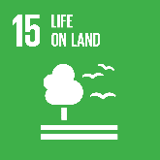
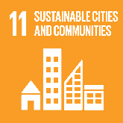
Protect, restor and promote sustainable use of terrestrail ecosystems, sustainably manage forests, combat desertification and halt and revers land degradation hand biodiversity loss.

Learn more at globalgoals.org

CONDUCT THE AUDIT

GATHER THE FOLLOWING MATERIALS

- Student worksheet(s) | - Audit form | - Science notebook
- Clip boards | - Regional/state tree, plant and animal field guides | - Stakes or utility flags and string
- Soil and water quality testing kits or probes | - Binoculars | - SEEK app by iNaturalist or other
- Water and soil temperature thermometers (optional) | - Air temperature and surface  temperature thermometers (optional)

PROCEDURE
GLOBAL
NATIONAL
LOCAL

- Before the audit, contact local experts who are willing to assist. These individuals can provide more in depth understanding and can help direct the team when questions arise and/or concerns arise.
- Read through the audit. As an Eco-Action Team determine, based on the area being investigated, how much time will be needed to complete the baseline or post-action audit.
- Highlight the locations on a school map where teams will collect data.
- Conduct the baseline audit and make plans to conduct the post-action audit.
- Analyze the results and develop an action plan.
- Frequently communicate results and plans with the school and community.

DASHBOARD METRICS

- How many square feet of wildlife habitat does your school contain?
- After implementing the action plan, how many more square feet of habitat was added?
- What are the average number of minutes students spend in the garden or outdoor learning space each week?

AFTER THE AUDIT

NEXT STEP: DEVELOP AN ACTION PLAN

Move into Step 3 of the Seven Step Framework by using the audit results to develop an action plan.

Identify community leaders, experts, advocacy organizations who can assist students with solution implementation and advise the
Eco-Action Team how to address issues of social justice.

UPDATE YOUR DASHBOARD

Login to the school’s dashboard and complete the following tasks.

  - Upload your audit results and your action plan.
  - Add any related photos or videos.
  - After completing the post-action audit and moving through the Seven Step Framework apply for an award.

STUDENT PHOTOGRAPHERS

Invite students to protect wildlife and conserve habitat by participating in National Wildlife Federation’s photography contests

  - National Wildlife Federation’s Photo Contest, opens in January.

  - National Wildlife Federation’s Garden for Wildlife Photo Contest opens in August.

NEXT PATHWAY

Biodiversity –
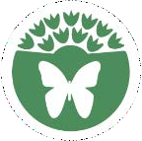
Biodiversity is the variety of life on our planet, and a wide diversity of plant and animal species are key to healthy, functioning ecosystems. Investigate and strategize ways to improve biodiversity on the school grounds.

WOW-Watersheds Pathway –
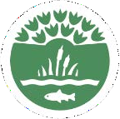
We all live in a watershed-the land area that channels rainfall and snowmelt to waterways and to outflow points such as reservoirs, bays and oceans. People and wildlife rely on a healthy watershed to meet there needs.
Conduct investigations to better understand the watershed’s health and determine ways make improvements for the community and for local wildlife.

CONNECT TO THE GLOBE PROGRAM

The Global Learning and Observations to Benefit the Environment (GLOBE) Program is an international science and education program that provides students and the public worldwide with the opportunity to participate in data collection, the scientific process, and contribute meaningfully to our understanding of the Earth system and global environment.

Atmosphere
air temperature | clouds | precipitation | surface ozone | surface temperature | water vapor

Biosphere
Arctic bird migration | carbon cycle | green up-green down | land cover classification | Ruby-Throated hummingbirds

Hydrosphere
dissolved oxygen | mosquitos | nitrates | pH | temperature

Pedosphere
characterization | fertility | soil moisture-sensors | pH | temperature

