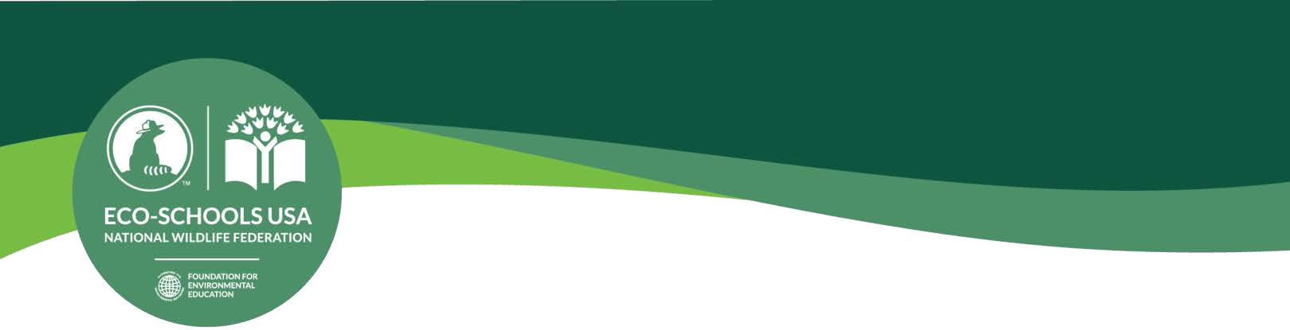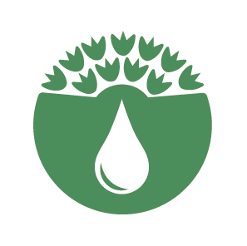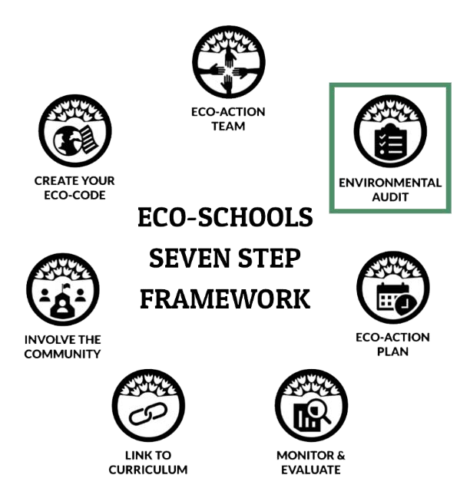

Water Conservation Pathway
BEFORE AND AFTER THE AUDIT, GRADES 3-5

BEFORE

BE PREPARED
- Read through this document, the baseline audit and the post-action audit.
- Invite community experts to participate.
- Gather science tools (if applicable) and print materials.
- Conduct mini-lessons (if needed) to strengthen concept foundation.

ENDURING UNDERSTANDING
- Usable water is a limited, valuable natural resource.
- Leaking and/or inefficient water using appliances waste water and cost money.
- Access to clean water is important to our health and to our ability to carry out day-to-day tasks.
- Nature can be used to conserve water.

COMMUNITY AND CULTURE
- The frequency and intensity of local water crises have been increasing, with serious implications for public health, environmental sustainability, food and energy security, and economic development.
- Demographics continue changing and unsustainable economic practices are affecting the quantity and quality of the water at our disposal, making water an increasingly scarce and expensive resource
— especially for the poor, the marginalized and the vulnerable.
- Cultural differences play a key role in the way water is perceived, valued and managed.
- Cultural diversity is a source for learning sustainable practices.
- Intercultural dialogue should be a guiding principle in developing solutions, raising awareness and promoting action.
- Create an inclusive, safe place for Eco-Action Team members and others within and outside of the school community to participate.

Questions? eco-schoolsusa@nwf.org

INTERDISCIPLINARY CONNECTIONS

- Language Arts – Practice crafting communications based on audience and purpose. Students can hone skills to help them effectively communicate via school website, letter writing campaigns, and journalism (school newsletter or news cast).
Social Studies
Technology
Engineering
Science
Language Arts
Math
Geography

- Math – Determine the number of drips per minute and calculate the total water lost over a day, week, month and school year.

- Technology – Research current available technology to conserve water. Have students use engineering design to come up with their own systems, applications or appliances.

- Social Studies – Identify the indigenous peoples of your state. What role did water play in their way of knowing and living?

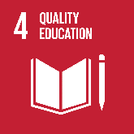
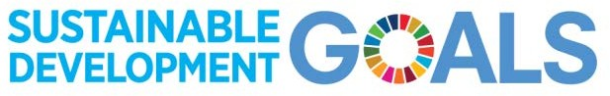Ensure inclusive and equitable quality education and promote lifelong learning opportunities for all.

In 2016, seventeen Global Goals for Sustainable Development were adopted by world leaders at a United Nations Summit. These goals universally apply to all countries, therefore Eco-Schools USA is committed to doing our part. Over the next fifteen years, efforts will be made by governments, institutions and citizens all across the globe to end all forms of poverty, fight inequalities and tackle climate change, while ensuring nobody is left behind.

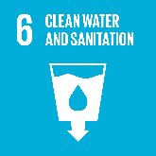
Ensure availability and sustainable management of water and sanitation for all.

Learn more at globalgoals.org

GATHER THE FOLLOWING MATERIALS

- Student worksheet(s) | - Audit form | - Clip boards
- School map(s) – inside and outside | - Beaker, graduated cylinders or  other container used to measure volume | - Stop watch or phone’s built-in stop watch

DASHBOARD METRIC

- On average, by how many gallons has the school’s water usage decreased?

PROCEDURE
GLOBAL
NATIONAL
LOCAL

- Before the audit, contact local experts who are willing to assist. These individuals can provide more in depth understanding and can help direct the team when questions arise and/or concerns arise.
- Read through the audit. As an Eco-Action Team determine, based on the size of your school and the number of appliances/devices, how much time will be needed to complete the baseline or post-action audit.
- Highlight the locations on the school maps where teams will collect data.
- Conduct the baseline audit and make plans to conduct the post-action audit.
- Analyze the results and develop an action plan.
- Frequently communicate results and plans with the school and community.

AFTER

NEXT STEP: DEVELOP AN ACTION PLAN

Move into Step 3 of the Seven Step Framework by using the audit results to develop an action plan.

Identify community leaders, experts, advocacy organizations who can assist students with solution implementation and advise the
Eco-Action Team how to address issues of social justice.

UPDATE YOUR DASHBOARD

Login to the school’s dashboard and complete the following tasks.

  - Upload your audit results and your action plan.
  - Add any related photos or videos.
  - After completing the post-action audit and moving through the Seven Step Framework apply for an award.

RANGER RICK,
A MENTOR FOR TODAY’S KIDS

Ranger Rick, the National Wildlife Federation’s friendly raccoon, helps children of all ages discover and connect with nature so they become good stewards of the environment.

  - Ranger Rick for ages 7-12, classroom subscriptions
  - Ranger Rick Photo Contest
  - Ranger Rick Educator Guide
  - Ranger Rick Zoobooks

NEXT PATHWAY

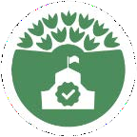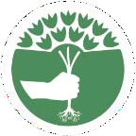
Healthy Schools Pathway –
Providing students and staff with a healthy learning and working environment is an important component of every sustainable school. Learn more about conditions that can impact the learning environment and how to inform the community and advocate for change.
Schoolyard Habitats® Pathway –
Water is a critical habitat element and plays an important role in the preparation, implementation and maintenance of gardens for wildlife.

- CONNECT TO THE GLOBE PROGRAM

The Global Learning and Observations to Benefit the Environment (GLOBE) Program is an international science and education program that provides students and the public worldwide with the opportunity to participate in data collection, the scientific process, and contribute meaningfully to our understanding of the Earth system and global environment.

Atmosphere
Air temperature | clouds | precipitation

Biosphere
green up-green down

Hydrosphere
alkalinity | freshwater macroinvertebrates | water temperature | water pH

Pedosphere
soil pH | soil fertility | soil temperature

