Water Washing Lab
Adapted from San Antonio Water System Urban Water Cycle

Background Information
The water cycle is sometimes called “nature’s washing machine.” A. As water flows, it picks up contaminants, which often settle to the bottom. B. As water infiltrates through soil and rocks at the bottom of bodies of water, the soil/rocks act as a natural filtering mechanism. C. During evaporation, only pure water can enter the atmosphere (AKA distillation).

As populations grow and areas become settled, the demand for clean water exceeds the rate at which it can be naturally purified and wastewater treatment plants become necessary. “Primary treatment uses screens and a grit tank to remove large floating objects and allow solids (rocks, sand) to settle out. Then the waste stream flows into a primary settling tank where suspended organic solids settle out as sludge. This removes 60% of suspended solids and 35% of organic wastes. Secondary treatment is a biological process in which aerobic bacteria remove as much as 90% of the remaining organic wastes” (Miller, 510). See diagram below:

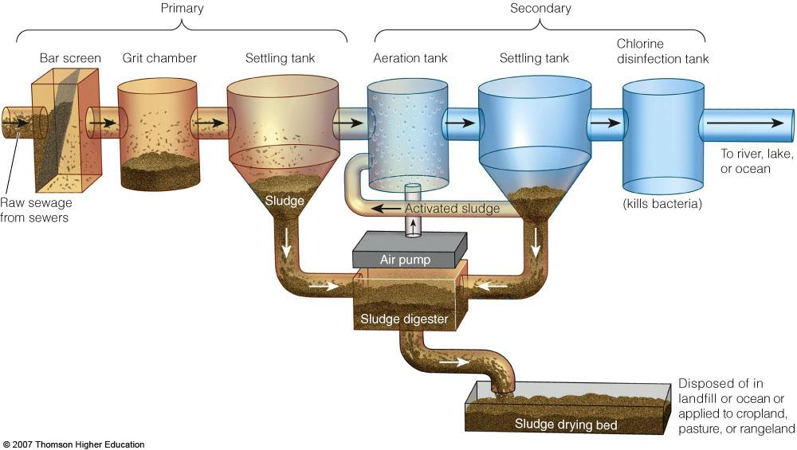

Before discharge, water usually undergoes chlorination, UV ray exposure, or ozone exposure to kill pathogens. U.S. federal law requires primary and secondary treatment for all municipal sewage treatment plants, but exemptions from secondary treatment are possible when the cost of installation poses an excessive burden. The US Safe Drinking Water Act of 1974 requires the Environmental Protection Agency to establish national drinking water standards (maximum contaminant levels) for any pollutants that may have an adverse effect on human health.

- Make a short acrostic poem of things found in wastewater.
- Match:
primary wastewater treatment biological
secondary wastewater treatment physical
- Name two alternatives to chlorine used to treat wastewater for pathogens before discharge.

Preparation
“Wastewater” for today contains soil, coffee grounds, vegetable oil, soap, salt and vinegar.
“Cleaning supplies” include coffee filters, spoons, straws, cotton balls, etc.

Procedures
Get a cup of wastewater.
Using the cleaning materials on the front desk, clean the water! Cleanest water wins!
Make a data chart like the one below to objectify your cleaning abilities.

Cleaning Strategy Used | Substance Removed

Follow Up
- Name the contaminants in this lab that you could not remove. Why?
- Name other real contaminants in your drinking water that are not removed during a wastewater treatment process.
- How are your procedures today similar to ones used by wastewater treatment plants?
- How are they different?
- There are alternative, organic cleaning agents (see chart). Why are these organic alternatives easier to remove from wastewater than harsh cleaning agents?

Cleaning Agent | Alternative
Room deodorizer | Baking soda
Drain cleaner | Boiling water, vinegar and baking soda, plunger
Window cleaner | Vinegar wiped with newspaper
Scouring powder | Baking soda and vinegar
Tarnish remover | Salt, baking soda, and a piece of aluminum foil in warm water

