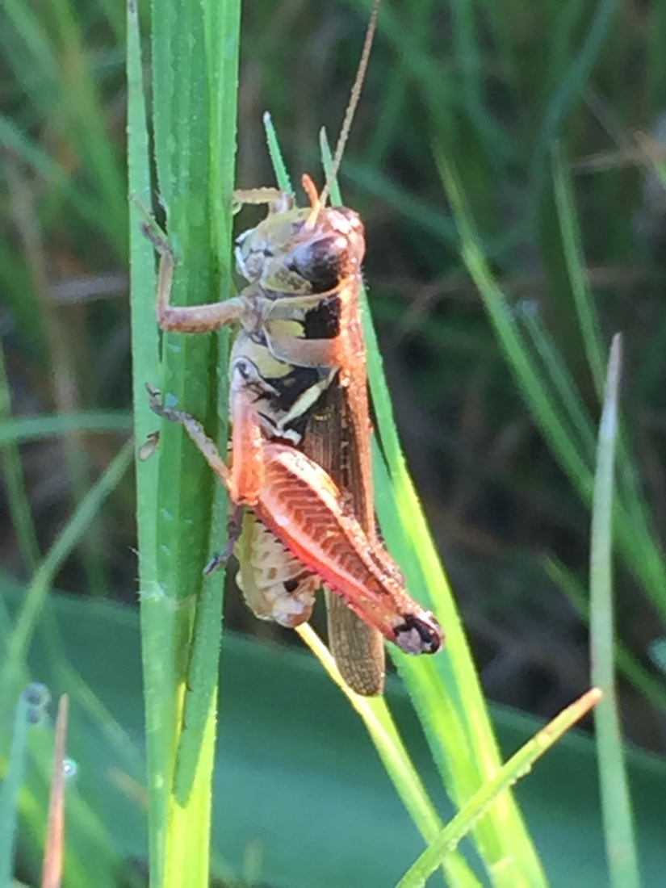
Prairie

Mini-Mowers

Introduction

Even a small patch of prairie will support a large diversity of insects and other wildlife. Amongst all the amazing insects in a prairie food web, grasshoppers are large enough for students to study their structural adaptations, from their giant sci-fi heads to their large spiny legs. Their behaviors of “freezing”, then jumping in alarm, makes for fun times in the field observing and capturing the grasshoppers with both cameras and nets.

This lesson is well suited to be broken into parts and completed over a few days in the classroom and on the prairie. Having cross-curricular objectives, this lesson could also be executed with a team of teachers or in a self-contained classroom setting.

Objectives (TEKS in resource section)

Students will:
- describe the flow of energy through a prairie food web
- explore how adaptations allow grasshoppers to survive in their prairie environment
- demonstrate that some traits and behaviors are inherited
- explore the life cycle of an insect
- collect, record, and analyze information using cameras
- represent data on a frequency plot
- demonstrate safe lab and field practices
- collaborate to produce explanations
- research and make a PowerPoint presentation

Teacher Preparation

Materials needed for each group of four students:
- digital camera (if available)
- a long-handled net
a mesh aerial net for catching flying insects or
a muslin beating net for sweeping the vegetation
- collection container - clear with small breathing holes
pint or quart-size plastic jars with a knee-high nylon stocking over the opening fitted with a rubber or other insect keeper
band.

- a poster board and markers (to be used in the explanation section)
- insect field guides if available
- ruler

Materials for Individual students
- science journal
pencils (colored pencils would work nicely)

Materials needed for each class
- a copy of fable for teacher to read (optional: copy for each group)
- an anchor chart to record student responses prompted by fable
- a frequency plot prepared to record all insects captured
- a copy of Tasks 5 and 6 (journaling instructions) for each student to tape/glue into their journal (see resource section)

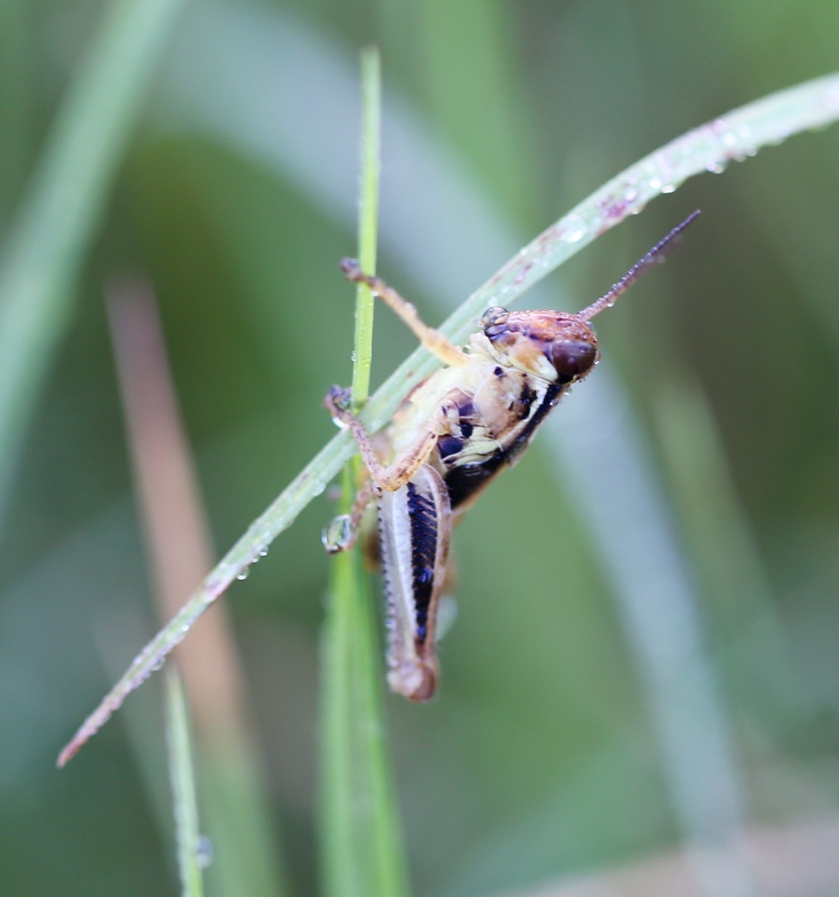

Engage

Aesop’s Fable

The Ant and the Grasshopper

Procedure
Read an Aesop’s fable called “The Ant and the Grasshopper”. (See source website in Resources.)
Instruct the students to:
• listen to the fable
• jot down any science facts that they perceive
• add any information or questions about grasshoppers.

Small group discussion
After the reading, give students a few minutes to discuss their thoughts with the members of their group

Have class discussion
Record student ideas on an anchor chart.
Such as:
How does a grasshopper really spend its days?
How do grasshoppers make noises and “songs”?
What do the students already know about grasshoppers, particularly grasshopper adaptations?
How does a grasshopper species survive during the winter?
Are some life stages of a grasshopper better adapted to overwintering, and why?
How can a grasshopper be distinguished from a katydid or cricket?

Explore

Capture Grasshoppers with Cameras and Nets

Time Considerations
Allow about 10 minutes for demonstrations and explanations,
20 minutes for student to collect grasshoppers, and about
10-15 minutes for journaling.

Teacher explanation of field and lab safety
- Demonstrate to students how to handle the nets and containers safely.
- Demonstrate how to use the net to capture an insect and how to get the insect into the container without damaging it.
- Demonstrate the proper use of the camera.
- Explain about respecting all living organisms - to not cause injury to insects and plants.
- Remind students that grasshoppers have short antenna that point forward (katydids and crickets
have long antenna that sweep back along their bodies)
- Remind students that all insects will be released after observations.

Teacher explanation of field activity tasks
Students are divided into groups of 4 and all seven tasks are described.
Tasks 1-4 can be rotated every few minutes to keep all students happy.

Tasks 1-4: Field Activities
Task 1: use net to catch a grasshopper (or other insects)

Task 2: place grasshoppers into container and keep container safe
Task 3: take photos of grasshoppers and their environment
Task 4: identify the captured insect and record the insect on the class frequency plot

Task 5 :Observations
Instruct students to carefully observe:
- the grasshoppers for adaptations (behavioral and physical) such as:
–adaptations that may help them to elude capture by predators (students)
–adaptations for eating tough vegetation
- plants that could be food and shelter for the grasshoppers
- other organisms that might be in the same food web with the grasshoppers

Task 6: Journal Activities
- Each student will draw a larger than life-size (15-20 cm) diagram of the grasshopper and record their field observations in their journal.
- Label grasshopper diagram to show physical adaptations and record any behavioral adaptations that were observed.
- draw a prairie food web that includes a grasshopper

Task 7: Insect Release
Gently release all insects in about the same area in which they were captured.

Explain

Group Explanations

Teacher will post all class frequency plots on walls (needed for topic 1)
and encourage students to refer to their journals to accomplish the following assigned group work.

Give each student a copy of the “Group Explanations Presentations - Grading Rubric”.
Briefly explain the rubric and remind them to refer to it as they plan their presentation.

Remind students to focus on the content and rubric, not on making a beautiful art project.

Assign one of the following topics to each group to prepare a 3-minute poster presentation that will be presented to the class. (Make a copy of the groups’ assignment.)

Give each group 15+ minutes to prepare.

Have each group present their work to the class.

Topics for Presentations
- Compare the frequency plots looking for variations in the data. Make inferences about the causes of the variations in the insect populations. Be sure to use the specific data as evidence to support your conclusions.

- Draw a prairie food web showing the flow of energy in the prairie ecosystem, including the grasshopper (be sure to also include the Sun). Label producers and consumers. Formulate an explanation of how important the grasshopper may be in the prairie food web. Predict the impact on the food web if the grasshoppers were all removed. (Provide a plausible reason that could account for the grasshoppers to be removed from the food web.)

- Choose three key physical adaptations (inherited traits) that help the grasshopper to survive in its environment. Describe how the particular adaptations help the grasshopper survive, then rate the adaptations in order of importance to the grasshopper’s survival. Explain your ratings.

- Choose three key behavioral adaptations (instincts) of grasshoppers (observed in the field), that help the grasshopper survive in its environment. Explain the advantages of each adaptation, and propose how it might help the grasshopper to have more than one behavioral adaptation.

5) Were any of the grasshoppers behaviors that you observed, learned behaviors, rather than instinctive (inherited)? Explain your reasoning. Propose an experiment that could help you
determine whether or nor a grasshopper demonstrates a learned behavior.

Elaborate

Metamorphosis - PowerPoint Presentation

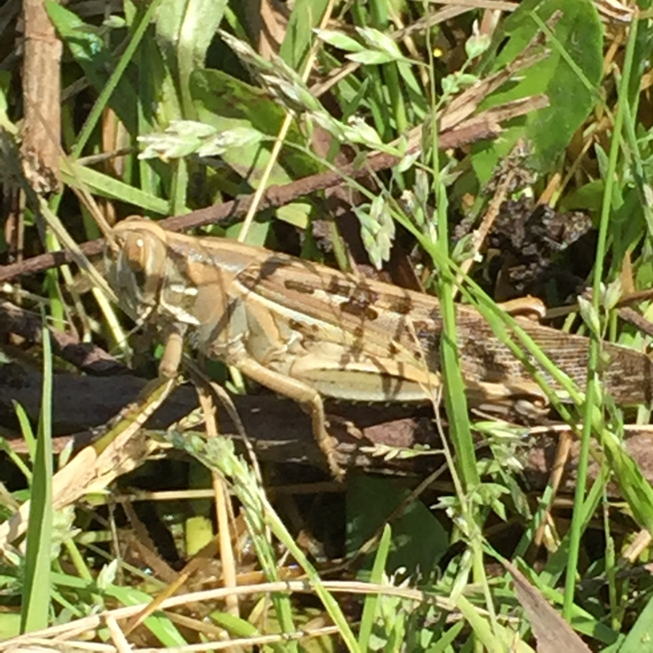
Assign students to create a PowerPoint presentation that explores the life cycle of a grasshopper (incomplete metamorphosis). This work could be done as “an at home” or “in the computer lab” assignment. Students will make a 2-3 minute presentation to the class.

Task
Students should research details about the life cycle of grasshoppers such as,
- where eggs are laid,
- what time of year eggs are laid,
- number of nymph stages
- diet differences from nymph to adult grasshopper
- the time span of each life stage, etc.
- how grasshopper species survive winter on the prairie,
- what prairie plants are eaten by grasshoppers,

At least 5 of these points should be included in the PowerPoint

Teacher Note:
Give students a copy of the PowerPoint grading rubric and briefly explain the rubric so the students will understand the expectations of the assignment.
Give the students the time limit for the presentation.
Make sure that they understand, that their presentation will be cut off at the end of the time limit.

Extenson
Students can be assigned to compare the life cycle of the grasshopper to an insect that has complete metamorphosis such as a butterfly or beetle. (Incomplete metamorphosis is also described as simple or gradual.)

Evaluate

Have each group of students discuss how they could improve their insect collecting process. They should list their ideas in their journals and each group will share their ideas with the class. As ideas are presented, students may add things they hadn’t thought of that are shared by other groups.

Use the following products for evaluation of students.

Science Journals: MonitoringSsheet - At the beginning of the Explore activity, tell students that you
will be checking their journal work, (possibly for a grade).

Group Explanation Presentations - Grading Rubric
Give each student a copy of the rubric before they begin their work and have them fill in the top
of the sheet. Rubrics can be clipped together, top rubric graded, and info transferred to other
rubrics when time permits. This way every student has a graded rubric to take home.

PowerPoint Presentations - Grading Rubric
Give each student a copy of the rubric at the beginning of the assignment. Have them put their
names on the sheet and return it to you when they show their PowerPoint presentation to
the class. Then you can use that sheet to grade the presentation.

See resource section for rubrics and journal monitoring sheet.

Resources:

1) Aesop’s Fable “The Ant and the Grasshopper”
http://www.dltk-teach.com/fables/grasshopper/mstory.htm

2) Field Guide to Grasshoppers, Katydids, and Crickets of the United States
by John L. Capinera, Ralph D. Scott, and Thomas J. Walker , 2004.

3) Teacher note* - Student Photographs
Transfer all of the students’ photos from the cameras into one file. When the students are
making their PowerPoints, they can browse through all the photos in the one file choosing any
to include in their presentations.

4) Teacher note* - Journal Handout
Make a copy of the “handout” below for every student to glue/tape into their journal
The handout will help the students to be more accountable for their time and journaling efforts.

Tasks 5 and 6 Student Page

Journal handout tape/glue into your journal.

Task 5 - Observations During Field Activity

- Observe the grasshoppers for adaptations (behavioral and physical) that may help them to elude capture by predators (students).
- Observe and describe plants that could be food and shelter for the grasshoppers.
- Observe other organisms that could be part of the food web with the grasshoppers.
- Explain which organisms are producers and which are consumers.
- Explain how grasshoppers interact with the living and non-living parts of the ecosystem.

Task 6 – Journal Activities
- Draw a larger than life-size diagram (15-20 cm) of a grasshopper and record your field observations in your journal.
- Label the grasshopper diagram to show physical adaptations and record any behavioral adaptations that were observed, such as jumping away when approached.
- Draw a prairie food web (on a separate page) that includes a grasshopper.
Be sure to include the Sun, and label all organisms with their name and role (consumer, producer,
etc). You may add organisms that you did not observe, but reason by inference that they could be
included, such as a bird.
Did you capture any decomposrs? How do they fit into the food web?
Name at least one decomposer that might be found in a prairie ecosystem. Make sure you have at least one decomposer on your food we diagram.

Write a sentence to explain how the food web would be affected by changes such as fires or floods.

Teacher Page
Science Journal Monitoring (carry this sheet on a clipboard in the field and classroom,
checking journals as you circulate amongst students. Journals could also be checked while students are working on their group presentations.) Teacher can use this monitoring sheet to help determine a journal grade if desired.)

Class: ____________________________________________ Date: __________

legend: WD = well done NMD= needs more details M =missing

Student name | grasshopper diagram  physical adaptations - labeled | grasshopper behavioral adaptations described | Prairie food web, including grasshopper

Student Page

Group Explanation Presentations - Grading Rubric

Date: ___________

Your name (circle your name): ___________________________________________

Partners’ names: _______________________________ _________________________________

________________________________

Topic: (circle the group’s assigned topic)

1 - frequency plots, 2 - prairie food web 3 - physical adaptations
4 - behavioral adaptations 5 - learned behaviors

criteria | 3 points | 2 points | 1 points
Topic content | All parts the assignment were addressed. Rich in details. | At least 4 parts of the assignment were addressed, and/or  sparse details. | Fewer than 4 parts of the assignment were covered, few if any details, or the presentation wandered off track.
Visual Presentation  of Poster | Diagrams and sketches were easy to interpret and were appropriate to the assigned topic. | Diagrams and sketches were easy to interpret and/or were mostly appropriate to the assigned topic. | Diagrams and sketches were not easy to interpret and /or were not appropriate to the assigned topic.
Poster and oral presentation  participation | All students contributed to the poster content and the oral presentation  Names and jobs are listed on the back of the poster | The majority of the students contributed to the poster and/or the oral presentation  Names and jobsare listed on the back of the poster | Poster and/or presentation was dominated by one or two students.  Names and jobs are not listed on the back of the poster

9 pts = 100 8 pts = 95 7 pts = 90 6 pts = 85 5 pts = 80 4 pts = 75 3 pts = 70

Your group’s grade: ____________________________

Grasshopper PowerPoint Presentation - Grading Rubric
Student name: __________________________________ Date: ___________

criteria | 3 points | 2 points | 1 points
title slide | Contains:  title, student’s name, date  field photo  nicely formatted | Missing one item,  but nicely formatted | Missing 2 or more items and/or  poorly formatted
Content Slides | - The life cycle of grasshopper is correctly represented.  (Incomplete metamorphosis)  - All Information is correct and flows in a logical order.  - Rich details, including appropriate visuals.  - If assigned, a correct comparison is made to an insect with complete metamorphosis.) | - The life cycle of grasshopper is correctly represented.  - Information flows in a mostly logical order.  - some details and  appropriate  visuals  - some small errors | - The life cycle of grasshopper may or may not be correctly represented.  - few details, and/or  - few visuals and/or not matching text  - several errors
Bibliography slide | contains:  - at least 3 references  - correctly formatted  - alphabetical order | contains:  - 2 references  - correctly formatted  - alphabetical order | contains:  - 1 correctly formatted reference, or  - references are incorrectly formatted.
Oral  Presentation | Student was  confident in speech and information,  referred only briefly to slides, had good eye contact with class  easily understood | Student lacked confidence in speech and/or information, or  mostly read slides  some eye contact  easily understood | Student seemed unprepared for presentation, or  Read all slides, or  no eye contact with class  difficult to understand

12 pts = 100 11 pts = 95 10 pts = 90 9 pts = 85 8 pts = 80 7 pts = 78 6 pts = 75 5 pts = 74 4 pts =7 Your grade:______________________
TEA Cross-curricular Objectives:

Grade 4
112.15 Science
1A Demonstrate safe practices and the use of safety equipment during classroom and
outdoor investigations.
2B Collect and record data by observing and measuring.
2C construct simple tables, charts, bar graphs using tools and current technology
to organize, examine and evaluate data.
4A Collect, record, and analyze information using tools, including, cameras, computers, hand
lenses, metric rulers, collecting nets, and notebooks, etc.
9A Investigate that most producers need sunlight, water, and carbon dioxide to make their
own food, while consumers are dependent on other organisms of food
9B Describe the flow of energy through food webs, beginning with the Sun, and predict how
changes in the ecosystem affect the food web such as fire in a forest.
10A Explore how adaptations enable organisms to survive in their environment.
10B Demonstrate that some likenesses between parents and offspring are inherited, passed
from generation to generation such as eye color in humans or shapes of leaves in plants.
Other likenesses are learned such as table manners or reading a book and seals
balancing balls on their noses.
10C Explore, illustrate, and compare life cycles in living organisms such as butterflies, beetles,
radishes, or lima beans.
111.6. Mathematics
9A Represent data on a frequency table, dot plot, or stem-and-leaf plot marked with whole
numbers and fractions.
126.7. Technology Applications
2A,B,C,D,E,F The student collaborates and communicates both locally and globally using
digital tools and resources to reinforce and promote learning.
110.15 English Language Arts:
15 A,B,C,D,E, Use elements of the writing process to compose text.
24 A,B,C,D,E, Research/gathering sources
25 Research/synthesize information
26 Research/organizing and presenting ideas

Grade 5

112.16. Science
1A Demonstrate safe practices and the use of safety equipment during classroom and
outdoor investigations.
2C Collect information by detailed observations and accurate measuring
4A Collect, record, and analyze information using tools, including cameras, computers, hand
lenses, rulers, collecting nets, and notebooks, etc.
9A Observe the way organisms live and survive in their ecosystem by interacting with the
living and non-living elements.
9B Describe how the flow of energy derived from the Sun, used by producers to create their
food, is transferred through a food chain and web to consumers and decomposers.
10A Compare the structures and functions of different species that help them live and survive
such as hooves on prairie animals or webbed feet in aquatic animals.
10B Differentiate between inherited traits of plants and animals such as spines on a cactus
or shape of a beak and learned behaviors such as an animal learning tricks or a child
riding a bicycle
10C Describe the differences between complete and incomplete metamorphosis of insects.
111.7. Mathematics
9A Represent categorical data with bar graphs or frequency tables and numerical data,
including data sets of measurements in fractions or decimals, with dot plots or stem and
leaf plots
126.7. Technology Applications
2A,B,C,D,E,F The student collaborates and communicates both locally and globally using
digital tools and resources to reinforce and promote learning.
110.16.English Language Arts:
15 A,B,C,D,E, Use elements of the writing process to compose text.
24 A,B,C,D,E, Research/gathering sources
25 Research/synthesize information
26 Research/organizing and presenting ideas

