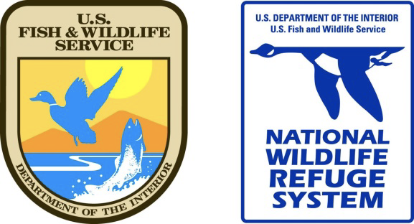

Dance Like an Attwater Prairie Chicken
Grade Level, TEK (Objective):
K, B.9. The student knows that plants and animals have basic needs and depend on the living and nonliving things around them for survival.
1 – 5, B.10. The student knows that organisms resemble their parents and have structures and processes that help them survive within their environments.

Materials:
Speaker for kid-friendly music
Markers or Crayons
Print (found at end of document)
- pictures in color for visual aids
- multiple sheets of “insects, leks, prairie” place markers
- Attwater Chicken Masks

Additional Resources:
https://www.fws.gov/refuge/attwater_prairie_chicken/
https://www.youtube.com/watch?v=BGSWi_vgu9A
9:00 minute video “Little Grouse on the Prairie”: https://attwater.org/
https://www.audubon.org/news/what-heck-lek-quirkiest-mating-party-earth

Program Instructions:
- Gather everyone in a circle & ask some inquiry questions (5 minutes)
- What is a wildlife refuge?
- Who is the National Park Service?
- What do park rangers do?
- Who is your favorite dancer?
- Show us your favorite dance!
*Relate it back to the theme. We’re going to talk about a fun little bird that likes to dance. Park rangers in Texas work hard to protect their habitat because they are endangered.
- Background information (10 minutes)
Have visual aids, show Attwater pictures/point out features
Show booming video a few times: https://www.youtube.com/watch?v=BGSWi_vgu9A
9:00 minute video “Little Grouse on the Prairie”: https://attwater.org/
About the Attwater Prairie Chicken (APC)
- a species of bird closely related to the grouse
- male bird likes to dance and boom (which means it makes a loud noise to attract a female partner)
- male has large, orange sacs on the side of his face that attract females
- bird becoming so scarce that there are only two known counties in Texas with small colonies
- requires tall grass prairies because it provides a safe environment to raise babies and hide from predators as well as insects, seeds, and flowers which are the food source
- Houston was once covered in a coastal prairie
- Leks are large groups of birds. They hang out together. For more information, go to the Audubon site https://www.audubon.org/news/what-heck-lek-quirkiest-mating-party-earth
- Birds eat grasshoppers, butterflies, moths, dragonflies and spiders.
Challenges
- It is endangered due to a loss of habitat due to urbanization of Houston. What does endangered mean? What does urbanization mean?
- Fire ants are an invasive, or nonnative, species that harm baby birds. What does invasive mean?
Solutions
-Protect habitat for birds, in places like the Attwater Prairie Chicken National Wildlife Refuge
-Participate in the Friends of the Attwater Prairie Chicken Student Festival Art Contest to raise awareness and concern

III. Lead students through any of these activities!
Activity 1: What adaptations does the bird have?
Students color their own male bird mask to match the colors of a prairie chicken.
Students vote on their favorite, as a female bird would do! Graph the results.

Activity 2: High Grass Prairie Chicken Musical Chairs
Count the number of kids and place that number of place markers, or “chairs,” (insect, lek, prairie) out in the playing area
The “chairs” include leks, insects, and prairie. The “chairs” are essential to the life and survival of the bird.
Begin the music and have the kids dance around like APC in a circle. Ensure that there is always one less “chair” than number of kids.
Once the music stops, the kids to run to one of the “chairs”. Whoever does not make it is out.
Add “chairs” for times when park rangers:
- protect more habitat
- have a successful captive breeding season causing lek gains
- females like the dancing of male birds, causing lek gains
- more grasses are planted in an area causing habitat gains
- good weather causing insect gains
- no pollution causing insect gains
Remove “chairs” for times when the community:
- freeway built causing loss of habitat
- hurricane causes loss of habitat
- industrial fire causes loss of insects
- runoff of pesticides into waterways causes loss of insects
- predatory hawks cause loss of leks (birds keep running and hiding)
- female birds don’t like the dancing of male birds, causing loss of leks

Activity 3: APC Dance- Off!
Ask for 3-4 volunteers, have them do their best APC impression for 30 seconds (dance and boom)
Have their peers vote by clapping the most/loudest

Activity 4: Insect Sweep
Using nets, sweep the grasses around your area to collect insects. Put them in a small container, and determine if there are enough bugs to sustain a population of birds at your school. For every one bird, you need ten insects per day. No nets? Just let the kids look around…
More detail here: https://www.youtube.com/watch?v=vKVVrIkSW5w
Not enough insects? Let students brainstorm what to do around the area to increase the number of insects. Hint: add native plants, which is their food source, or add hiding places, to escape predation.

Leks

Leks
Insects

Insects
Prairie

Prairie

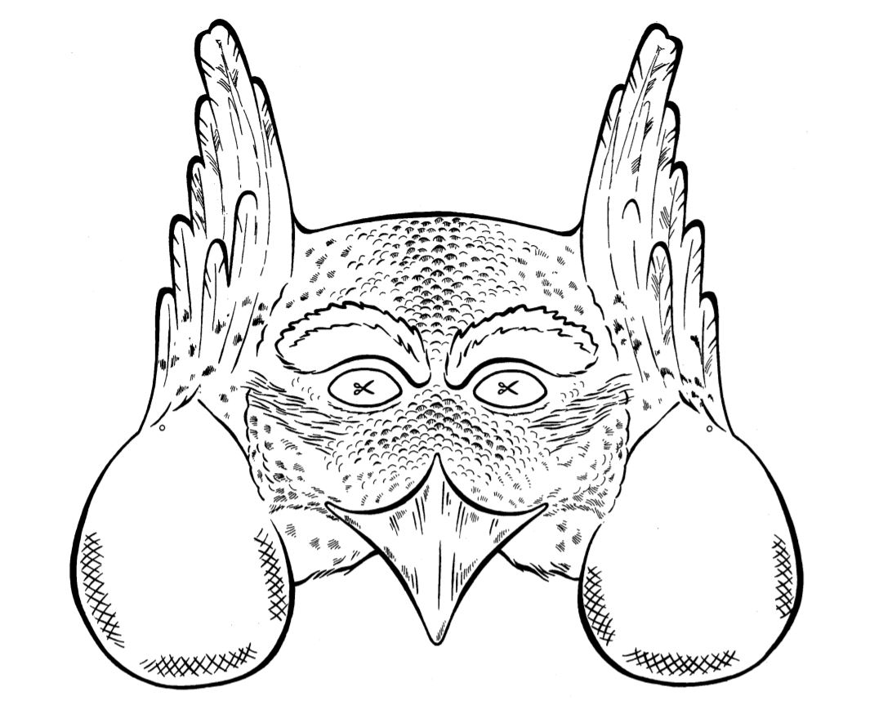

Attwater Prairie Chicken
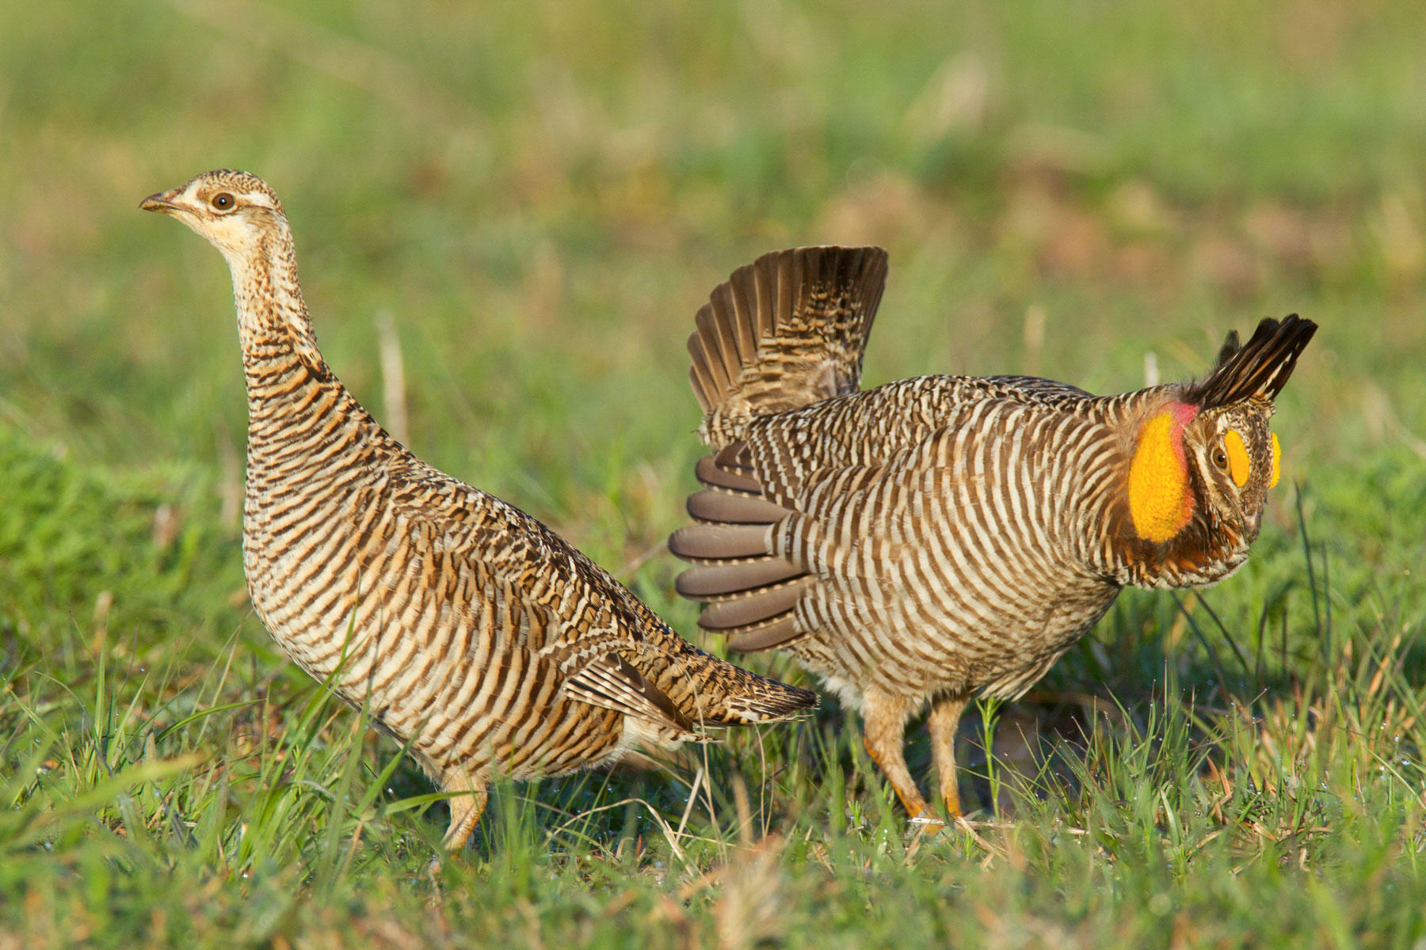

Coastal Prairie Habitat
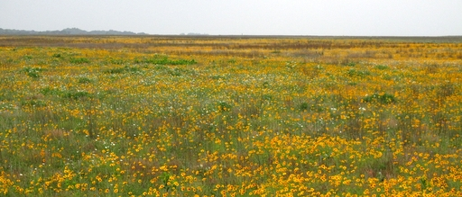

Baby Attwater Prairie Chicken
