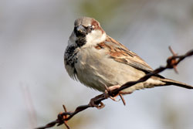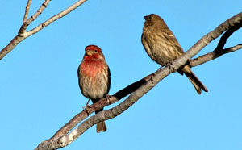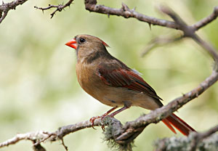
House Sparrow House Finch Northern Cardinal
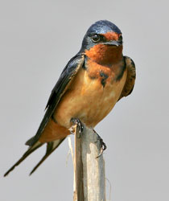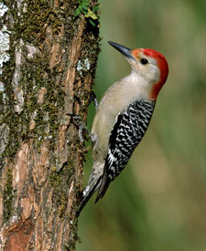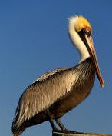
Barn Swallow Red-bellied Woodpecker Brown Pelican (Galveston)
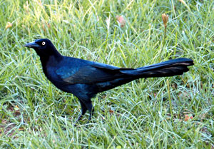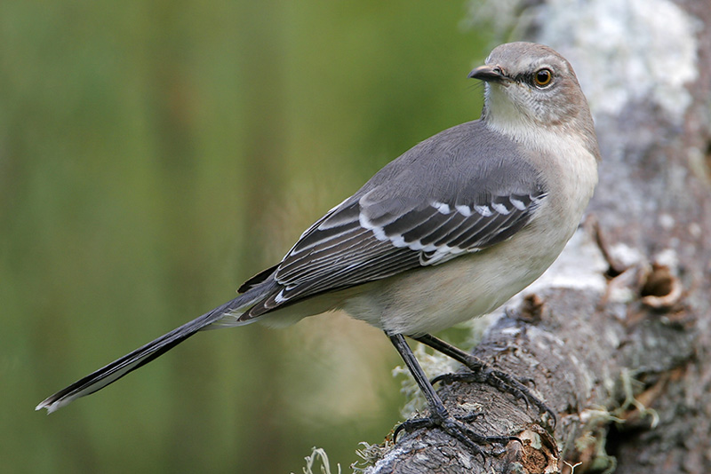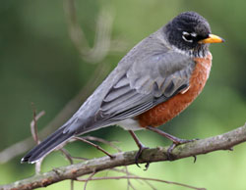
Great Tailed Grackle Northern Mockingbird American Robin
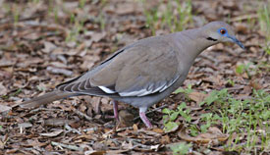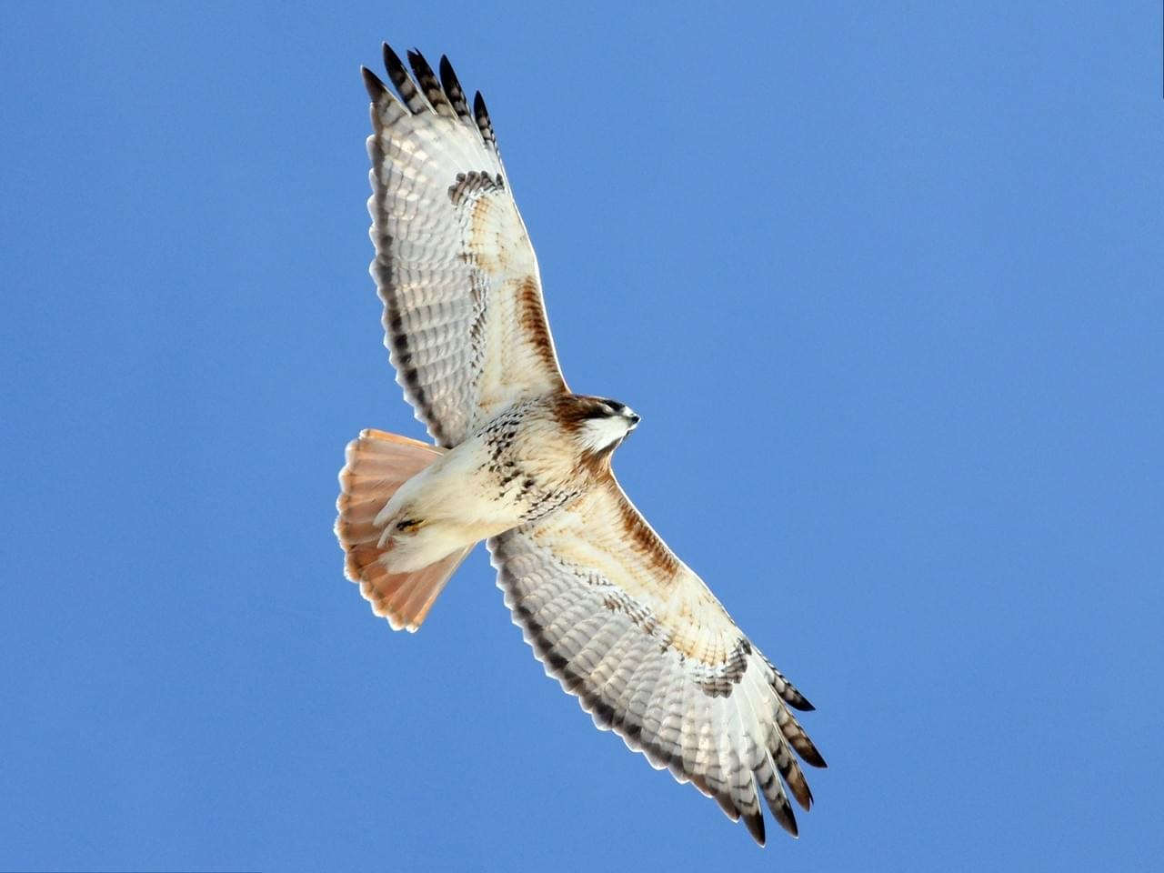
White-winged Dove Red-tailed Hawk

Common Birds in or around the Schoolyards of Houston
Start Here: hereinhouston.org/wildlife
Photo Credits:
“Top Birds of Houston - Bird-Friendly Communities.” Bird, www.birdfriendlyhouston.org/birding/top-birds/.
“Red-Tailed Hawk Photos and Videos for, All About Birds, Cornell Lab of Ornithology.” Photos and Videos for Red-Tailed Hawk, All About Birds, Cornell Lab of Ornithology, www.allaboutbirds.org/guide/Red-tailed_Hawk/media-browser/60384771.
The Texas Breeding Bird Atlas, txtbba.tamu.edu/species-accounts/brown-pelican/.

