Climate Change
5E Lesson Plan

Science/AP Environmental Science, Environmental Systems/ high school students

Materials List:
- 50 yellow puff balls for each group of 4 students
- Container for puff balls
- File folders cut into 1/4ths
- Cup
- 3x5 index cards (2 for each group)
TEKS for Environmental Science:
(9D) Science concepts. The student knows the impact of human activities on the environment. The student is expected to describe the effect of pollution on global warming, glacial and ice cap melting, greenhouse effect, ozone layer, and aquatic viability;

Required Course Content for AP Environmental Science:
STB-4 – Local and regional human activities can have impacts at the global level.

Lesson Objective/Summary: Students will investigate the greenhouse effect to better understand how human actions impact climate change. Prior to teaching this, the teacher has mentioned the greenhouse effect and greenhouse gases, but has not delved into the mechanics behind it and the importance of having the greenhouse effect working for our planet. Teacher will start this simulation without explaining. Telling them what it represents. This activity has such a “game” feel that the students are immediately drawn in and participate.

Differentiation Opportunities:
This activity is full of visual, kinesthetic and auditory opportunities. Additionally, students have the opportunity to work as individuals, in small groups, and as a whole class. Lastly, the formative assessment gives them a choice on how to complete the assignment. All students have the same prompt but the final product will be different and will fit the students comfort level and strength.

Greenhouse Effect 5E Lesson:
Teacher prep:
- Fold the index cards in half (hamburger style) to make a ramp. Each group will need 2 index cards. These can get soft if used for multiple class periods, so have extra on hand to refresh those that stop working as ramps.
- Cut the file folders into 4 pieces. Each group will need 8 total pieces.
- Puff balls and index cards go on one side of the table with 2 students. The cup goes on the other side of the table with the other 2 students.
- Place 5 file folders evenly spaced apart in between the two groups of students.

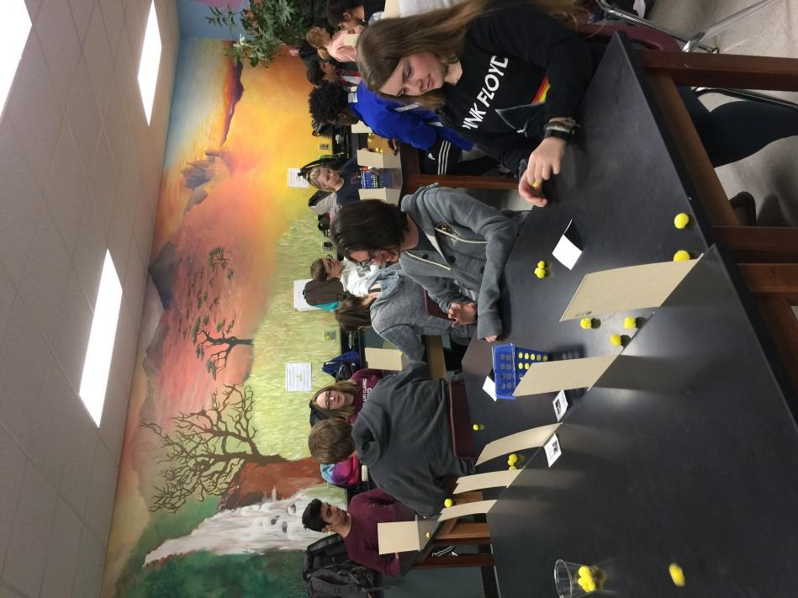

The set up: five file folder pieces spread out evenly, puff balls in a container with index card ramps on one side, cup on the other.

Engage: Students will practice their flicking technique. This will be loud, “messy” and fun.
- Students should practice flicking the puff balls OVER the file folders using the index card as a ramp. They should try to get the puff ball to land on the table on the other side of the file folders.
- One side practices for a minute then they switch sides so the other 2 students can practice trying to get the puff balls over the file folders.
- Clean up the puff balls.
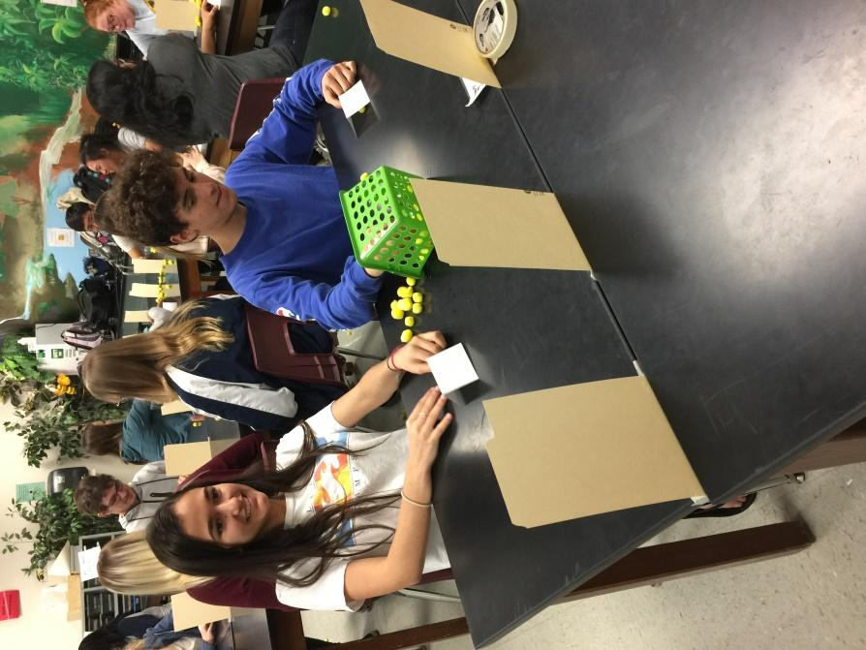

Students practicing flicking the puff balls over the 5 file folder pieces.

Explore #1: Students complete the full activity and record class data.
- The students with the puffballs will start flicking the puffballs over. They should only grab from the container of puffballs. They cannot reflick puffballs that didn’t make it over. Once they finish all the puffballs in the container, they are done.
- The students on the receiving end will ignore all the puffballs except the ones that land on the table. If a puffball lands on the table, the students will try to flick it through the gap between the file folders to the other side. If the puff ball makes it, they do nothing. If it does not make it through the gap and bounces off the file folder, the student must place it in the cup.
A few notes: Students should flick back the puff balls from where they land. They should not move the puffball to make a better shot through the folders. They should also only flick the puffball once. They cannot “dribble” the puffball.
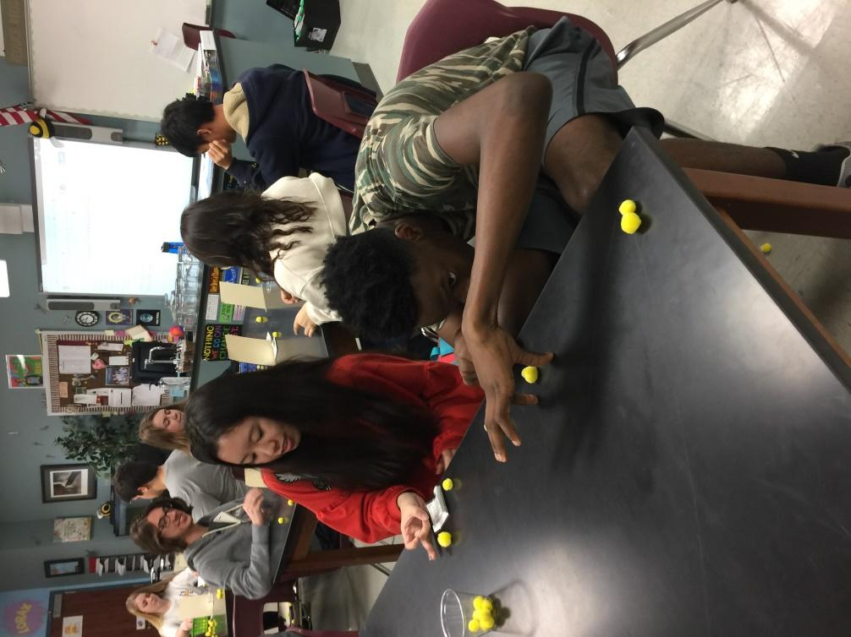

Students try to flick the puff balls back through the gaps between the file folders. Note the cup of puff balls that didn’t make it through and ended up in the cup. These will be counted and recorded later.
- Once the container of puff balls is empty and all puff balls have tried to be returned through the gap, students count and record the number of puffballs collected in the cup. You can use Google sheets to collect data. The chart looks like this: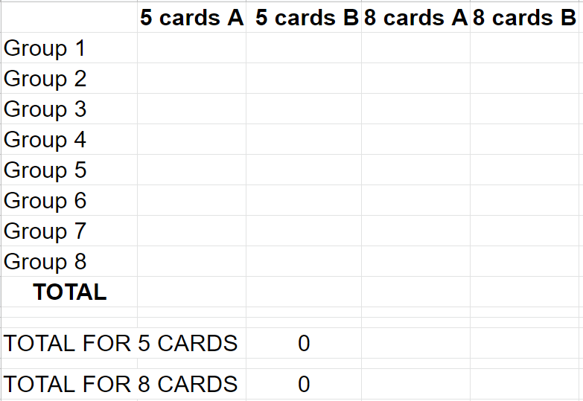

- Reset the setup by cleaning up the puff balls. It is okay if different groups have amounts of puff balls because the data that will be analyzed will be class data so the same number of puff balls should be flicked in all rounds. Let the students switch roles and repeat steps 1-3.
- Reset the setup and switch roles again.
- This time and add 3 more file folders to make a total of 8. These should be set up so they are evenly spaced apart.
- Repeat steps 1-4.
- Have the students look at the data and discuss in their groups what the notice about their group data and the whole class data.
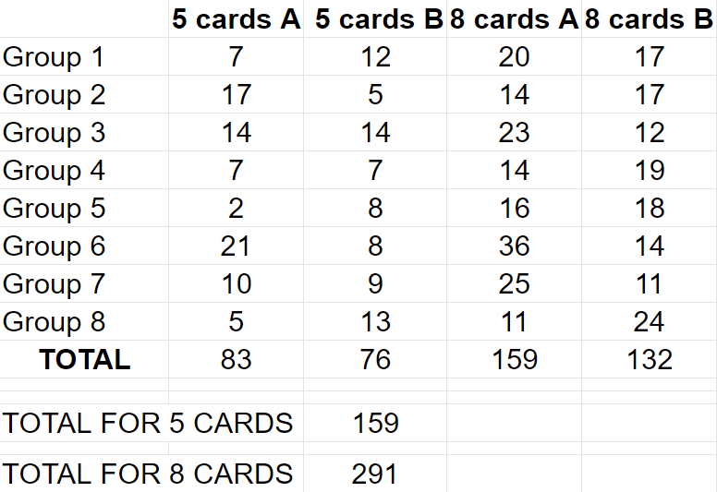
Sample chart with class data.

Explanation #1:
- Have a full class discussion about the data and what the students think is going on in the simulation.
- Show the students the following HHMI Biointeractive video clip: https://www.biointeractive.org/classroom-resources/greenhouse-effect
- Students meet in lab groups and discuss the video, data, simulation, and global warming.
- Have a full group discussion. These questions might help guide the discussion if needed.
  - What does the container of puff balls represent?
  - What do the puff balls represent as they go over the file folder pieces?
  - What does the table top represent on the other side of the file folders represent?
  - What do the puff balls represent as they are flicked back through the file folders?
  - What do the file folder pieces represent?
  - What happens to the puff balls that make it through the gap?
  - What happens to the puff balls that don’t make it through the gap? Why is this significant?
  - What does adding 3 more file folders represent?
  - What happens to the number of puff balls that don’t make it through the gap as the number of file folder pieces goes up? How does this relate to the real world?
The simulation:
- The container of puff balls represents the sun.
- The puffballs represent radiation from the sun (it is UV when it goes over the file folder. UV is high energy…it goes high over the file folders. It is infrared when the opposite side flicks it between the cards Infrared is lower energy…it goes low in between the gaps of the card).
- The table top on the other side of the file folders represent Earth.
- Absorption of the UV radiation by the Earth is represented when a puffball lands on the other side of the table.
- Puff balls that do not make it over represent those reflected.
- The file folders represent the greenhouse gases.
- The puff ball bouncing off the card when the students are trying to return it back to “space” represents the greenhouse gases absorbing the infrared radiation and releases it back out.
- The amount of puff balls in the cup represent the amount of radiation remaining in the atmosphere.

Explore #2:
Students go to the Greenhouse gas emissions interactive dashboard and look at the information for Houston, Texas.

Explain #2:
Working in pairs, students make a list of greenhouse gas sources in the Houston area. Afterwards, we make a master list of their sources.

Elaboration:
The goal of this elaboration is to answer the following question: what can be done to decrease greenhouse gases coming from the sources we listed?

Invite a guest speaker from the Citizens’ Climate Lobby to speak about what the students can do personally and politically to decrease greenhouse gas emissions.
Evaluation:
Formative assessment: students, utilizing either a computer or paper, draw a diagram/cartoon that explains how changes in greenhouse gases impact the temperature on Earth.

This website is very helpful with cartoon layouts: https://www.printablepaper.net/category/comics.

