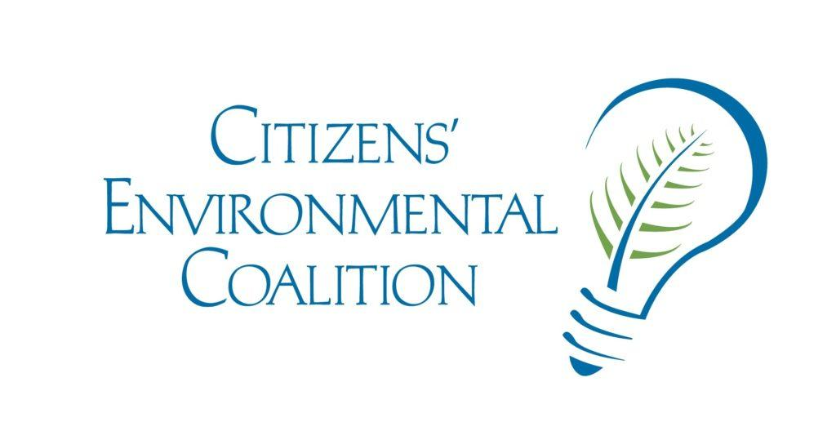
Community-Based Learning Experiences
5E Lesson Plan
HEREinHouston.org

1. Alicia Mein-Johnson
Citizens’ Environmental Coalition
alicia@cechouston.org

2. Subject area / course / grade level: Science, Middle or High School

3. Materials List: notecard, tape, microscope, dissecting scope, access to the outdoors, if possible but not necessary, borrow Plume Air Quality meter from David McMac/McMac Consulting/Air Champion program and/or GASTEC Air Quality meters from Carolina Biological Supply

4. Overarching TEKS, ELPS, CCRS, and Global Graduate/other district standards (chart or list).

TEK | CCRS | ELPS
8th grade & Biology: functions of human systems, levels of organization, reproduction in organisms, human impact on ecosystems, processing skills | Human practices and their impacts | Listening, writing
Environmental Science: impact of human activities on the environment, processing skills | Human practices and their impacts | Listening, writing
Chemistry: quantify changes in chemical reactions | Human practices and their impacts | Listening, writing

5. Lesson Objective/Summary: Students collect air quality data from different areas of campus and compare to data in Houston. They create a plan to improve air quality on their campus. Connections to health, air quality, pollen/plants, chemical reactions and all of the processing TEKS.

6. Differentiation Opportunities: Students determine a way to reduce air pollution on campus (this can be as easy or hard as they want it to be) and options remain for students to follow through on the plan. To extend the lesson, students may relate the effects of rising carbon dioxide levels to ocean acidification using this activity from NOAA. Reach out to the NOAA Flower Garden Banks Marine Sanctuary (off the Texas coast) for a speaker relating the health of coral reefs to ocean acidification/air quality.

7. Community-Based Resources:

A. Use guest speakers from One Breath Partnership or the Houston Health Museum or David Mclean (McMac Consulting) for the engagement, encouraging students to become Air Champions. Native Plant Society of Houston may offer a speaker on botany.

B. Use Air Now for local air quality data for comparison.

C. Use Take Care of Texas for solution ideas.

8. Engage: Taped message from David Mclean asking students to predict sources of pollutants on their campus as part of an Air Champion program. Or show a video from the Galena Park High School Students, like this one.

9. Explore: Using a map of campus, students will hypothesize four separate locations (indoor or outdoor) that may have high levels of particulate matter/poor air quality. They will test for particulate matter using a notecard with a 1 cm x 1 cm hole cut out, with tape over it. Leaving it in the locations for a few hours/one day, when they return, they can look at the particulate matter under a microscope or dissecting scope.

If possible, borrow a Plume Flow Device from the Air Champion program, or find GASTEC Air Sampling meters on Carolina Biological Supply. Collect data on campus for NO2, VOC, PM1, PM2. 5 and PM10, and compare with current data in Houston using Air Now.

10. Explanation: Students research predominant plants blooming in Houston at the time of year, and determine if any of their particulate matter on the notecard/tape is pollen. They must investigate types of particulate matter to determine the composition of the remaining PM.

Students will explain why their Plume/GASTEC data did, or did not, match the air quality data in Houston. Chemistry students expound upon the atmospheric reactions creating ground level ozone.

Students propose a way to decrease pollutants on campus to improve air quality (indoor or outdoor).

11. Elaboration: Choose a guest speaker based on objectives for your course. Speaker from One Breath Partnership explains the air quality issues facing Houston, and how data is collected in town; explains the chemical reactions to create ozone. Or, speaker from the Houston Health Museum discusses impacts of air quality on human health & body systems. Or, speaker from Native Plant Society of Houston discusses the benefits of plants in carbon dioxide sequestration.

Students discuss solutions to improving Houston’s air quality (both indoor and outdoor) with speakers, and further develop a real solution. Students create a video or write a letter to the leader on campus (open-ended), asking for help enacting their solution. They must explain how they came to this solution (thus evaluating their learning objectives).

12. Evaluation: Students submit a self-reflection about what they learned, how they learned it, and questions they still have about the original learning objectives.

Students also enact their air quality solutions, as part of a Student Council project, where time, energy and resources can be spent on implementation.

