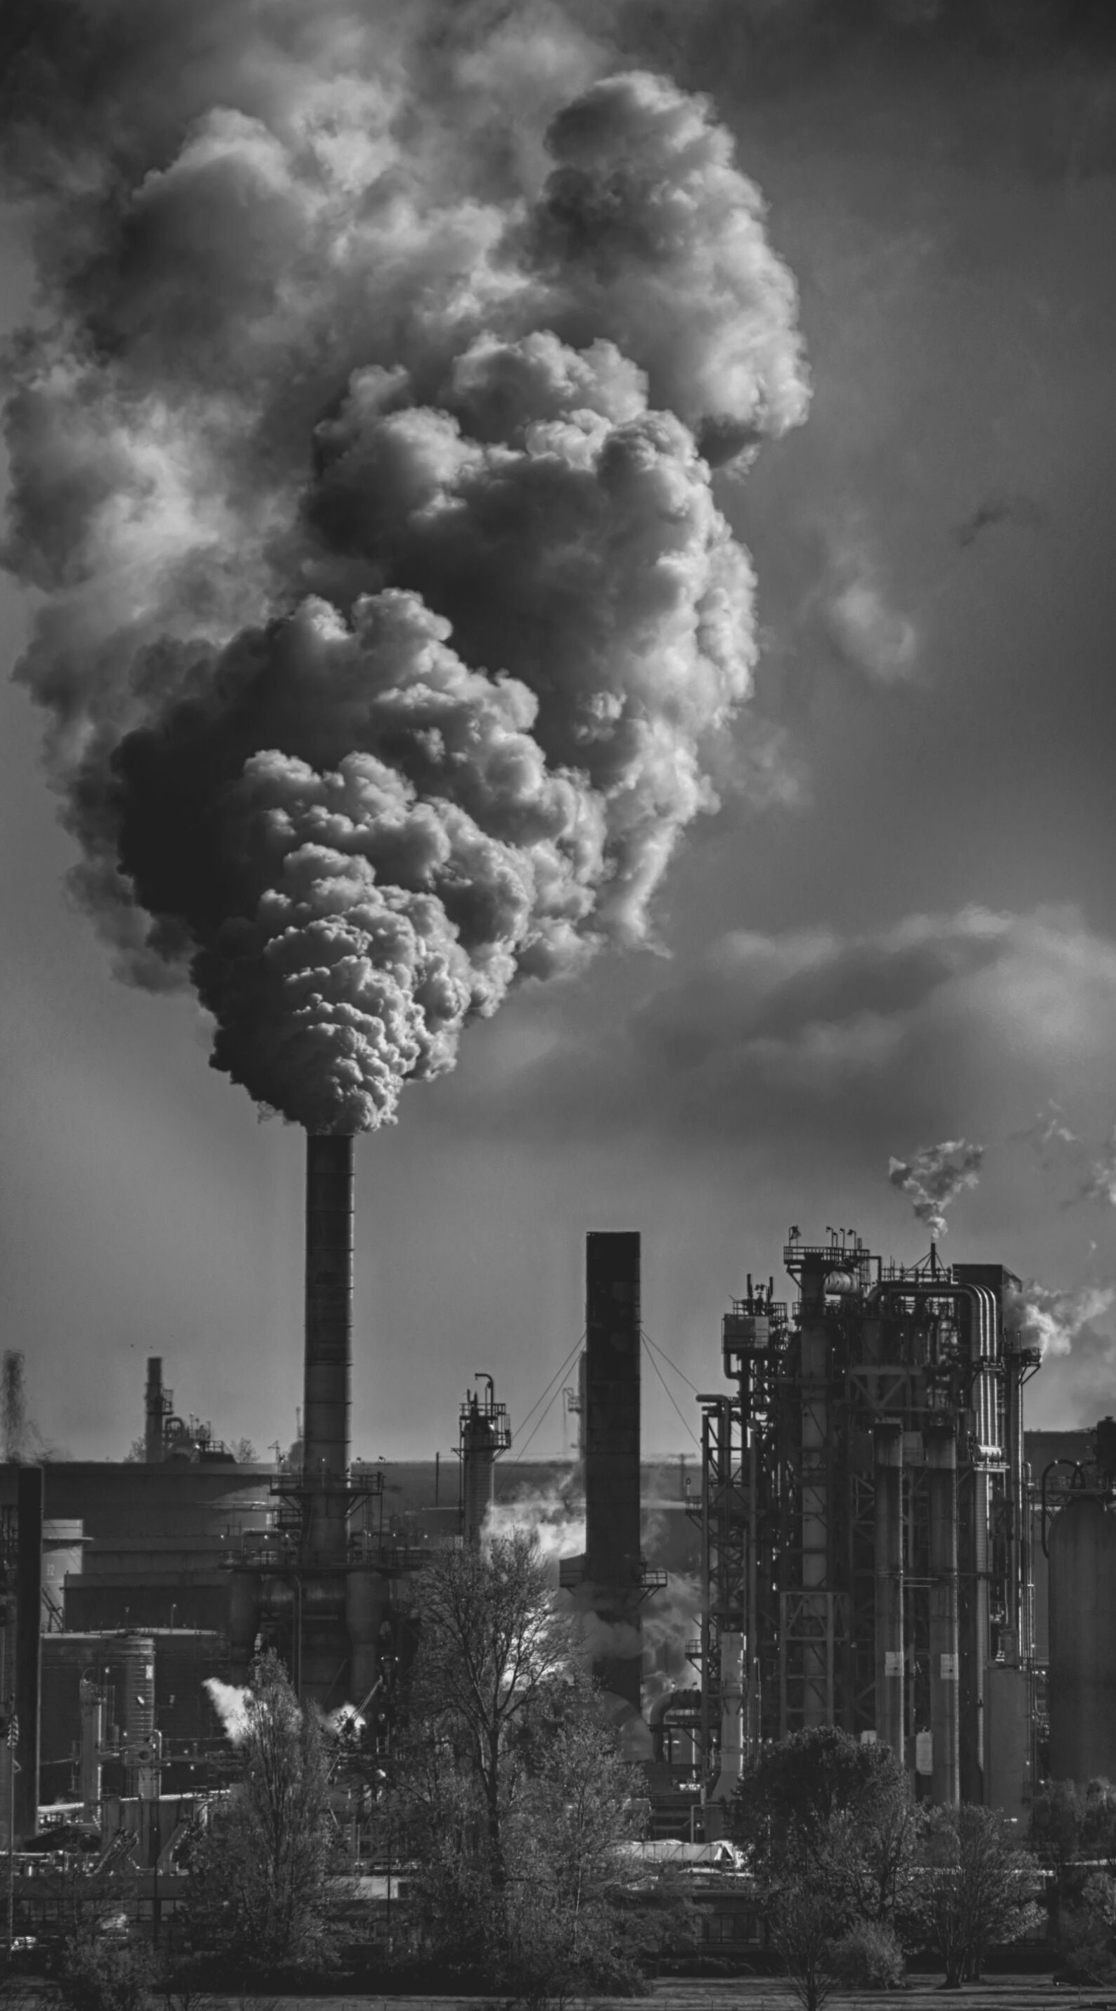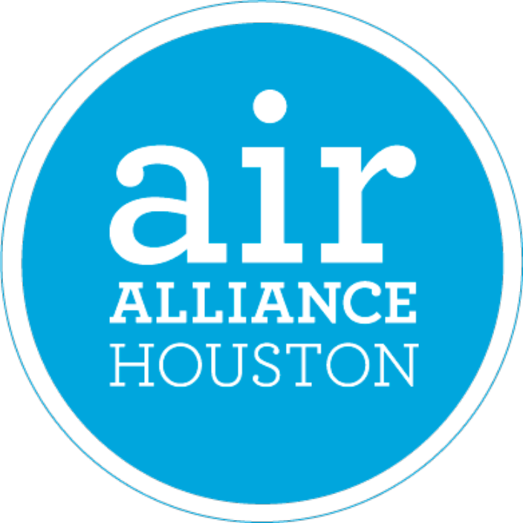

Air Pollutant Fact Sheets
What you need to know about Houston's "Dirty Dozen"

Prepared by: Cally Xi

Ozone (O3)

What is it?
Ozone is an odorless, colorless gas comprised of three oxygen atoms (1,2). Depending on where these ozone molecules are located in the atmosphere, they can be helpful or harmful to human health (1). If ozone exists in the atmosphere 10-30 miles above the Earth's surface - the stratosphere - it is beneficial and blocks harmful ultraviolet light from damaging our skin. However, if ozone exists at ground level - tropospheric ozone - it promotes photochemical smog formation and could lead to adverse health effects (2,3).

Emission Source
Ozone is not a directly emitted pollutant but is a byproduct of the reaction between nitrogen oxides (NOx), volatile organic compounds (VOCs), heat, and sunlight.
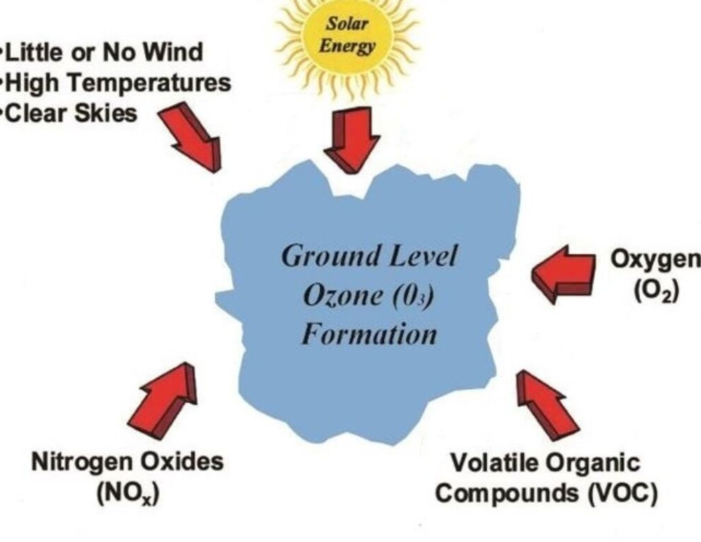
Nitrogen oxides are produced from fossil fuel-burning sources like power plants and automobiles. VOCs are generated by sources like gasoline and solvents (2).

Who is at Risk?
The people who are most at risk from breathing air containing ozone are (4):
people with asthma children
older adults
adults who are active outdoors people with heightened sensitivity to
ozone. For example, people with reduced intake of certain nutrients like Vitamin C and E may be at greater risk from ozone exposure (1,4).

Health Effects
Short-term ozone exposure can have negative effects on human health, including respiratory system irritation, which will lead to coughing, throat irritation, and/or
chest tightness (2). Ozone can also reduce lung function, meaning that you may struggle to breathe deeply or vigorously. This health impact in particular can aggravate asthma attacks, making ozone particularly harmful for those who have asthma. Ozone can also worsen chronic lung diseases like emphysema and bronchitis.
Ozone can inflame and damage cells in your lung lining. After a few days, the damaged cells are shed and are replaced with new cells. However, if this damage happens repeatedly, the lungs may change in a way that causes long-term effects (1).

OZONE FACT SHEET | AIR ALLIANCE HOUSTON
1

What can you do?

The best way to protect your health is to find out when ozone levels are high in your area and act to minimize exposure. The Environmental Protection Agency (EPA) and local air agencies have tools that will provide you with information on current ozone levels and suggested actions to reduce your ozone exposure. The Air Quality Index (AQI) reports current levels of ozone and other common air pollutants. The color scheme can help you determine if local air quality may adversely impact your health. For example, orange means that conditions are "unhealthy for sensitive groups," so a member of a sensitive group may want to reduce outdoor exercise. Purple indicates “very unhealthy” air quality, meaning that everyone should avoid outdoor activity (1).

Ozone Concentration (ppm) (8-hour average, unless noted) | Air Quality Index Values | Air Quality Index Values
0.0 to 0.064 | 0 to 50 | Good
0.065 to 0.084 | 51 to 100 | Moderate
0.085 to 0.104 | 101 to 150 | Unhealthy for Sensitive Groups
0.105 to 0.124 | 151 to 200 | Unhealthy
0.125 (8-hr) to 0.404 (1-hr.) | 201 to 300 | Very Unhealthy

There are a few things you can do to reduce ozone levels. Because cars and other vehicles are the largest source of ozone precursors, driving less, carpooling, and taking public transport are great ways to reduce ozone production. If you must drive, make sure that your car is well-maintained and be careful not to spill gasoline when you fill up your tank. Lastly, make sure that you tightly seal the lids of chemical products like solvents and cleaners (1).

References

- Environmental Protection Agency. Smog - Who does it hurt? What you need to Know About Ozone and Your Health.; 1999. https://www.epa.gov/sites/production/files/2015-06/documents/smog.pdf
- Chen TM, Gokhale J, Shofer S, Kuschner WG. Outdoor air pollution: Ozone health effects. Am J Med Sci. 2007;333(4):244-248. doi:10.1097/MAJ.0b013e31803b8e8c
- Gad SC. Ozone. In: Encyclopedia of Toxicology: Third Edition. Academic Press; 2014. doi:10.1016/B978-0- 12-386454-3.00895-2
- Environmental Protection Agency. Health Effects of Ozone Pollution. https://www.epa.gov/ground-level- ozone-pollution/health-effects-ozone-pollution. Published 2018. Accessed June 27, 2019.

OZONE FACT SHEET | AIR ALLIANCE HOUSTON 2

1,3-Butadiene

What is it?
1,3-Butadiene is a highly reactive, colorless gas with a mild, gasoline-like smell (1,2). In addition to the toxic properties of butadiene, the chemical is a volatile organic compound (VOC) that contributes to ozone formation (3). 1,3-butadiene is mostly used to produce synthetic rubbers, which are then used in industrial and consumer products like truck tires, computers, and protective clothing.
Butadiene is also used to produce petrochemicals and to make plastics like shock-resistant polystyrene.

Emission Sources
The largest source of outdoor 1,3-butadiene is motor vehicle exhaust, while smaller sources include 1,3-butadiene production and the burning of fossil fuels, wood, plastic, and rubber (1,4). As a result, greater 1,3- butadiene levels tend to be found in highly industrialized cities, near oil refineries, chemical manufacturing plants, and plastic and rubber factories (1). The largest source of indoor 1,3-butadiene is tobacco smoke.
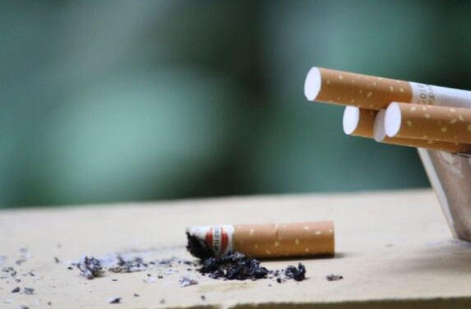

Who Is at Risk?
The highest 1,3-butadiene exposures occur in occupational settings. Workers in industrial activities like petroleum refining and rubber manufacture have the greatest chance of being exposed (2).
Residents who live near industrial facilities like oil refineries, chemical manufacturing plants, or plastic and rubber factories have an elevated risk of exposure to 1,3- butadiene (1).

Health Effects
People are usually exposed to 1,3-butadiene through inhalation. In a study involving industrial rubber workers, those exposed to large amounts of 1,3-butadiene gas experienced eye, nose, throat, and lung irritation. In some, coughing, fatigue, and drowsiness also developed. However, it is unclear whether 1,3-butadiene was the cause of these symptoms (1).
Chronic (long-term) exposure to 1,3- butadiene via inhalation may lead to an increase in cardiovascular diseases. One study found that chronic 1,3-butadiene exposure may be linked to excess mortality from certain types of cardiovascular diseases such as arteriosclerotic heart disease, a disease where the walls of the arteries supplying blood to the heart thicken and harden (1,5).

1, 3- BUTADIENE FACT SHEET | AIR ALLIANCE HOUSTON
1

Health Effects (cont.)
In animal studies, 1,3-butadiene is linked with a wide range of non-cancer health effects, such as nasal inflammation, changes to lung, heart, and reproductive tissues, brain and behavioral effects, and blood changes. In studies conducted on mice, 1,3- butadiene caused reproductive and developmental effects, including ovarian atrophy, the deterioration of the ovaries.
However, there is currently no human data on these effects (1).
The International Agency for Research on Cancer (IARC) has classified 1,3-butadiene as a Group 1 carcinogen, meaning that inhalation of 1,3-butadiene causes cancer in humans. There is evidence showing that greater exposure to butadiene can lead to increased risk for haematolymphatic malignancies - cancers of the blood-forming tissues or cells in the immune system. 1,3- butadiene has also been linked to excess leukemia deaths in workers and a elevated incidence of leukemia cases among children in South-east Texas (2).

References
- Agency for Toxic Substances and Disease Registry. Toxicological Profile for 1,3-Butadiene.; 2012.
- International Agency for Research on Cancer. 1,3-butadiene. IARC Monogr Eval Carcinog Risks to Humans. 2012;100F:309-338.
- Czader BH, Rappenglück B. Modeling of 1,3-butadiene in urban and industrial areas. Atmos Environ. 2015;102:30- 42. doi:10.1016/j.atmosenv.2014.11.039
- Agency EP. Health Assessment of 1,3-Butadiene.; 2002.
- Mosby. Mosby’s Dictionary of Medicine, Nursing & Health Professions. (O’Toole MT, ed.). St. Louis: Elsevier; 2009.

What Can You Do?
To reduce your exposure to outdoor 1,3- butadiene, try to spend as little time as possible near areas of heavy vehicle traffic. If possible, avoid living, working, or playing close to busy roads and industrial facilities (1).
To reduce your indoor 1,3-butadiene exposure, ensure proper ventilation from wood-burning fireplaces. Additionally, when you are in an enclosed space like a garage, make sure to turn off all vehicle engines.
Lastly, avoid tobacco smoke, especially when indoors (1).

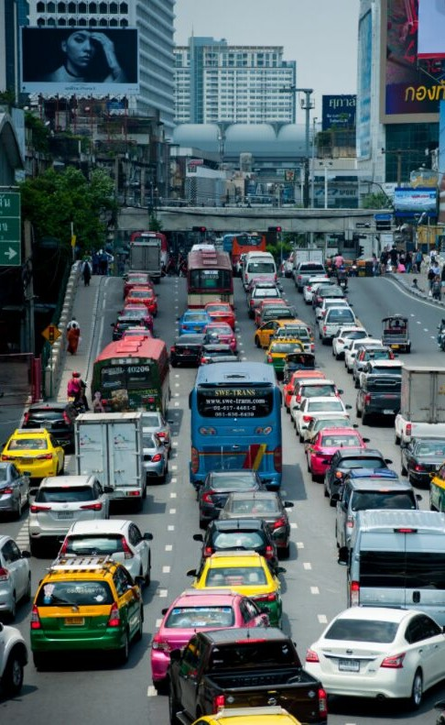
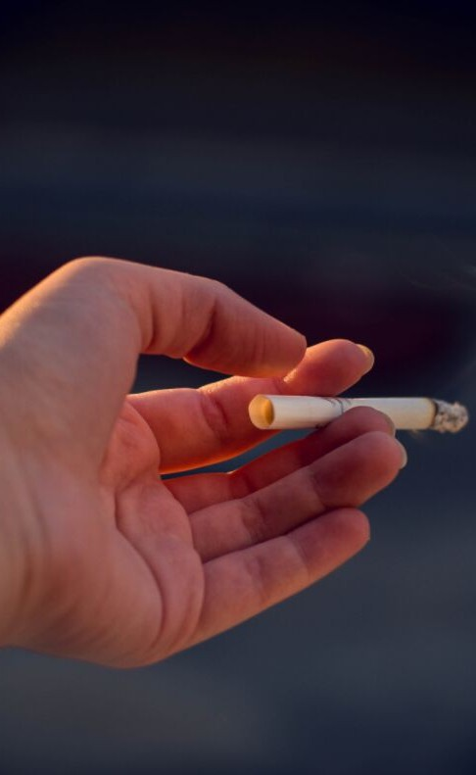

1, 3- BUTADIENE FACT SHEET | AIR ALLIANCE HOUSTON 2

Hexavalent Chromium (VI)

What is it?
Chromium is a naturally occurring metal found in rocks, animals, plants, and soil. The two main forms of chromium are trivalent chromium (Chromium III) and hexavalent chromium (Chromium VI) (1). These compounds have no identifying taste or odor (2). Trivalent chromium is an essential nutrient for the body. In contrast, hexavalent chromium is produced through industrial processes and is harmful to human health.
Chromium compounds like Chromium VI are used in industries like electroplating and stainless-steel production (3). As a result, chromium is found in products such as stainless-steel cookware, metal-on-metal hip replacements, and wood treated with copper dichromate (1).

Emission Sources
People are usually exposed to chromium VI by breathing it in, ingesting it through food or water, or touching it with bare skin (3).
Chromium in the air occurs from industrial processes, metal working, and the burning of fossil fuels and pressure-treated wood. The most important industrial source of chromium VI in the atmosphere is ferrochrome production. Ore refining,

cement-producing plants, and catalytic converters for automobiles are some examples that contribute to chromium compounds in the atmosphere (4). It is important to note that the most common route of exposure to elevated levels of chromium VI is from indoor cigarette smoke (1).

Who is at Risk?
Workers in chromate production, stainless- steel production, chrome plating, and tanning industries are exposed to much greater concentrations of hexavalent chromium compared with the general population (1).

Additionally, those who live close to waste disposal and recycling sites that process chromium-containing materials or chromium manufacturing and processing plants are more likely to be exposed to greater amounts of chromium than the general population (1).

HEXAVALENT CHROMIUM FACT SHEET | AIR ALLIANCE HOUSTON
1

Health Effects

The most common health problems in people exposed to chromium involve the respiratory tract, including a runny nose and breathing problems such as cough, shortness of breath, and wheezing. Inhaling high concentrations of hexavalent chromium may also have gastrointestinal and nervous system effects. Workers have also developed allergies to compounds containing chromium, which can cause breathing issues and skin rashes (1).
Oral consumption of hexavalent chromium in food and water can also lead to adverse health effects. Acute (short-term) oral exposure to high doses of chromium has produced health effects like abdominal pain, vomiting, and bloody diarrhea. Long-term oral exposure to chromium has been linked with diarrhea, abdominal pain, indigestion, and vomiting (1).
In workers exposed to hexavalent chromium, dermal contact can be an issue. Chromium VI compounds can produce effects on skin such as irritation, burns, and allergic eczema. However, for individuals not working in a chromium-related industry, environmental exposure will not usually cause dermal effects (1).
While more research is needed, many studies indicate that chronic (long-term) exposure to hexavalent chromium may
cause negative health outcomes. Chronic inhalation of chromium in humans can cause respiratory effects such as bronchitis, pneumonia, and asthma. Additionally, long- term oral or inhalation exposure to hexavalent chromium can produce effects on the liver, kidney, gastrointestinal tract, immune system, and potentially the blood (1,5,6).
The International Agency for Research on Cancer (IARC) has classified hexavalent chromium as a Group 1 carcinogen, meaning that it causes cancer in humans. Occupational exposure to hexavalent chromium compounds is associated with increased risk of respiratory system cancers, especially lung cancer. In animal studies, hexavalent chromium exposure caused additional outcomes like stomach, intestine, and lung tumors (1).
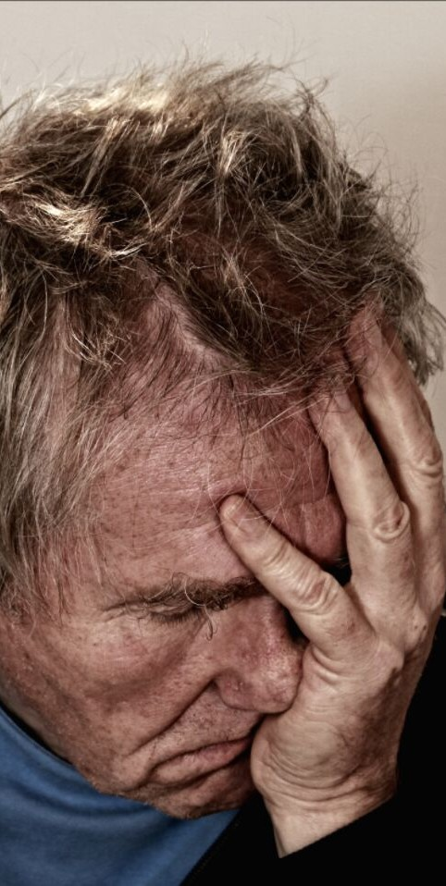
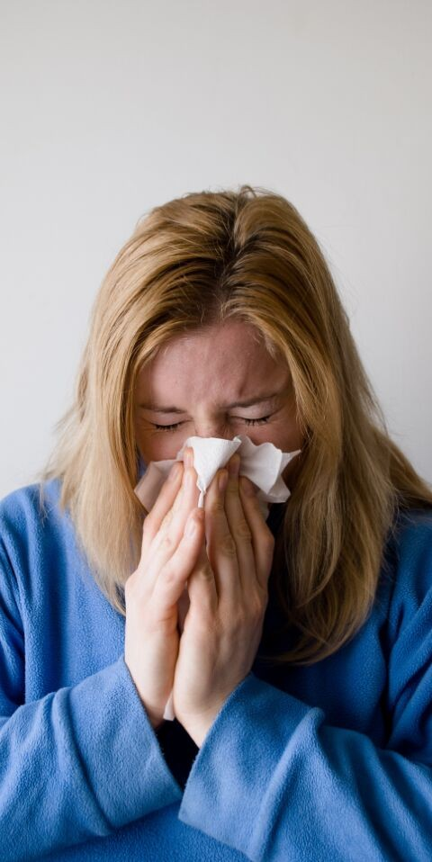

HEXAVALENT CHROMIUM FACT SHEET | AIR ALLIANCE HOUSTON
2

What Can You Do?
There are a few steps you can take to reduce your risk of exposure to chromium. Chromium is a component of tobacco smoke, so stop smoking altogether or avoid smoking indoors to limit exposure to children and other family members (1).
Older, pressure-treated lumber may be treated with chromated copper arsenate. Try to avoid burning, cutting, or sanding these materials to reduce your chromium exposure risk (1).
Children should avoid playing in soil near uncontrolled hazardous waste sites where chromium VI may have been disposed (3).
Lastly, clothing or items removed from the workplace might carry chromium VI if you work somewhere with high chromium exposure. Make sure to wash these to remove residual chromium (1).

References

- Agency for Toxic Substances and Disease Registry. Toxicological Profile for Chromium.; 2012. https://www.ncbi.nlm.nih.gov/books/NBK158855/pdf/Bookshelf_NBK158855.pdf.
- Agency for Toxic Substances and Disease Registry. Chromium-ToxFAQs. https://www.atsdr.cdc.gov/toxfaqs/tf.asp?id=61&tid=17. Published 2012. Accessed July 18, 2019.
- US Department of Health and Human Services. Hexavalent Chromium.; 2018. doi:10.1201/b11069-16
- US Environmental Protection Agency. Toxicological Review of Trivalent Chromium.; 1998. https://cfpub.epa.gov/ncea/iris/iris_documents/documents/toxreviews/0028tr.pdf.
- International Programme on Chemical Safety. Environmental Health Criteria 61 - Chromium. Geneva; 1988. http://www.inchem.org/documents/ehc/ehc/ehc61.htm#SectionNumber:8.3.
- US Environmental Protection Agency. Toxicological Review of Hexavalent Chromium.; 1998. https://cfpub.epa.gov/ncea/iris/iris_documents/documents/toxreviews/0144tr.pdf.

HEXAVALENT CHROMIUM FACT SHEET | AIR ALLIANCE HOUSTON 3

Benzene

What is it?
Benzene is a colorless liquid with a sweet smell. Benzene evaporates into the air very quickly, is highly flammable, and dissolves slightly in water. Because it is a widely used chemical formed from both natural and anthropological processes, benzene is found in air, water, and soil (1).
Most benzene produced is made from petroleum and ranks as one of the top 20 chemicals by production volume produced in the United States. Benzene has a wide variety of uses, including as a component in motor fuels, as a solvent for fats, as a component of plastics, rubber, and as a chemical intermediate. It is also used to manufacture pharmaceuticals, detergents, and pesticides (1,2).

Emission Sources
Industrial processes are the main source of man-made benzene in the environment.
Emissions are often caused by burning coal and oil, benzene waste and storage operations, motor vehicle exhaust, and evaporation from gasoline stations. Other sources of exposure include vapors of gases from products that contain benzene like glues, paints, and detergents. However, for
U.S. smokers, cigarette smoke is the most significant source of benzene exposure.

Smoking accounts for approximately half of the total benzene exposure of the U.S. population (1).
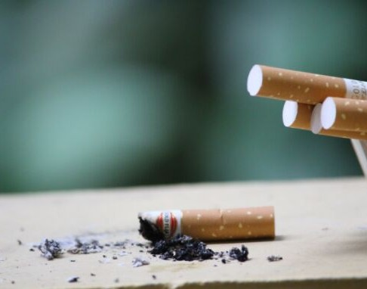

Benzene does have natural sources, including gas emissions from volcanoes and forest fires. Although there are natural sources of environmental benzene, man- made industry contributes to the vast majority of benzene in the air (1).

Who is at Risk?

People living in cities or in industrial areas are usually exposed to higher levels of benzene in the air compared to those living in rural areas. Those living near hazardous waste sites, petroleum refining operations, petrochemical and manufacturing sites, and gas stations may be exposed to higher levels of benzene.

BENZENE FACT SHEET | AIR ALLIANCE HOUSTON
1

Who is at Risk? (cont.)

Additionally, smokers are subject to significantly higher levels of benzene. The average smoker (32 cigarettes/day) ingests about 1.8 milligrams of benzene/day, which is about 10 times the average daily intake of benzene by nonsmokers (1).
Children exposed to the same levels of benzene vapor as adults may receive larger doses because they have greater lung surface-area-to-body ratios and are lower to the ground, where benzene vapor tends to be found (3).

Health Effects

Inhalation is the major route of exposure for benzene. Acute (short-term) exposure to lower concentrations can cause drowsiness, dizziness, rapid heart rate, headaches, tremors, confusion, and unconsciousness.
Usually, once people are removed from the benzene exposure and breathe fresh air, they will stop feeling these effects (2).
Prolonged exposure to benzene may lead to harmful reproductive effects. In a study of
women workers exposed to high levels of benzene, researchers found that the women had irregular menstrual cycles as a result of decreased ovary size (1). However, it is not certain that benzene caused these effects. It is currently unknown whether or
not benzene causes male reproductive issues (2). Animal studies show that breathing in benzene has harmful effects on a developing fetus, including low birth weight, delayed bone formation, and bone marrow damage (1).
Data from both human and animal studies indicate that benzene is genotoxic, meaning that it is toxic to our genes. Chromosomal abnormalities such as deletions and breaks in peripheral white blood cells and bone marrow cells are the predominant effects seen in humans (1).
Benzene causes harmful effects in the tissues that make blood, especially the bone marrow. These effects interrupt normal blood production and cause decreases in blood components. A decrease in red blood cells can lead to anemia while a decrease in other components can cause excessive bleeding. Additionally, excessive exposure to benzene can harm the immune system, increasing the chance for infection and potentially lowering the body’s defense against cancer (1).

BENZENE FACT SHEET | AIR ALLIANCE HOUSTON
2

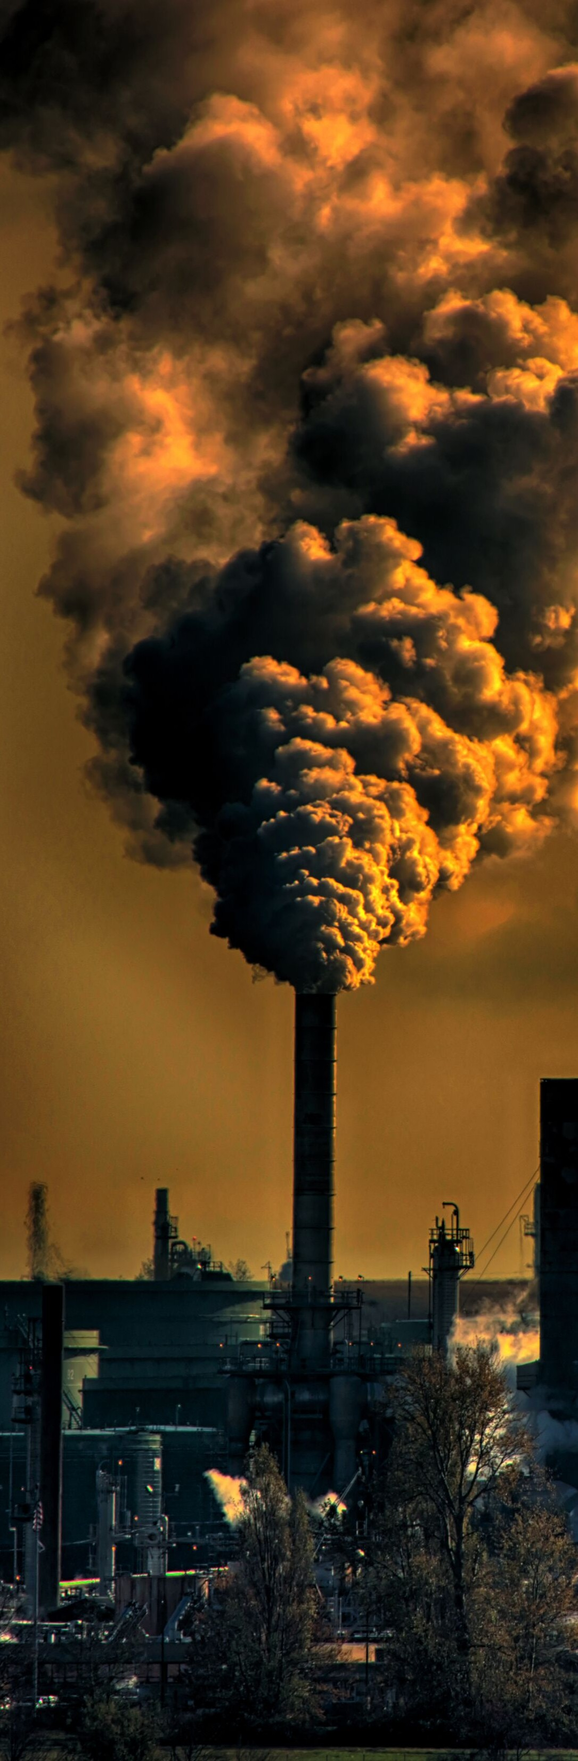Health Effects (cont.)

The International Agency for Cancer Research (IARC) has classified benzene as a Group 1 carcinogen, meaning that it causes cancer in humans (3). Long-term exposure to benzene can lead to cancer of the blood- forming organs, also known as leukemia.
Benzene exposure has been associated with a specific type of leukemia called acute myeloid leukemia (AML) (1,4).

What Can You Do?
The primary measure that you can take to decrease benzene exposure is to decrease or stop cigarette use. Families are discouraged from smoking in the house.
Additionally, reducing contact with gasoline will help to decrease benzene exposure (1).

References

- Agency for Toxic Substances and Disease Registry. Toxicological Report for Benzene.; 2007. https://www.atsdr.cdc.gov/toxprofiles/tp3.pdf
- US Environmental Protection Agency. Benzene Hazard Summary.; 2016
- Agency for Toxic Substances and Disease Registry. Medical Management Guidelines for Benzene.; 2014.
- International Agency for Research on Cancer. Benzene. IARC Monographs on the Evaluation of Carcinogenic Risks to Humans. 2018;120:1-309.

BENZENE FACT SHEET | AIR ALLIANCE HOUSTON 3

1,2-
Dibromoethane

What is it?
1,2-Dibromoethane is a colorless liquid with a mild, sweet odor. Historically, it was used as an additive in leaded gasoline and as a fumigant pesticide. However, it is no longer used for these purposes. Currently, dibromoethane is used as a pesticide treatment of felled logs and beehives as well as an intermediate in dye, resin, gum, and wax production (1,2). Its trade names include Bromofume and Dowfume (2).

Emission Sources
The primary sources of airborne dibromoethane are industrial production and processing facilities (1). Waste sites containing dibromoethane can also pollute surrounding waters and soils. Exposure to dibromoethane may occur by breathing in contaminated air or by drinking or touching contaminated water, especially well water near farms or waste sites. Children in particular can be exposed by playing in soils at or near waste sites containing dibromoethane(2).

Who is at Risk?
Generally, your exposure to dibromoethane is much lower than levels that can harm you. However, people in occupations that use dibromoethane may be exposed to greater concentrations than the general public (2). Additionally, people at-risk include those with pre-existing skin disorders, eye problems, and impaired liver, kidney, and respiratory tract function. Children may also be more vulnerable due to higher lung surface-area-to-body ratio (3).

Health Effects
Exposure to dibromoethane can cause a variety of health effects. Respiratory symptoms of dibromoethane inhalation include nose and throat irritation. Moderate to severe exposures to dibromoethane may produce respiratory issues ranging from cough, chest pain, and shortness of breath to bronchitis, pulmonary edema (excess fluid in lungs), and hemorrhage (3).
Dibromoethane may also impact the brain and spinal cord. Workers have reported that inhaling dibromoethane led to drowsiness and confusion (1). The inhalation of vapors in a confined, oxygen-deprived space
has caused unconsciousness, coma, and death (3).

1, 2- DIBROMOETHANE FACT SHEET | AIR ALLIANCE HOUSTON
1

Health Effects (cont.)
Liquid dibromoethane is a skin irritant. In worker studies, skin contact led to erythema (skin redness) and discomfort. Prolonged contact may cause blistering and skin ulcers (1,3).
Exposure to dibromoethane can also cause serious systemic health effects, including in the liver, kidneys, gastrointestinal tract, and reproductive organs. Inhalation or ingestion of dibromoethane has resulted in liver failure and necrosis. In several cases of dibromoethane poisoning, lesions in the kidneys were reported. Ingesting dibromoethane can also cause vomiting, diarrhea, nausea, and abdominal pain. In animal studies, ingestion led to gastrointestinal lesions. Lastly, worker studies show that inhalation and oral exposure to dibromoethane may lead to infertility and damage to male reproductive organs and sperm. Animal research indicates similar reproductive health outcomes.
However, more research is needed to confirm these findings with certainty (1,3).

References
- Agency for Toxic Substances and Disease Registry. Toxicological Profile for 1,2-Dibromoethane.; 2018. https://www.atsdr.cdc.gov/toxprofiles/tp37.pdf.
- Agency for Toxic Substances and Disease Registry. 1,2-Dibromoethane ToxFAQs.
- Agency for Toxic Substances and Disease Registry. Medical Management Guidelines for Ethylene Dibromide (C2H4Br2).; 2014.
- International Agency for Research on Cancer. Ethylene Dibromide. IARC Monographs on the Evaluation of Carcinogenic Risks to Humans. 1999;71(641):669.

The International Agency for Research on Cancer has classified dibromoethane as a Group 2A carcinogen, meaning that it is “probably carcinogenic to humans.” This means that there is inadequate evidence for carcinogenicity in humans, but that there is adequate evidence for carcinogenicity in animals (4). Animal studies indicate that oral exposure to dibromoethane may lead to gastrointestinal and endocrine cancer outcomes, while inhalation of dibromoethane may cause reproductive and respiratory cancer outcomes (1).

What Can you Do?
If you live close to an industrial facility that produces dyes, resins, gums, or waxes, try to avoid letting your children play in the dirt and swimming in nearby waters.
Additionally, dibromoethane can permeate clothing, leather, and regular rubber, so if exposed, make sure to remove contaminated clothing and rinse your skin thoroughly with soap and water (3).

1, 2- DIBROMOETHANE FACT SHEET | AIR ALLIANCE HOUSTON 2

Acrylonitrile

What is it?
Acrylonitrile is one of the world's most important industrial chemicals. It is a material used to create acrylic fibers, styrene plastics, and adhesives. These are then used as components of clothing, furniture, appliances, motor vehicles, and food packaging (1).
At room temperature, acrylonitrile is a clear, colorless, or slightly yellow liquid. It is unstable and forms toxic vapors at room temperature. It has an unpleasant onion or garlic-like odor. However, the smell is not a reliable warning indicator because dangerous concentrations are too low for humans to detect (1). Therefore, you could be overexposed to acrylonitrile without knowing it's there.

Emission Sources
Because acrylonitrile evaporates easily, it is primarily released into the environment by industrial facilities during its manufacture and use (2). Small amounts can also be found in cigarette smoke (3).
Humans are usually exposed to acrylonitrile via inhalation, although acrylonitrile can be ingested through drinking water and can irritate skin through direct contact. However, unless you live near a factory where

acrylonitrile is made or near a hazardous waste site that contains acrylonitrile, you are unlikely to be exposed (2).

Who is at Risk?
People who work in industries involving acrylonitrile will be subject to greater exposures and therefore may experience more health effects (2). Some examples of workers at greater risk of acrylonitrile exposure include: factory workers making nitrile rubber products and employees who work in adhesive and coating industries (4).
There is evidence that children are more sensitive to acrylonitrile than adults (2). Children exposed to acrylonitrile vapor may receive larger doses because they have a larger lung surface-area-to-body-weight ratio. Acrylonitrile is heavier than air, so children tend to inhale more vapors due to their shorter stature (1).

ACRYLONITRILE FACT SHEET | AIR ALLIANCE HOUSTON
1

Health Effects

Acute (short-term) exposure to acrylonitrile produces a variety of systemic effects, primarily affecting the lungs and the nervous system. Workers exposed to acrylonitrile reported respiratory symptoms such as nose and throat irritation, tightness in the chest, cough, and difficulty breathing (1,2). In fatal cases, pulmonary edema (fluid accumulation in the lungs) developed (1).
Acrylonitrile can have negative effects on the nervous system. Initial symptoms are usually general and include irritability, dizziness, nausea, vomiting, headache, and limb weakness. If exposure continues, nervous system responses may include drowsiness, convulsions, hallucinations, loss of consciousness, and coma (1).
People exposed to acrylonitrile may exhibit cardiovascular symptoms such as tachycardia (elevated heart rate) followed by bradycardia (low heart rate) (1,2). After entering the human body, acrylonitrile breaks down into many chemicals, including cyanide. This may lead to negative effects on the cardiovascular system, leading to symptoms like low blood pressure and irregular heartbeat. These compounds may also cause liver dysfunction, leading to symptoms like jaundice and anorexia (1).
Contact with acrylonitrile in both liquid and gaseous forms can lead to impacts on skin and eye health. Acrylonitrile can cause skin blisters and burns that look similar to second-degree burns. Eye contact with acrylonitrile can lead to irritation and increased tear production (1).
The International Agency for Research on Cancer (IARC) classified acrylonitrile as a Group 2B carcinogen, meaning that it is possibly carcinogenic to humans (3).
Long-term exposure to acrylonitrile in the air or water may increase your risk of getting cancer. Studies show that workers who are repeatedly exposed to acrylonitrile in the workplace have a higher-than-average chance of developing lung cancer, though this is not confirmed (2).
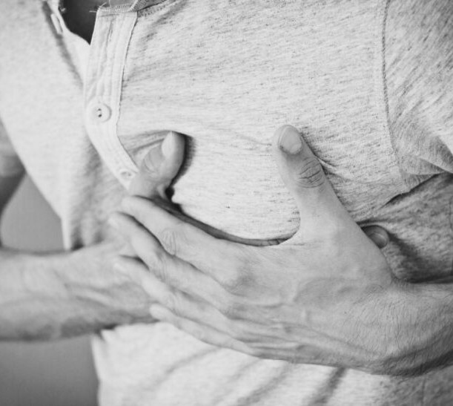
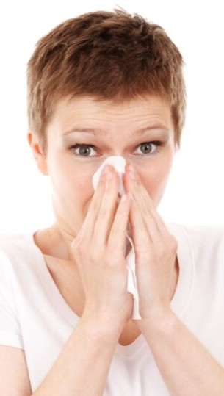

ACRYLONITRILE FACT SHEET | AIR ALLIANCE HOUSTON
2

What Can You Do?

If you are exposed to acrylonitrile vapors, move yourself to an area with fresh air as soon as possible. Any health outcomes will resolve themselves soon after (2). For those in the workplace, it is important to remove contaminated clothing and rinse the skin with water and mild soap (1). This will help reduce adverse dermal health outcomes.

References

- Agency for Toxic Substances and Disease Registry. Medical Management Guidelines for Acrylonitrile (CH2 = CHCN).; 2014. https://www.atsdr.cdc.gov/mmg/mmg.asp? id=443&tid=78.
- Agency for Toxic Substances and Disease Registry. Toxicological Profile for Acrylonitrile.; 1990. https://www.atsdr.cdc.gov/ToxProfiles/tp.asp? id=447&tid=78.
- International Agency for Research on Cancer. Acrylonitrile. IARC Monographs on the Evaluation of Carcinogenic Risks to Humans. 1999;71:43-107. https://monographs.iarc.fr/wp- content/uploads/2018/06/mono71-7.pdf.
- The National Institute for Occupational Safety and Health. Acrylonitrile. https://www.cdc.gov/niosh/topics/acrylonitrile/def ault.html. Published 2019. Accessed July 10, 2019.

ACRYLONITRILE FACT SHEET | AIR ALLIANCE HOUSTON 3

Formaldehyde

What is it?
Formaldehyde is a colorless, flammable gas at room temperature with a strong, distinct odor. An ever-present chemical, formaldehyde is found in commercial products including cigarettes, carpets, cosmetics, wood products, medicines, and preserved foods. Industrially, formaldehyde is used to make resins for wood products, fertilizer, paper, and plywood.

Emission Sources
For the general population, the major sources of formaldehyde include combustion sources, tobacco smoke, home goods, and consumer goods. Combustion sources include automobiles, power plants, and oil refineries (2). Home goods that release formaldehyde into the air include wood pressed products made with urea- formaldehyde resins, particleboard, and plywood (1,2). Consumer products that release formaldehyde include cosmetics, soaps, and household cleaning agents (2).

Additionally, preexisting air pollutants will react with each other to create secondary formaldehyde. Because there is a great diversity in air pollutants that will react to create formaldehyde, the amount of secondary formaldehyde in the air may exceed that which is directly emitted from cars and industrial sources (2).

Who is at Risk?
Work environments are usually the largest source of airborne formaldehyde. The occupational groups considered to be most at risk are industrial workers from chemical industries and plywood factories, embalmers, and pathology and anatomy laboratory workers (2).
Additionally, those with asthma may be at risk for worsening symptoms if exposed to formaldehyde for long periods of time (1).

Health Effects
People are usually exposed to formaldehyde through inhalation. The most common exposure effects of formaldehyde vapors consist of irritation of the eyes, nose, and throat, with eye irritation being the most sensitive (1). Other symptoms of formaldehyde exposure include sneezing, coughing, sore throat, increased tear production, and nausea. Formaldehyde may also affect the brain; studies report that

FORMALDEHYDE FACT SHEET | AIR ALLIANCE HOUSTON
1

Health Effects (cont.)
exposure to formaldehyde may decrease performance in short-term memory tests and the ability to concentrate (1,2).
Recently, formaldehyde has been heavily studied for its genotoxicity - its toxicity to DNA molecules in genes. Studies have reported increased frequency of abnormal DNA outcomes and DNA damage in formaldehyde-exposed workers, namely those who are most at-risk: industry workers, embalmers, and pathology and anatomy workers. Studies have also suggested that these toxic interactions between formaldehyde and DNA may ultimately lead to cancer formation (2).
In 2004, the International Agency for Research on Cancer (IARC) classified formaldehyde as carcinogenic to humans. Studies have shown that exposure to formaldehyde can cause increased risk of leukemia and nasopharyngeal cancer (cancer that affects the upper part of the throat behind the nose). In addition, there may be a link between exposure to formaldehyde and sinonasal cancer, a rare

References
- Agency for Toxic Substances and Disease Registry. Toxicological Report for Formaldehyde. 2010:1-468
- Costa S, Teixeria JP. Formaldehyde: Human Exposure, Metabolism and Potential Health Effects. In: Patton A, ed. Formaldehyde: Synthesis, Applications, and Potential Health Effects. New York: Nova Science Publishers; 2015:1-31
- National Institute of Environmental Health Sciences. Formaldehyde. https://www.niehs.nih.gov/health/topics/agents/formaldehyde/index.cfm. Published 2018. Accessed June 20, 2019.
cancer affecting the nasal cavity and sinuses (1,2).

What Can You Do?
Formaldehyde levels are usually higher indoors, so ventilating the home by opening windows or using fans is the easiest way to lower formaldehyde levels. Additionally, limit the use of pressed wood in homes or seal uncovered pressed wood products to reduce the amount of formaldehyde that is released (1). If possible, use lower-emitting pressed wood products certified as CARB (California Resource Board) Phase 1 or 2 compliant, or made with ULEF (ultra-low- emitting formaldehyde) or NAF (no-added formaldehyde) resins (3).
Formaldehyde is a component of tobacco smoke. If possible, reduce or avoid smoking cigarettes in enclosed spaces such as inside the home or car to limit exposure to children and other family members (1).
Lastly, some permanent-press fabrics emit formaldehyde. So, washing new clothes before wearing them will lower the amount of formaldehyde released and reduce exposure to families (1).

FORMALDEHYDE FACT SHEET | AIR ALLIANCE HOUSTON 2

Acrolein

What is it?
Acrolein is a clear or yellow liquid with a burnt, sweet odor (1). It is primarily used to make other chemicals and can also be found in animal feed supplements (1,2). Acrolein may also be used as a pesticide and is sometimes added into the irrigation and the water supplies of some industrial plants to control underwater plant, algae, and slime growth (1). At much higher concentrations, it is used as a chemical weapon component (1,2). However, acrolein is highly reactive and degrades quickly in air, water, and soil, so environmental accumulation is rare (1,2).

Emission Sources
Acrolein enters the environment through both man-made and natural sources.
Acrolein is released into the environment as a product of natural fermentation and ripening processes. It is also emitted by forest fires due to the incomplete combustion of organic matter (3).
Acrolein enters the environment due to human processes like burning tobacco and vehicle fuels, overheating cooking oils, and gas and diesel motor vehicle emissions.
Acrolein is heavily released by industrial sources, such as waste incinerators, furnaces, powerplants, and the combustion of petrochemical fuels and

certain plastics (1,3). Acrolein is also formed through the reactions and breakdown of other airborne pollutants present in Houston, such as 1,3-Butadiene (3).

Who is at Risk?
The general population may be exposed to acrolein via smoking, second-hand smoke, breathing in contaminated air, and through ingestion of certain fried foods (1,2).
However, firefighters and populations living or working in areas with high volumes of automobile traffic may be exposed to higher levels of acrolein through inhalation of smoke and exhaust (2).

Health Effects
Acrolein can cause toxic effects through inhalation, oral, and dermal exposures. Acrolein primarily enters the body through inhalation, where it can enter the body's tissues within seconds. Symptoms of inhaling acrolein include irritation of the nose, throat, and lungs, accompanied by a

ACROLEIN FACT SHEET | AIR ALLIANCE HOUSTON
1

Health Effects (cont.)

decrease in breathing rate. More serious health problems can occur with higher amounts of acrolein in the air, including lung hemorrhage, and death (1-3).
Coming into contact with acrolein vapor or liquid causes eye irritation. At low airborne levels, eye irritation and increased blinking occurs. At these low levels, humans seem to adapt to acrolein-caused eye irritation. At high levels, humans will experience increased eye irritation and tear production. It is unknown at what level acrolein liquid or vapor will cause structural damage to the eye (1).
It's currently unknown if eating food or drinking water containing acrolein will affect your health, but animal studies show that oral exposure to acrolein can lead to stomach irritation, vomiting, stomach ulcers, and bleeding (1).
Regarding acrolein’s ability to cause cancer, there is little evidence proving the carcinogenicity of acrolein. The International
Agency for Research on Cancer (IARC) has not classified acrolein according to its carcinogenicity and the EPA has stated that the potential carcinogenicity of acrolein cannot be determined due to inadequate research and data (1).

What Can you Do?
To decrease your exposure to acrolein, reduce your exposure to tobacco smoke, smoke from burning wood products, and exhaust from diesel or gasoline vehicles. Decreasing your intake of fried foods will also reduce your acrolein exposure (1).
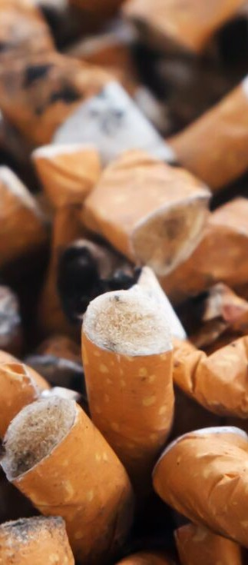

ACROLEIN FACT SHEET | AIR ALLIANCE HOUSTON 2

References

- Agency for Toxic Substances and Disease Registry. Toxicological Profile for Acrolein.; 2007. https://www.atsdr.cdc.gov/toxprofiles/tp124.pdf.
- O. F, N. R, J. T, A. A, M.H. L, D.J. P. Acrolein health effects. Toxicol Ind Health. 2008;24(7):447-490. http://ovidsp.ovid.com/ovidweb.cgi?T=JS&PAGE=reference&D=emed8&NEWS=N&AN=2008594740.
- World Health Organization. Concise International Chemical Assessment Document 43 - Acrolein. Geneva; 2002.

Chlorine

What is it?
Chlorine is a greenish-yellow gas with a pungent, irritating odor similar to bleach (1). It is one of the most commonly manufactured chemicals in the United States and is widely used in industry and as an ingredient of household products like bleach (1,2). When shipped, it is pressurized and cooled to change it into a clear, amber liquid (1,3). When the liquid is released, it turns into a gas that stays close to the ground and quickly spreads (1). In gas form, chlorine is poisonous (1,3).
The most important use of chlorine is as bleach when producing paper and cloth. Chlorine is also vital for killing harmful bacteria in swimming pools and for being a part of the sanitation process for industrial waste and sewage (1).

Emission Sources
Chlorine does not usually present a health risk to the general population because it's very reactive and does not build up in the environment. However, you may be exposed if an accident takes place nearby, such as a chlorine tank rupture at a facility or a liquid chlorine spill during transportation. When chlorine is released during these types of incidents, it will react with other chemicals
in the air to form a greenish-yellow chlorine gas cloud, which may expose nearby populations to high levels of gas through inhalation (2). Additionally, people who mix acidic solutions with bleach or certain types of swimming pool chemicals may accidentally be exposed to chlorine gas.

Who is at Risk?
In general, people who suffer from respiratory conditions such as allergies or are heavy smokers tend to experience more severe effects than healthy people or nonsmokers (2). Children may be more susceptible to chlorine exposure because they are generally shorter in stature and may inhale more chlorine gas closer to the ground. Additionally, children may be more susceptible than adults to chlorine gas health effects because of the smaller diameter of their airways and greater lung surface-area-to-body ratio (2,3).

CHLORINE FACT SHEET | AIR ALLIANCE HOUSTON
1

Health Effects

The toxic effects of chlorine occur due to its corrosive properties (3). The main targets of chlorine gas are the respiratory airways and the eyes. Exposure to low concentrations of chlorine may cause eye and nose irritation, sore throat, and coughing (2,3).
At higher concentrations, inhaling chlorine gas can produce immediate chest pain, nausea and vomiting, shortness of breath, cough, and buildup of fluid in the lungs (pulmonary edema). Inhaling chlorine gas can be fatal, but only if you're exposed to extremely high concentrations (2,3).
Chlorine has not been implicated in cancer studies. The United States Environmental Protection Agency (EPA), International Agency for Research on Cancer (IARC) and the Department of Health and Human Services (DHHS) have not classified chlorine for carcinogenicity (2) due to a lack of data.
Long-term exposure to chlorine, usually in workers, may cause corrosion of the teeth.
Additionally, multiple exposures to chlorine have led to flu-like symptoms and a high risk of developing reactive airways dysfunction syndrome (RADS) (3).

What Can You Do?
Leave the area where the chlorine was released and get to fresh air. Go to the highest ground possible because chlorine is heavier than air and will sink to low-lying areas. If the chlorine release was indoors, get out of the building (1). If you are a heavy smoker or suffer from respiratory conditions like allergies, avoid spending extended periods of time outdoors or doing strenuous activity if the chlorine smell outside is really strong.

References

  - Center for Disease Control and Prevention. Facts About Chlorine. https://emergency.cdc.gov/agent/chlorine/basics/facts.asp. Published 2019.
  - Agency for Toxic Substances and Disease Registry. Toxicological Profile for Chlorine.; 2010. https://www.atsdr.cdc.gov/toxprofiles/tp172.pdf.
  - Agency for Toxic Substances and Disease Registry. Medical Management Guidelines for Chlorine (Cl2).; 2014.

CHLORINE FACT SHEET | AIR ALLIANCE HOUSTON 2

Hexamethylene Diisocyanate (HDI)

What is it?
HDI is the common name for hexamethylene diisocyanate, which is known in industry as Mondur HX and Desmodur H (1). HDI is a pale-yellow liquid with a sharp, irritating odor (2). Over 99% of the HDI used in the U.S. is used as hardeners in automobile and airplane paints. The remaining 1% is sold as rocket fuel binder and paint thickener (1).

Emission Sources
HDI is usually found in the air near locations where spray paints that contain HDI are used, such as auto body shops. However, HDI breaks down quickly in both the air and water, so it is unlikely to build up in the environment. As a result, the general population is exposed to HDI when spray- painting a car with an HDI hardener or drinking contaminated tap water. People can also be environmentally exposed if they live near a hazardous waste site where HDI is disposed (1).

Who is at Risk?
Individuals who have the greatest exposure to HDI are those who work in an industry or business in which HDI is used. During the paint hardener spraying process, small droplets of HDI in the air are breathed in by or lands on the skin of exposed workers (1).

Health Effects
Acute (short-term) health effects may occur immediately or soon after HDI exposure.
Contact with HDI can severely irritate and burn the skin, eyes, nose, and throat.
Additionally, exposure to HDI can cause headache, dizziness, nausea, and vomiting. Lastly, inhaling HDI can irritate the lungs, causing coughing, shortness of breath, and labored breathing. High exposures can cause serious respiratory issues like pulmonary edema, which is a build-up of fluid in the lungs (2).
Chronic (long-term) health effects primarily impact the respiratory system. Research shows that long-term exposure to HDI may cause chronic lung problems (1-3). Animal studies also show that long-term exposure to HDI may have effects on nasal tissue, the respiratory tract, and the lungs (1). However, it is not confirmed that these effects will be the same in humans.

HEXAMETHYLENE DIISOCYANATE | AIR ALLIANCE HOUSTON
1

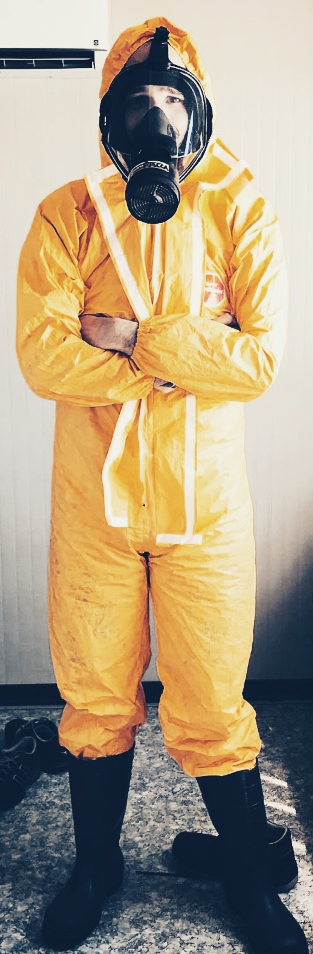What Can You Do?
To reduce your exposure to HDI, make sure to properly use personal protective equipment. It is important to wear gloves and clothing that HDI will not permeate.
Safety equipment suppliers and manufacturers can give recommendations on the most protective glove and clothing material for your HDI use. To protect your eyes, wear indirect-vent, impact, and splash resistant goggles when working with liquids. If needed, use respiratory protection to prevent inhalation exposures (2).

References

- Agency for Toxic Substances and Disease Registry. Toxicological Report for Hexamethylene Diisocyanate.; 1998.
- New Jersey Department of Health. Hazardous Substances Fact Sheet - Hexamethylene Diisocyanate. Trenton; 2009.
- United States National Library of Medicine. Hexamethylene Diisocyanate. Hazardous Substances Data Bank. https://toxnet.nlm.nih.gov/cgi- bin/sis/search/a? dbs+hsdb:@term+@DOCNO+6134. Published 2012. Accessed July 12, 2019.

HEXAMETHYLENE DIISOCYANATE | AIR ALLIANCE HOUSTON 2

